SUPPLEMENTAL MATERIALS FOR:

TITLE:
EPA Method 1615. Measurement of Enterovirus and Norovirus Occurrence in Water by Culture and RT-qPCR. I. Collection of Virus Samples

AUTHORS:
Fout, G. Shay, Cashdollar, Jennifer L, Varughese, Eunice A., Parshionikar, Sandhya U., Grimm, Ann C.

Sampling Apparatus Assembly:

1. Intake Module (Figure S1)

1.1) Attach the swivel female insert to a section of tubing with a hose clamp.

1.2) Attach a quick connect body to the other end of the tubing with a hose clamp.

1.3) Attach an optional backflow regulator to the swivel female insert.

2. Cartridge Housing Module (Figure S2)

2.1) Attach a quick connect insert to the inlet of the cartridge housing using thread tape.

2.2) Attach a quick connect body to the outlet of the cartridge housing using thread tape.

3. Discharge Module (Figure S3)

3.1) Attach a quick connect insert to one end of the straight connector using thread tape.

3.2) Attach a flow meter with attached rate totalizer to the other end of the straight connector using thread tape.

3.3) Attach the reduction nipple using thread tape

3.4) Attach the bronze globe valve to the reduction nipple using thread tape

3.5) Attach the GHT fitting to the other end of the globe valve using thread tape

Sampling Apparatus Calibration: check the calibration after every sampling event until a determination can be made about the number of sampling events that can be performed without affecting the calibration. Note that due to the difference in volume collected and water quality this number might be quite different depending on whether ground or surface water samples are collected. Continue to check the calibration at the determined time, but as a minimum check it once a month for every month that samples will be collected.
Name of the reagent | Company | Catalogue number | Comments (optional)
1/2-in tubing | Cole-Parmer | 72010-20
Backflow regulator | Watts | Series 8 C | Recommended but optional
Bronze globe valve | Cole-Parmer | 98675-09
Cartridge housing | Argonide | H2.5-5
Aluminum foil squares | Cole-Parmer | 06275-40
GHT fitting | United States Plastic | 63016
Flow meter | Flow Technology | FT6-8NENWULEG-3
Hose clamp | Cole-Parmer | 06403-12
NanoCeram cartridge filter | Argonide | VS2.5-5
PTFE thread tape | Cole-Parmer | 08270-34 | Use on all threaded connections
Quick disconnect body | Cole-Parmer | 31307-00, 31307-06, 31307-11
Quick disconnect insert | Cole-Parmer | 31307-31, 31307-46
Rate totalizer | Flow Technology | BR30-5-A-4 | Multipoint calibration between 4 and 10 L
Reduction nipple | Cole-Parmer | 06349-87
Straight connector | Cole-Parmer | 06349-03
Swivel female insert | United States Plastic | 63003

Figure S1. Intake Module
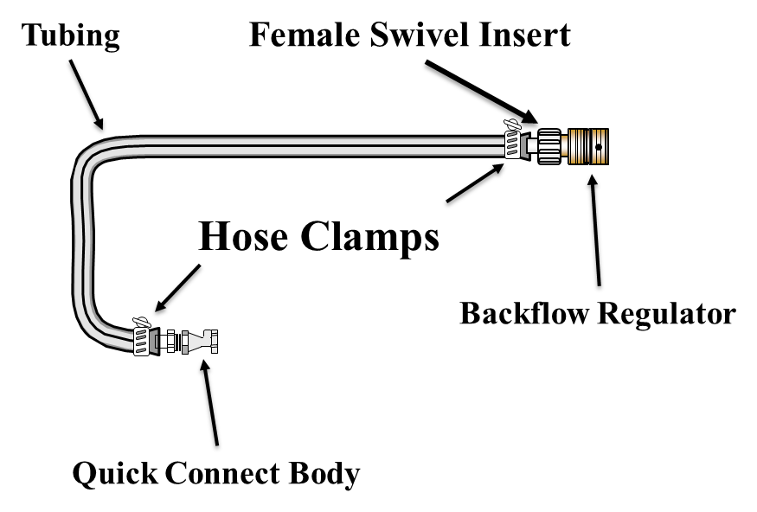

Figure S2. Cartridge Housing Module
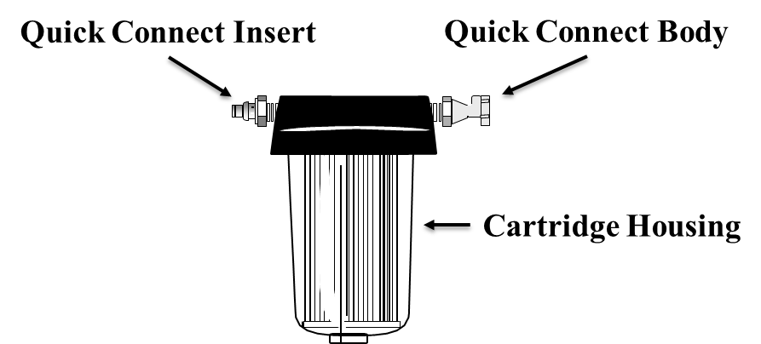

Figure S3. Discharge Module
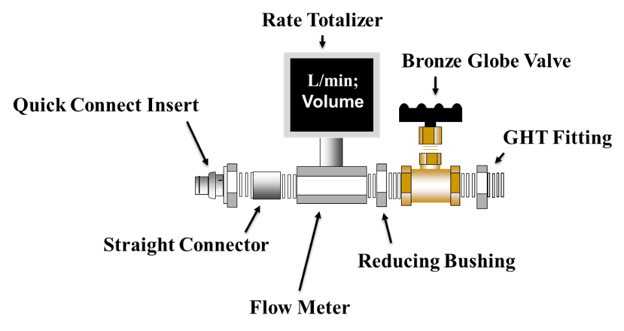

Table S1. Sample Data Sheet
Sample Number
Utility/Site Name
Site Address
City, State
Sampler’s Name ⁽¹⁾
Water Type | Surface Waters |  | Treated Surface or Groundwaters | Untreated Groundwater |  | Other (specify in comments section
Location at Sampling Site | Treatment Plant/Pumping Station |  | Distribution System | Other (specify in comments section) |  | Matrix Spike
 |  | Start of Sampling Event |  |  | End of Sampling Event
Date
Time
Totalizer Reading (L)
Flow Rate (L/min)
Total Sample Volume (L)
Water Parameter Readings
Water Temperature
pH
Turbidity (NTU)
Free Chlorine (mg/L)
Quality Controls
Flow meter model and serial number:
Totalizer model and serial number:
Date of last flow meter/totalizer calibration:
Metering pump model and serial number
Temperature meter model and serial number:
pH meter model and serial number
Turbidity meter model and serial number
Chlorine test meter model and serial number
Metering pump flow rate QC check performed |  | Yes
Comments:

(1) If any other individuals assist the sampler, include their name in the comments section and add the initials of the person who performed measurements after the recorded value.

