SUPPLEMENTARY INFORMATION
The physical principles outlined in this article are applicable at the bench scale. Experiments can therefore be performed in a smaller demonstration flume, which can be constructed at a relatively low cost and used in conjunction with aquarium or water-feature pumps as an economical, portable means to recirculate water within the flume.
As proof of concept, we constructed a small flume with a 22” L x 4” W x 8” H channel using the materials outlined in Table S1. The total cost for these materials was less than $300. Channel dimensions can be scaled down further for convenience and cost savings. A brief summary of flume construction is provided below.
DEMONSTRATION FLUME CONSTRUCTION
Acrylic walls were chosen for their relatively low cost, light weight, and suitability for cutting. We used a computer-aided drawing package (AutoCAD 2016) to specify flume wall dimensions. The CAD files were input to a laser cutter to maximize precision and edge smoothness. (A standard band saw or table saw can be used if a laser cutter is not available. It is highly recommended that edges are sanded to maximize contact during welding.)
Acrylic pieces were held in place with standard ninety-degree angle clamps, and pieces were joined using an acrylic welding solvent. Plumber’s caulk was applied to the flume edges after construction to provide a watertight seal. Small, 3” L x ¼” D acrylic tubes were stacked (in parallel) at the channel inlet for flow conditioning.
A small aquarium pump, such as the one specified in Table S1, was placed at the bottom of the upstream reservoir. In this configuration, flexible tubing connects the pump inlet to the effluent reservoir downstream of the channel. The pump outlet can be left without tubing and discharged directly into the inlet reservoir.

Table S1 – Materials list for demonstration flume
Material | Company | Product Number | Comments/Description
Clear Cast Acryli2412" x 48" cut sheet, 1/4" thickness | Peterson Brothers Plastics, Chicago, IL | Custom | 2 sheets @ $55/ea
Weld-On 4 Acrylic Adhesive - 4 Oz and Weld-On Applicator Bottle with Needle | Weld-On (distributed by Amazon) | UNSPSC Code 31201607; ASIN: B0096TWKCW | $14
Dap 08641 Clear Silicone Sealant 9.8-Ounce | DAP (distributed by Amazon) | 08641; ASIN: B000BD0QAK | $8
Dripless 10oz Cradle Hex Rod Caulk Gun | Dripless (distributed by Amazon) | CH200; ASIN: B000CSR5PS | $6
Extruded Acrylic Round Tube, 3/8" OD, 1/4" ID, 6' Length, Clear | McMaster Carr | 8532K11 | Cut into 3-in pieces and stacked in parallel at flume input for flow conditioning, 10 @ $2.73/ea
Taam Rio Hyperflow Water Pump | Taam (distributed by Amazon) | ASIN: B000BJM9FO | Pump sized to achieve 13 cm/s flowrate. $95

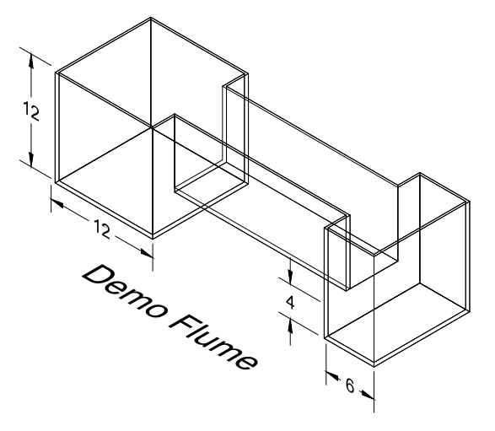
Figure 1- Isometric View of Demonstration Flume. All dimensions are in inches.

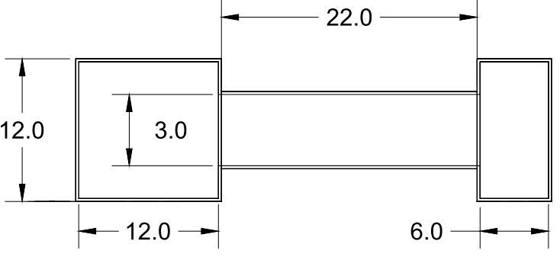
Figure 2 - Top View of Demonstration Flume. Inlet reservoir is on the left.
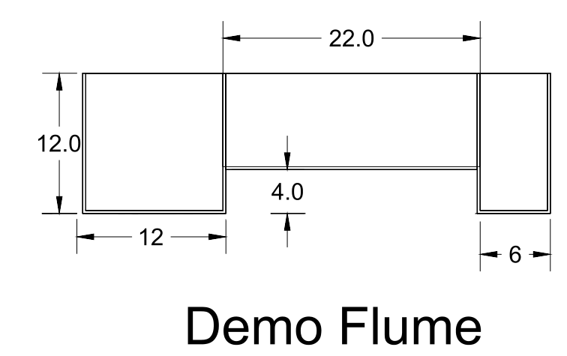

Figure 3 - Side View of Demonstration Flume. Inlet reservoir is on the left.

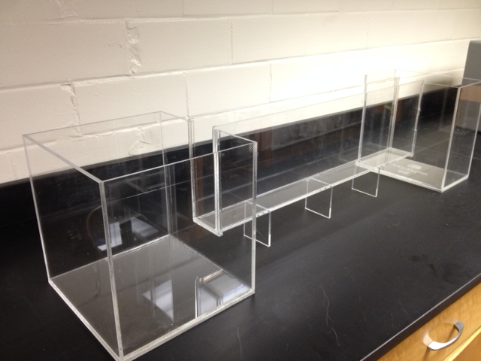
Figure 4 - Completed demonstration flume

