Supplementary File 2: Instruction of the practice session
Practice Session
1. Start the program by clicking on 'start' with the left mouse button.
2. Walk to the end of the aisle by using the 3D SpaceNavigator.
3. Press down the 3D SpaceNavigator to obtain a better view of the Olive oil (see Figure 1). Turn the 3D SpaceNavigator so that you see the olive oil shelf in front of you.

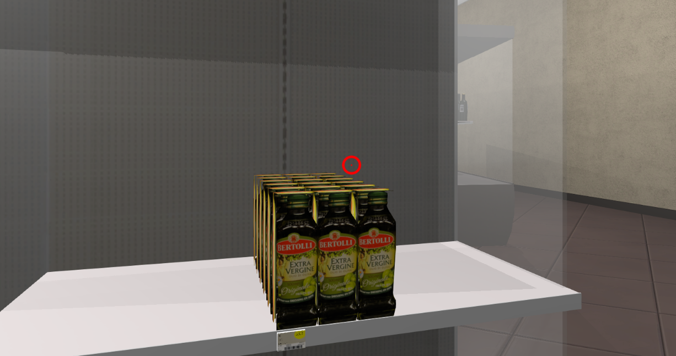
Figure1 Olive oil
4. Pull the 3D SpaceNavigator up to go back to the normal eye view.
5. Walk to the back of the store, where you see bottles of wine on the shelf.
6. Use the mouse to select the right arrow in order to turn to the wine shelf (when arrows appear on screen (see Figure 2), you must first select an arrow by pressing the left mouse button before you can move again).
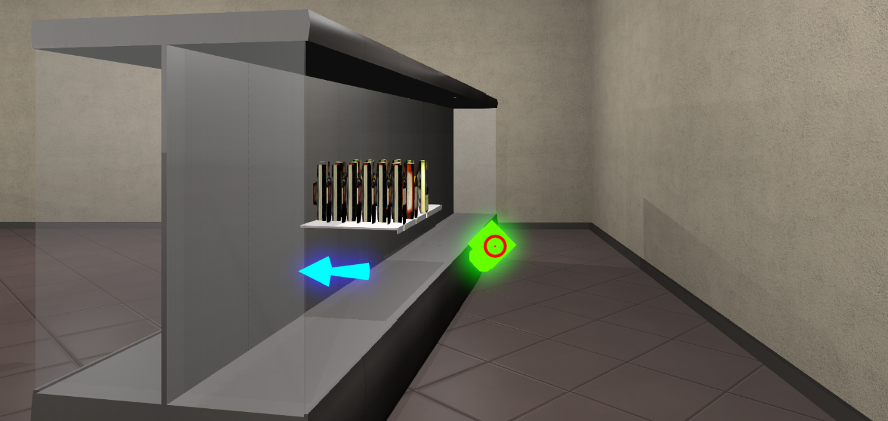
Figure 2 Arrow at an intersection.
7. Walk to the wine shelf using the 3D SpaceNavigator.
8. Use the mouse to move the red-circle-visor on one of the wines. Practice with the + and - buttons to select the quantity and press either "Return" to return the wine, or press 'Buy' to make a purchase (see Figure 3).

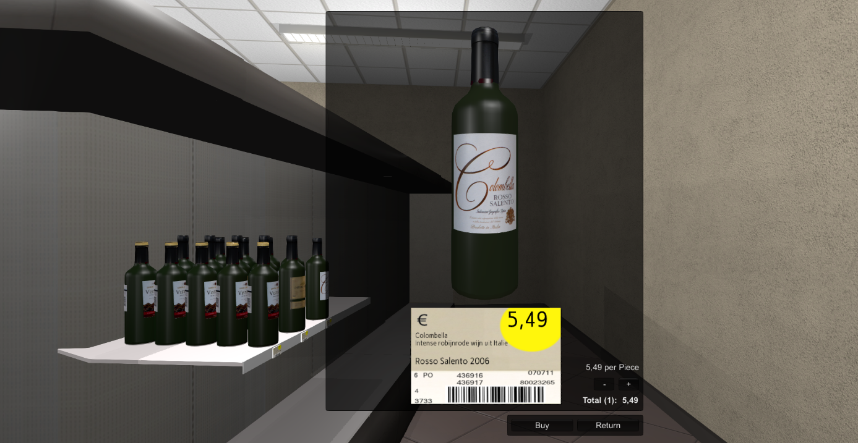
Figure 3 Pop-up window to show selected product.
9. Press “F1” to check your shopping basket and click “Close’’ to close it.
10. After you have bought all the products you want, press “Esc” to exit the store.
Now call the researcher to bring you to the next part of the study.

