APPENDIX B
The GUI for the chemiluminescence measurement and an example from a measurement with the software are shown.
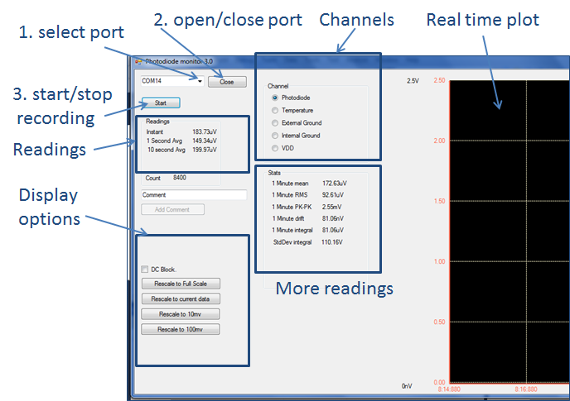

Figure 1B: Graphical user interface (GUI) from the bespoke software used for real-time detection of chemiluminescence. Critical features and functions in the software GUI are labelled (blue arrows).

