Supplemental file

Picture explaining how the different coating have been disposed in the 96-well plate.
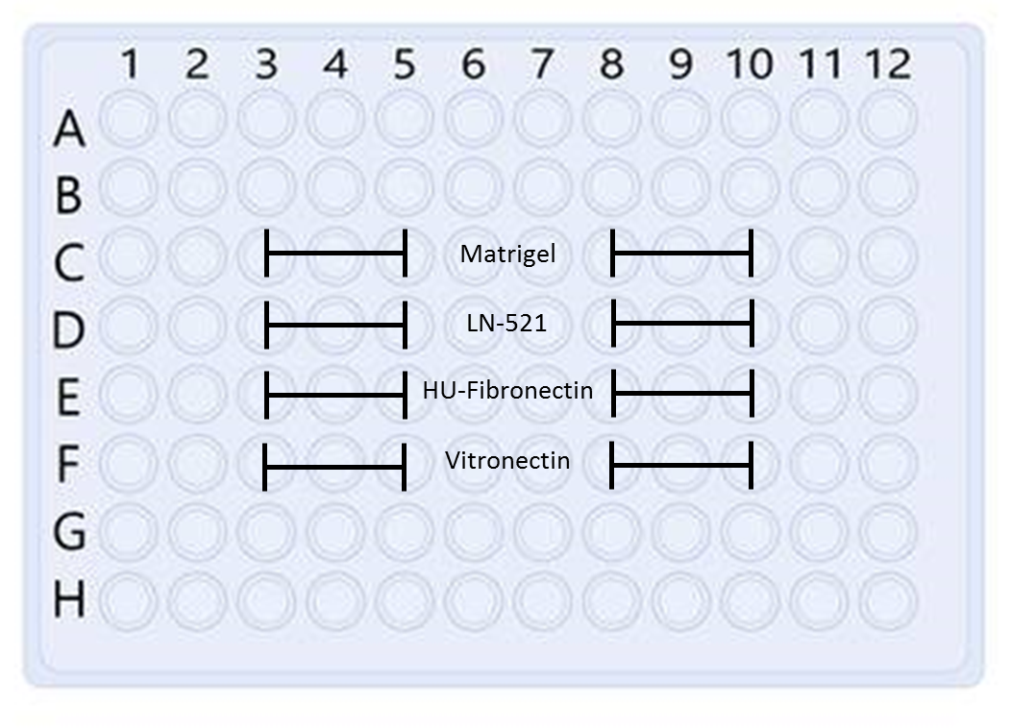

Experimental parameters:

To Acquire the images:
- Application: Confluence
- Image Acquisition setting: Auto Exposure
- Configuration: Brightfield
- Acquisition resolution: 1um/pixel
- For the Contrast: auto contrast
- For the Focus set up:
- “hardware autofocus – register auto mode”
- Target focal plane bright focus.

For the Analysis:
- Application: Confluence
- Analysis resolution: 2um/pixel
- Algorithm: Texture
- Intensity threshold: 15
- Precision: High
- Min cluster size: 50 µm^3

Imaging parameters used

Channel Name | Name | Cube | Contrast Method | Emission Wavelength | Peak Emission | Peak Excitation
Channel 1 | DAPI | DAPI | FLUO | nm | 461 | 0 nm
Channel 2 | RHOAD | RHOAD | FLUO | nm | 578 | 0 nm

Channel Name | Lookup table name | Exposure time | Gain | Differential interference contrast | Condenser | Resolution XY | Resolution Z
Channel 1 | Blue | 220.02 ms | 0 | - |  | 0.469 µm | 1.281 µm
Channel 2 | Red | 795 ms | 0 | - |  | 0.469 µm | 1.281 µm

Camera settings
Camera | Hamamatsu-C11440-42U-USB-001428
Format | --
Digitization | 16 bits
Gamma | 0.9807789
Quality Mode | 1 MHz
Image Flip X Axis | No
Image Flip Y Axis | No
Black-Value | 0
White-Value | 65535
Shading Correction | OFF

Microscope Settings
System Name | LAS X
Microscope Model | DMI8
OBjective | HC PL FLUOTAR L 40x/0.60 DRY
Order number (Obj.) | 11506201
Numerical aperture | 0.6
Refractive index | 1
Mounting Medium Refraction index
Z Movement | Z then Lambda
Camera Light | 100%

