Biomark primer qualification.

Create a folder in which you will have all files for your qualification.

Files needed:

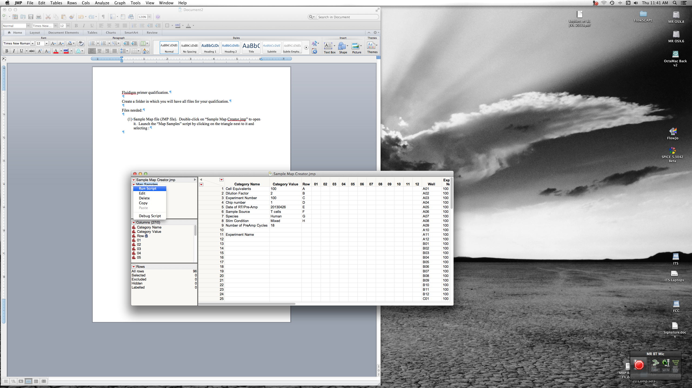

1. Sample Map file (JMP file). Double-click on “Sample Map Creator.jmp” to open it. Launch the “Map Samples” script by clicking on the triangle next to it and selecting “Run Script”.  
     
   Fill out the information as needed (check boxes indicate wells that should be omitted from analysis).  
     
   When done, JMP will ask you where to save the new Sample Map file – choose your new qualification folder.
2. Probe Map file (JMP file or XLS file). Duplicate an existing Probe Map file and edit it as needed. Save it in your new qualification folder.
3. Raw sample data (CSV file). Do NOT modify this file, use it directly from the output of the BioMark Fluidigm software.

Launch the “Primer Analysis” script (double-click on “Primer Analysis.jsl”, and click on “Run Script” or press command-R). The script will prompt you to identify the Probe map file, the Sample map file, and the Raw data file.

After running, you will have one window open, “Qual Data”. Save this to your folder.

Now launch the “Piecewise Analysis” script. You must have the “Qual Data” file open – if not, open it. Run the “Piecewise Analysis” script – you will be prompted for various QC parameters.

When finished, the script produces a table called “Results” which has all the information on qualification – save it in your folder. It also produces a graphical report. If you want to print the report, you should first click on it, do a “Page Setup”, and choose “60%” (for example) so everything fits better. You can also save the report as a file – although this isn’t necessary, you can regenerate it simply by re-running the script.

The report summarizes several pieces of information. On the far left, is the gene name (and alias if given), and if it passed or failed QC (and why it failed). If it passed, the next line shows the range of cell-equivalents over which linearity could be found. The bar chart summarizes how many of the 8 replicates passed QC for each piece-wise series. There are seven series (dilutions 1-6, 2-7, 3-8, … 7-12), shown in order. Green bars indicate how many of the 8 replicates passed the r2 QC (e.g., >0.97), blue indicate how many passed the slope QC (e.g., >0.8 and <1.3), and red indicates how many passed both.

The first plot shows all dilutions and all replicates. The next 3 plots show the fits for the first, fourth, and seventh series (unless you opted to show all 7 in which case all are shown).

