**Supplementary File 1 on:**

Characterizing microbiome dynamics – Flow cytometry based workflows from pure cultures to natural communities

Johannes Lambrecht1, Florian Schattenberg1, Hauke Harms1, Susann Müller1

1*Department of Environmental Microbiology, Helmholtz Centre for Environmental Research - UFZ, Permoserstr. 15, 04318 Leipzig, Germany*

*Corresponding Author:*

*Susann Müller*

*Email Address: susann.mueller@ufz.de*

*Tel: (+49)-0341-235-1318*

*Email Addresses of Co-authors****:***

*Johannes Lambrecht (johannes.lambrecht@ufz.de)*

*Florian Schattenberg (florian.schattenberg@ufz.de)*

*Hauke Harms (hauke.harms@ufz.de)*

**Content** **Page**

Supplementary File 1 - S1 Sample sets 02

Supplementary File 1 - S2 Bench top analyzer event count limitations 03

Supplementary File 1 - S3 Establishing stable cytometer performance 03

Supplementary File 1 - S4 Cytometer calibration with standard beads

Supplementary File 1 - S5 Staining control by biological standard

Supplementary File 1 - S6 Gating strategies 04

Supplementary File 1 - S7 Cell counting 06

Supplementary File 1 - S8 Biological and technical replicates 07

Supplementary File 1 - S9 Fixation stability 11

Supplementary File 1 - S10 Dissipation of aggregates 13

Supplementary File 1 - S11 CHIC biogas Community 15

References 16

## Supplementary File 1 - S1 Sample sets

### Pure culture

The investigated pure culture (PC) was *Pseudomonas putida* KT2440 out of the DSMZ collection (number 6125). It was inoculated and grown according to published protocols 1. In short, it was cultivated in minimal medium (6 g L-1 Na2HPO4, 3 g L-1 KH2PO4, 0.5 g L-1 NaCl, 1 g L-1 NH4Cl, 0.5 g L-1 MgSO4, 15 mg L-1 CaCl2, 3.6 mg L-1 ZnSO4 x 7 H2O, 0.625 mg L-1 CuSO4 x 5 H2O, 0.15 mg L-1 H3BO3, 6 mg L-1 FeSO4 x 7 H2O, 5 mg L-1 CaCO3, 3 mg L-1 MnSO4 x 7 H2O, 0.7 mg L-1 CoSO4 x 7 H2O) with 2 g L-1 glucose and incubated over night at 30 °C and 180 rpm. The main cultivation was inoculated to OD600nm of 0.05 (path lengthcuvette = 0.5 cm) with a pre-culture and performed in 500-mL shaking flasks with 100 mL medium.

### Activated sludge community

The activated sludge community (ASC) was obtained and stored according to published protocols 2. In short, aliquots were taken from the activated sludge basin of the full-scale municipal waste water treatment plant in Eilenburg, Germany (51°27'39.4"N, 12°36'17.5"E, ~10200 m3 wastewater per day, water purification according to German law – Waste Water Ordinance – AbwV 2004) frozen and stored at -20 °C. A sample was slowly defrosted and used to inoculate a batch cultivation to an initial OD600nm of 0.09 (path lengthcuvette = 0.5 cm). The batch cultivation was performed in 50-mL flasks with 10 mL medium, consisting of synthetic wastewater (0.198 g L-1 peptone, 0.2 g L-1 meat extract, 0.219 g L-1 yeast extract, 0.1 g L-1 glucose, 0.49 g L-1 Na-propionate, 0.0059 g L-1 CaCl2 x 2 H2O, 0.0294 g L-1 KCl, 0.06 g L-1 NaCl, 0.04 g L-1 K2HPO4, 0.2156 g L-1 KH2PO4 and 0.0196 g L-1 MgSO4 x7 H2O) and peptone medium (1:1 (v/v)). The batches were cultivated at 30 °C and 150 rpm for 3 to 4 days over a time range of 24 days. They were sampled prior to the transfer to a new batch with fresh medium.

### Biogas community

The biogas community (BC) samples were obtained from an industrial scale plug flow reactor located at 51°21'16.6"N 12°26'15.0"E. It was fed with corn silage and cattle manure and was equipped with a paddle style agitator. The four sample ports installed along its axis were sampled during the experiment. Port I was situated near the substrate input and port IV near the waste output valves. Prior to every sampling, 10 L of digestate was discarded to rinse the sample ports.

## Supplementary File 1 - S2 Bench top analyzer event count limitations

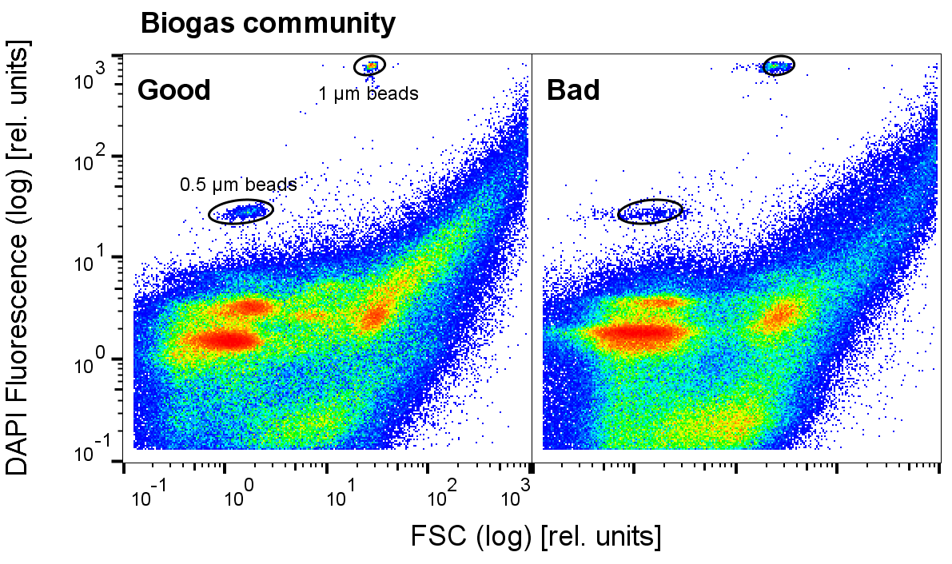

S2 figure 1: **Effect of particle load and sample dilution on the FSC resolution of a biogas community sample at the bench top analyzer.** FSC vs DAPI fluorescence plots illustrate **A** good and **B** bad FSC resolution. 250,000 events were recorded in the cell gate at **A** 1,100 events s-1 and **B** 1,300 events s-1 (Additional file 1 – S4 figure 3). The stained samples were diluted differently: **A** 300 µL sample with 1700 µL PBS and **B** 750 µL sample with 1250 µl PBS. Samples containing more microscopic non cell particles generally exhibit lower cell count limits. This effect amounts to different dilution optima for different sample sets or even different time points of one experiment.

## Supplementary File 1 - S3 Establishing stable cytometer performance

Standard particles i.e. beads are used for calibration of the cytometers before and in between the analysis of sample sets. The addition of bead suspension directly to the samples furthermore enables the direct comparison of samples measured at different days, or over weeks and even months. It also allows the detection of potential intra-day instabilities.

The growth curve analysis of the pure culture exemplifies a sample batch measured without the addition of beads. In this one session measurement series, instrument instabilities displayed by sudden shifts or resolution changes in the histogram would have been easy to spot due to the simple, well known structure of the resulting dot plots. However, it is advised to always add beads to the analyzed samples.

## Supplementary File 1 - S4 Cytometer calibration with standard beads

S4 figure 1: **Bead mix templates for linear and logarithmic range calibration of the research centered cell sorter.** The templates are the basis for every calibration and should not be altered for a given sample set. Bead mix and template for calibration in the linear range are shown in **A** and **B**. Calibration in the linear range is performed by adjusting the instrument optics. Bead mix and template for the subsequent calibration in the logarithmic range are shown in **C** and **D**. Calibration in the logarithmic range is performed by adjusting the PMT gain values. The bead mix is usually measured continuously while the dot plots are refreshed regularly to follow the calibration progress. After finalizing both calibrations one full measurement containing 5,000 events is acquired to document the instrument adjustment before sample measurement. The bench top analyzer is only calibrated in the logarithmic range.

## Supplementary File 1 - S5 Staining control by biological standard

S5 figure 1: **Gate template and example dot plot of the biological standard.** One sample containing *Escherichia coli* BL21 (DE3) is stained with every staining batch to control the staining process. It is measured after calibration of the instrument and needs to fit the preset gatetemplate. 50,000 events are acquired.

## Supplementary File 1 - S6 Gating strategies

### Pure culture

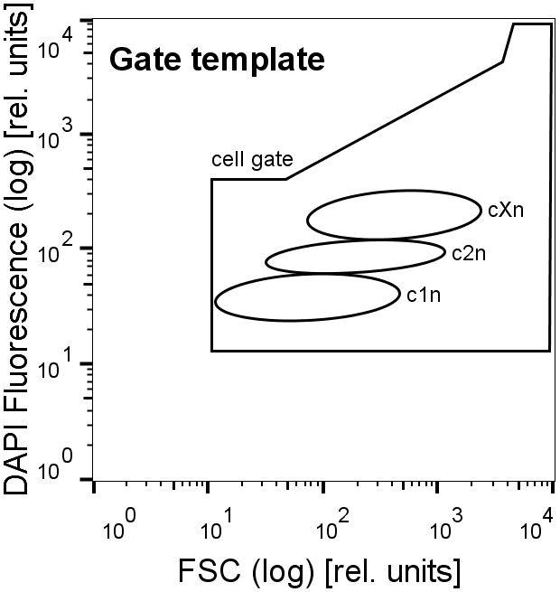

S6 figure 1: **Master gate template of the pure culture.** Three subcommunities with one (c1n), two (c2n) and multiple chromosomes (cXn) were identified inside the cell gate.

### Activated sludge community

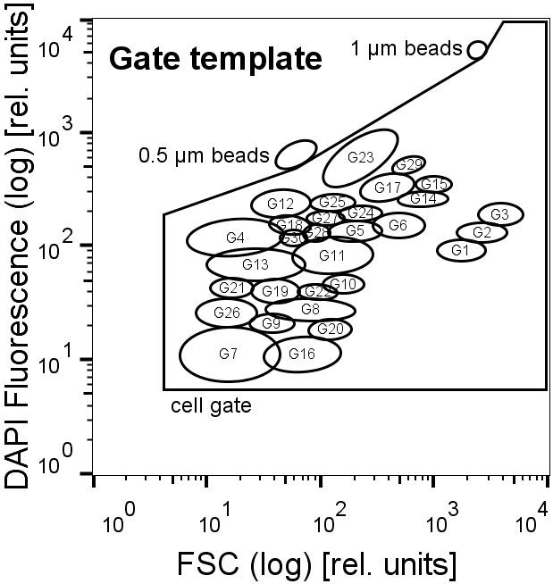

S6 figure 2: **Master gate template of the activated sludge community.** 30 Subcommunities were identified inside the cell gate.

### Biogas community

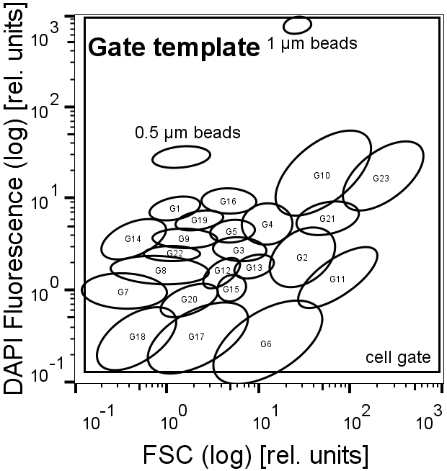

S6 figure 3: **Master gate template of the biogas community.** 23 subcommunities were identified during the whole experiment. The sample points shown in this publication do not comprise all these subcommunities. The beads are located in the cell gate but were not considered for the 250,000 cells measurement-stop threshold. They were also excluded with a not-gate before determining the relative subcommunity abundances.

### Waste water treatment plant samples

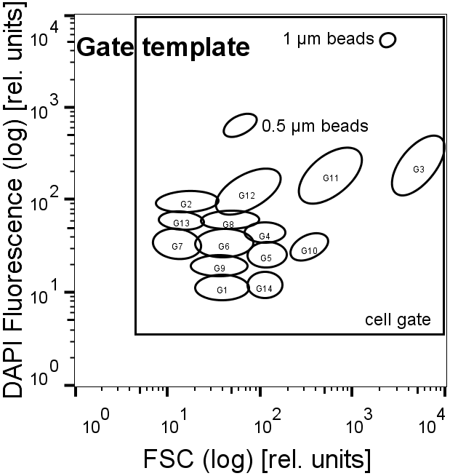

S6 figure 4: **Master gate template of waste water treatment plant samples.** Planktonic and sludge based microbial communities with 12 subcommunities were compared. The beads are located in the cell gate but were not considered for the 250,000 cells measurement-stop threshold. They were also excluded with a not-gate before determining the relative subcommunity abundances.

## Supplementary File 1 - S7 Cell counting

The cell numbers in the sample can be determined by adding a set volume of bead suspension with a defined concentration (1 μm yellow-green FluoSpheres) to a defined total sample volume. The concentration of the beads in the sample is therefore known. The number of beads is counted within a bead gate. Consequently the measured volume can be calculated. Dividing the event count in the gate of interest by this measured volume yields the subcommunities cell number in the total sample volume. This cell number needs to be multiplied with the dilution factors used during the preparation to gain the concentration per mL in the original culture. These calculations are summarized in the following formula:

$$Cell number [{mL}^{-1}]=\frac{f∙{EC}_{GX}∙C_{1µm YG}∙V_{1µm YG}}{{EC}_{1µm YG}∙V_{sample}}$$

With

f: dilution factor

ECGX: event count in the gate of interest (GX)

C1µm YG: concentration of 1 μm YG beads in the bead suspension [mL-1]

V1µm YG: volume of bead suspension [mL]

EC1µm YG: event count in the bead gate

Vsample: total sample volume [mL]

## Supplementary File 1 - S8 Biological and technical replicates

**Activated sludge community**

**A**

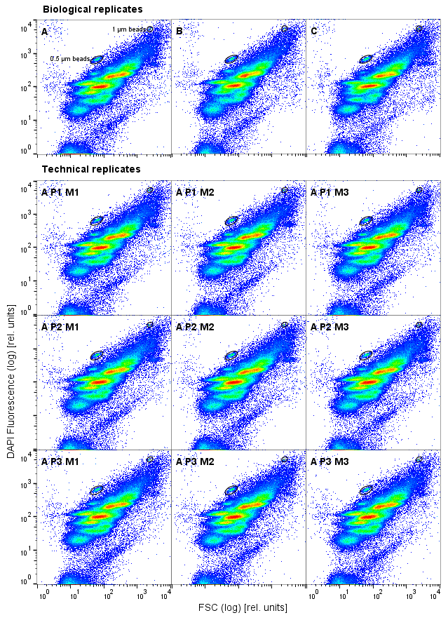

**B**

**C**

**D**

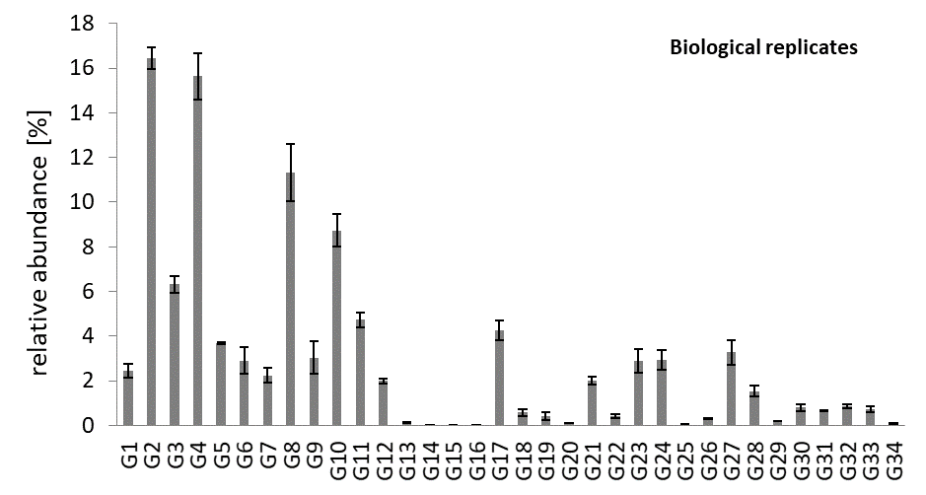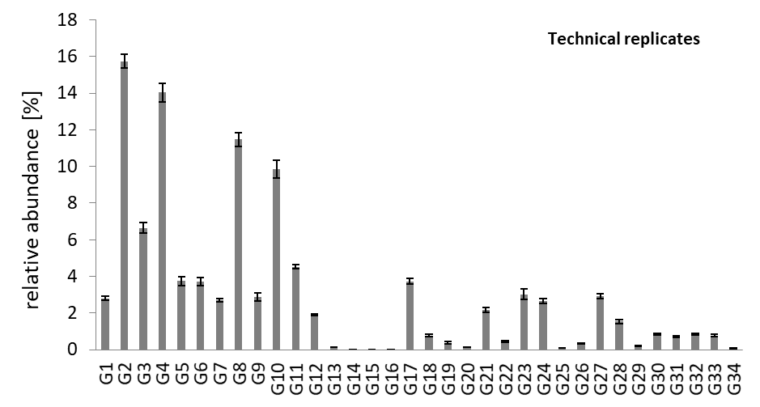

S8 figure 1: **Reproducibility of cytometric data of the activated sludge community.** FSC vs. DAPI fluorescence plots with control beads (**A, B**) and bar plots of the 34 subcommunity abundances [%] with error bars representing ± one standard deviation(**C, D**). The relative abundances were determined with the gate template shown in Additional file 1 - S6 figure 2. Three biological replicates A, B and C were taken and three technical replicates were prepared from sample A: P1, P2, P3 and measured thrice respectively: M1, M2, M3. 250,000 events were recorded in the cell gate.

**Biogas community**

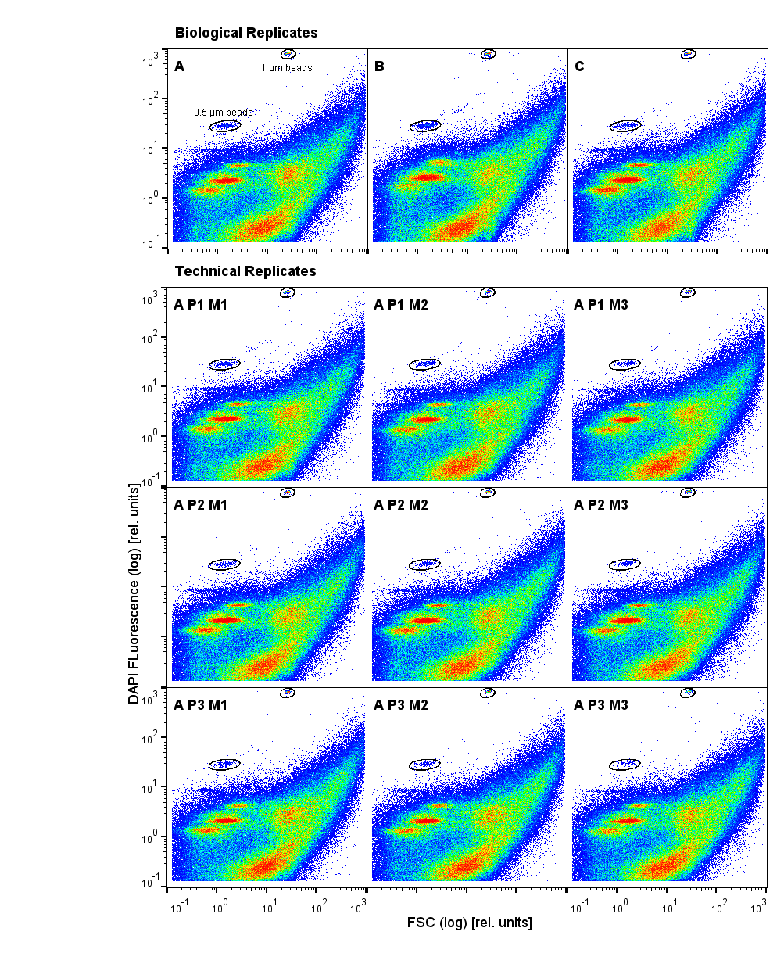

**B**

**A**

**D**

**C**

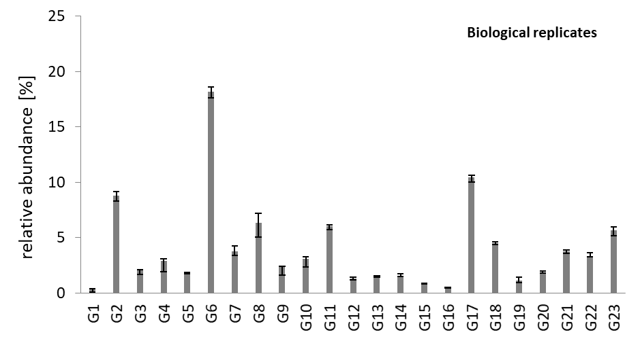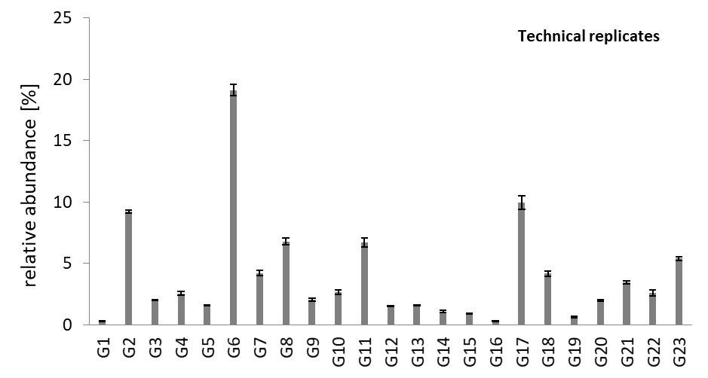

S8 figure 2: **Reproducibility of cytometric data of the biogas community.** FSC vs. DAPI fluorescence plots with control beads (**A, B**) and bar plots of the 23 subcommunity abundances [%] with error bars representing ± one standard deviation (**C, D**). The relative abundances were determined with the gate template shown in Additional file 1 - S6 figure 3. Three biological replicates A, B and C were taken at day 460 out of port II and three technical replicates were prepared from sample A: P1, P2, P3 and measured thrice respectively: M1, M2, M3. 250,000 events were recorded in the cell gate.

## Supplementary File 1 - S9 Fixation stability

**Activated sludge community**

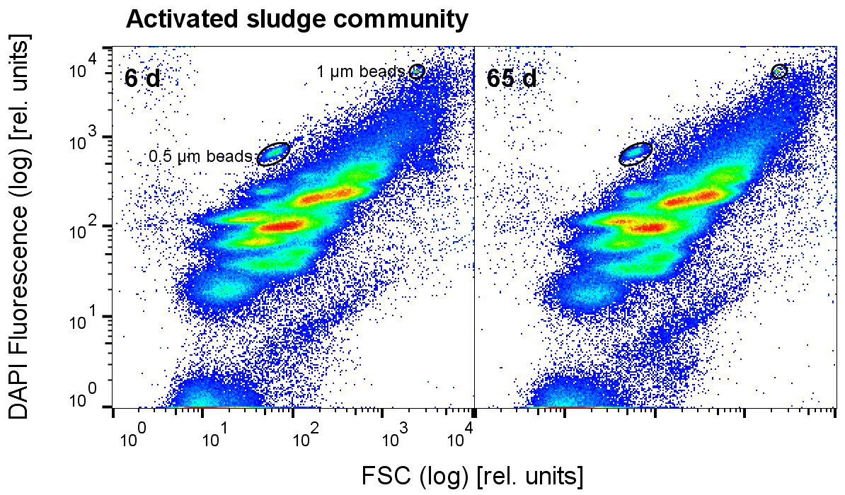

S9 figure 1: **Sample stability of the activated sludge community.** The sample was taken from the **A P1 M1** replicate shown in Figure S5, stabilized 30 min in 2% formaldehyde and stored in 70% ethanol over 60 days at -20 °C (1 Sampling and fixation). FSC vs. DAPI fluorescence plots with control beads are shown. 250,000 events were recorded in the cell gate. The sample stability of the activated sludge community after stabilization in 2% formaldehyde and fixation in 70% ethanol has also been recently demonstrated 3.

**Biogas community**

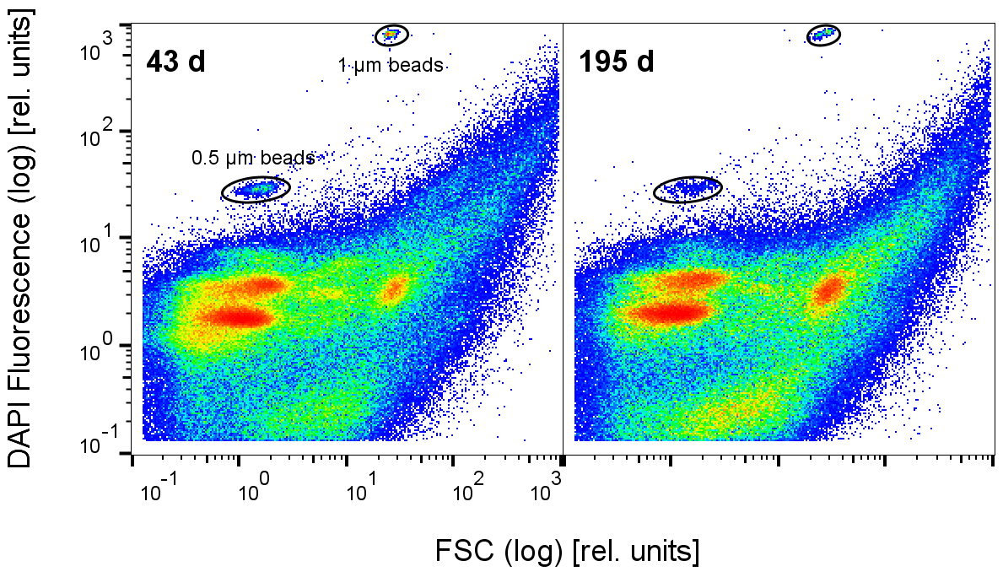

S9 figure 2: **Sample stability of the biogas community.** Samples were stored over 195 days at 4 °C after fixation by drying (1 Sampling and fixation). FSC vs. DAPI Fluorescence plots with control beads are shown. 250,000 events were recorded in the cell gate.

## Supplementary File 1 – S10 Dissipation of aggregates

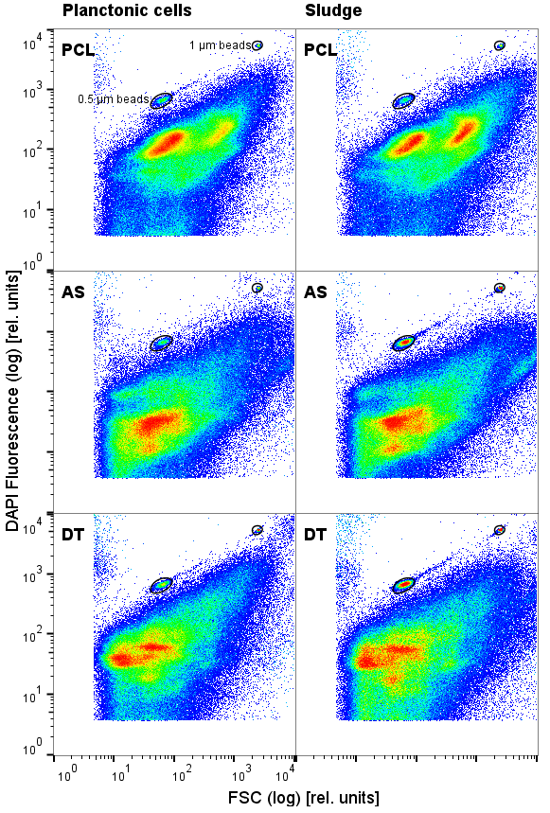

S10 figure 1: **Comparison between P planktonic and S sludge based communities in waste water.** Samples were taken from the primary clarifier (**PCL**), activated sludge basin (**AS**) and digester tank (**DT**) of a full-scale waste water treatment plant. 250,000 events were recorded in the cell gate. Control beads are marked with ellipses.

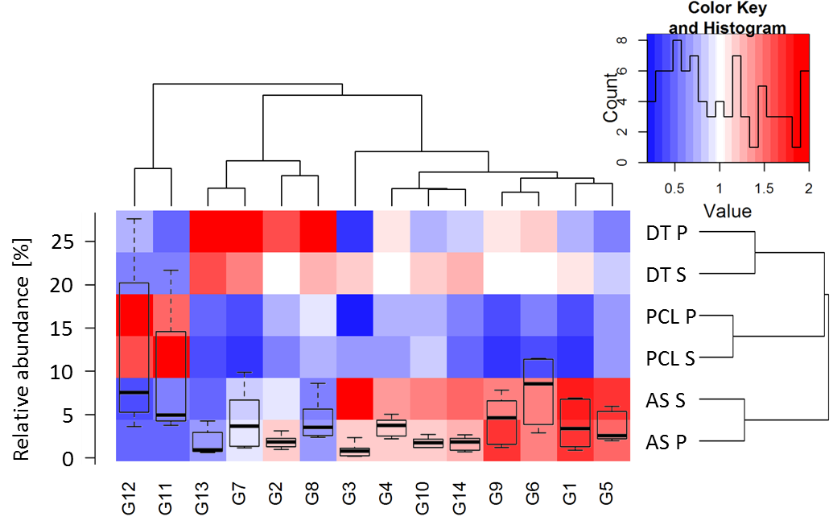

S10 figure 2: **flowCyBar analysis of planktonic (P) and sludge based (S) communities in waste water.** Samples were taken from the primary clarifier (**PCL**), activated sludge basin (**AS**) and digester tank (**DT**) of a full scale waste water treatment plant (Additional file 1 figure 1 S4). Relative abundances were determined using the gate template shown in additional file 1 figure 4 S6.

The staining protocol for this experiment differed slightly from the presented activated sludge community protocol. The first sonication step (2.1.2. B)) was skipped during staining. The planktonic cells were separated by a short and less intense centrifugation step (2 min at 4 °C and 1,500 x g) before the first washing step. They remained in the supernatant, were harvested from there and not sonicated again (2.1.5 B) skipped).

## Supplementary File 1 – S11 CHIC biogas community

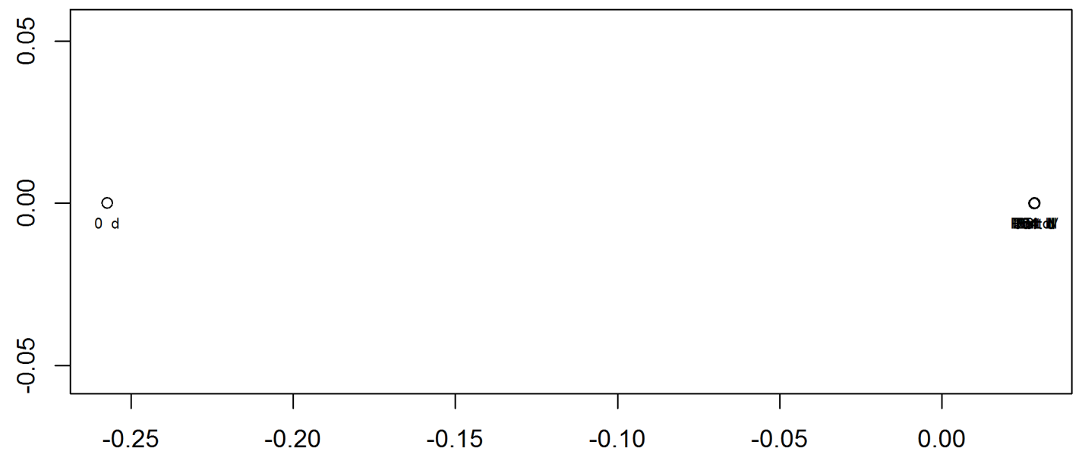

S11 figure 1: **Similarity analysis of the biogas community samples.** This CHIC based NMDS plot (R < 0.001) includes all biogas community samples and displays the extreme difference of the microbial community at day 0. This demonstrates the nature of the CHIC based NMDS plot, when analyzing very different samples. The algorithm will group the comparably similar samples from day 69 onwards close together. A plot of this sample set excluding day 0 yields interpretable results (Figure 8).

## References

1. Jahn, M., Seifert, J., Hübschmann, T., Bergen, M. Von, Harms, H., Müller, S. Comparison of preservation methods for bacterial cells in cytomics and proteomics. *J Integr OMICS*. **3** (1), 25–33, doi: 10.5584/jiomics.v3i1.115 (2013).

2. Liu, Z. *et al.* Ecological Stability Properties of Microbial Communities Assessed by Flow Cytometry. *mSphere*. **3** (1), e00564–17, doi: 10.1128/mSphere.00564-17 (2018).

3. Günther, S., Faust, K., Schumann, J., Harms, H., Raes, J., Müller, S. Species-sorting and mass-transfer paradigms control managed natural metacommunities: Species-sorting and mass-transfer paradigms in metacommunities. *Environ Microbiol*. **18** (12), 4862–4877, doi: 10.1111/1462-2920.13402 (2016).