Syntax is given for SPSS 22.0

TO CREATE THE LOGIT TRANSFORMED VARIABLE

Recall that the dependent measure, proportion correct, is not continuous and is not unbound. That is, the proportion correct data are not continuous for a given trial block (TB; only the values 0, 0.2, 0.4, 0.6, 0.8, and 1 are possible).

Thus, we need to perform a Logit transform on the dependent measure (http://www.stata.com/support/faqs/statistics/logit-transformation/) before doing a mixed model analysis.

- TB1 values of 0 were replaced with 0.01 and values of 1 were replaced with 0.99, else preserved to create TransTB1. This method is preferred to removal of 1’s and 0’s a general linear transformation because it preserves the shape of the data after the logit transform (see http://stats.stackexchange.com/questions/109702/empirical-logit-transformation-on-percentage-data/110037#110037).

- Then used the Compute variable function to logit transform (http://www.stata.com/support/faqs/statistics/logit-transformation/) TransTB1 to create “LogitTB1”

Sample syntax below for (1) and (2) below:

RECODE TB1 (0=0.01) (1=0.99) (ELSE=Copy) INTO TransTB1.
EXECUTE.

COMPUTE LogitTB1=LN(TransTB1/(1-TransTB1)).
EXECUTE.

The same was done for all the other Trial Blocks as well.

PERFORMING A LINEAR MIXED EFFECTS ANALYSIS

First, to ascertain that DRUG and VEHICLE groups are indeed not different during Training (i.e. initial learning)

We first create a data file where the trial blocks are structured in long form. We then need to run a mixed model below.

MouseID and OdourSet are the random effects. LogitTBs is the dependent measure, DrugGroup (K252a or vehicle) and PropCorrectTBs (Trial Blocks of Training) are the two factors.

The Syntax below was used:

DATASET ACTIVATE DataSet4.
MIXED LogitTBs BY DrugGroup PropCorrectTBs MouseID OdourSet
/CRITERIA=CIN(95) MXITER(100) MXSTEP(10) SCORING(1) SINGULAR(0.000000000001) HCONVERGE(0, ABSOLUTE) LCONVERGE(0, ABSOLUTE) PCONVERGE(0.000001, ABSOLUTE)
/FIXED= DrugGroup PropCorrectTBs DrugGroup*PropCorrectTBs| SSTYPE(3)
/METHOD=REML
/PRINT=SOLUTION
/RANDOM=intercept | subject(MouseID*OdourSet)
/SAVE=FIXPRED PRED RESID
/EMMEANS=TABLES(DrugGroup*PropCorrectTBs) COMPARE (DrugGroup) ADJ(BONFERRONI)
/EMMEANS=TABLES(DrugGroup*PropCorrectTBs) COMPARE (PropCorrectTBs) ADJ(SIDAK).

Second, the best comparison to test the differential memory of the two groups during short-term and long-term memory is to show that TB1 for the K252a group at LTM is the only group that is significantly different from TRAINING TB4, and it is significantly differently from Vehicle TB1 at LTM.

The best way to do this is the do a linear mixed model. LogTrans is the logit transformed dependent measure, proportion correct. The factor Test_Training indicates whether or not the data are from the Training session or Testing Session. Short_Long indicates whether or not the mouse was in the STM group or the LTM group. DrugGroup (K252a or vehicle) indicates whether or not the mouse was in the K252a or vehicle group. MouseID nested in Short_Long and then nested in OdourSet are the random effects.

The Syntax below was used:

DATASET ACTIVATE DataSet2.
MIXED LogTrans BY Test_Training DrugGroup MouseID Short_Long OdourSet
/CRITERIA=CIN(95) MXITER(100) MXSTEP(10) SCORING(1) SINGULAR(0.000000000001) HCONVERGE(0, ABSOLUTE) LCONVERGE(0, ABSOLUTE) PCONVERGE(0.000001, ABSOLUTE)
/FIXED=Test_Training DrugGroup Test_Training*DrugGroup Short_Long Short_Long*Test_Training Short_Long*DrugGroup Short_Long*DrugGroup*Test_Training| SSTYPE(3)
/METHOD=REML
/PRINT=SOLUTION
/RANDOM=intercept | subject(MouseID*Short_Long)
/RANDOM=intercept | subject(OdourSet*MouseID*Short_Long)
/SAVE=FIXPRED PRED RESID
/EMMEANS=TABLES(Test_Training*DrugGroup*Short_Long) COMPARE (Short_Long) ADJ(SIDAK)
/EMMEANS=TABLES(Test_Training*DrugGroup*Short_Long) COMPARE (DrugGroup) ADJ(SIDAK) /EMMEANS=TABLES(Test_Training*DrugGroup*Short_Long) COMPARE (Test_Training) ADJ(BONFERRONI).

Analysis results found in: Discrim_Output_FULL.spv

Full model:

Type III Tests of Fixed Effectsª
Source | Numerator df | Denominator df | F | Sig.
Intercept | 1 | 10.891 | 152.112 | .000
Test_Training | 1 | 60.916 | .419 | .520
DrugGroup | 1 | 45.592 | .838 | .365
Test_Training * DrugGroup | 1 | 60.916 | .885 | .351
Short_Long | 1 | 10.891 | .300 | .595
Test_Training * Short_Long | 1 | 60.916 | 4.423 | .040
DrugGroup * Short_Long | 1 | 45.592 | 2.100 | .154
Test_Training * DrugGroup * Short_Long | 1 | 60.916 | 5.025 | .029
a. Dependent Variable: LogTBs.

Results: The three-way interaction and 1 two-way interactions are significant.

Proceed to the post-hocs:

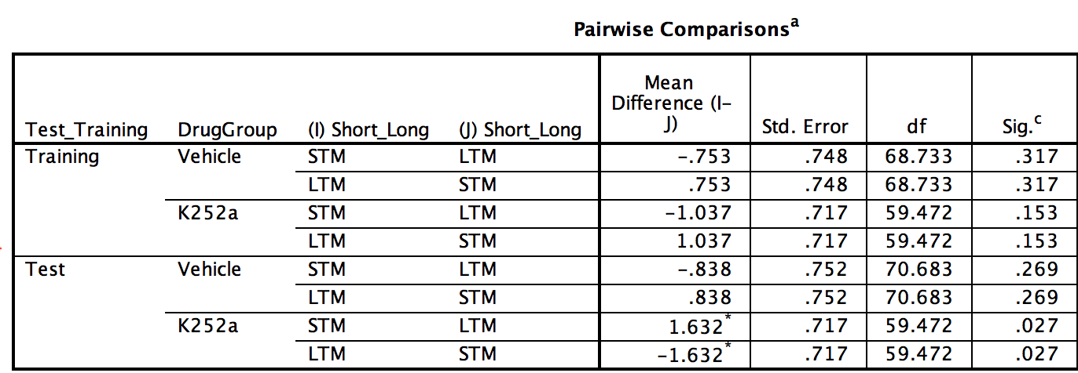

For the drug group, there is a significant difference between TB1 between STM and LTM (p = .027)

Importantly, no significant differences in training.

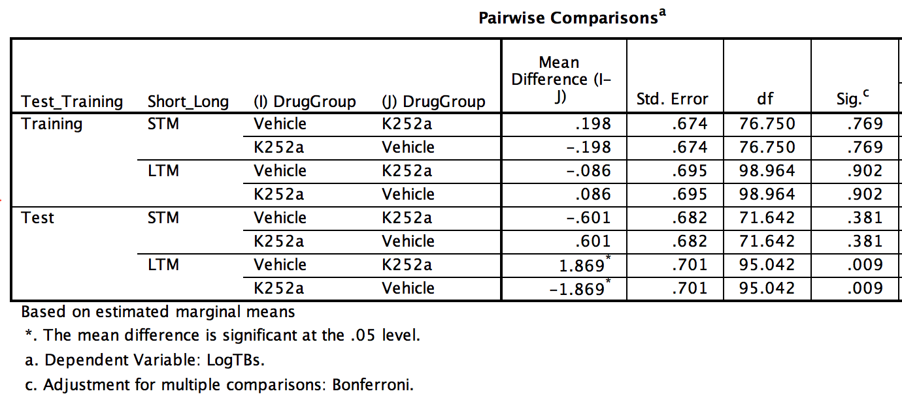

The important comparison for us here is that for LTM, drug and vehicle group were different (p = .009)

Again, no significant differences in training.

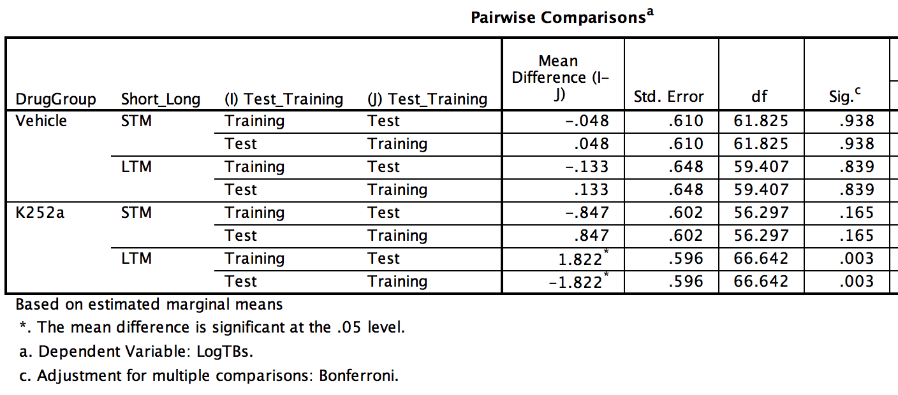

The only significant difference in this analysis is that for the drug group, in LTM the test and training measures were different. That is, TB1 for drug at LTM was significantly lower than TB4 at training (p = .003).

TO RUN THIS MIXED MODEL FOR THE RETRIEVAL CONTROL

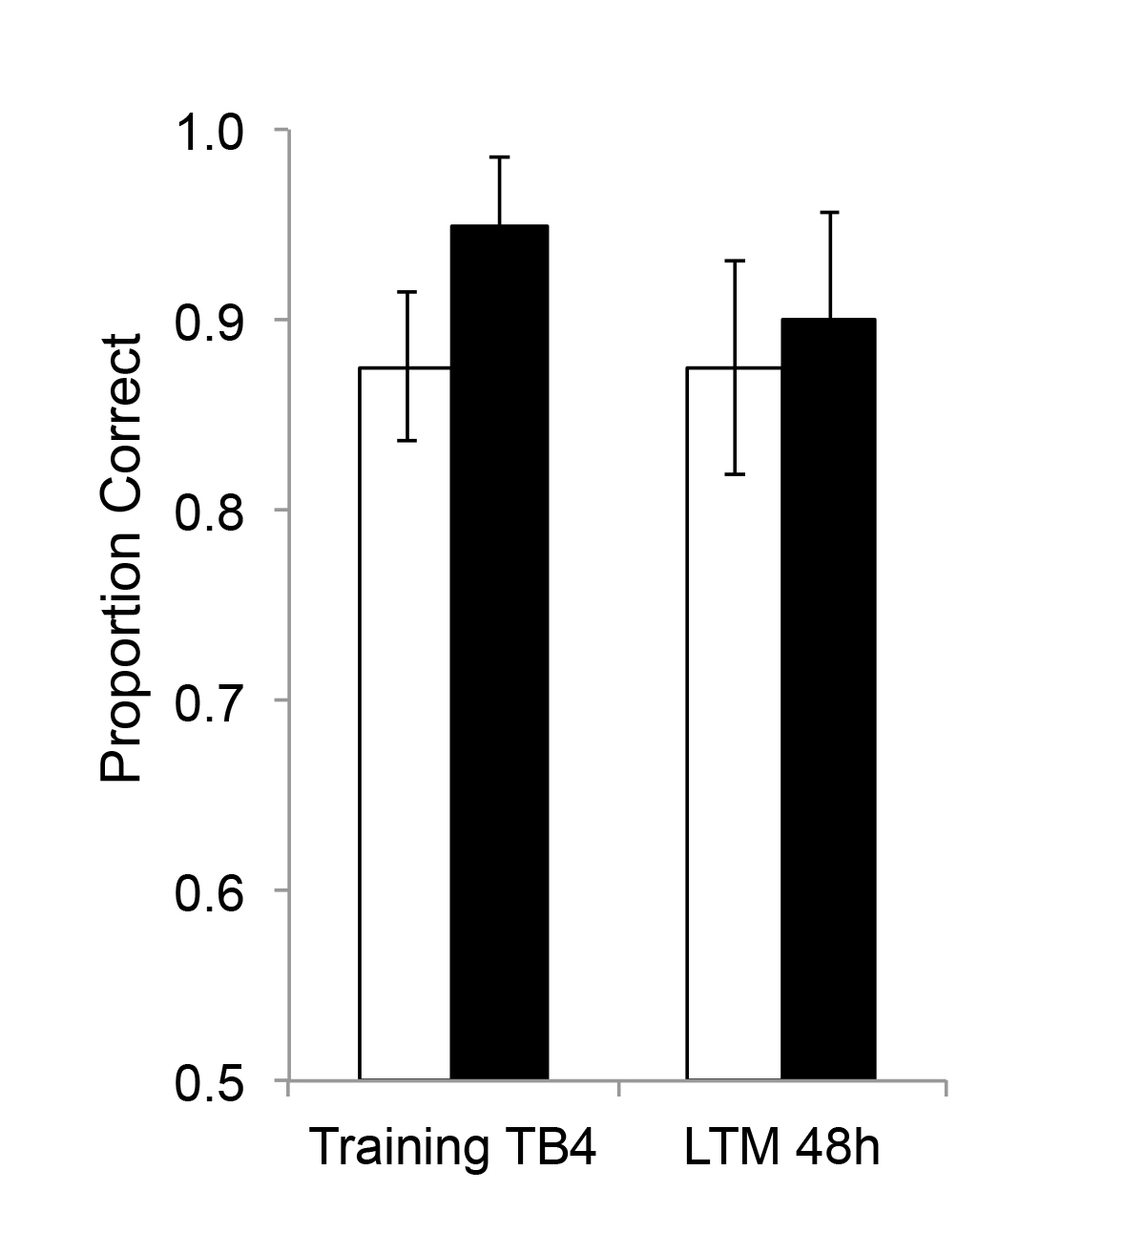
We’ll run a separate mixed model on the pre-retrieval infusion group, since these data were collected completely separately. In addition, it doesn’t make sense to compare these with the other data because the infusion timing is different as well.

So using a new data file, found in: TONG_Discrim_Retrieval.sav
I created a new variable LogTBs. In this variable, for the TRAINING group LogitTB4 was copied, for any testing group, LogitTB1 was used.

This mixed model has two fixed effects: test_training and experimental group (which infusion they received). We do not have “short_long” since all animals are tested at LTM.

DATASET ACTIVATE DataSet1.
MIXED LogTBs BY Test_Training DrugGroup MouseID Trial
/CRITERIA=CIN(95) MXITER(100) MXSTEP(10) SCORING(1) SINGULAR(0.000000000001) HCONVERGE(0, ABSOLUTE) LCONVERGE(0, ABSOLUTE) PCONVERGE(0.000001, ABSOLUTE)
/FIXED=Test_Training DrugGroup Test_Training*DrugGroup | SSTYPE(3)
/METHOD=REML
/PRINT=SOLUTION
/RANDOM=intercept | subject(Trial*MouseID)
/SAVE=FIXPRED PRED RESID
/EMMEANS=TABLES(Test_Training*DrugGroup) COMPARE (DrugGroup) ADJ(BONFERRONI)
/EMMEANS=TABLES(Test_Training*DrugGroup) COMPARE (Test_Training) ADJ(BONFERRONI).

Full Model:

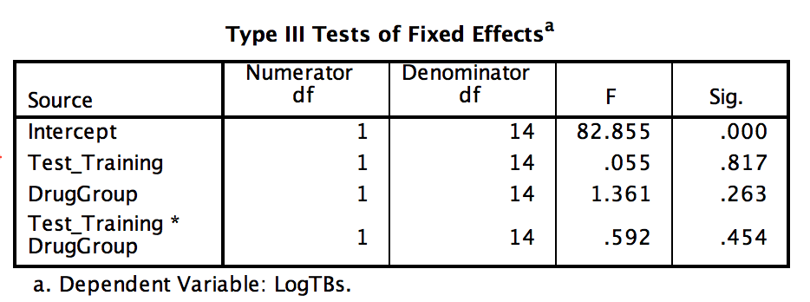

No significant interaction or main effects.

Post-hocs show no significance for all pairwise comparisons:

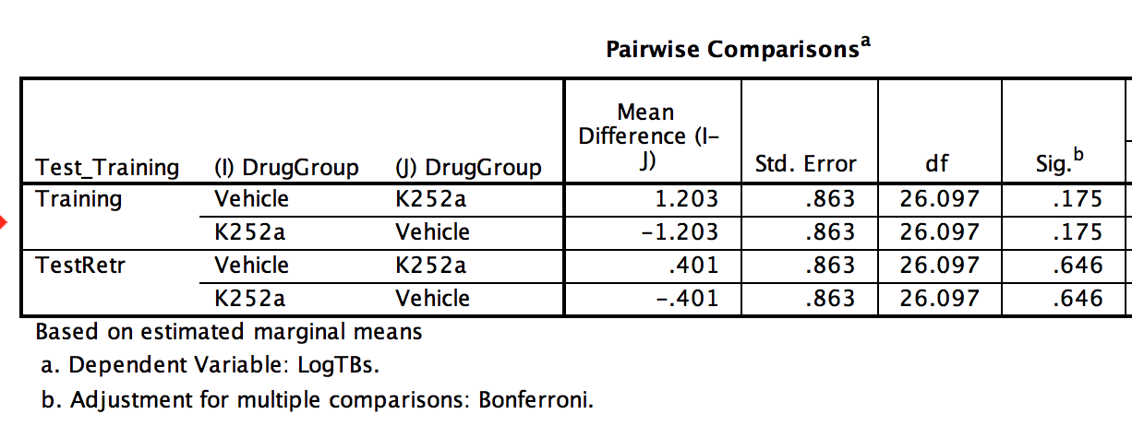
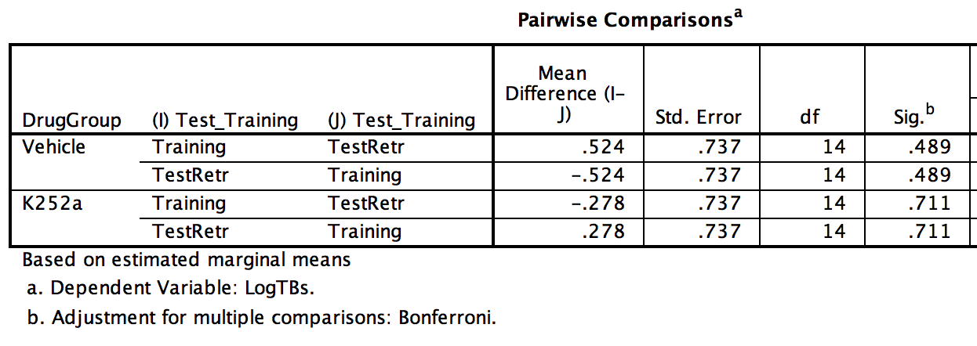

TO ANALYZE THE DISCRIMINATION INDEX DATA

To investigate the relationships between the Discrimination Index.

We want to show that for LTM at TESTING the K252a group has a lower Discrimination Index than the others.

To do this, we convert the original data set to a long form, where a new variable, called DigTrial, will indicate T1, T5, T10, T15, T20. It’s easier to use the Data -> Restructure function so you can sort of visualize what you want as you work,b ut the syntax is below as well:

VARSTOCASES
/MAKE DigTrial FROM LogitDiscrimIndeT1 LogitDiscrimIndeT5 LogitDiscrimIndeT10 LogitDiscrimIndeT15
LogitDiscrimIndeT20
/INDEX=TrialPeriod(DigTrial)
/KEEP=MouseID Trial Test_Training Short_Long DrugGroup LogitTB1 LogitTB2 LogitTB3 LogitTB4 DigT1R
DigT1U DigT5R DigT5U DigT10R DigT10U DigT15R DigT15U DigT20R DigT20U T1 T2 T3 T4 T5 T6 T7 T8 T9 T10
T11 T12 T13 T14 T15 T16 T17 T18 T19 T20 TB1 TB2 TB3 TB4 DiscrimIndeT1 DiscrimIndeT5 DiscrimIndeT10
DiscrimIndeT15 DiscrimIndeT20 TransDiscrimIndeT1 TransDiscrimIndeT5 TransDiscrimIndeT10
TransDiscrimIndeT15 TransDiscrimIndeT20 TransTB1 TransTB2 TransTB3 TransTB4
/NULL=KEEP.

Then we can apply the syntax below to make the fixed effects comparison. We used a data file with just the STM/LTM data (no Retrieval):

DATASET ACTIVATE DataSet3.
MIXED LogDiscrim BY Test_Training DrugGroup TrialPeriod Short_Long Trial MouseID
/CRITERIA=CIN(95) MXITER(100) MXSTEP(10) SCORING(1) SINGULAR(0.000000000001) HCONVERGE(0, ABSOLUTE) LCONVERGE(0, ABSOLUTE) PCONVERGE(0.000001, ABSOLUTE)
/FIXED=Test_Training Short_Long DrugGroup TrialPeriod Test_Training*Short_Long
Test_Training*DrugGroup Test_Training*TrialPeriod Short_Long*DrugGroup Short_Long*TrialPeriod
DrugGroup*TrialPeriod Test_Training*Short_Long*DrugGroup Test_Training*Short_Long*TrialPeriod
Test_Training*DrugGroup*TrialPeriod Short_Long*DrugGroup*TrialPeriod Test_Training*Short_Long*DrugGroup*TrialPeriod | SSTYPE(3)
/METHOD=REML
/PRINT=SOLUTION
/RANDOM=intercept | subject(MouseID)
/RANDOM=intercept | subject(Trial*MouseID)
/SAVE=FIXPRED PRED RESID
/EMMEANS=TABLES(Short_Long*DrugGroup*Test_Training*TrialPeriod) COMPARE (Short_Long) ADJ(BONFERRONI)
/EMMEANS=TABLES(Short_Long*DrugGroup*Test_Training*TrialPeriod) COMPARE (DrugGroup) ADJ(BONFERRONI)
/EMMEANS=TABLES(Short_Long*DrugGroup*Test_Training*TrialPeriod) COMPARE (Test_Training) ADJ(BONFERRONI)
/EMMEANS=TABLES(Short_Long*DrugGroup*Test_Training*TrialPeriod) COMPARE (TrialPeriod) ADJ(BONFERRONI).

The full model yields the following Fixed Effects table:

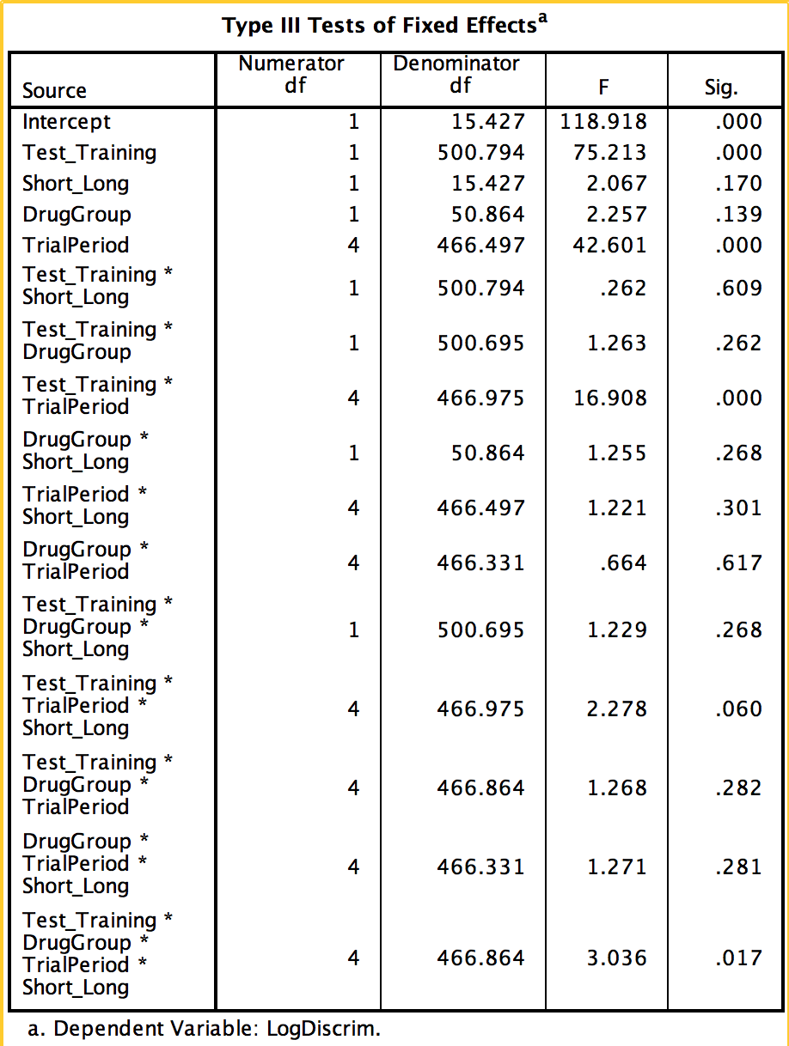

From this, we see that we do have a significant 4-way interaction (p < .05). A significant two-way interaction of Testing_Training and TrialPeriod (p < .05). Finally, we find significant main effects of Test_Training (p < .05) and TrialPeriod (p < .05), meaning that DIs differ between the Testing and Training phases, and that DIs differ between T1-T20.
We can see where exactly these are in the post-hoc comparisons.

In the post-hoc comparisons (Bonferroni correction for multiple comparisons):

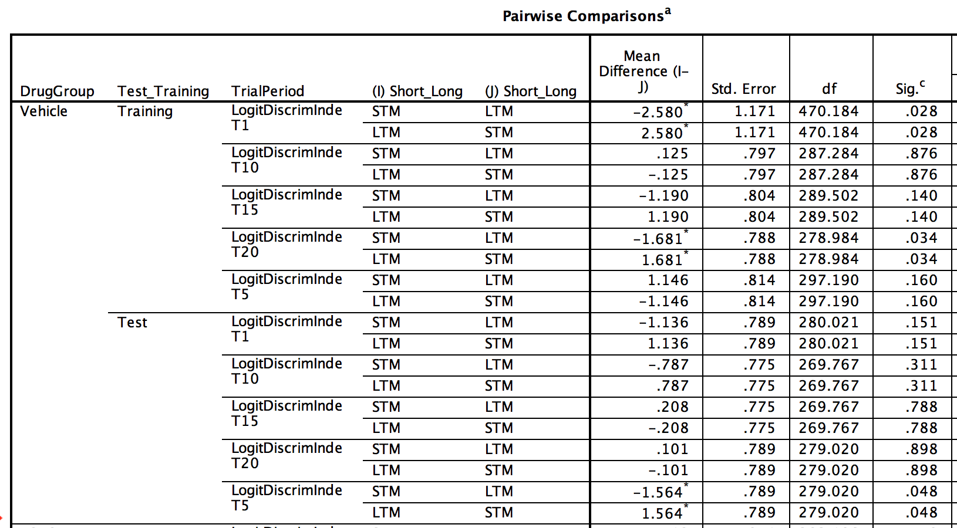

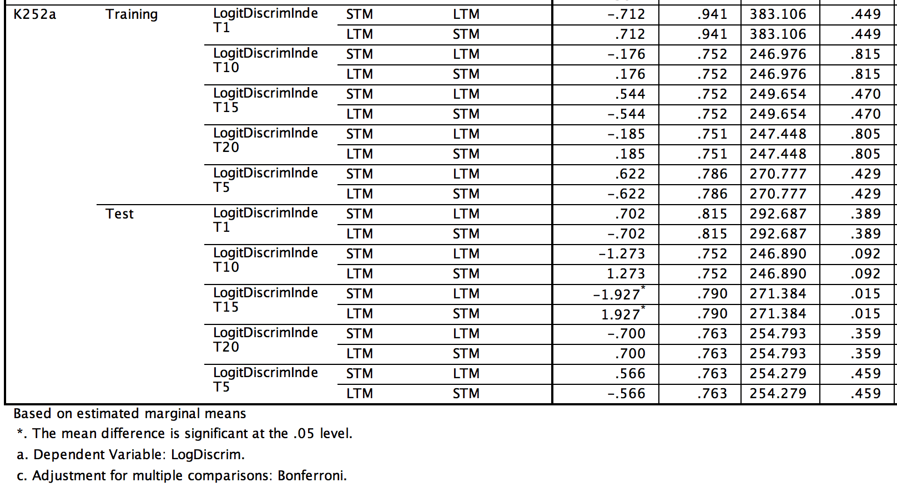
I don’t think these comparisons tell us anything too too interesting.

NEXT

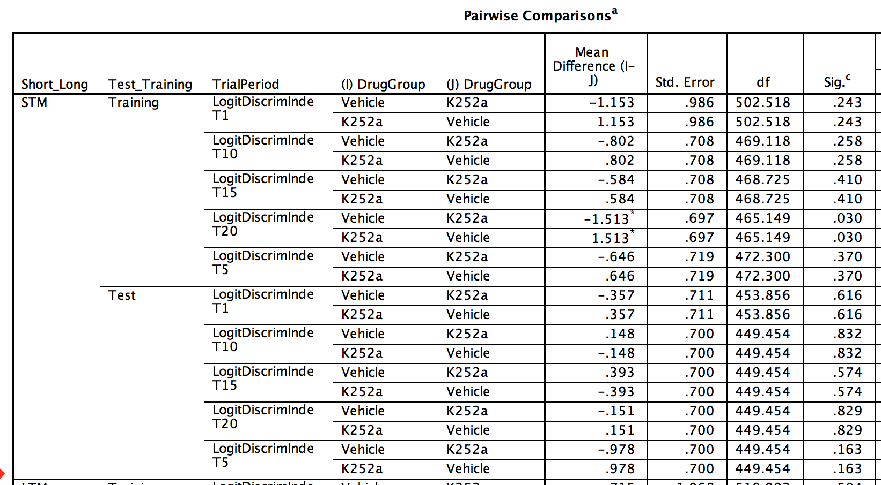
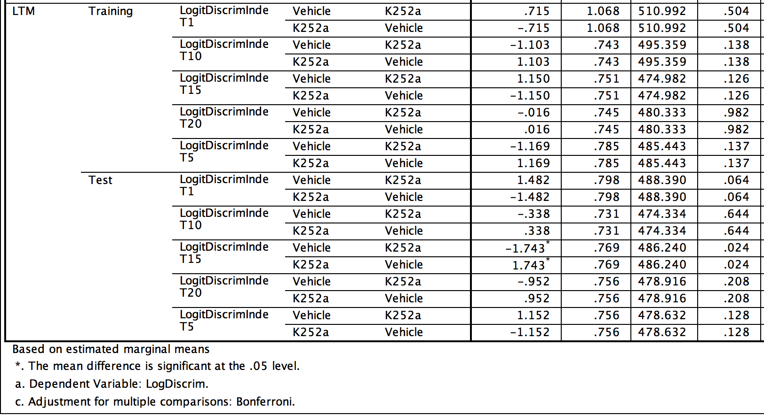

In these comparisons, we see that during the LTM test period, the DI on T1 is marginally different between the vehicle and drug group (p = .064). Importantly, the same comparison for STM is not significantly different (p > .05).

NEXT:

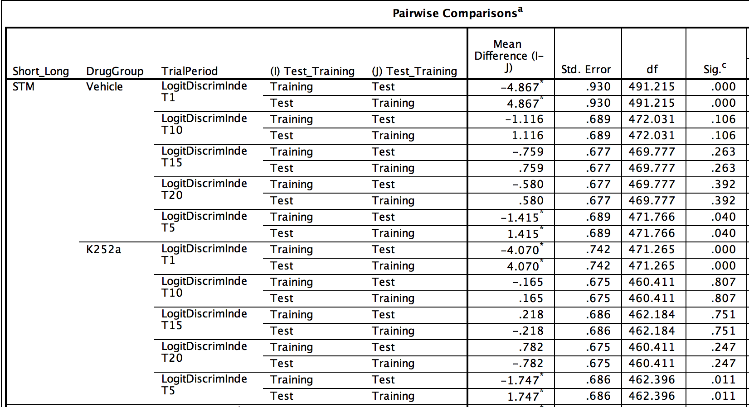
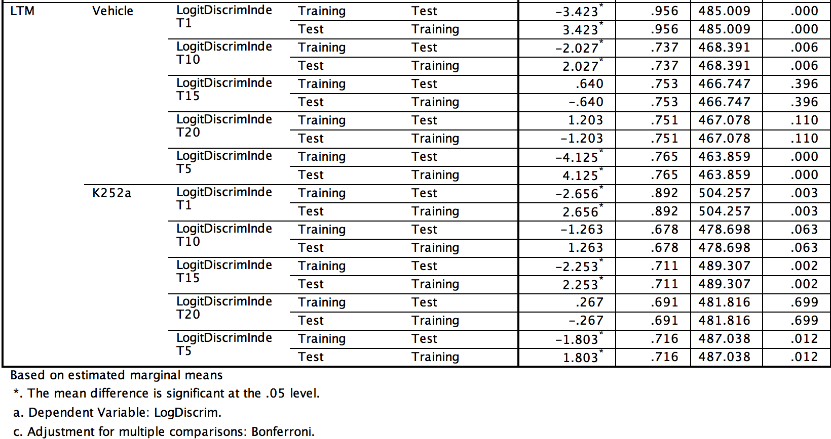

This comparison tells us that the DIs of T1 for Test at STM and LTM are significantly higher for than the DIs of Training. This makes sense. It confirms that learning occurred during training and that in all cases, even the LTM K252a group, there was some retention of the learning (at least in terms of confidence?)

NEXT:
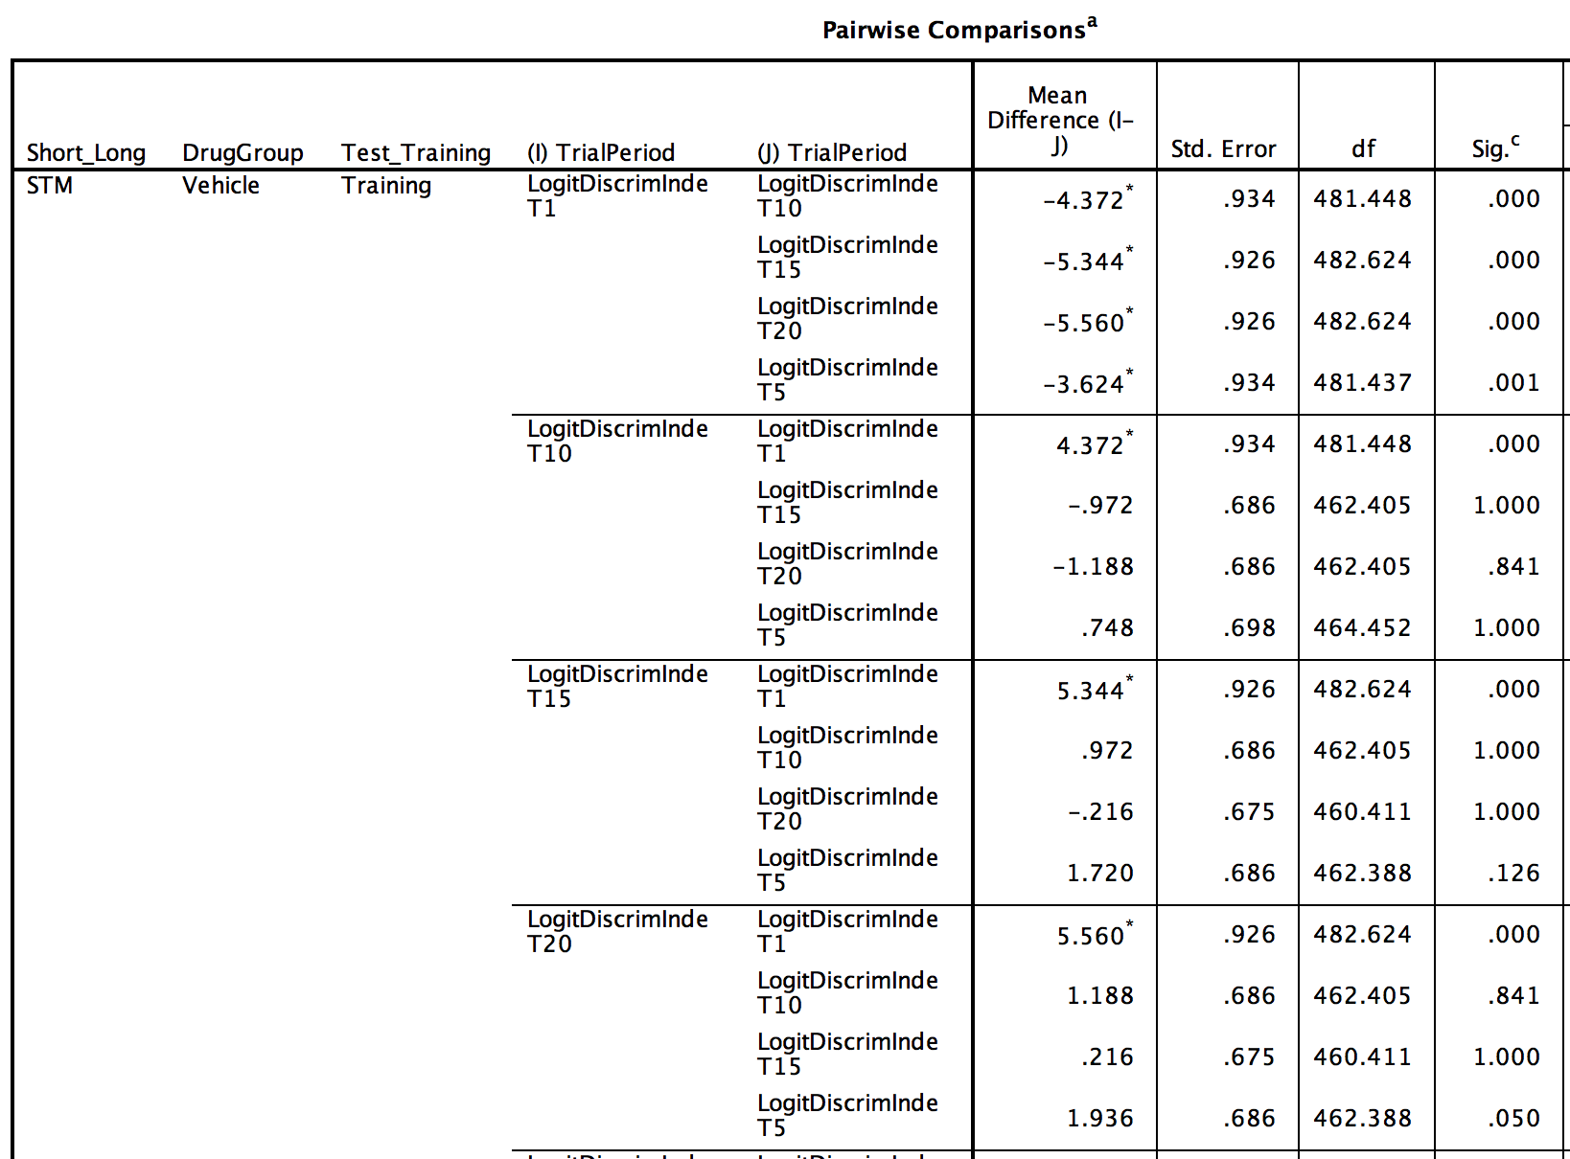
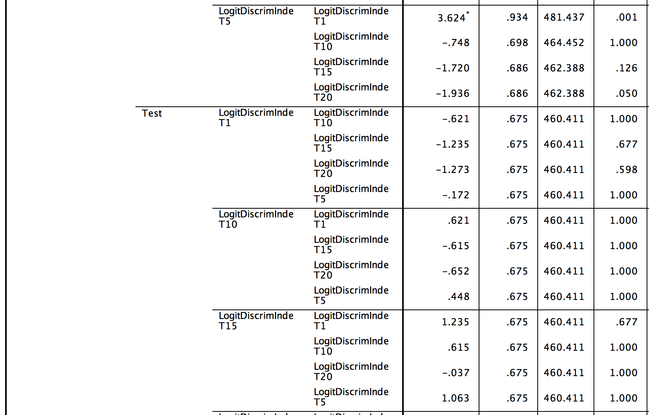
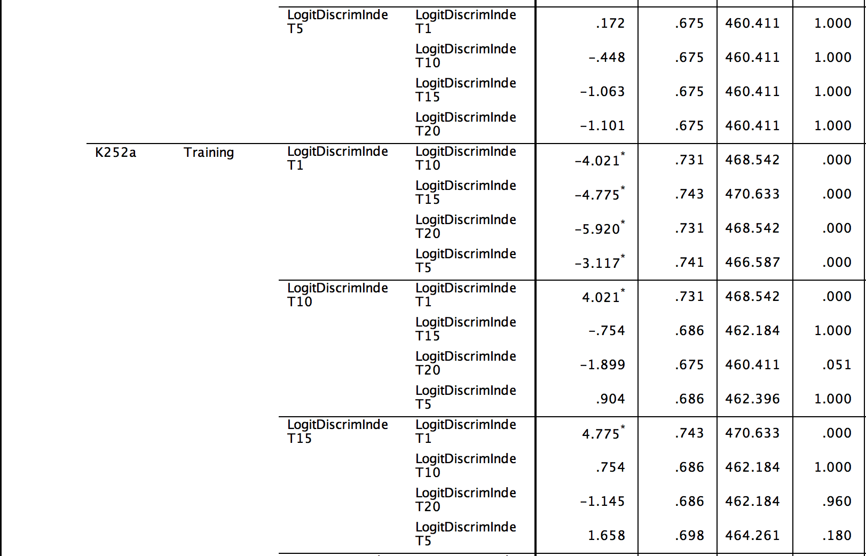
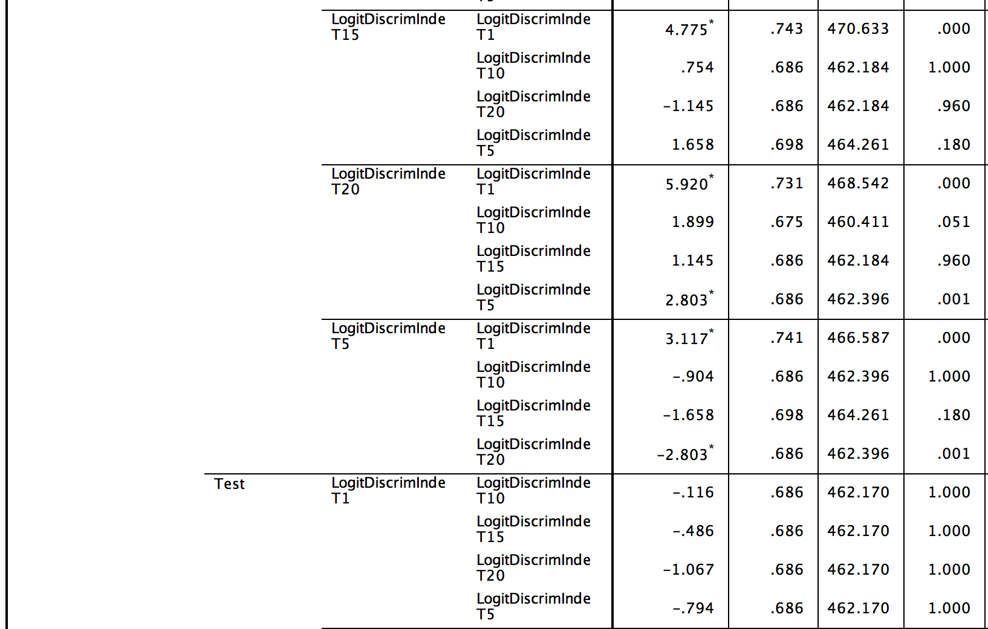
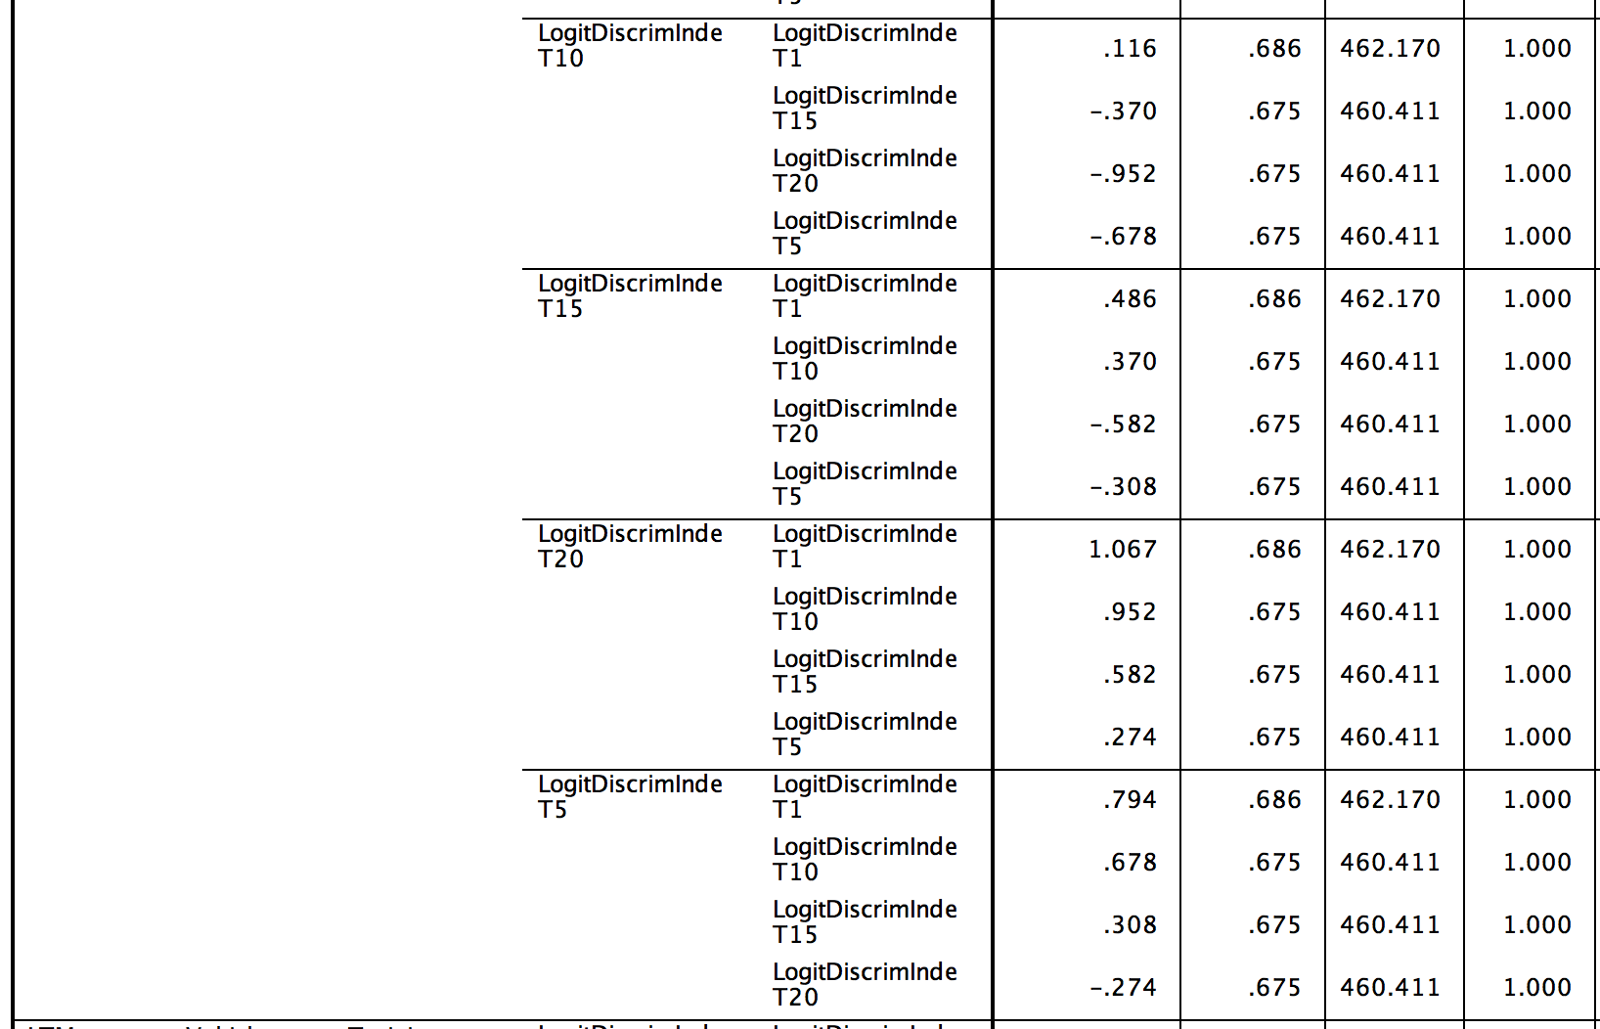
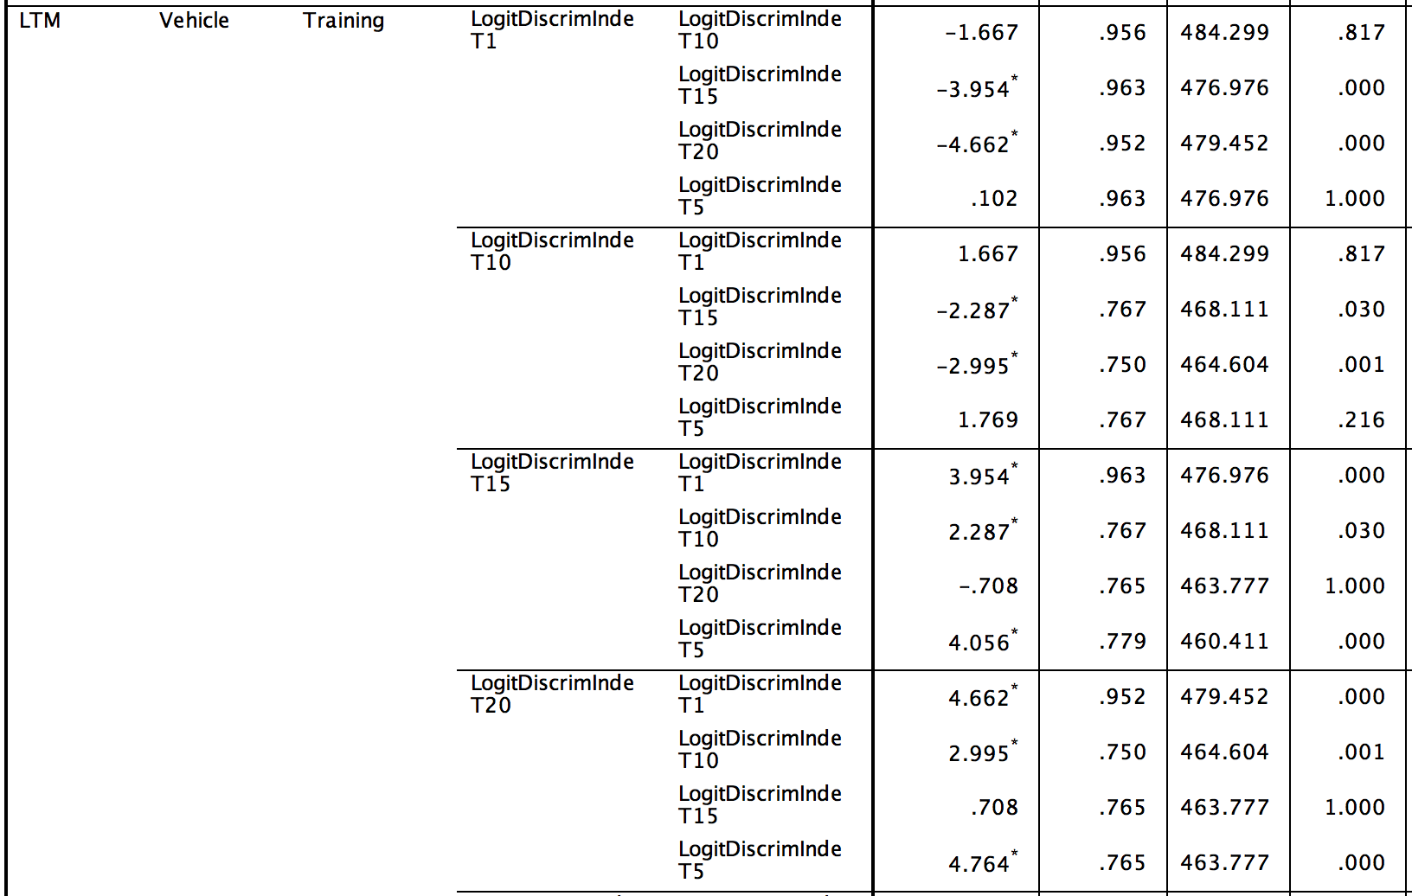
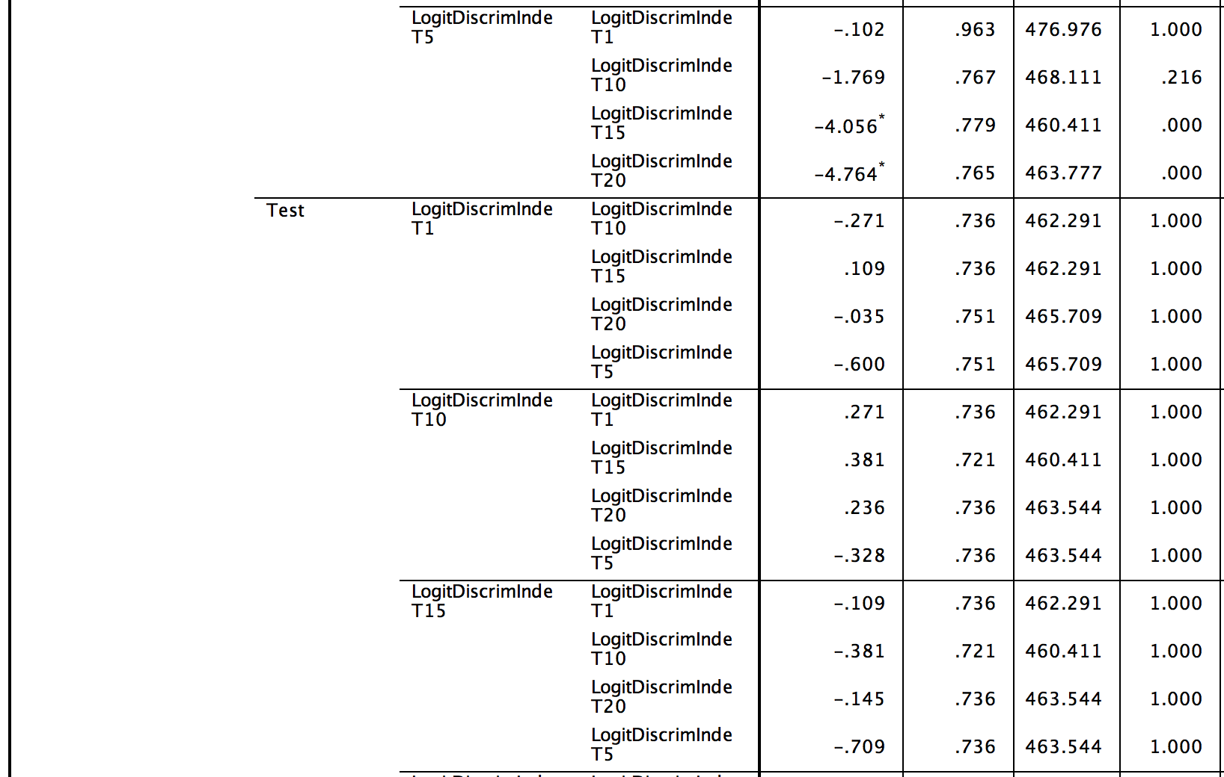
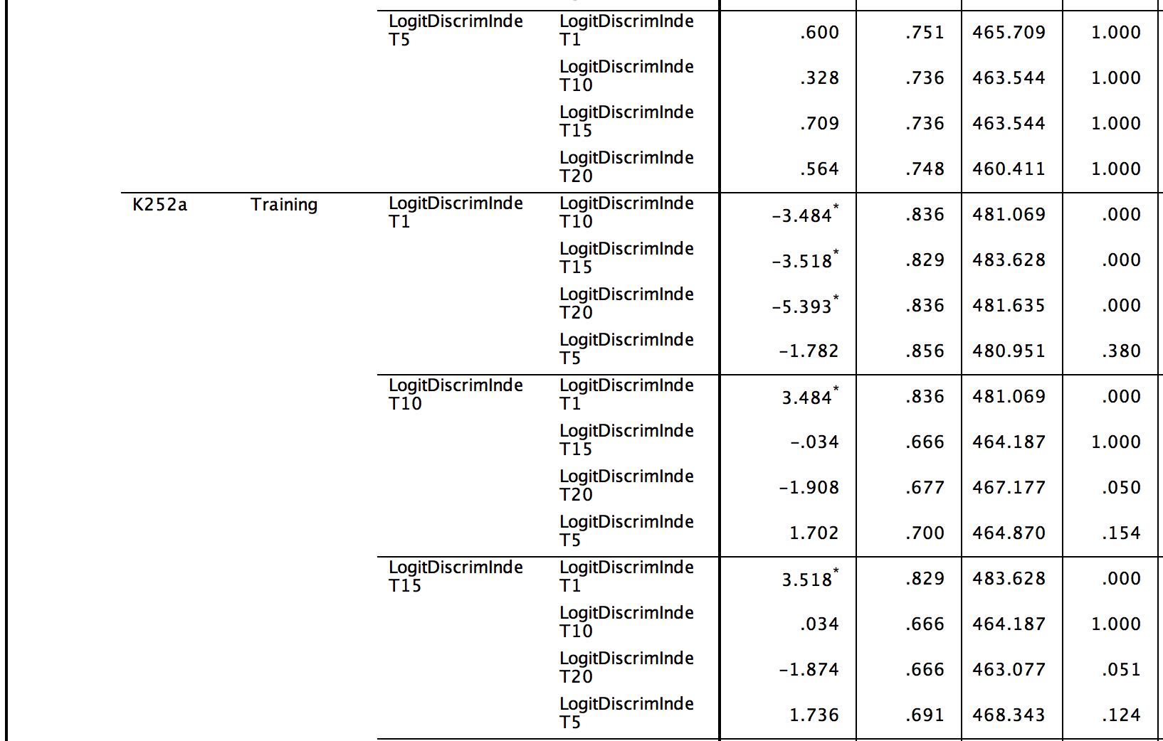
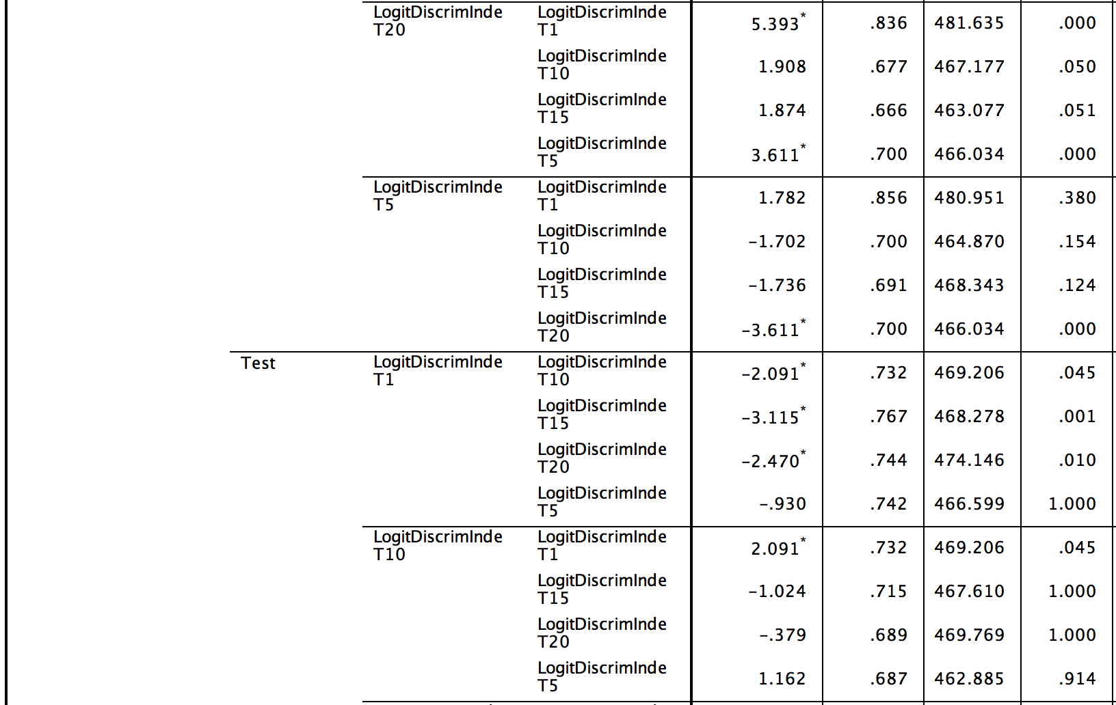
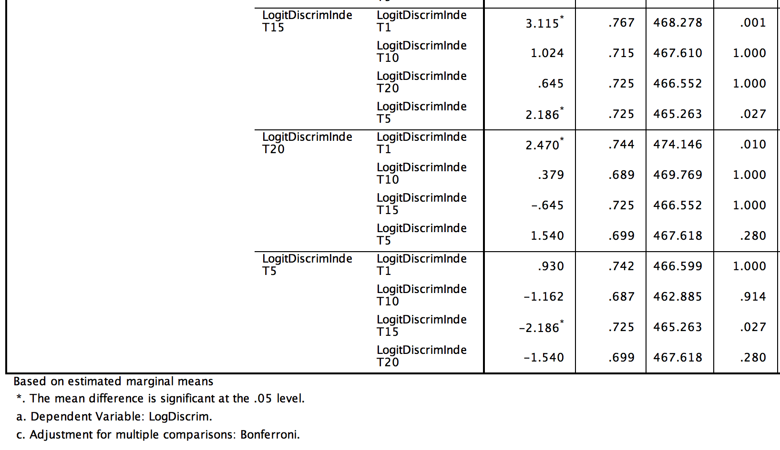

In this complicated set of comparisons, we see that for all groups during training, the DI at T1 is significantly different from T20 (p < .05). This confirms that all animals learn to discriminate the odours during training. The interesting results are that during the STM testing period, no trials are different from each other for either K252a (p > .05) and Vehicle (p > .05) groups. This suggests that no re-learning occurred during the testing phases for these groups. Perhaps the strength of association was already saturated via intact memory retention. During the LTM testing period, the Vehicle group likewise shows no differences between any of the trials (ps > .05). In contrast, during LTM testing for the K252a (the one which showed decreased memory retention from the proportion correct data) we see that the DI at T20 is significantly higher than T1 (p < .05) suggesting that some learning is actually occurring during the testing trials, perhaps because of poor memory, associative strength still exists.

Since the previous analysis gave me a p = .064 for the key comparison, I’m curious it’s because I’m not making the comparisons directly. To do this, I needed to recode the data as below:

Output: Discrim_Output_Index.spv
Data file: TONG_Discrim_LongFormWithNew.sav

I created the variable “New” that encompasses Test_Training and Short_Long, by having 4 levels.
- when Test_Training = Training, Short_Long = STM; New = 1 and combinations thereof for NEW= 2,3,4
- The purpose of this is to allow for the data points within these to be directly compared to one another, instead of the average of each label.

For the SYNTAX

DATASET ACTIVATE DataSet3.
MIXED LogDiscrim BY New DrugGroup TrialPeriod Trial MouseID
/CRITERIA=CIN(95) MXITER(100) MXSTEP(10) SCORING(1) SINGULAR(0.000000000001) HCONVERGE(0, ABSOLUTE) LCONVERGE(0, ABSOLUTE) PCONVERGE(0.000001, ABSOLUTE)
/FIXED=New DrugGroup TrialPeriod
New*DrugGroup New*TrialPeriod
DrugGroup*TrialPeriod New*DrugGroup*TrialPeriod | SSTYPE(3)
/METHOD=REML
/PRINT=SOLUTION
/RANDOM=intercept | subject(MouseID)
/RANDOM=intercept | subject(Trial*MouseID)
/SAVE=FIXPRED PRED RESID
/EMMEANS=TABLES(DrugGroup*New*TrialPeriod) COMPARE (New) ADJ(BONFERRONI).

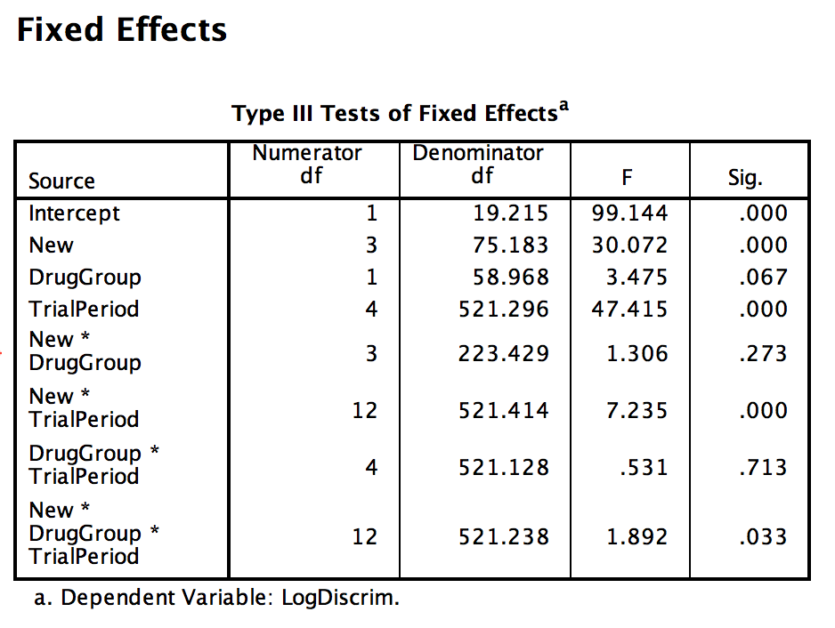

There is the significant 3-way interaction, but …

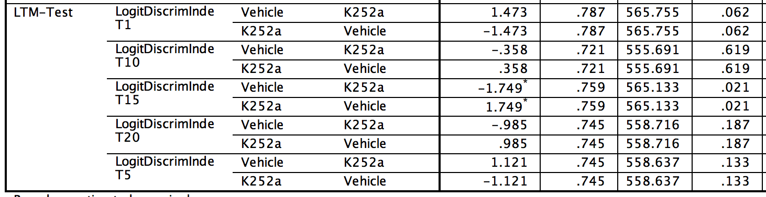

Here again, the key comparison has p = .062, marginal.

TO ANALYZE DIFFERENCES IN DISCRIMINATION INDEX GIVEN CORRECT OR INCORRECT T1

Data File: TONG_Discrim_LongFormDigYN_STM-LTM.sav

Here, our interest is in exploring any differences that exist between the infusion groups, testing groups depending on their correct or incorrect choice on each of T1, T5, T10, T15, T20. We’ll remove the training trials from the data file and just look at STM and LTM.

To do this we run a mixed model with 4 fixed factors: infusion, STM/LTM, Correct/Incorrect (called T), and which trial (called TrialPeriod below)

DATASET ACTIVATE DataSet1.
MIXED LogitDiscrim BY DrugGroup Short_Long TrialPeriod T MouseID Trial
/CRITERIA=CIN(95) MXITER(100) MXSTEP(10) SCORING(1) SINGULAR(0.000000000001) HCONVERGE(0, ABSOLUTE) LCONVERGE(0, ABSOLUTE) PCONVERGE(0.000001, ABSOLUTE)
/FIXED= DrugGroup Short_Long [TrialPeriod] [T]
[TrialPeriod]*DrugGroup [TrialPeriod]*Short_Long Short_Long*DrugGroup [T]*DrugGroup [T]*Short_Long [T]*[TrialPeriod]
Short_Long*DrugGroup*[TrialPeriod] [T]*[TrialPeriod]*DrugGroup [T]*[TrialPeriod]*Short_Long [T]*Short_Long*DrugGroup
DrugGroup*Short_Long*[TrialPeriod]*[T] | SSTYPE(3)
/METHOD=REML
/PRINT=SOLUTION
/RANDOM=intercept | subject(MouseID*Short_Long)
/RANDOM=intercept | subject(Trial*MouseID*Short_Long)
/SAVE=FIXPRED PRED RESID
/EMMEANS=TABLES(DrugGroup*Trial*Short_Long*[TrialPeriod]*[T]) COMPARE (DrugGroup) ADJ(BONFERRONI)
/EMMEANS=TABLES(DrugGroup*Trial*Short_Long*[TrialPeriod]*[T]) COMPARE ([TrialPeriod]) ADJ(BONFERRONI)
/EMMEANS=TABLES(DrugGroup*Trial*Short_Long*[TrialPeriod]*[T]) COMPARE ([T]) ADJ(BONFERRONI).

The full model shows:

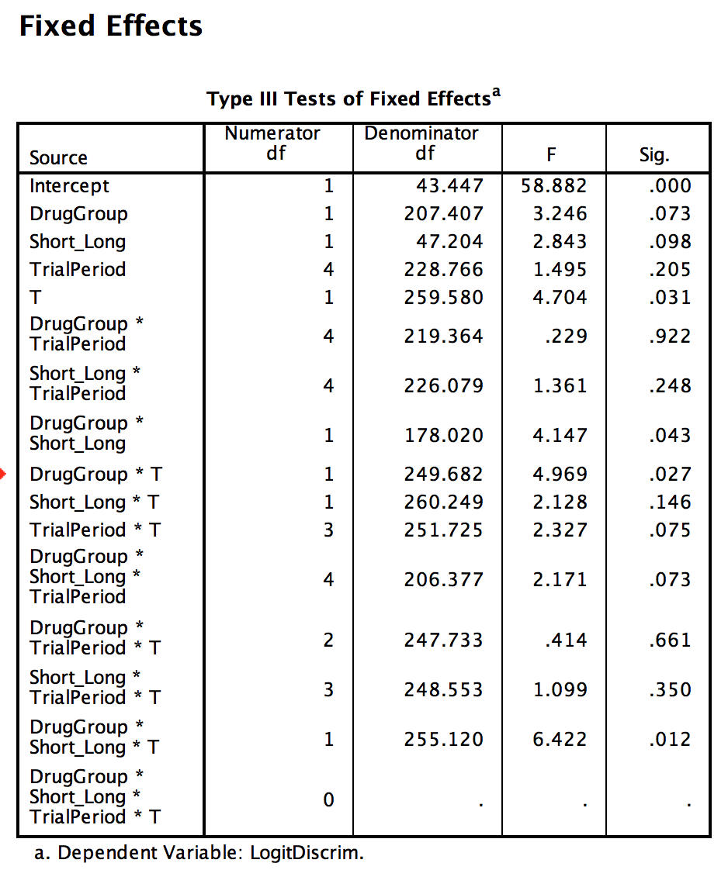

There is significant 3-way interaction of Infusion, STM/LTM, and Correct/Incorrect (F(1, 225.120) = 6.422, p < .05); 2-interaction of Infusion and Correct/Incorrect (F(1, 249.682) = 2.969, p < .05), Infusion and STM/LTM (F(1, 178.020) = 4.147, p < .05); main effect of Correct/Incorrect (F(1, 259.580) = 4.704, p < .05).

To understand the exact differences, we look at post-hoc pairwise comparisons with the Bonferroni correction

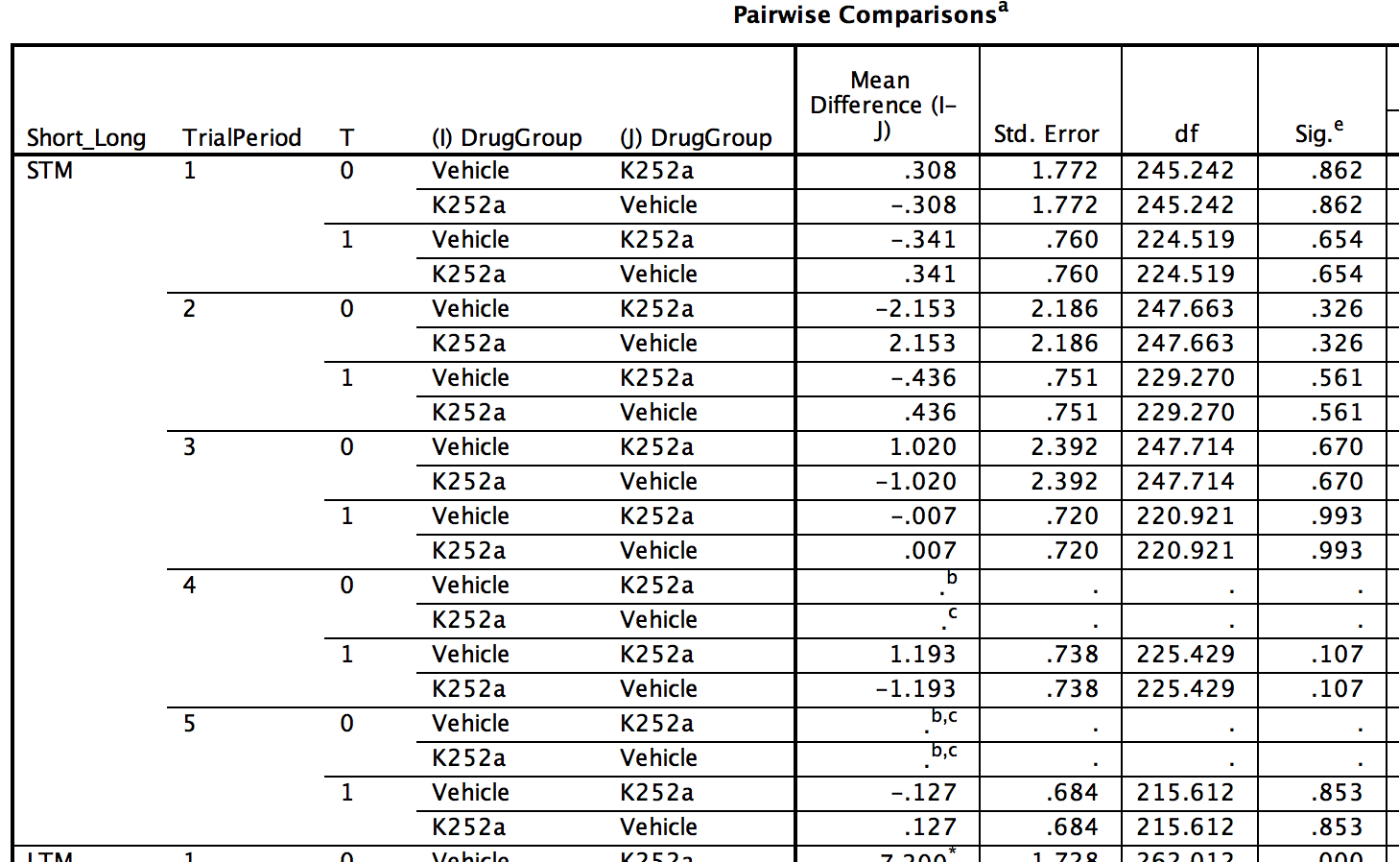
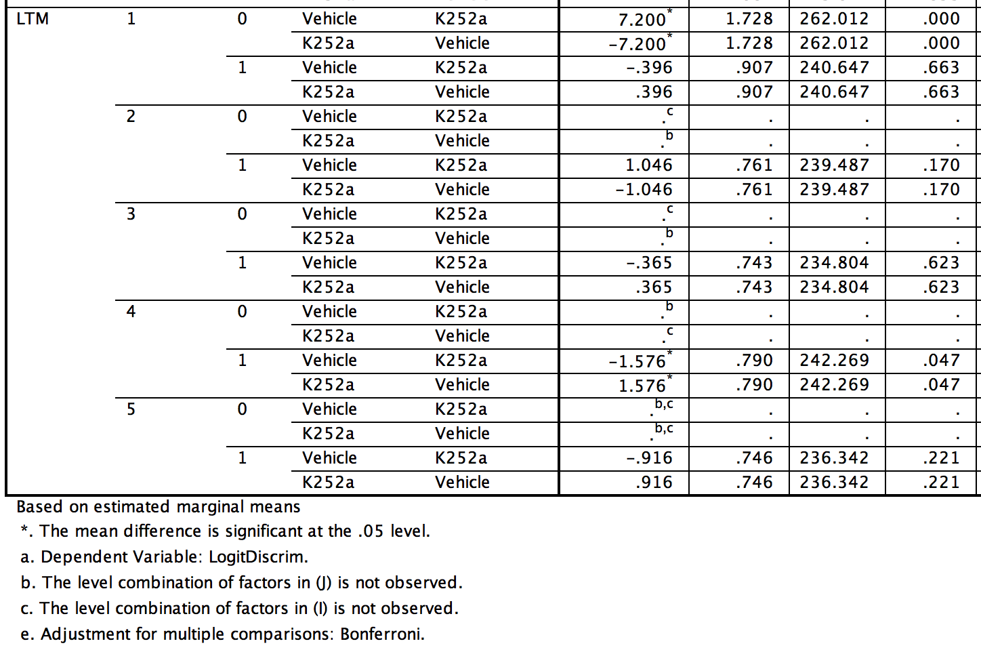
We see here that, during STM testing, correct and incorrect trials were not different for the drug and vehicles during any of digging time probe trials, including T1 (p > .05). During LTM, however, we found that vehicle had a significantly higher DI than the drug group during T1 for the incorrect T1s only (p < .05).
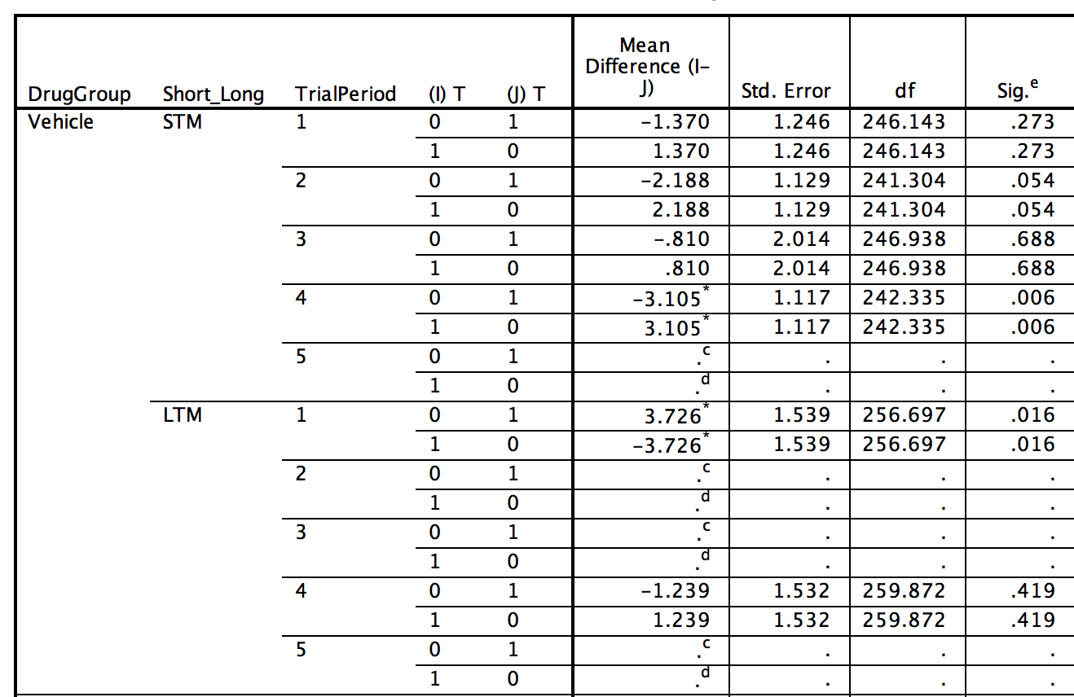
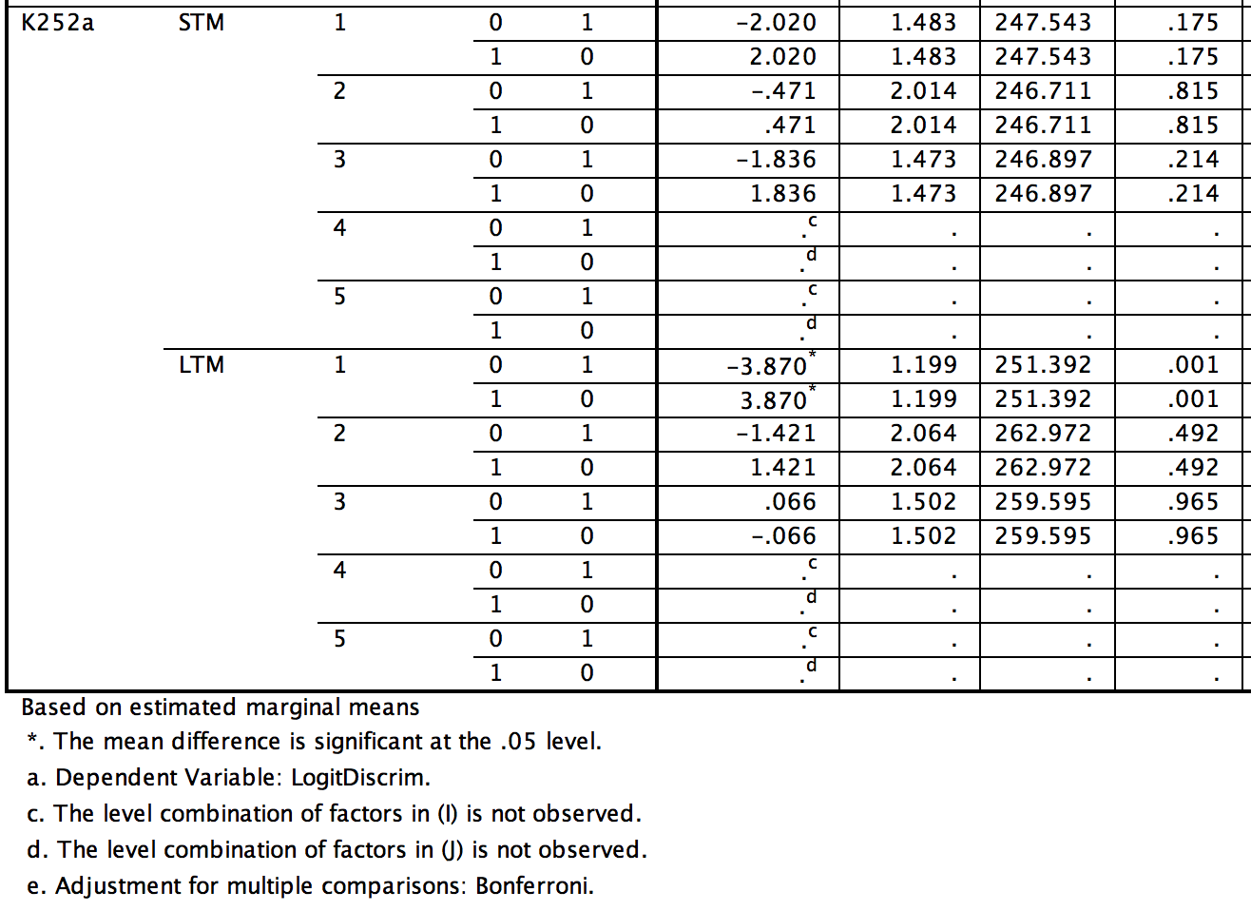
The post-hoc tests also show that for STM trials, neither the drug or vehicle group had different number of correct and incorrect T1 (ps > .05). During LTM testing, the drug group had significantlyfewer correct trials than incorrect trials (p < .05)

Pre-Retrieval infusions Digging Time/Discrimination Index

Data file: TONG_K252aSTMLTMDiggingLongForm-RetrievalOnly.sav
Output file: TONG_Discrim_DiscIndex.spv

DATASET ACTIVATE DataSet4.
MIXED DigDiscrim BY Test_Training DrugGroup DigTrial MouseID Trial
/CRITERIA=CIN(95) MXITER(100) MXSTEP(10) SCORING(1) SINGULAR(0.000000000001) HCONVERGE(0, ABSOLUTE) LCONVERGE(0, ABSOLUTE) PCONVERGE(0.000001, ABSOLUTE)
/FIXED=Test_Training DrugGroup DigTrial Test_Training*DrugGroup Test_Training*DigTrial DrugGroup*DigTrial Test_Training*DrugGroup*DigTrial | SSTYPE(3)
/METHOD=REML
/PRINT=SOLUTION
/RANDOM=intercept | subject(MouseID)
/RANDOM=intercept | subject(Trial*MouseID)
/SAVE=FIXPRED PRED RESID
/EMMEANS=TABLES(DrugGroup*Test_Training*DigTrial) COMPARE (DrugGroup) ADJ(BONFERRONI)
/EMMEANS=TABLES(DrugGroup*Test_Training*DigTrial) COMPARE (Test_Training) ADJ(BONFERRONI)
/EMMEANS=TABLES(DrugGroup*Test_Training*DigTrial) COMPARE (DigTrial) ADJ(BONFERRONI).

FULL MODEL:

Type III Tests of Fixed Effectsª
Source | Numerator df | Denominator df | F | Sig.
Intercept | 1 | 14.000 | 446.844 | .000
Test_Training | 1 | 126.000 | 103.911 | .000
DrugGroup | 1 | 14.000 | .047 | .831
DigTrial | 4 | 126.000 | 45.219 | .000
Test_Training * DrugGroup | 1 | 126.000 | .338 | .562
Test_Training * DigTrial | 4 | 126.000 | 8.867 | .000
DrugGroup * DigTrial | 4 | 126.000 | .072 | .991
Test_Training * DrugGroup * DigTrial | 4 | 126.000 | 1.441 | .224
a. Dependent Variable: DigDiscrim.

Significant two-way interaction of Test_Training and DigTrial, and main effects of DigTrial and Test_Training.

In post-hoc tests:

Test_Training | DigTrial | (I) DrugGroup | (J) DrugGroup | Std. Error | df | Sig.^{b}
Training | 1 | Vehicle | K252a | .111 | 99.038 | .838
 |  | K252a | Vehicle | .111 | 99.038 | .838
 | 2 | Vehicle | K252a | .111 | 99.038 | .133
 |  | K252a | Vehicle | .111 | 99.038 | .133
 | 3 | Vehicle | K252a | .111 | 99.038 | .604
 |  | K252a | Vehicle | .111 | 99.038 | .604
 | 4 | Vehicle | K252a | .111 | 99.038 | .761
 |  | K252a | Vehicle | .111 | 99.038 | .761
 | 5 | Vehicle | K252a | .111 | 99.038 | .900
 |  | K252a | Vehicle | .111 | 99.038 | .900
TestRetr | 1 | Vehicle | K252a | .111 | 99.038 | .604
 |  | K252a | Vehicle | .111 | 99.038 | .604
 | 2 | Vehicle | K252a | .111 | 99.038 | .327
 |  | K252a | Vehicle | .111 | 99.038 | .327
 | 3 | Vehicle | K252a | .111 | 99.038 | .427
 |  | K252a | Vehicle | .111 | 99.038 | .427
 | 4 | Vehicle | K252a | .111 | 99.038 | .690
 |  | K252a | Vehicle | .111 | 99.038 | .690
 | 5 | Vehicle | K252a | .111 | 99.038 | .528
 |  | K252a | Vehicle | .111 | 99.038 | .528

No significant comparisons

DrugGroup | DigTrial | (I) Test_Training | (J) Test_Training | Std. Error | df | Sig.^{c} | 95% Confidence Interval for Difference^{c}
 |  |  |  |  |  |  | Lower Bound | Upper Bound
Vehicle | 1 | Training | TestRetr | .099 | 126.000 | .000 | -.754 | -.363
 |  | TestRetr | Training | .099 | 126.000 | .000 | .363 | .754
 | 2 | Training | TestRetr | .099 | 126.000 | .000 | -.791 | -.400
 |  | TestRetr | Training | .099 | 126.000 | .000 | .400 | .791
 | 3 | Training | TestRetr | .099 | 126.000 | .047 | -.393 | -.002
 |  | TestRetr | Training | .099 | 126.000 | .047 | .002 | .393
 | 4 | Training | TestRetr | .099 | 126.000 | .014 | -.441 | -.050
 |  | TestRetr | Training | .099 | 126.000 | .014 | .050 | .441
 | 5 | Training | TestRetr | .099 | 126.000 | .390 | -.281 | .110
 |  | TestRetr | Training | .099 | 126.000 | .390 | -.110 | .281
K252a | 1 | Training | TestRetr | .099 | 126.000 | .000 | -.835 | -.444
 |  | TestRetr | Training | .099 | 126.000 | .000 | .444 | .835
 | 2 | Training | TestRetr | .099 | 126.000 | .002 | -.512 | -.121
 |  | TestRetr | Training | .099 | 126.000 | .002 | .121 | .512
 | 3 | Training | TestRetr | .099 | 126.000 | .606 | -.247 | .144
 |  | TestRetr | Training | .099 | 126.000 | .606 | -.144 | .247
 | 4 | Training | TestRetr | .099 | 126.000 | .001 | -.520 | -.129
 |  | TestRetr | Training | .099 | 126.000 | .001 | .129 | .520
 | 5 | Training | TestRetr | .099 | 126.000 | .088 | -.365 | .026
 |  | TestRetr | Training | .099 | 126.000 | .088 | -.026 | .365

DrugGroup | Test_Training | (I) DigTrial | (J) DigTrial | df | Sig.^{c}
Vehicle | Training | 1 | 2 | 126.000 | .080
 |  |  | 3 | 126.000 | .000
 |  |  | 4 | 126.000 | .000
 |  |  | 5 | 126.000 | .000
 |  | 2 | 1 | 126.000 | .080
 |  |  | 3 | 126.000 | .001
 |  |  | 4 | 126.000 | .000
 |  |  | 5 | 126.000 | .000
 |  | 3 | 1 | 126.000 | .000
 |  |  | 2 | 126.000 | .001
 |  |  | 4 | 126.000 | 1.000
 |  |  | 5 | 126.000 | 1.000
 |  | 4 | 1 | 126.000 | .000
 |  |  | 2 | 126.000 | .000
 |  |  | 3 | 126.000 | 1.000
 |  |  | 5 | 126.000 | 1.000
 |  | 5 | 1 | 126.000 | .000
 |  |  | 2 | 126.000 | .000
 |  |  | 3 | 126.000 | 1.000
 |  |  | 4 | 126.000 | 1.000
 | TestRetr | 1 | 2 | 126.000 | .027
 |  |  | 3 | 126.000 | .021
 |  |  | 4 | 126.000 | .002
 |  |  | 5 | 126.000 | .012
 |  | 2 | 1 | 126.000 | .027
 |  |  | 3 | 126.000 | 1.000
 |  |  | 4 | 126.000 | 1.000
 |  |  | 5 | 126.000 | 1.000
 |  | 3 | 1 | 126.000 | .021
 |  |  | 2 | 126.000 | 1.000
 |  |  | 4 | 126.000 | 1.000
 |  |  | 5 | 126.000 | 1.000
 |  | 4 | 1 | 126.000 | .002
 |  |  | 2 | 126.000 | 1.000
 |  |  | 3 | 126.000 | 1.000
 |  |  | 5 | 126.000 | 1.000
 |  | 5 | 1 | 126.000 | .012
 |  |  | 2 | 126.000 | 1.000
 |  |  | 3 | 126.000 | 1.000
 |  |  | 4 | 126.000 | 1.000
K252a | Training | 1 | 2 | 126.000 | .000
 |  |  | 3 | 126.000 | .000
 |  |  | 4 | 126.000 | .000
 |  |  | 5 | 126.000 | .000
 |  | 2 | 1 | 126.000 | .000
 |  |  | 3 | 126.000 | .035
 |  |  | 4 | 126.000 | .242
 |  |  | 5 | 126.000 | .005
 |  | 3 | 1 | 126.000 | .000
 |  |  | 2 | 126.000 | .035
 |  |  | 4 | 126.000 | 1.000
 |  |  | 5 | 126.000 | 1.000
 |  | 4 | 1 | 126.000 | .000
 |  |  | 2 | 126.000 | .242
 |  |  | 3 | 126.000 | 1.000
 |  |  | 5 | 126.000 | 1.000
 |  | 5 | 1 | 126.000 | .000
 |  |  | 2 | 126.000 | .005
 |  |  | 3 | 126.000 | 1.000
 |  |  | 4 | 126.000 | 1.000
 | TestRetr | 1 | 2 | 126.000 | 1.000
 |  |  | 3 | 126.000 | .998
 |  |  | 4 | 126.000 | .003
 |  |  | 5 | 126.000 | .008
 |  | 2 | 1 | 126.000 | 1.000
 |  |  | 3 | 126.000 | 1.000
 |  |  | 4 | 126.000 | .200
 |  |  | 5 | 126.000 | .389
 |  | 3 | 1 | 126.000 | .998
 |  |  | 2 | 126.000 | 1.000
 |  |  | 4 | 126.000 | .408
 |  |  | 5 | 126.000 | .748
 |  | 4 | 1 | 126.000 | .003
 |  |  | 2 | 126.000 | .200
 |  |  | 3 | 126.000 | .408
 |  |  | 5 | 126.000 | 1.000
 |  | 5 | 1 | 126.000 | .008
 |  |  | 2 | 126.000 | .389
 |  |  | 3 | 126.000 | .748
 |  |  | 4 | 126.000 | 1.000

