- Building model

  - Build porphycene structure: Open pdb file with GaussView
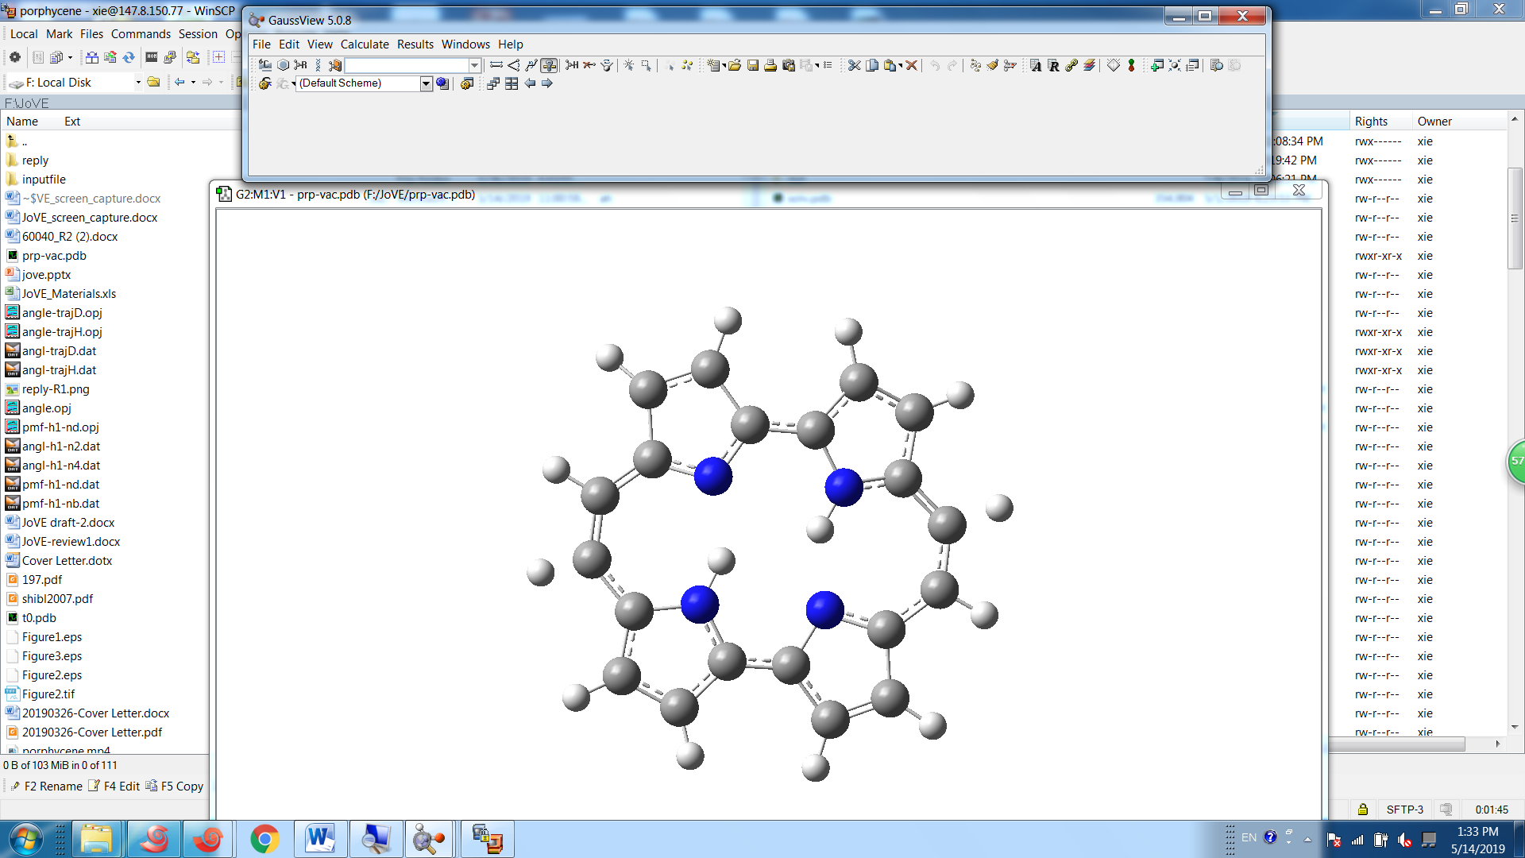

1.2 solvate model
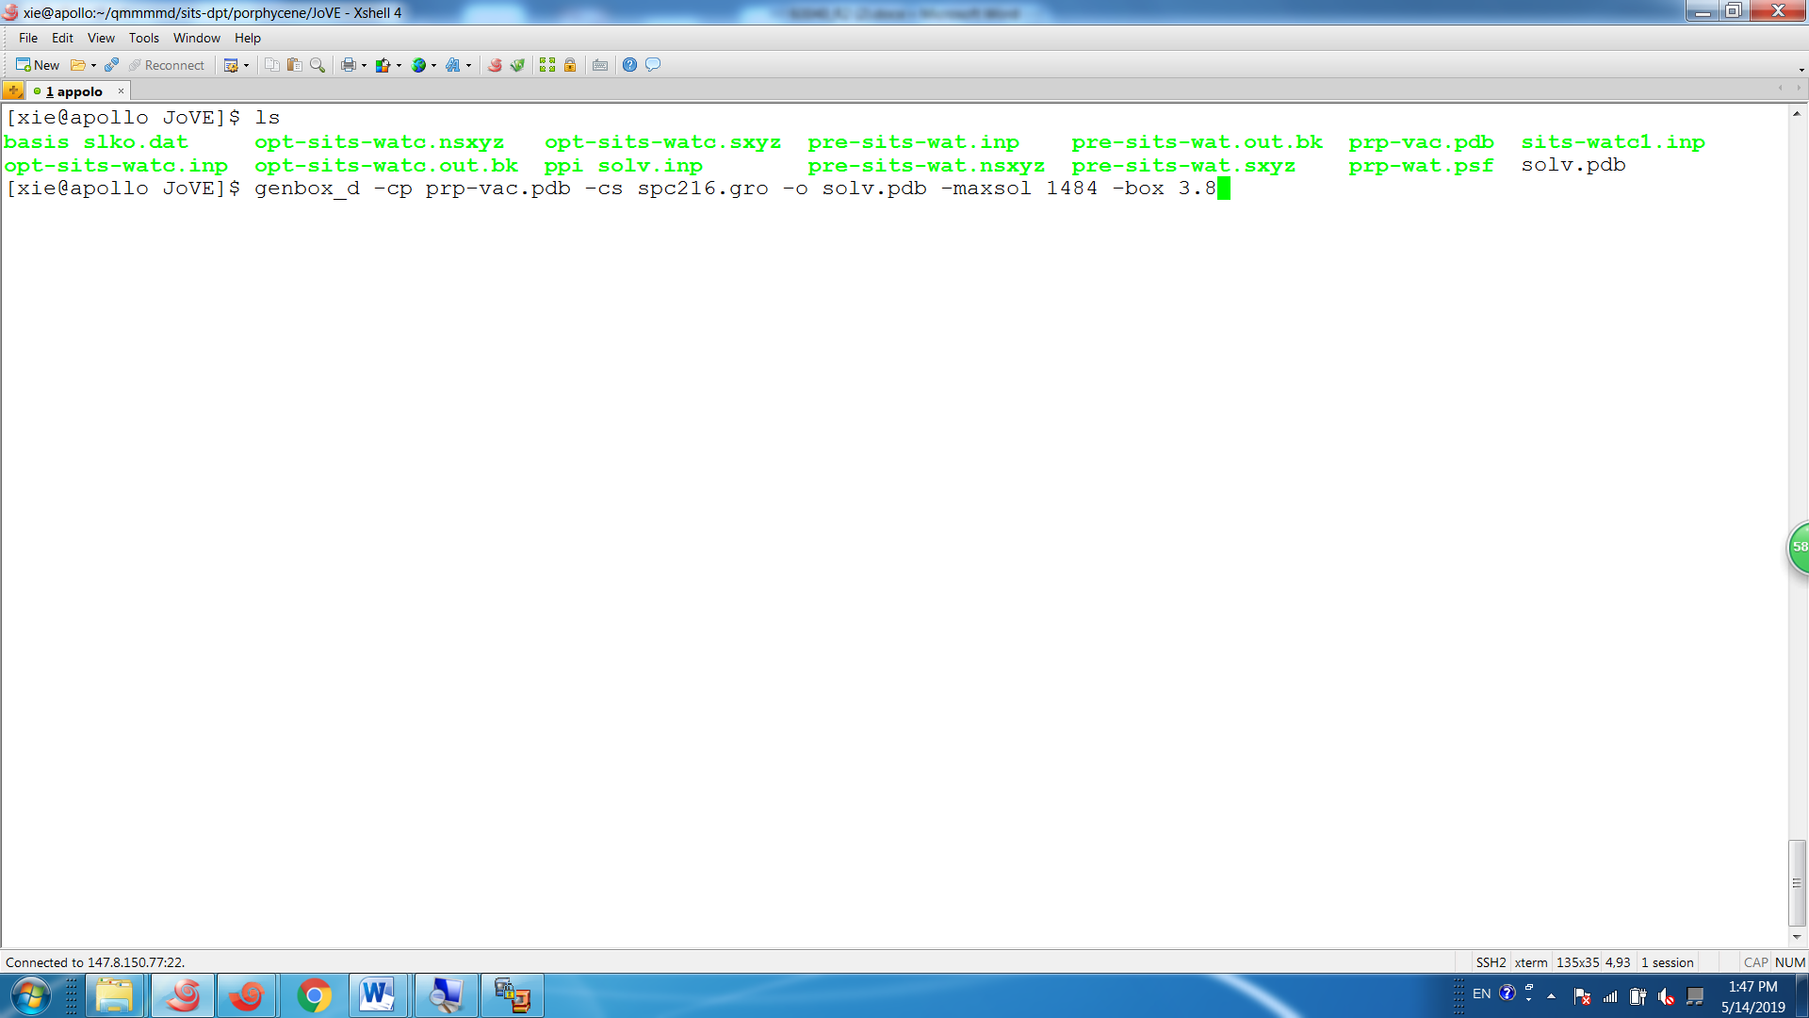
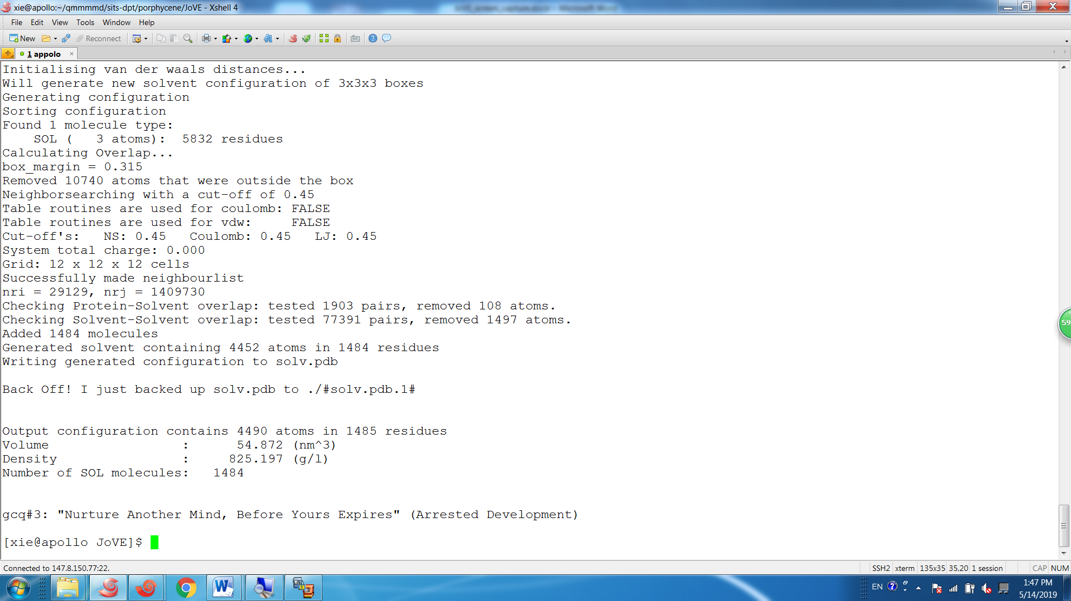

- Pre-sits

2.1. Set up temperature parameters: Input templow 260, temphigh 1100 and ntemp 160 in the input file.

2.2. Initiate the pre-sits: Set runtype 100 and step 120,000 in the input file.
Then issue the following command: $PATH/qm4d $INPUTFILE > $OUTPUTFILE.

2.3. Calculating the decomposed energies
2.3.1. Extract energy changes:

- Opt-sits

3.1. Initiate opt-sits: Set runtype 0 in the input file.

3.2. Monitoring the energy changes and $\{n_{k}\}$ values.

3.2.1. Plot the energy propagation with “grace” program and make sure the energy fluctuation can cover the lowest and the highest ends of the temperature range.
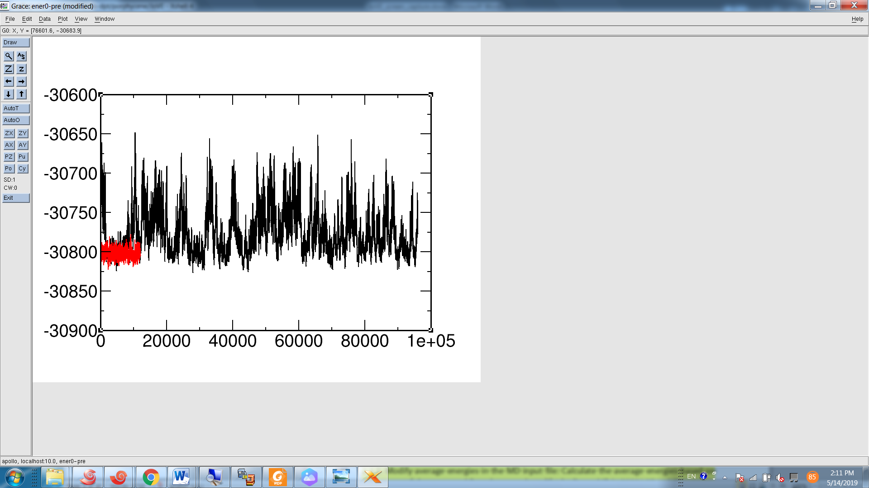

3.2.2. After optimization, save the final $\{n_{k}\}$ values of the opt-sits step into a new file, which is named as nk.dat in this protocol.

- Running production simulations

4.1. Prepare MD input file: Set runtype 1 in the new input file to start the production simulation step. Specify the file name of stored $\{n_{k}\}$ file as nkfile nk.dat in the input file.

4.2. Initiate production MD simulation: Issue the following command to start MD simulations:
$PATH/qm4d $INPUTFILE > $OUTPUTFILE.

- Data analysis

5.1. Monitoring the distance changes

5.1.1. Monitor the bond forming and breaking process during the production phase, use the grep command to check the distance changes of H1-N1 and H1-N2 along the simulation time.

5.2. Extracting reaction coordinates and calculating free energy
5.2.1 Extracting reaction coordinates

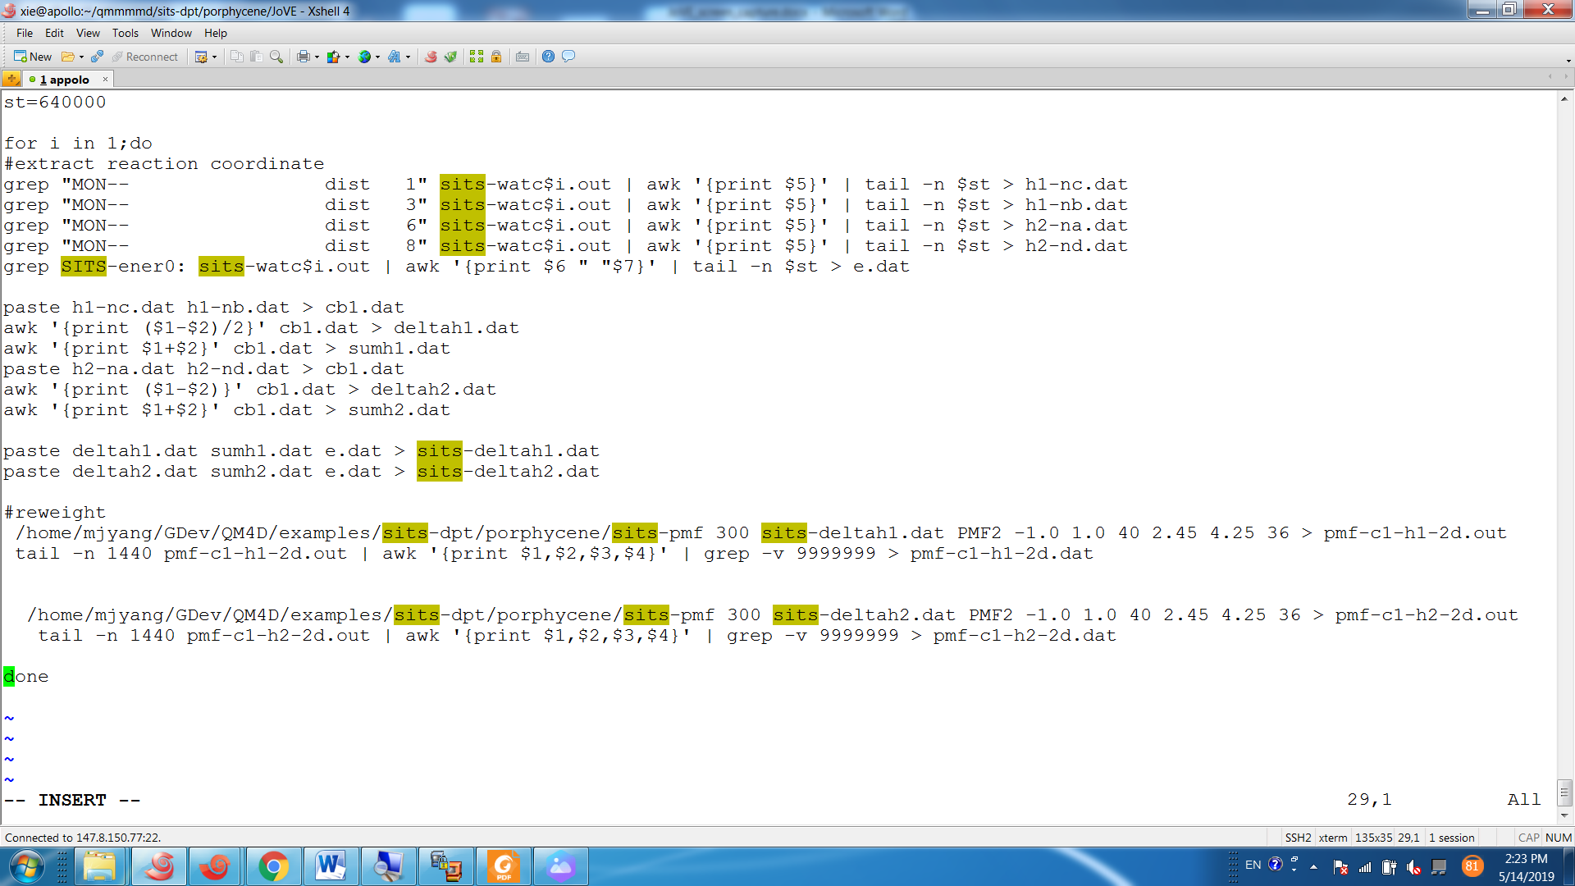

5.2.2. Organize data in four columns: q₁, q₂, U₀ and U’
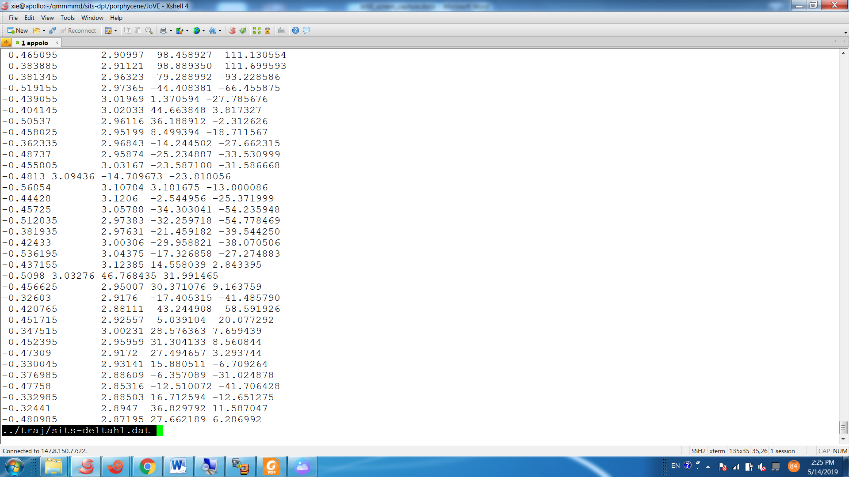

5.3.2. To project the free energy on the two-dimensional landscape,
