Supplementary data

Material :
Primers :
5’biot-temp-30 : biotin-CCGAATCAGGAAGATAACAGCGGTTTAGCC
temp-25 : TCAGGAAGATAACAGCGGTTTAGCC
prim-20 : GGCTAAACCGCTGTTATCTT

Primer combinations:
for SAXS : temp-25 + prim-20
for SPR : 5’biot-temp-30 + prim-20

Methods:
Annealing:
The primers 5’biot-temp-30 and prim-20 or temp-25 and prim-20 were mixed at a final concentration of 100 µM each in 20 mM Tris pH 7.0, 75 mM NaCl, 2 mM Mg Ac and annealed using a linear temperature gradient from 98°C to 23°C at 0.5°C temperature decrease per minute using an Eppendorf Mastercycler pro.

SPR experiment:
Data were collected on a BIAcore 3000 on a streptavidin coated chip. All experiments were performed in 20 mM Tris pH 7.0, 100 mM NaCl with a flow rate of 15 µl/min.
Sensor preparation : 75 µL of a 1 µM solution of 5’biot-temp-30 + prim-20 annealed primers were loaded at 5µL/min on one flow cell, a second flow cell was used for background subtraction. Unbound DNA was eliminated by a 2 min wash with 0.05% SDS.
SPR run: A dilution series from 0.625 to 320 nM of E9 exo^{minus} (2-fold step) was injected each during 3 min followed by a 5 min dissociation. The protein was washed between injections with a 2 min 0.05% SDS wash before being re-equilibrated in running buffer for 5 minutes.
Data analysis: Background subtracted signals were imported to LibreOffice Calc for curve fitting using the Solver non-linear function. Single exponential fit gives a K_{D} of 12 ± 6 nM. Figure was generated using MS Excel.
Supplementary Figure 1: SPR signal curves for binding of E9 exo^{minus} to DNA.

Sample preparation for SAXS:
800 µl of E9exo^{minus} (7.8 µM) were mixed with 80 µl annealed primers at 100 µM. The salt was diluted to 75 mM and the sample then concentrated to 60 µl (~ 8-10 mg/ml protein, DNA 1.2 x).

Concurrent SAXS analysis of the first peak:
The analysis of the first peak representing the E9 exo^{minus} +DNA complex using classical frame selection and EFA analysis shows that in this case there is no significant improvement of the scattering signal using deconvolution.
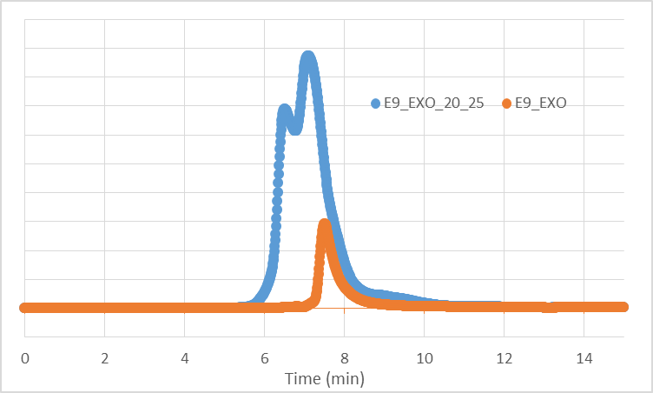
Supplementary Figure 2: UV spectra from SEC-SAXS of the E9 exo^{minus} with (blue) versus without (orange) DNA (data not shown) showing that the second peak corresponds to E9 exo^{minus} unbound form.

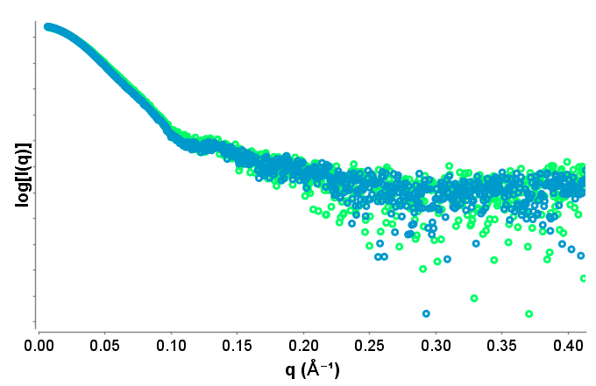
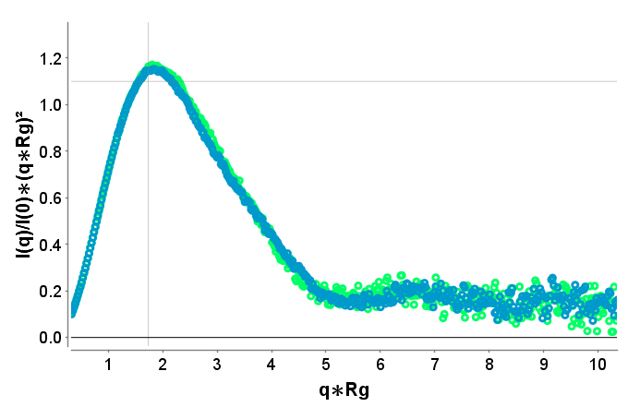
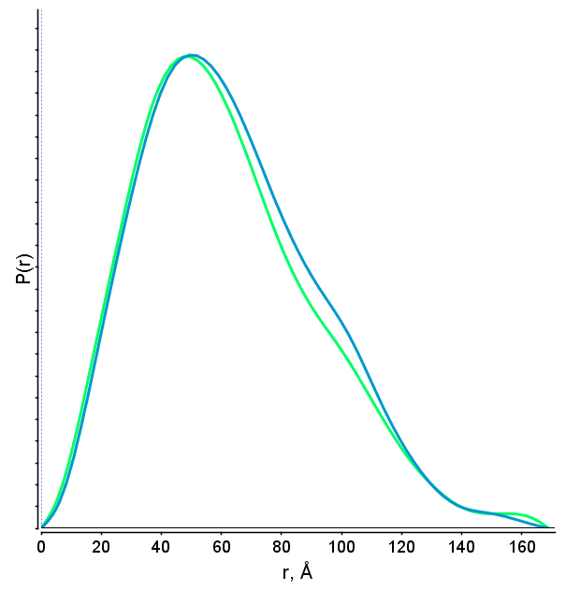
a)
b)
c)

Supplementary Figure 3: a) I versus q curve, b) Kratky plot, c) P(r) of E9 exo^{minus} +DNA. The blue curve represents the analysis using EFA and the green curve represents the analysis without EFA. The R_{g}s differ slightly (49.1Å versus 48.4 Å in real space).

