Appendix 1: Thermal Tests
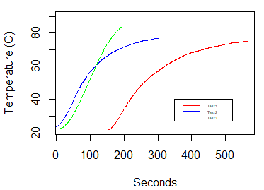

Figure 1: Three thermal tests conducted for a hydrothermal simulant solution shows temperature of the fluid increasing to approximately 70 °C.
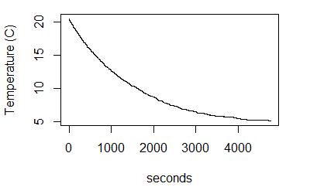

Figure 2: Ocean water simulant thermal test shows decrease in temperature from approximately room temperature to ~ 5 °C in ~1.5 h.

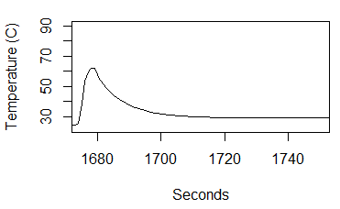
Figure 3: Thermal test shows hydrothermal fluid simulant injection heated to ~70 °C with rapid thermal loss to near 35 °C to open air within the ocean vessel.
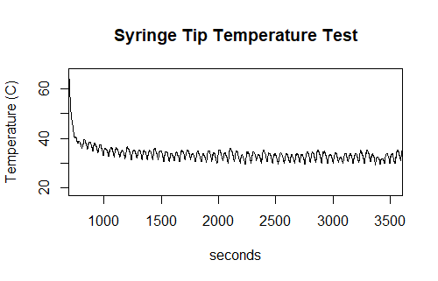
Figure 4: Second thermal test of hydrothermal simulant at the tip of the syringe. A temperature probe was placed at the needle tip of the syringe to measure thermal loss at the exit. The test shows almost immediate thermal loss at the exit tip of the syringe. The oscillations are caused by syringe pump vibrations at it injects the hydrothermal fluid simulant.

