Appendix 2: Setting Up Thermistors and the Temperature Controller

Tools needed:
- Wire cutter
- Wire stripper
- Tweezers (fine point)
- Mini screw driver set
- Magnifying glass

- To get a computer readout of the recorded temperatures using the thermistor probe, connect 3 male to female wire jumper multicolored ribbon cables to a RS-232 port cable wire (Figure 2B). Remove the plastic housing from the ribbon cable ends, and slowly pull the plastic cap off until the metal connector is exposed.

- Strip one end of the exposed cable ribbons using the wire stripper.

- On the other end of the ribbon cable, use a fine-pointed tweezer to carefully expand the diameter of the metal connector.

NOTE: This metal connector will need to be wide enough to fit around the RS-232 port connector pins (Figure 2A). Use a magnifying glass to see if the metal connector is wide enough.

- If the metal connector is wide enough, place the 3 metal connectors to pins 2, 3, and 5 on the RS-232 port cable wire (Figure 1).

- Ensure that the stripped ends of the ribbon cables are screwed into the temperature controller ports 7, 8, and 9 (Figure 1) using a mini 4-headed screw driver, and secure tightly.

- Once secure, place the USEB end of the RS-232 cable into the USB port on the computer.

- Open the software to check the connection (Step 4).

NOTE: The TE Technologies software is run via Windows operating systems only.
Figure 1: Temperature controller instrument TC-48-20 TE Technologies. Directions for lead connections to RS-232 port. (Image: Courtesy of TE Technologies)
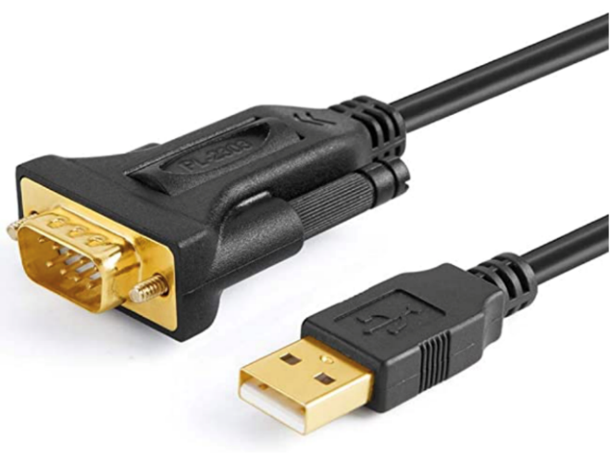
A
B

Figure 2: RS-232 port with labeled connector pins. (Image: Courtesy of TE Technologies and Amazon.com)

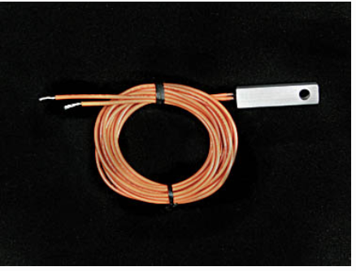
Figure 3: MP-3193 moisture-resistant thermistor. Two leads will be placed in temperature controller ports 1 and 2. The metal thermistor will be placed in ocean simulant. (Image: Courtesy of TE Technologies)

Using a TC-48-20 temperature controller:

- Insert the USB side of the RS232 adapter cable into the computer USB port. Plug in the power for the TC-48-20 temperature controller.

- Turn on the TC-48-20 software on the computer.

  - Scroll down to Communications Port. Select the first few communication ports and click on the Connect button to the left for each port, until the thermistor connects to the software. Note the green Reading Configuration bars all the way across.

  - Observe the flashing sampling icon, showing that it is sampling the current temperature at frequent intervals.

NOTE: If neither of these signals are observed, choose other communication ports. If none of the Communication Ports work, look for a pop-up message stating communications error or unable to communicate. If communications error pops up, close the program and restart.

  - Re-check ribbon cables, and make sure they are properly connected to the pins on the RS232 cable pinouts.

- Once connected, make sure that Output reads 100% in the red bars.

- Once the thermistor is flashing frequent interval measurements, change the interval time to 60 s. In the Controller Options box, towards the bottom, clear out 1 s and change to °C. Click on the OK button.

- Click on the oval Auto-scale button next to the TE Technologies logo to turn on auto-scale, and observe a yellow line that will show the temperature readout.

- Inside the plot area, right-click to adjust the plot such as scaling x and y axes.

- Right-click in the plot area and click on export to Excel before a new reading starts every 5000 s or 83.33 min (depending on the recording interval chosen). Save the temperature and time data in the spreadsheet automatically created by the software.

