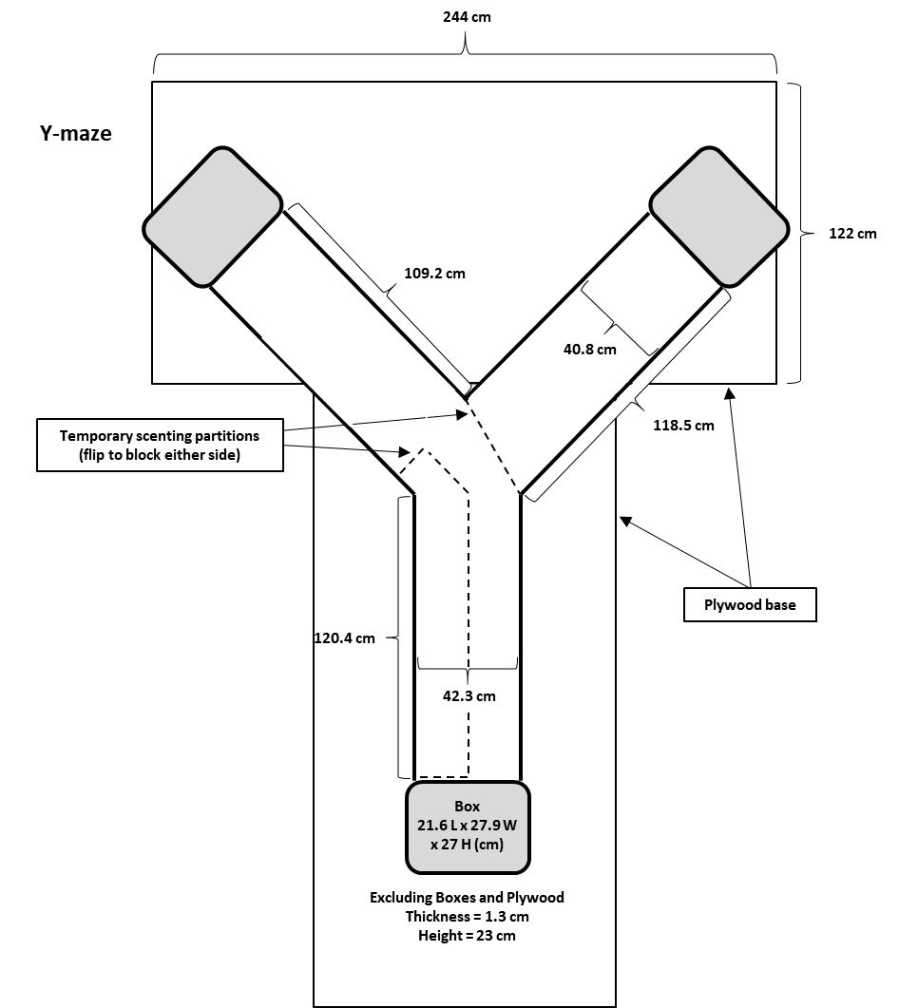
USGS Invasive Species Science Remote (Everglades NP) Y-maze materials and dimensions: Here, the modifications used in nocturnal Protocol section 2 of the manuscript have been outlined. The materials were selected for outdoor durability and ease of cleaning.
Figure 1. USGS Field Y-maze layout. Schematic of field Y-maze components and dimentions with partitions in place.
Each Y-maze’s three separate components (a base and two arms) were fastened together onto two sheets of plywood for stability and security during trials.
- Construct the Y-maze sides and bottom from two H.O.T. white polypropylene sheets (304.8 cm L x 121.9 cm W x 1.3 cm H). Heat weld the walls onto the bases using a heat gun fitted with a weld nozzle (4.5 x 12 mm) and spool of 5 mm polypropylene welding rod. Heat welds are used to ensure a strong bond with minimal seams (see Figure 1).

  - Y-maze base: Cut the base floor to measure 120.4 cm L x 42.3 cm W x 23.0 cm H with an inner shorter length of 108 cm L angling to a point at the end (42.8 cm on each side to the midline) where the two angled arms fit together.

  - Y-maze arms: Cut each arm to a mirrored angle at the base (118.5 cm along the outside length and 109.2 cm on the inside shorter length) and 40.8 cm wide with walls along the lengths and 23.0 cm high.

  - To create a channel for the acrylic top (see section 1.6) to slide onto, use mill-finished aluminum solid angle (243.8 cm L x 2.5 cm W x 2.5 cm H) cut to the length of the base walls (120 cm L) and both arms (120 cm long sides, 110.5 cm short sides).

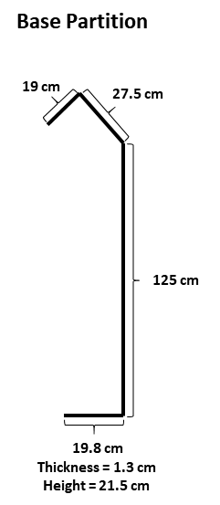
    - To affix the aluminum angle to the polypropylene walls, use Arrow 5 mm plain aluminum rivets with a grip length of 12 mm at approximately 30-cm spacing along the top edge of all the walls. Ensure that the aluminum angle is facing inward and at a height of 0.7 cm above the top of the walls to allow space for the acrylic top to slide in.
Figure 2. Temporary base partition dimensions. Partitions are made from 0.6-cm thick polypropylene. See section 1.3.1.

  - Construct temporary partitions for the base and non-scenting arm (see Figure 1) out of the same H.O.T. white polypropylene sheets used for the Y-maze bottom and walls.

    - Cut and heat weld the temporary partition for the base of the Y-maze as pictured in Figure 2.

    - Cut a rectangular piece of the polypropylene to measure 46 cm W and 22 cm H as the temporary partition plate for the non-scenting arm. This should completely block access to one arm.

NOTE: Temporary partitions can be affixed to easily cleanable weights (e.g., 1-gallon jugs of water) using hook and loop tape to keep them in place.

  - Affix baseplates to each opening of the Y-maze that will allow the boxes (see section 2) to attach. Baseplates are constructed out of the H.O.T. white polypropylene.

    - Cut baseplates to measure 42 cm W x 30 cm H and with a center “window” opening measuring 34 cm W x 16 cm H at 2 cm from the bottom of the baseplate and 13 cm from either end.

    - Affix the baseplates flush to the bottom of the Y-maze openings using aluminum angle and rivets on the outside walls.

  - Construct the top of the Y-maze from 0.6 cm-thick clear acrylic sheets (182.9 cm L x 81.3 cm W) to fit atop the base and each arm of the maze (see Figure 3).

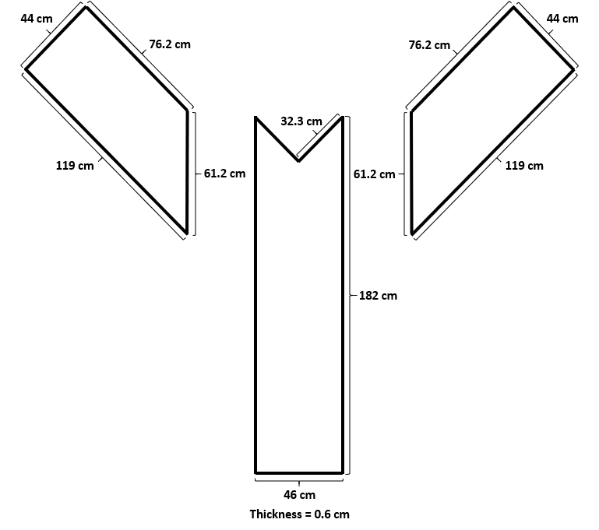
    - Cut the base acrylic top to measure 182.0 cm L x 46.0 cm W with a v-notch cut at one end measuring 32.3 cm L on either side and meeting in the center to accommodate the two angled arm pieces (see Figure 3).
Figure 3. Acrylic top dimensions. Schematic of Y-maze acrylic top pieces and dimensions. See section 1.6.

    - Cut the arm acrylic to 119.0 cm L x 44.0 cm W on the longer outer length, and 76.2 cm L on the inner shorter length. Cut one angled end across measuring 61.2 cm W to fit along the base (see Figure 3).

  - To secure the Y-maze in place and prepare for outdoor use, affix it in place to 122 cm x 244 cm plywood sheets.

    - Orient the plywood sheets side-by-side with the shorter end of one sheet meeting the center of the long end of the other forming a “T” so that they can fully support the base and wide arms of the Y-maze (see Figure 1).

    - Affix the maze to the plywood base using deck screws drilled through an aluminum angle bracket riveted along the bottom of the outside walls of the maze.

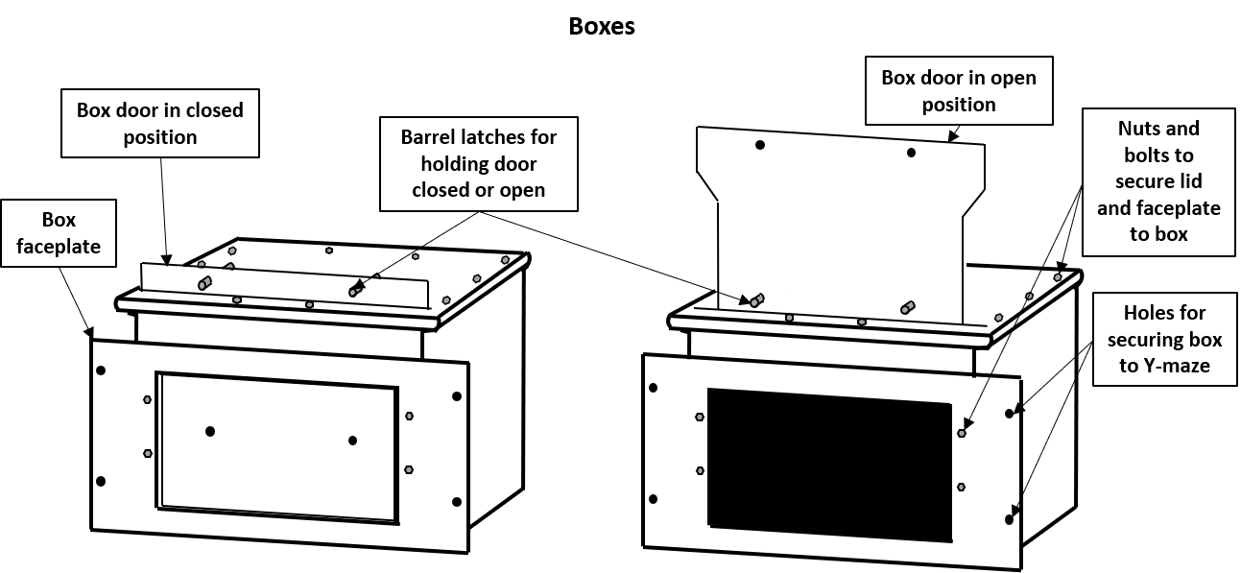
- Box materials and modifications: The three boxes (i.e., hanging file folder boxes, 54.9 cm L x 70.9 cm W) that will be fastened to the three ends of the Y-maze. These boxes also anchor the acrylic top in place (see Figure 4).
Figure 4. Box components and assembly. See section 2.

NOTE: Choose a dark-colored box to reduce light stress to the animals.

  - Drill drain holes in the bottom of each box and affix its lid into place using small screws and nuts.

  - On the long side of each box, cut a rectangular “window” opening (2.5 cm from each side) for egress/ingress (see Figure 5).

  - Cut a 37-cm long narrow slot, centered along the inside of the long edge of the lid on the edge closest to the side window, for the sliding door (see Figure 6).
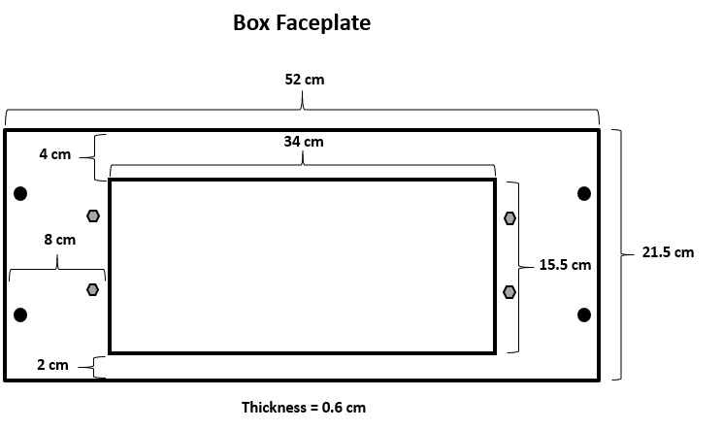
  - Bolt two barrel latches (centered and spaced at 13 cm apart) onto the lid of the box just behind the slot (see Figure 6). These latches will be used to secure the sliding door closed or open.
Figure 5. Box faceplate dimensions and modifications. Faceplate used on boxes is made from 0.3 cm plastic board. See section 2.2
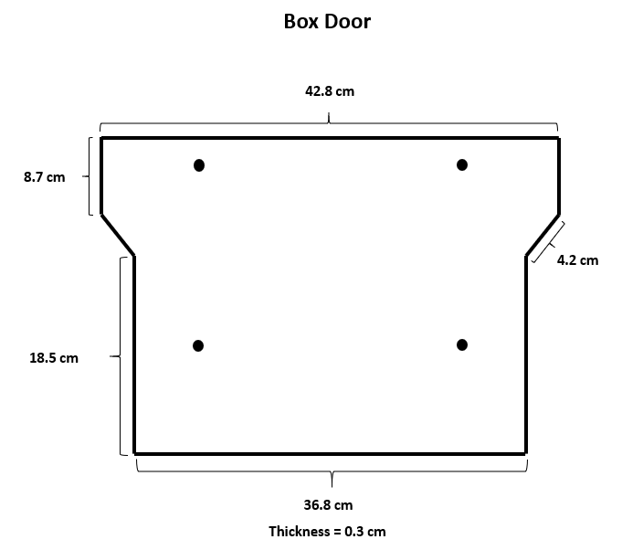
  - Construct a box door from 0.3 cm plastic board to the dimensions shown in Figure 7 and a box face plate with an internal opening from the polypropylene sheet to the dimensions shown in.
Figure 7. Box door dimensions and modifications. Box doors are made from 0.3 cm plastic board. See section 2.5.

  - Place the box door into the slot and use the latches as references to drill two sets of holes into the sliding door; one set lined up with the latches when the sliding door is closed, and another set lined up with the latches when the door is open.

  - Affix the box faceplate to the box using small nuts and bolts and fill any gaps with epoxy for good measure.

  - Align the box faceplate with the Y-maze arm faceplates to ensure a flush connection, then drill aligned holes through both so that they can be secured together with bolts and wingnuts (for easy removal).

NOTE: The first box’s faceplate can be used as a template when drilling the rest of the faceplate holes and ensures that every box is compatible with every Y-maze opening.

  - Align each box faceplate to the Y-maze baseplates and affix using bolts and wingnuts or locks. When these boxes are affixed, they also anchor the acrylic top in place.

- Enclosure materials and considerations: Each Y-maze is enclosed by a 610 cm L x 300 cm W x 280 cm H white pavilion tent to shield it from direct sunlight and prevent overheating the study animals. Center these tents directly overtop the middle of the Y-mazes and their polls are used to affix the monitoring cameras for behavior studies.

NOTE: Extra stabilizing measures are highly recommended if the tents must withstand wind gusts (e.g., fasten with 0.6 cm bolts to 0.9 m U-posts driven into the ground at every tent leg, with each junction in the tent frame also bolted together using 0.6 cm bolts).

  - To minimize any potential bias, evaluate the location of each enclosure, both independently and across enclosures, for the following factors:

    - Elevational gradient: Ensure that each enclosure is on a completely level surface and are at the same elevation.

    - Wind direction and force: Ensure that the enclosure is oriented so that narrower ends of the tents will face prevailing winds. Ensure any additional enclosures are not too proximal or lined up along prevailing wind directions that would allow any scent from one enclosure to potentially contaminate another.

    - Sun exposure: Ensure that each enclosure is oriented so that sunlight hits each portion of the internal Y-mazes in a balanced way (i.e., if one Y-maze gets sun along its long side at 10 AM, any others should also get sun at the same time along the opposite long side to equalize exposure to the arms). Enclosures should not be too proximal as to avoid casting shadows on one another.

