Supplementary Figure S2: Steps used to calculate the Ca²⁺ fluorescence intensity at protoplast of fruit cell. Fluorescence intensity units used in this study are based on previous reports [26-29].
The calculation process is as follows:
(A) First step: Use the software Image-Pro Plus to open the protoplast fluorescence image, click on the "Measure" tool on the toolbar and then select "Profile Line" from the drop-down menu.
(B) Second step: Select the “Circle” in the “Line Profile” window and draw an ellipse at protoplast.
(C) Third step: Click the “File” in the “Line Profile” window and then click “Export data” from the drop-down menu.
(D) Fourth step: If the blank Excel form has already been opened, click "Data Export" to automatically import the data into the Excel form. Use the Excel function (AVERAGE) to calculate the average fluorescence intensity within the ellipse.
Each treatment was repeated three times with more than 20 protoplasts each.
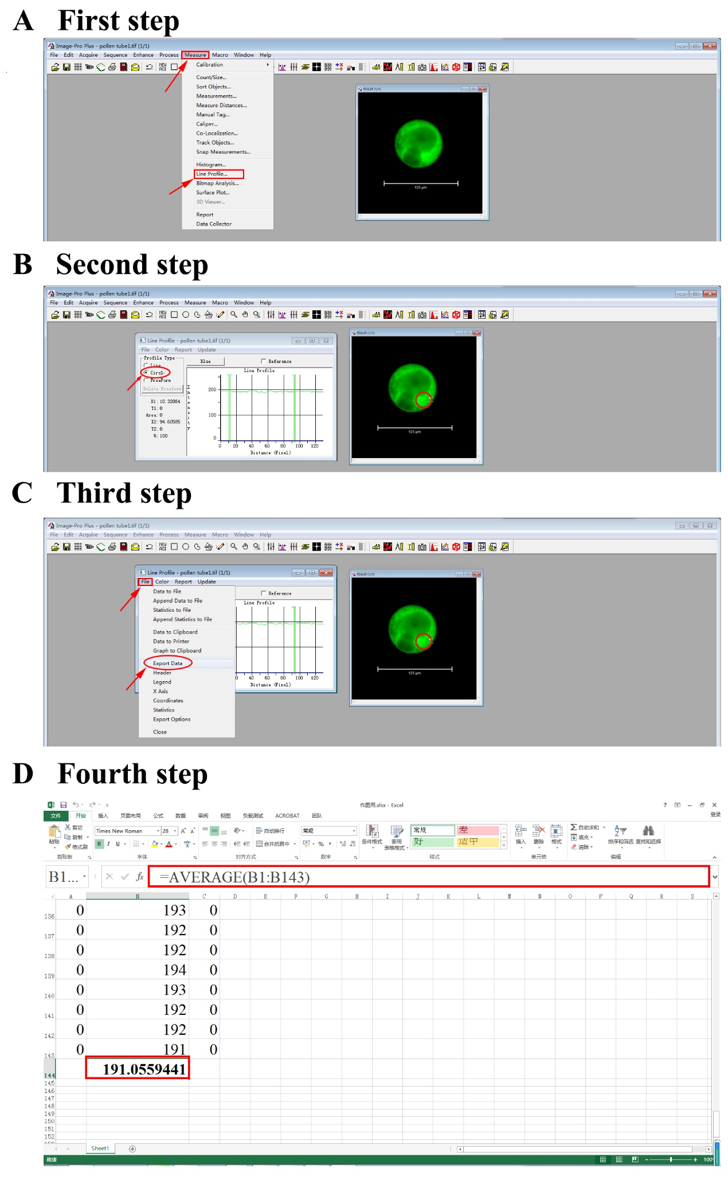
References
AK, H., E, P., and VE, P. Tbx6 regulates left/right patterning in mouse embryos through effects on nodal cilia and perinodal signaling. PLoS One. 3 (6), e2511, (2008).
DeSimone, J. A. et al. Changes in taste receptor cell [Ca²⁺]i modulate chorda tympani responses to salty and sour taste stimuli. Journal of Neurophysiology. 108 (12), 3206-3220, (2012).
Kao, J. P., Harootunian, A. T., and Tsien, R. Y. Photochemically generated cytosolic calcium pulses and their detection by fluo-3. Journal of Biological Chemistry. 264 (14), 8179-8184, (1989).
Merritt, J. E., Mccarthy, S. A., Davies, M., & Moores, K. E. Use of fluo-3 to measure cytosolic Ca²⁺ in platelets and neutrophils. Loading cells with the dye, calibration of traces, measurements in the presence of plasma, and buffering of cytosolic Ca²⁺. Biochemical Journal. 269 (2), 513-519, (1990).

