Proposal for the sketch de la video

INTRODUCTION

General presentation of DiCoExpress and its advantages by using the workflow.
Description of the public and the skills required to use DiCoExpress

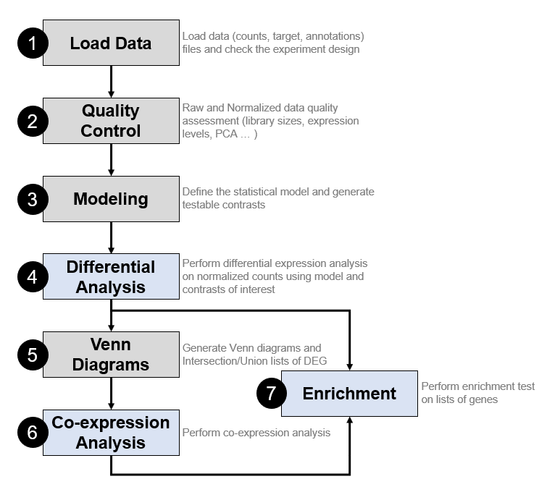

GETTING STARTED WITHDICOEXPRESS IN R-STUDIO

We do the video tutorial in R-Studio as it will allow in the same software to show the directory structure and also launch the commands without typing everyrhing.
The video will be a voice over screen of R-Studio in an R-project:
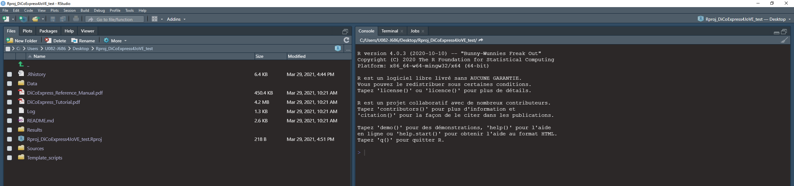

- First we’ll need to set the working directory to Template script
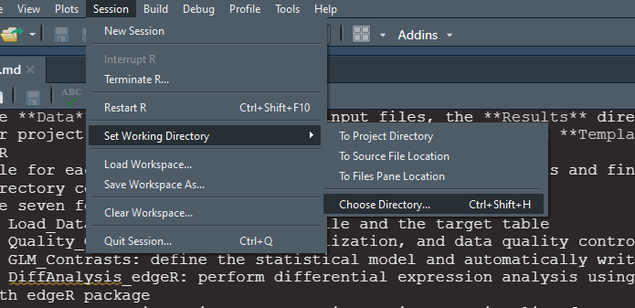

- We’ll do package installation tests

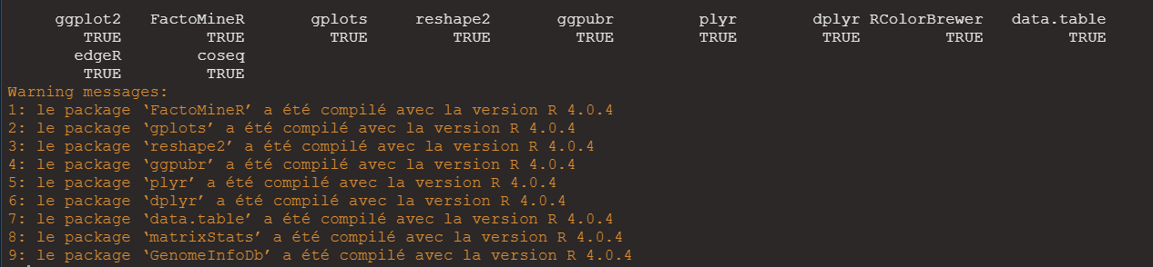

- Showing the directory structure in the folder

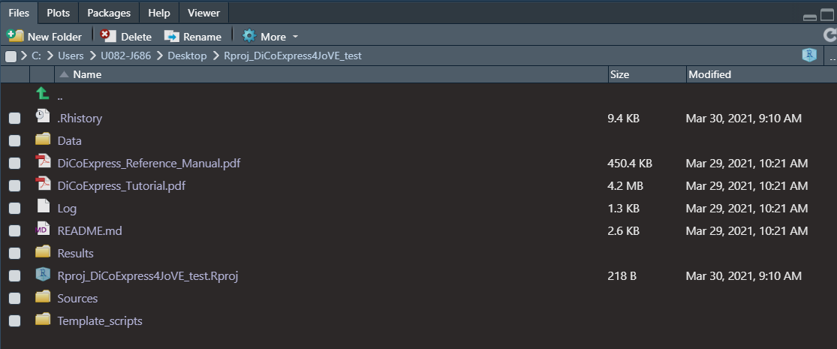
- Open “Template script”

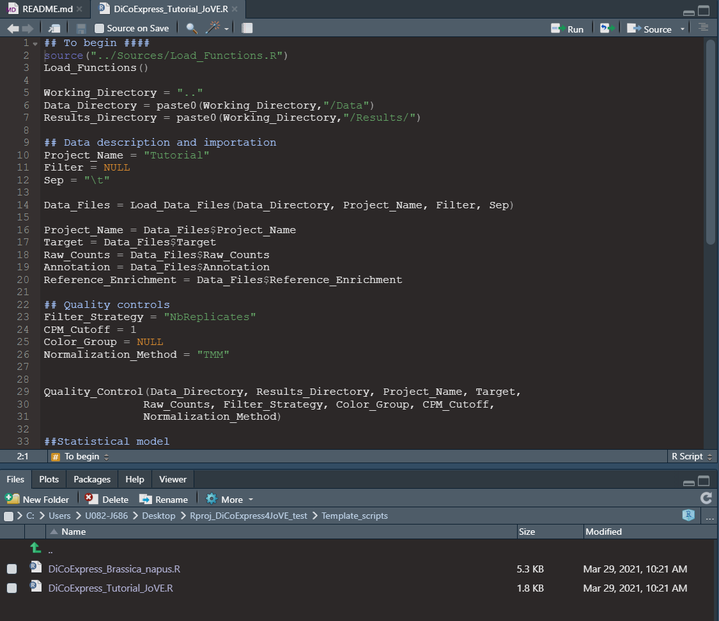

Presentation of the two mandatory files

Data analysis I : Quality control
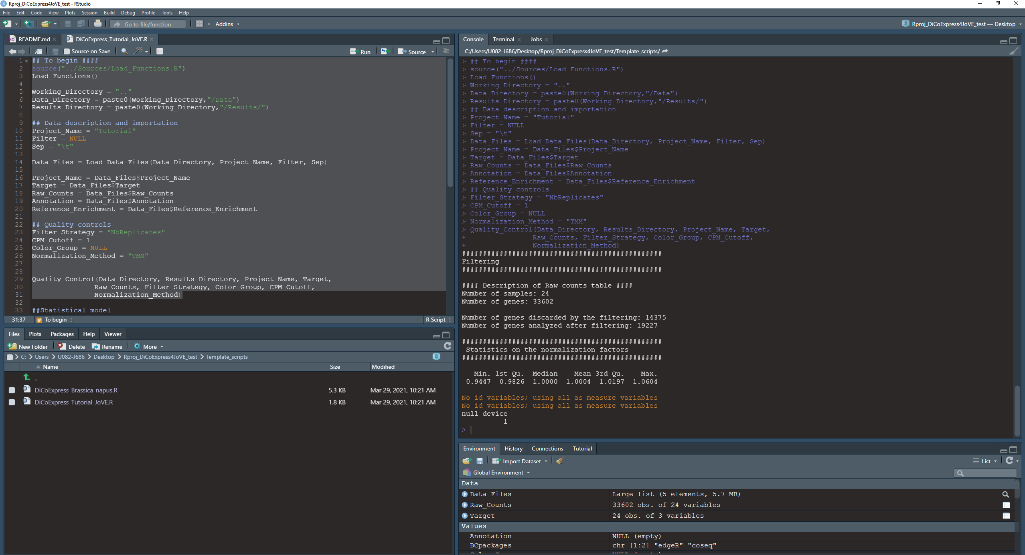

- Result I : showing and commenting the QC PDF file
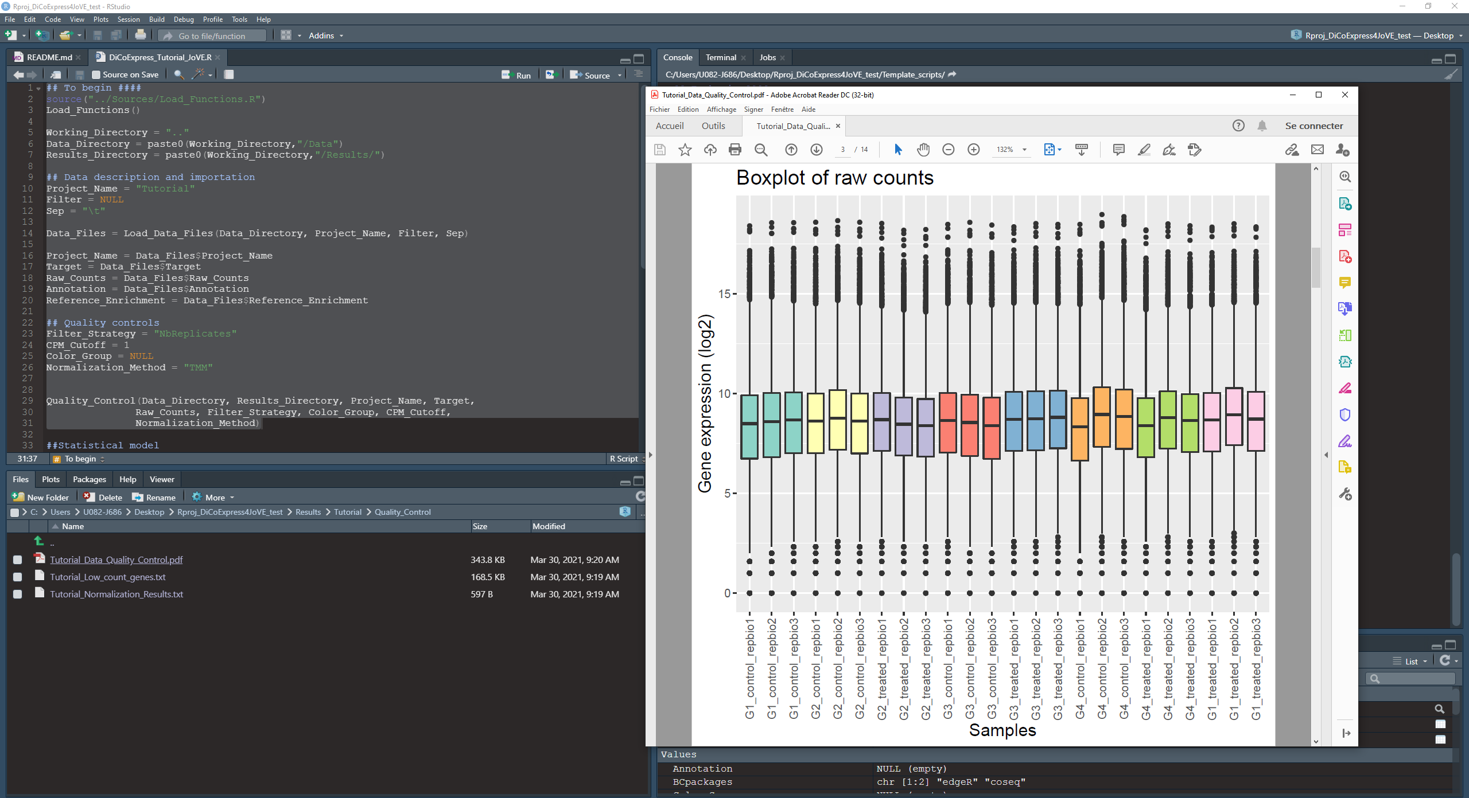
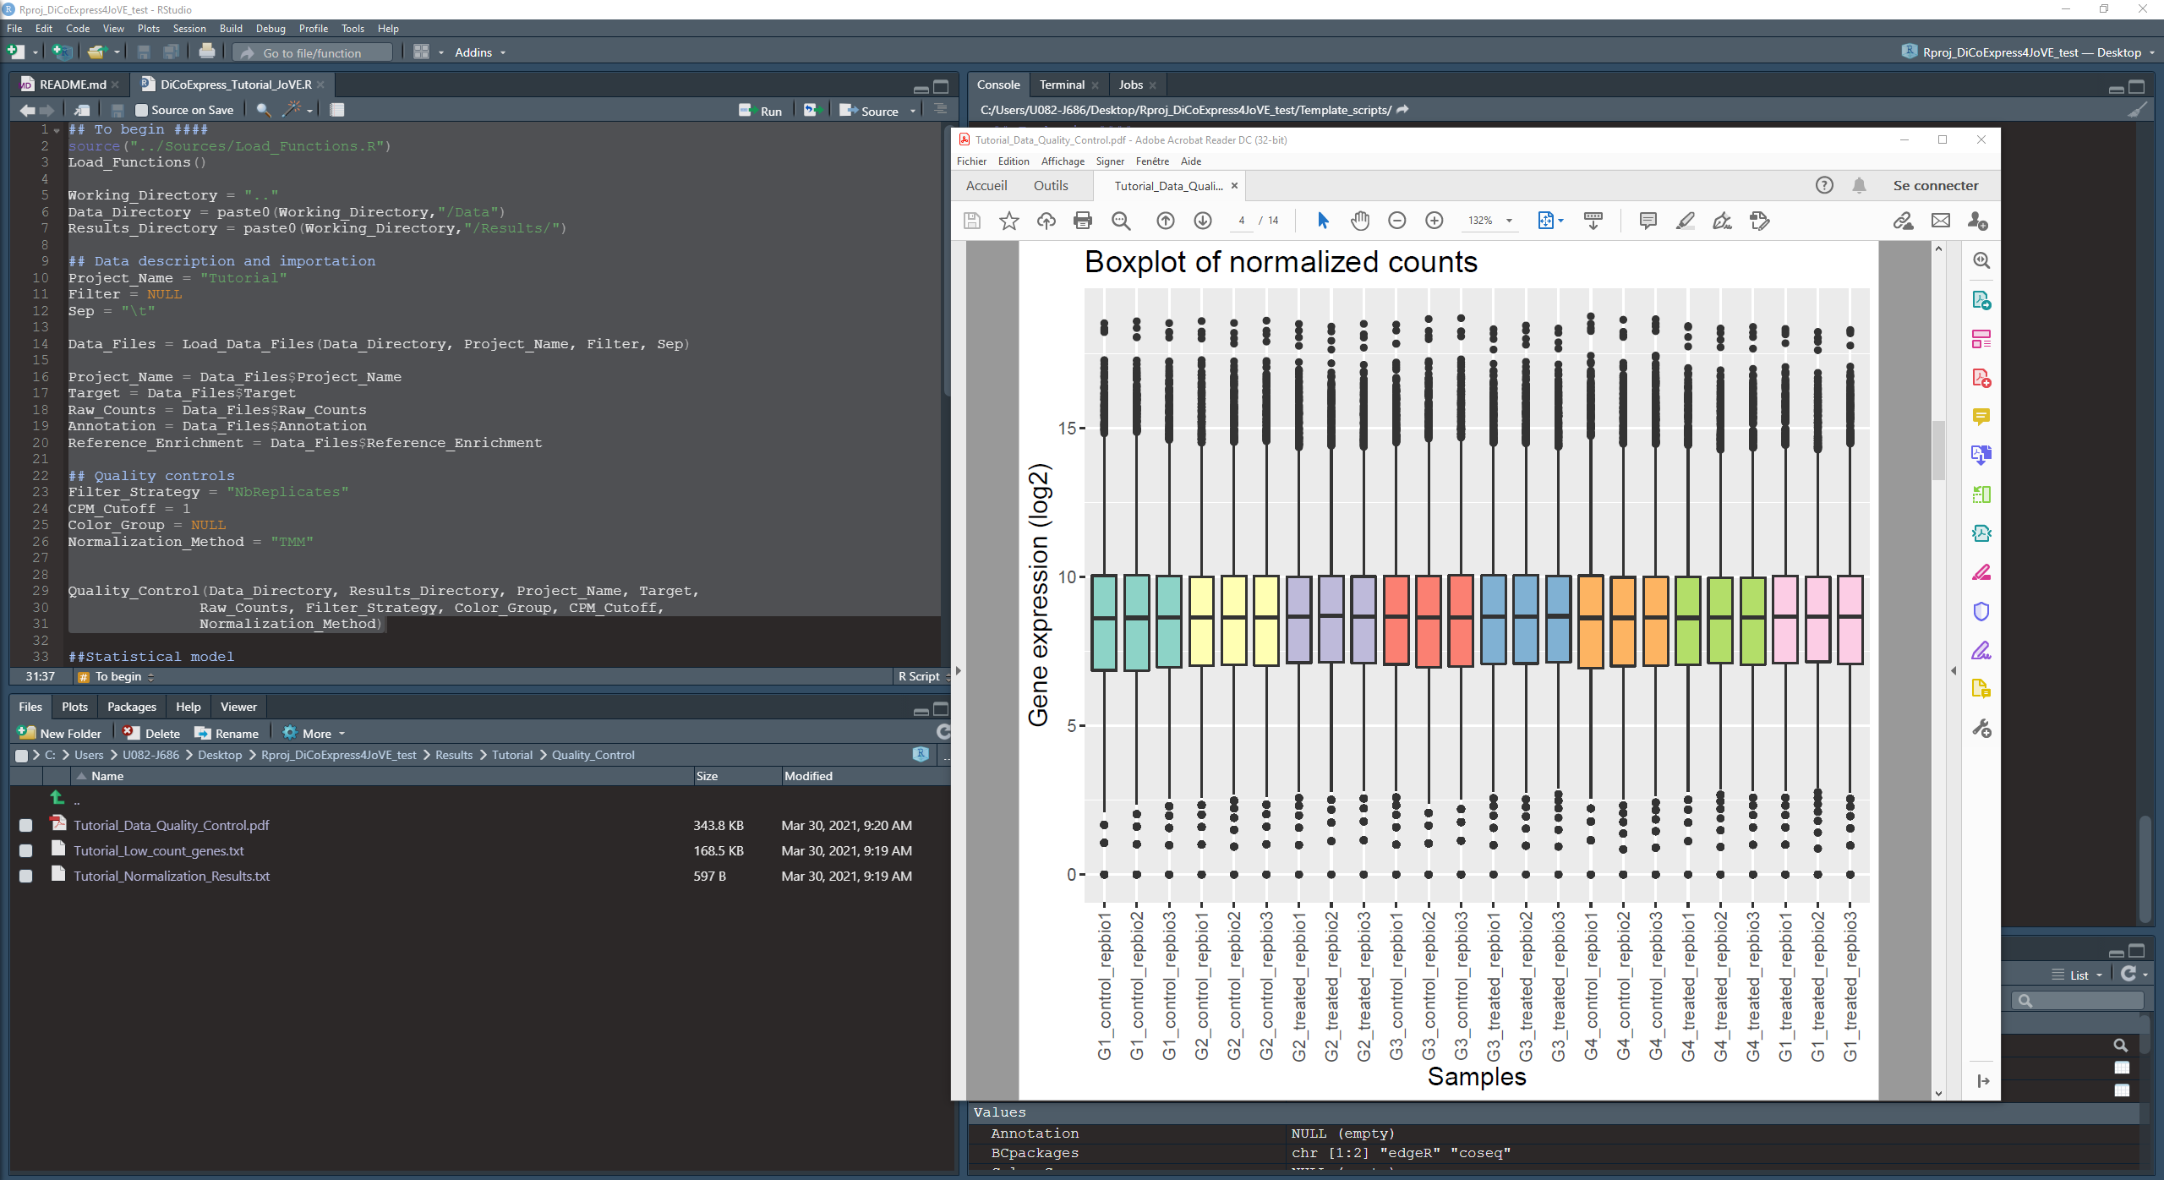

- Data analysis II: Statistical modelling and differential analysis

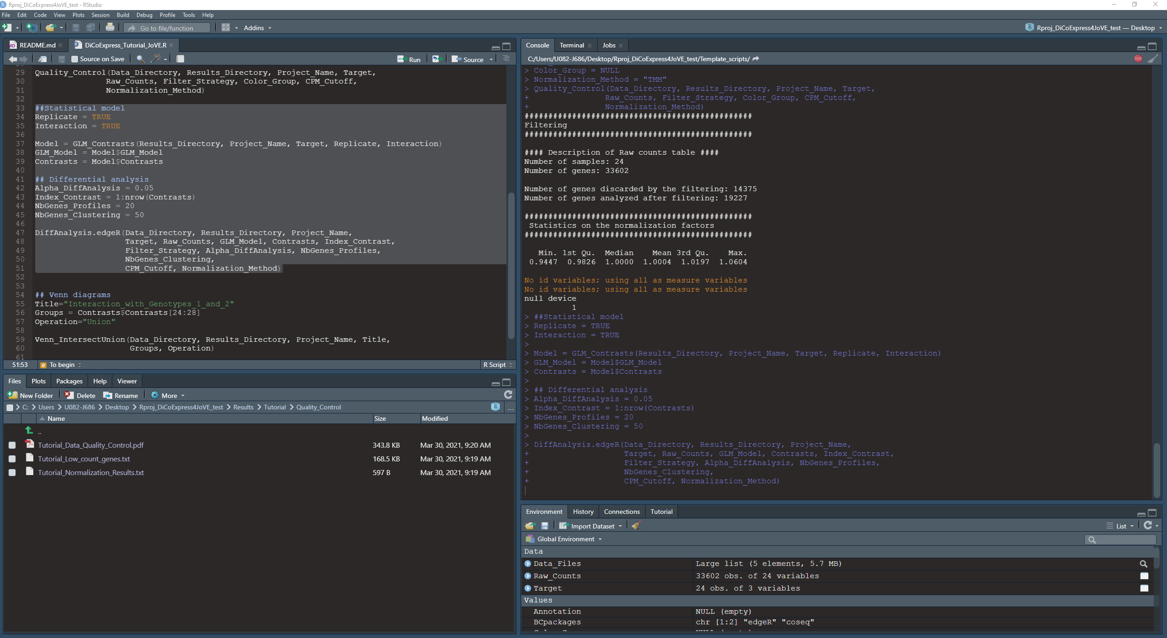

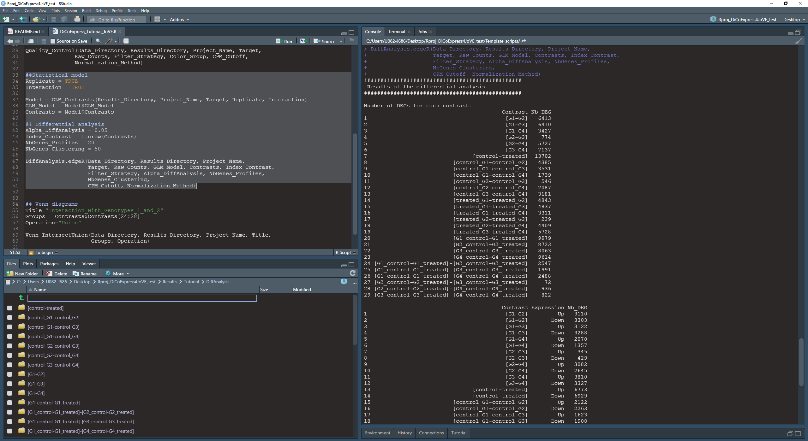

- Results II : show opening it an example of differential results after showing the evaluation of p-values and commenting on it

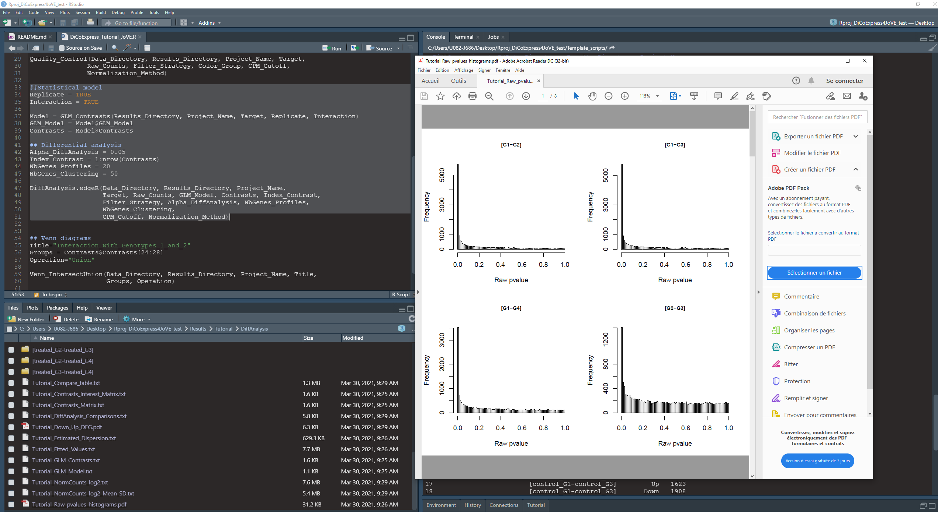

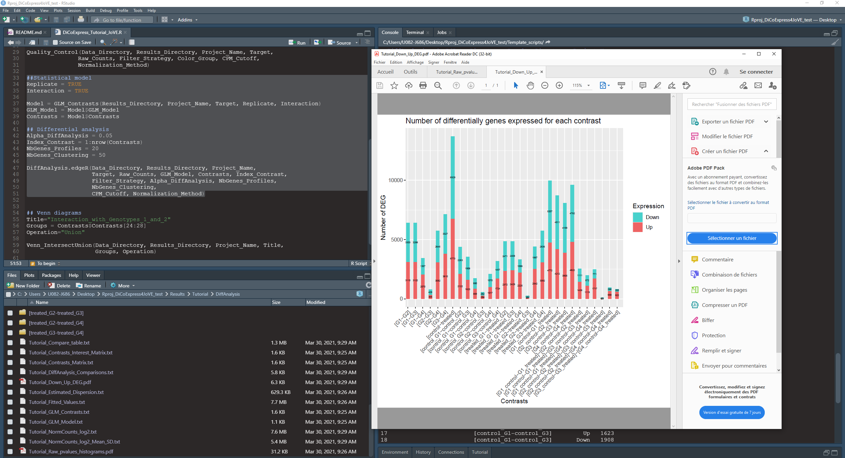

For one contrast we’ll show more of the results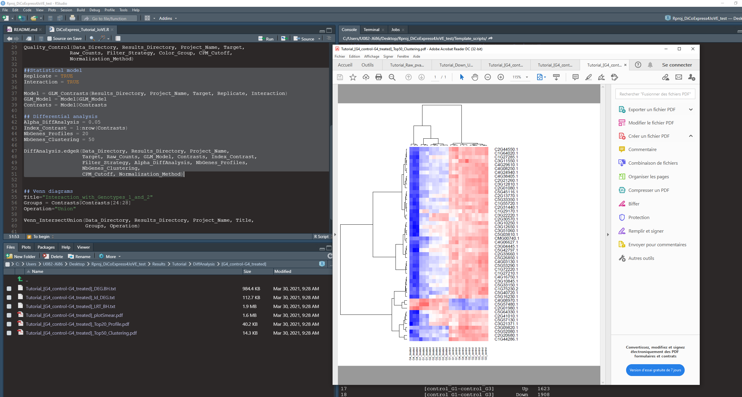

- Data analysis III: Enrichment of DEG lists

- Results III: show and describe an enrichment table

- Data analysis IV: Compare DEG lists

- Data analysis V: co-expression

- Results V: show co-seq output with comments on data quality check and the co-expression clusters

- Data analysis VI: enrichment of the coexpressed clusters

- Results VI: show an described the results

- Data analysis VII: generation of log files

CONCLUSION

