Supplementary information S1: Encapsulation efficiency methodological details

Table S1A. Ribosomal RNA standard.
Final mRNA (µg/mL) | Ribosomal RNA standard | TE buffer 1X | Solution
0.2 | 2 µL stock | 998 µL | A
0.15 | 187.5 µL solutionA | 62.5 µL | B
0.1 | 250 µL solutionA | 250 µL | C
0.05 | 250 µL solutionC | 250 µL | D
0.025 | 250 µL solutionD | 250 µL | E

Table S1B. RNA:pBAE with heparin standard
Final mRNA (µg/mL) | RNA:PBAE stock (6 µg/mL) | Heparin (100 µg/µL) | TE buffer 1X
0.2 | 8 µL | 45 µL | 197 µL
0.15 | 6 µL | 33.75 µL | 210.25 µL
0.1 | 4 µL | 22.5 µL | 223.5 µL
0.05 | 20.75 µL * | 11.25 µL | 218 µL
0.025 | 10.5 µL* | 5.62 µL | 233.8 µL

Table S1C. Heparin standard
Final heparin (µg/µL) | Heparin (100 µg/µL) | TE buffer 1X
18 | 45 µL | 205 µL
13.5 | 33.75 µL | 216.25 µL
9 | 22.5 µL | 227.5 µL
4.5 | 11.25 µL | 238.75 µL
2.25 | 5.62 µL | 244.38 µL

Supplementary information S2: Polymers characterization
Figure S2A shows the NMR proton spectra of the C6-pBAE. Chloroform-d was used as solvent (δ=7.25 ppm). Peaks between 5.7 ppm and 7.4 ppm correspond to the olefins’ signals associated to terminal acrylates of C6-pBAE. Once the peptides are added to the C6-pBAE, the resulting OM-pBAE is also characterized using ¹H-NMR. Figure S2B shows the NMR proton spectra of an example C6-peptide using Cys-His-His-His. D₂O was used as solvent (δ =4.64 ppm). The disappearance of the olefins’ signals associated to terminal acrylates (between 5 and 7 ppm) indicate the reaction of the CH3 oligopeptides since it is done by the acrylates of the polymer. Furthermore, the presence of peaks between 7 and 8.5 ppm indicates the presence of the histidine oligopeptide (-N(=CH)-NH-C(=CH)-).

C6-pBAE
¹H-NMR (400 MHz, CD3OD, TMS) (ppm): δ = 6.40 (d, CH₂=CH-), 6.10 (d, CH₂=CH-), 5.83 (d, CH₂=CH-), 4.18 (br, CH₂-O-C(=O)-CH-CH₂), 4.09 (t, -CH₂-CH₂-O-), 3.62 (t, CH₂-CH₂-OH), 2.78 (br, -CH₂-CH₂-N-), 2.45 (br, -N-CH₂-CH₂-C(=O)-O), 1.83–1.60 (br, -O-CH₂-CH₂-CH₂-CH₂-O), 1.40-1.18 (br, -CH₂-CH₂-CH₂-CH₂-OH, N-(CH₂)₂-CH₂-(CH₂)₂-OH), 0.88 (t, CH₂-CH₂-CH₃).

CH3-C6
¹H-NMR (400 MHz, D2O, TMS) (ppm): δ = 8.0-7.0 (br -N(=CH)-NH-C(=CH)-) 4.61-4.36 (br, -CH₂-CH-), 4.16 (t, CH₂-CH₂-O-), 3.55 (t, CH₂-CH₂-OH), 3.18 (t, CH₂-CH₂-N-), 3.06 (dd, -CH₂- CH-), 2.88 (br, OH-(CH₂)₄-CH₂-N-), 2.82 (dd, -CH₂-S-CH₂-), 2.72 (br, -N-CH₂-CH₂-C(=O)-O), 1.75 (br, -O-CH₂-CH₂-CH₂-CH₂-O), 1.65 (m, NH₂-CH₂-CH₂-(CH₂)₂ -CH-), 1.58 (br, -CH₂-CH₂-CH₂-CH₂-OH), 1.40 (br, -N-(CH₂)₂-CH₂-(CH₂)₂-OH), 0.88 (t, CH₂-CH₂-CH₃).

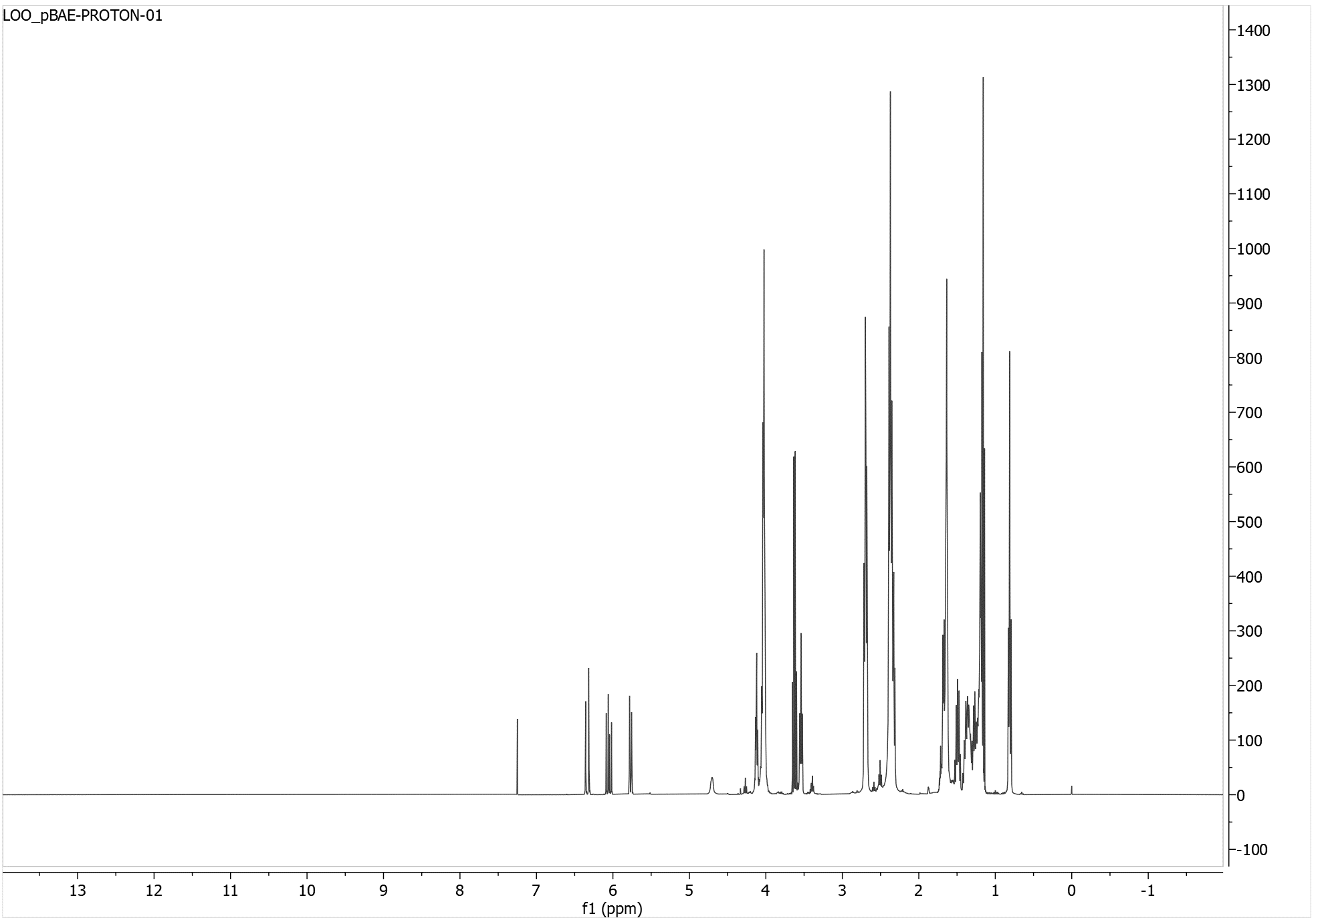
A

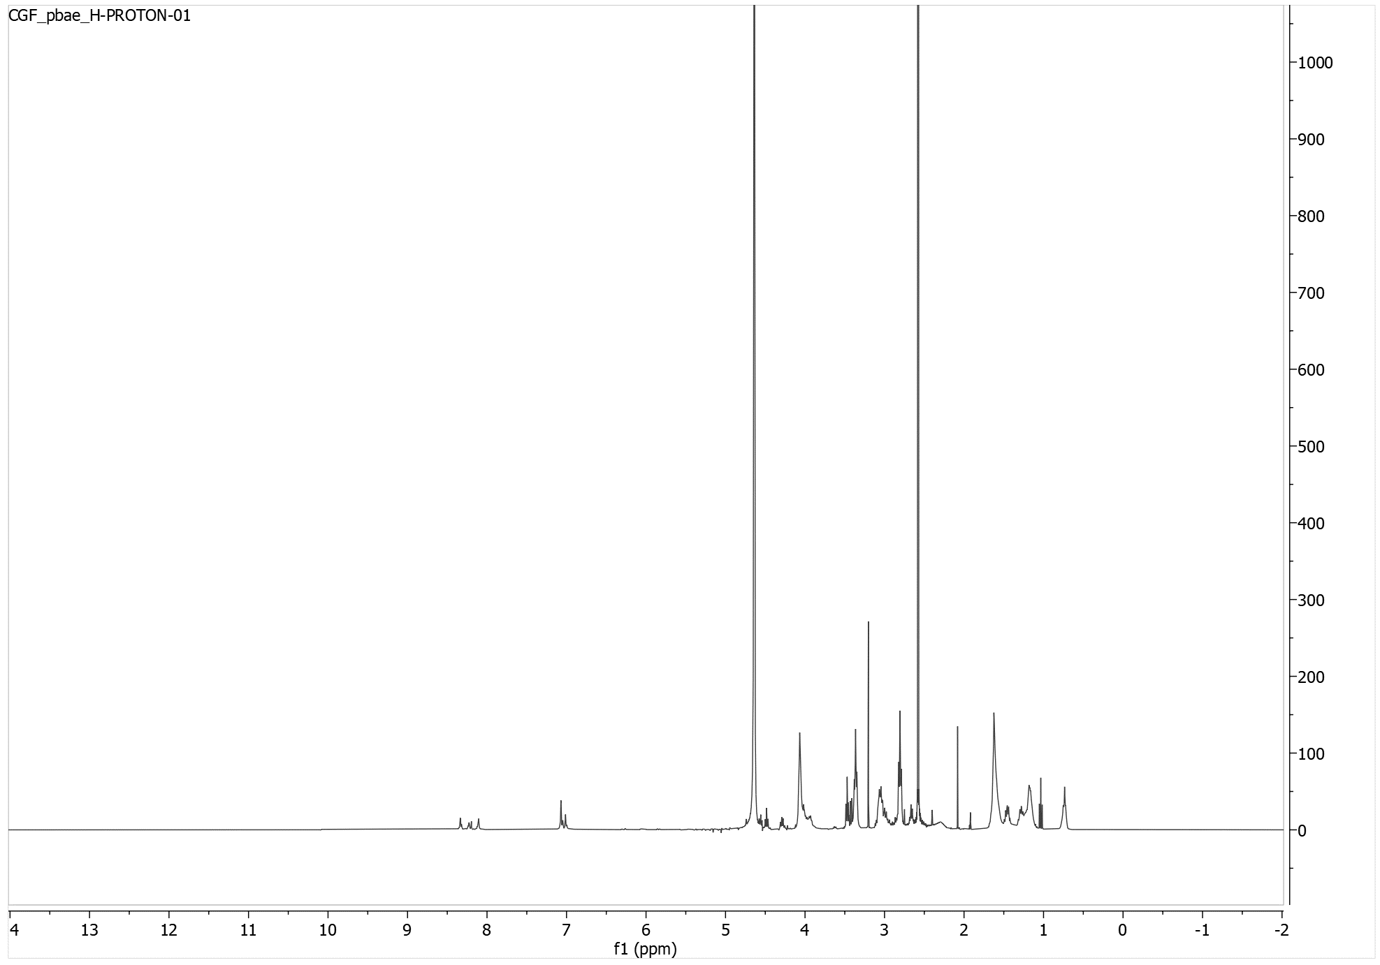
B

Figure S2 ¹H-NMR proton spectra of C6-pBAE and OM-pBAE. A. ¹H-NMR from the C6-pBAE. B. 1H-NMR from the C6CH3.

