Coverslip cleaning for live cell FCS experiments

Goal
Cleaning of glass coverslips to minimize background signal

Comments
- Cleaning procedure must be performed under the hood
- Use safety gloves when handling chloroform
- Reuse chloroform and NaOH solution
- Prepare 5 M NaOH solution on ice
- Materials: ultrasonic bath, 2 glass containers, metal rack, small beaker, funnel, 25 ml glass pipet, glass petri dish
- Discard used chemicals according to the local regulations.

Cleaning Protocol
- Arrange single coverslips in metal rack
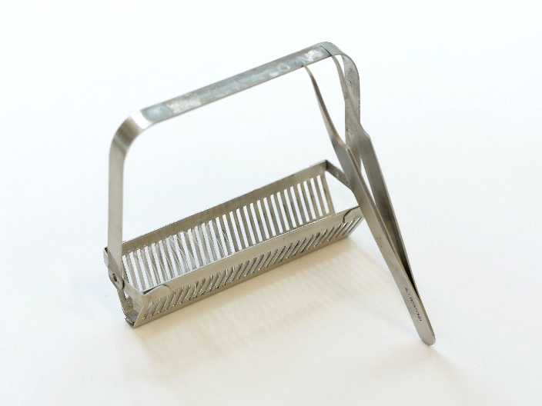 | 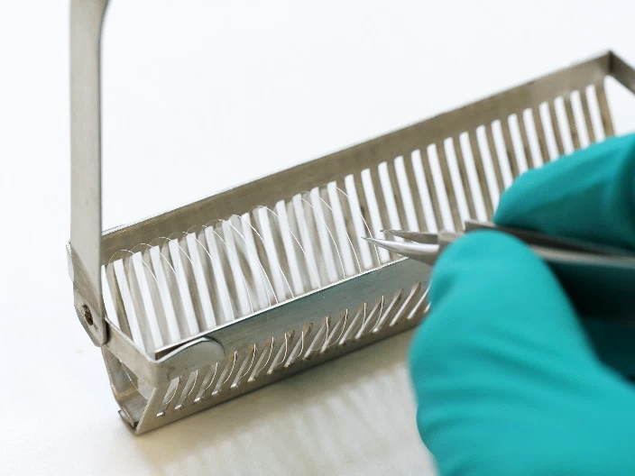
- Place glass container in ultrasonic bath, fill bath with deionized water
- Hang the rack into the glass container and fix with the loops
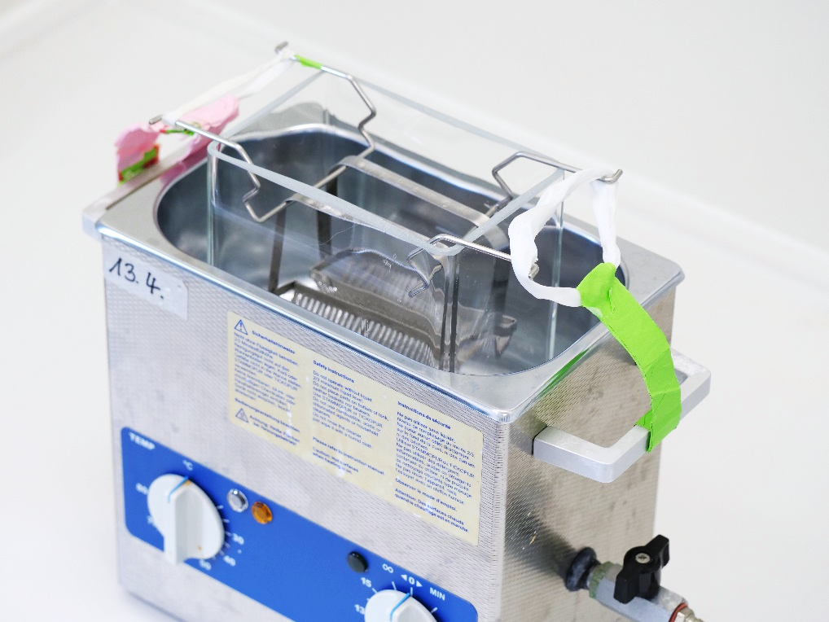
- Fill the glass container with chloroform and sonicate for 1 hour
- Place the rack in an empty glass container and let it dry
- Put on safety gloves!
- Pour the chloroform back into the bottle via a funnel by first scooping it with a beaker, then pipette the rest with a 25 ml glass pipette. Do NOT pour it directly out of the glass container! It will spill badly!
- Reinstall the rack in the glass container in the ultrasonic bath.
- Fill the glass container with 5 M NaOH solution and sonicate for 1 hour
- Wash three times in ddH₂O in a second glass container
- Dry glass coverslips
- Store in 100 % ethanol in a glass petri dish
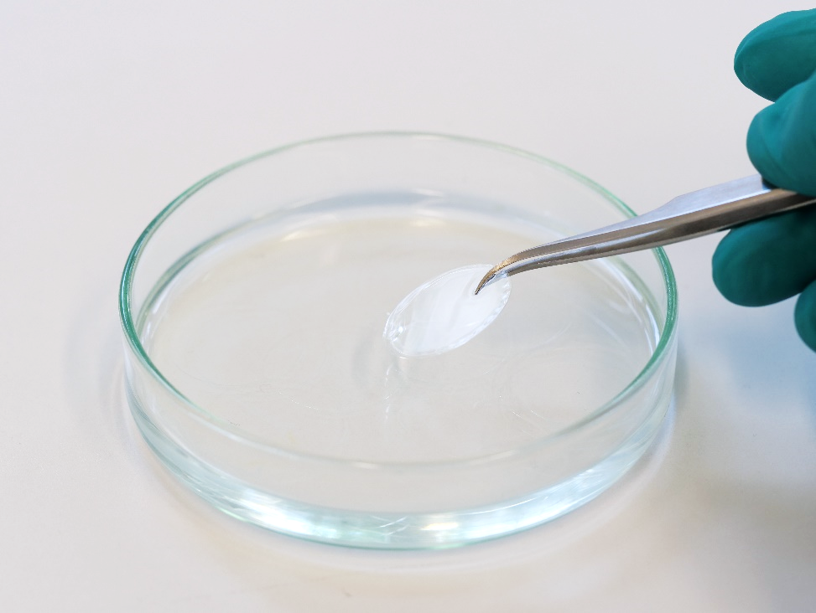
- Pour the NaOH back into the bottle as described before. Clean pipette by pipetting some ddH₂O.

