Supplementary Material
Reagents | Final concentration | Reaction
Asymmetric PCR (50 μL)
AccuPrime PCR buffer II 10x | 1x | 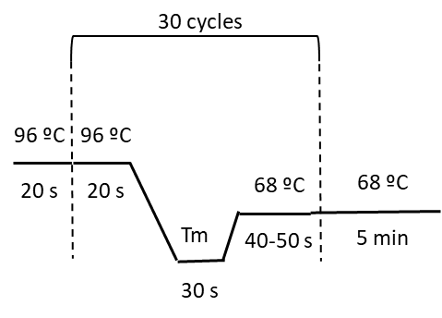
Primer A or D | 600 μM
Primer B or C | 60 μM
AccuPrime Taq 2 U/μL | 0.01 U/μL
Chromosomal DNA | 100 ng
ddH₂O | X μL
Pre-AD PCR (48 μL)
AccuPrime PCR buffer II 10x | 1x | 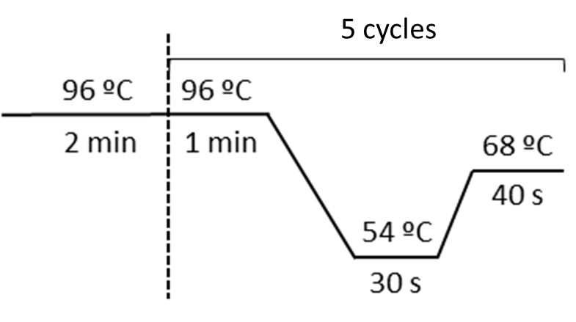
AB amplicon | 100 ng
BC amplicon | 100 ng
AccuPrime Taq 2 U/μL | 0.01 U/μL
ddH₂O | X μL
AD PCR (50 μL)
Pre-AD PCR | 48 μL | 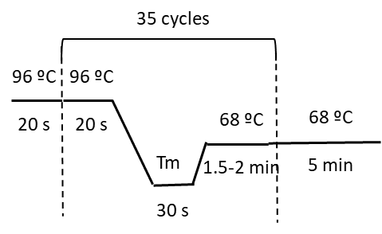
Primer A | 100 μM
Primer D | 100 μM
EF PCR (50 μL)
Biotaq PCR buffer 10x | 1x | 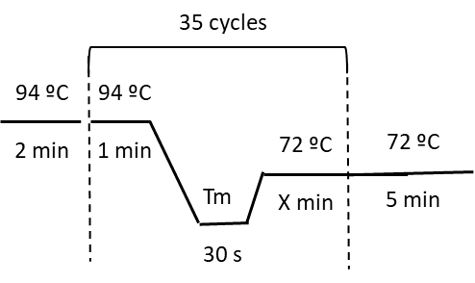
MgCl₂ 50 mM | 2 mM
dNTPs 10 mM | 0.2 mM
Primer E | 0.5 μM
Primer F | 0.5 μM
Biotaq 5 U/μL | 0.025 U/μL
Lysed colonies | 1 μL
ddH₂O | X μL
pDM4 PCR (50 μL)
Biotaq PCR buffer 10x | 1x | 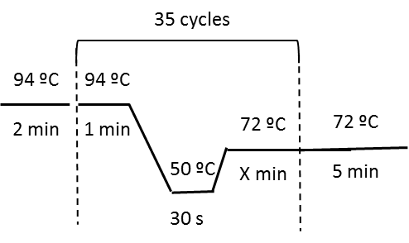
MgCl₂ 50 mM | 2 mM
dNTPs 10 mM | 0.2 mM
Primer pDM4for | 0.5 μM
Primer pDM4rev | 0.5 μM
DMSO | 10%
Biotaq 5 U/μL | 0.025 U/μL
Lysed colonies | 1 μL
ddH₂O | X μL

