Table 1. Characteristics of the Patients at Baseline and after VARD
Characteristic | Patient 1 | Patient 2 | Patient 3
Age(yrs) | 41 | 40 | 70
Gender | Male | Male | Male
Cause of pancreatitis | Alcohol abuse | Alcohol abuse | Gallstones
Disease severity
Admitted to ICU | Yes | Yes | Yes
SIRS | Yes | Yes | Yes
Organ failure | ARDS | ARDS; renal failure | ARDS; renal failure
Encapsulation of necrosis | Partial encapsulated | Partial encapsulated | Complete encapsulated
Distribution of necrosis | Pancreatic head and tail | Pancreatic body and tail | Pancreatic head and tail
No. of catheter drainage | 5 | 3 | 4
No. of necrosectomy | 2 | 2 | 1
Mean length of necrosectomy(h) | 4 | 3 | 2
Mean blood loss(mL) | 100 | 50 | 50
Mean length of stay in ICU(days) | 3 | 14 | 7
Mean length of stay in hospital(days) | 58 | 83 | 60
CT image before necrosectomy | 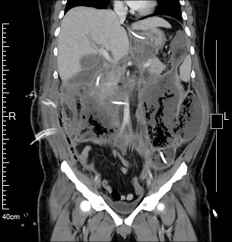 | 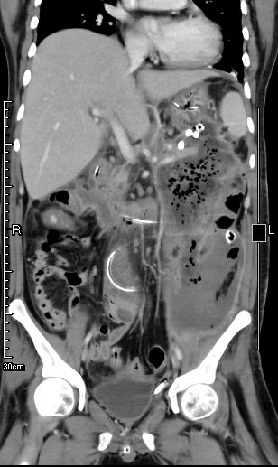 | 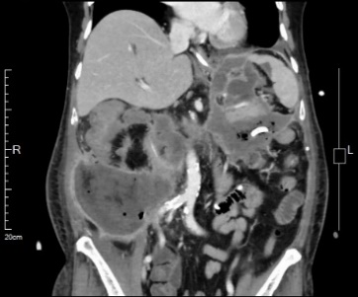
CT image after necrosectomy | 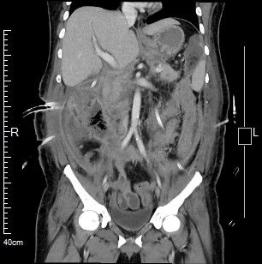 | 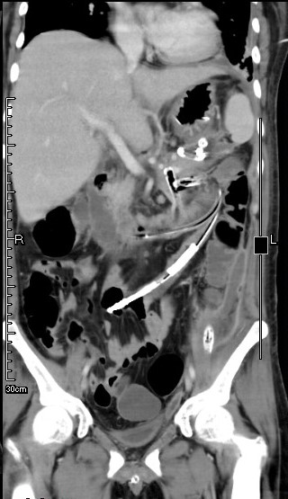 | 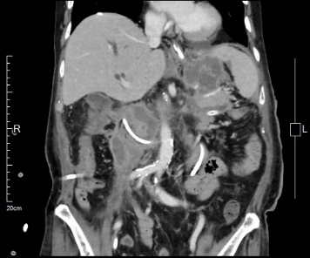
Operation images during ICG-guided VARD | 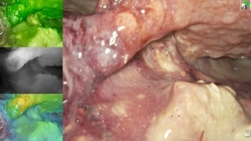 | 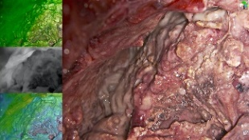 | 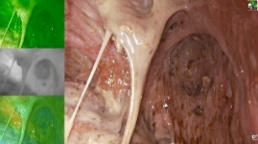
Abbreviation: ICU: intensive care unit; SIRS: Systemic inflammatory response; ARDS: acute respiratory distress syndrome;

