**NERVE BATH TECHNICAL DRAWING**

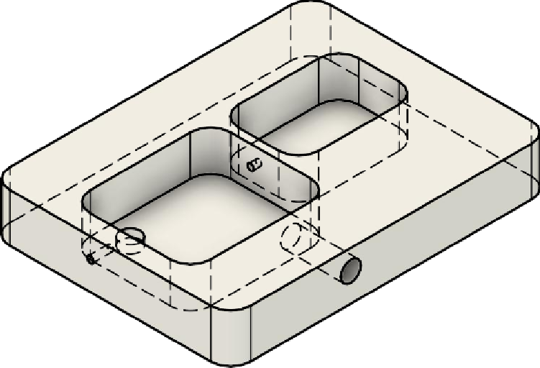

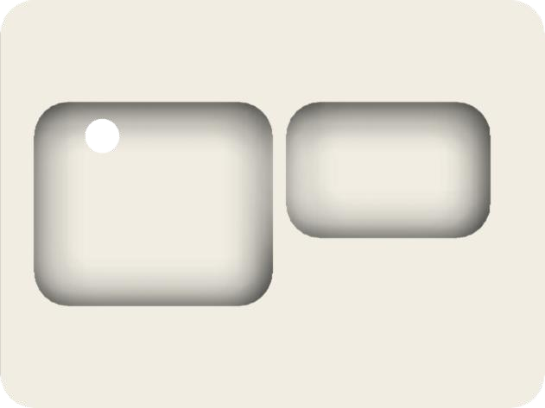

30

25

15

5

35

30

8

2

80

Sheet size

A4

Date

27/07/2018

1:1

Scale

Robert Toth

Created by

Rev.

v1.0

Nerve Oil Bath

Project

20

7

10

15

20

30

60

15

7

Ø5

Ø5

Ø1.5