Magnetic Force Microscopy (MFM) SOP
  - Paul Davis, Lance Patten, Corey Efaw, and Olivia Maryon

Introduction to Magnetic Force Microscopy
This standard operating procedure (SOP) has been developed to help users carry out MFM on Bruker dimension series AFMs, with an emphasis on the dimension icon platform. MFM is a dual pass lift mode technique that simultaneously captures topography (first pass, height channel) and magnetic response in the phase channel of the second, interleaved lift mode pass of each line. MFM phase images/values should be viewed as qualitative rather than quantitative, as the amount of phase shift observed (in degrees) depends on both the magnetic moment (magnitude and orientation) of the sample and that of the probe, as well as imaging parameters such as lift height and oscillation amplitude. Thus, direct comparisons of magnetic moment strength are only possible when using the same MFM probe with the same imaging parameters.

PROTOCOL

Startup

  - Turn on the AFM controller. The AFM is typically on. If this is the case, then proceed to Step 2.

WARNING: Do not power cycle the computer with the AFM on, as this could cause severe damage to the piezos!

NOTE: Allow the laser to warm up for ~30 min prior to imaging if very precise measurements are required for the experiment.

  - Log in on the spreadsheet sign in sheet located on the upper right of the AFM computer desktop. Open the AFM control software by double clicking the icon.

  - Select the appropriate experiment category, experiment group, and experiment, then click Load Experiment (Figure 1). For MFM, perform the corresponding selection sequence as Electrical & Magnetic > Lift Mode > MFM/EFM.

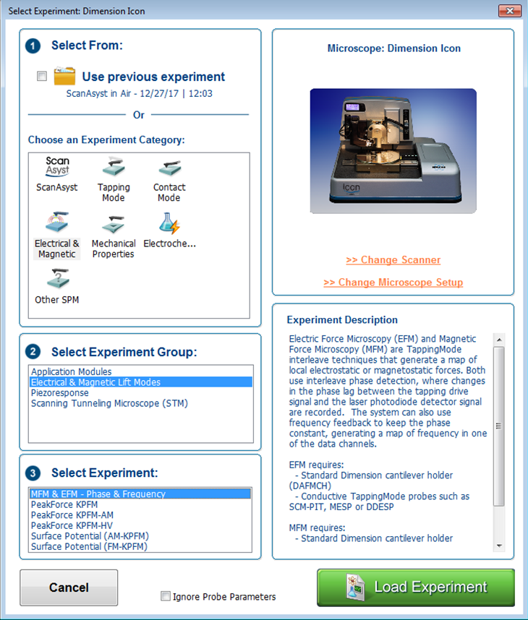
Figure 1. Select Experiment and Microscope Setup page.

Probe magnetization and mounting

  - Mount an MFM probe (e.g., MESP, MESP-RC, etc.) on the dimension series probe holder (model DAFMCH or DCHNM) by fitting the probe holder on the mounting block (Figure 2).
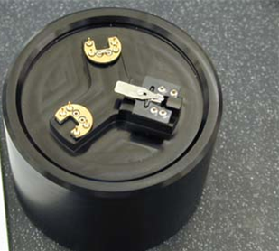
Probe Holder Clip
Probe Holder

Probe Holder Mounting Block
Figure 2. Probe holder mounting block with three probe mounting stations.
  - Install a probe on the probe holder and secure it with the spring-loaded probe holder clip (Figure 3). Ensure the probe is parallel to all edges and not touching the back of the holder’s channel by inspecting it under the optical microscope. Gently manipulate the probe as necessary with a pair of tweezers.

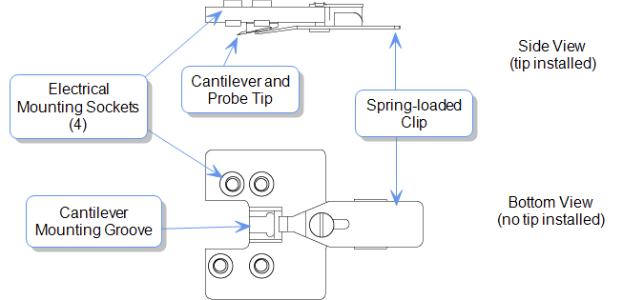
Figure 3. Schematic of the standard probe holder for the Dimension series AFM heads.

  - Prior to installing the probe holder on the AFM head, ensure the probe has been magnetized.

    - Remove the magnetizing magnet (Figure 4) from its case and carefully lower the magnet over the probe and probe holder until the magnet rests securely over the probe holder.

    - Leave the magnet in position for a few seconds (~2-5 s); the probe is now magnetized. Carefully lift the magnet from the probe holder, ensuring the probe cantilever is not damaged. Place the magnet back into its case.

`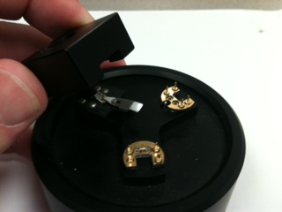 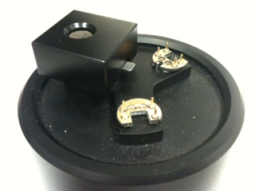
Figure 4. Magnetizing an MFM probe.
  - Mount the probe and probe holder on the AFM head.

    - Unlock the AFM head by turning the set screw (Figure 5) counterclockwise (icon head) or clockwise (D3100 head).

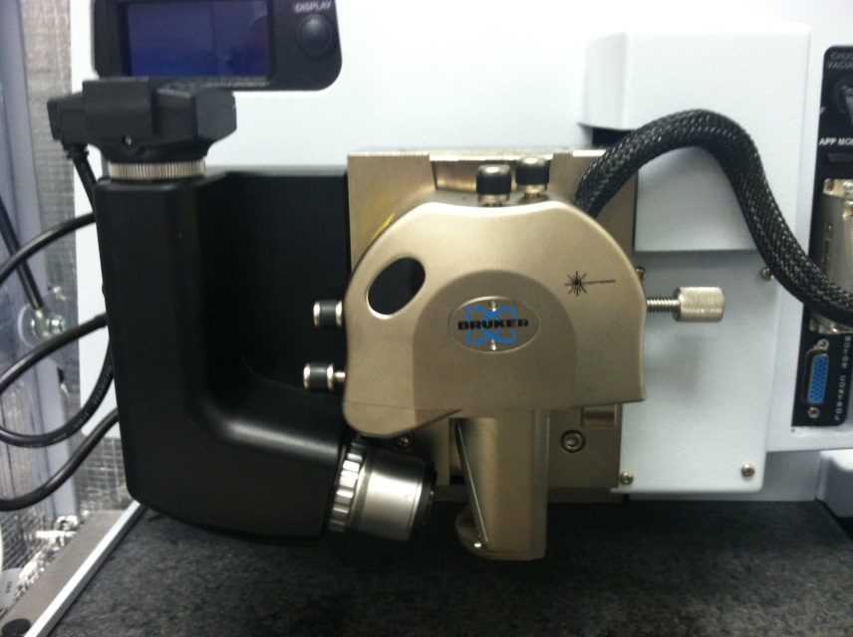
Laser Alignment Screws

Icon Set Screw

Detector Alignment Screws

Figure 5. Icon AFM head showing the location of the different screws.

    - Carefully remove the AFM head by sliding it up the dovetail holder. Install the probe and probe holder by aligning the holes on the probe holder with the contact pins on the AFM head (Figure 6).

WARNING: Handle the AFM head with extreme care! Any impact to the head may cause severe damage to the piezo tube, which is very expensive to repair/replace.

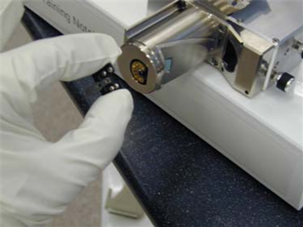
Piezo Tube

Contact Pins

Probe Holder

Figure 6. Installation of the probe holder on the AFM head.

  - Align the laser on the cantilever.

    - Press the display button above the icon head and optics to show the laser SUM and vertical and horizontal deflections (Figure 7).

    - While holding the AFM head, aim the laser onto a sheet of paper to view the beam.

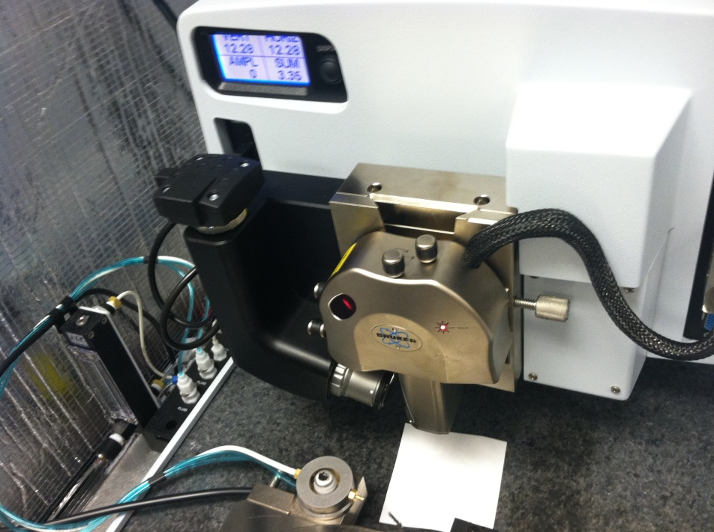
SUM and deflections
Icon head
Figure 7. Alignment of the laser onto the AFM probe cantilever.

    - Use the laser alignment screws (Figure 5) to adjust the laser until the cantilever is detected (red beam will appear split on the paper) and the SUM is maximized (Figure 8).

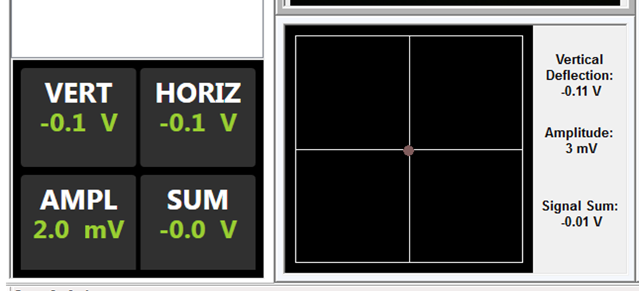
Red Dot
SUM
Figure 8. Position sensitive photodiode display showing sum and vertical/horizontal displacement (left) and beam location (right).

  - Gently reinstall the AFM head on the dovetail rail and turn the set screw to secure the head (Figure 5).

  - Adjust the red dot (Figure 8) using the detector alignment screws (Figure 5) until the vertical and horizontal deflections are approximately zero (± 0.05 V). Readjust the laser alignment screws to re-maximize the SUM if the SUM drops off. Continue iterating until the SUM is maximized and the deflections are approximately zero.

Tuning the Probe

  - Under setup on the workflow chart, bring the probe into focus using the focus controls. It is best to zoom in on the probe before attempting to bring the edges of the cantilever into sharp focus.

  - Tune the probe to select the main (topography) line tapping frequency and amplitude.

    - Select the Tune icon.

    - Set the Start Frequency (Figure 9) to the low end of the recommended frequency range for the selected probe (located on the probe box). Set the End Frequency to the high end of the recommended frequency range for the selected probe (located on the probe box).

    - Set the Target Amplitude to 500 mV (this corresponds to ~50 nm oscillation of the probe). Set the Peak Offset to 5.00%.

    - Ensure that Main (as opposed to Interleave) is selected in the mode section.

    - Click the Auto Tune icon at the bottom of the screen. The tip will now be automatically tuned. The resulting tuning curve should ideally consist of a single, relatively sharp Gaussian peak.
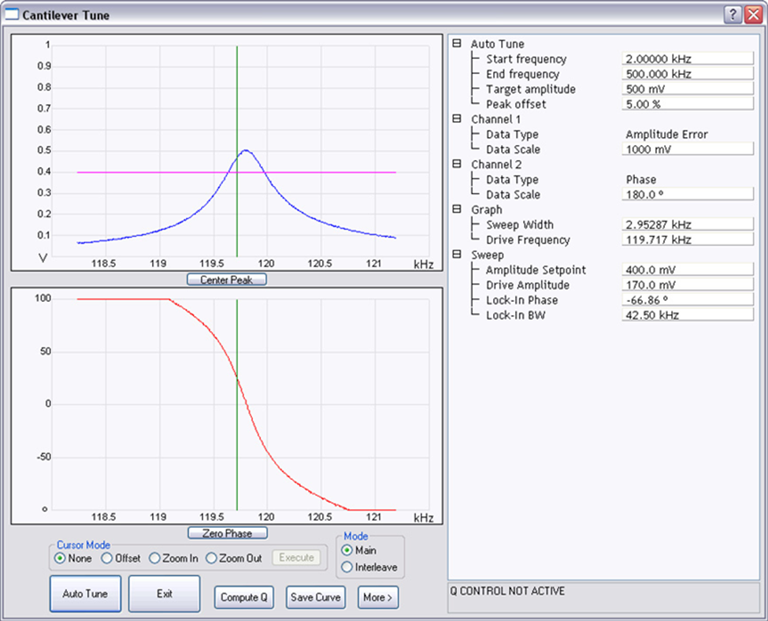
Figure 9. Cantilever tune screen with important parameter selections circled in red.

  - Tune the probe to select the Interleave (MFM) line tapping frequency and amplitude.

    - Once the main line auto tune is complete, select Interleave in the Mode section. Set the Target Amplitude to < 500 mV. 75 mV is a good starting point. Larger amplitudes will yield higher MFM sensitivity but are also more likely to result in the probe striking the surface and causing topographical artifacts or spikes in the MFM phase channel.

    - Set the Peak Offset to 0.00%. Click Auto Tune. The Interleave tune determines the drive amplitude and frequency employed while in lift mode. Click Exit once the second Auto Tune is complete.

Engaging the Surface

  - Under Navigate, to bring the probe near the surface, bring either the surface or tip reflection into focus by moving the scan head down (Figure 10). In surface focus mode, move the scan head down until the surface is in focus (cantilever will be ~1 mm from the surface). In Tip Reflection mode (safer), move the scan head down until first the surface is in focus (cantilever ~2 mm away from surface) and then continue until the probe is in focus (in tip reflection mode, the tip should come into focus when it is ~1 mm from the surface, i.e., move the head ~1 mm further down after the surface has come into focus).

NOTE: Use tip reflection when the surface of the sample is very reflective or does not have any defects to focus on.

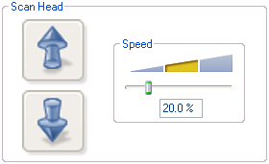
Figure 10. Z scanner head movement.
WARNING: Use caution when focusing on the surface using the Z motor. Always move the probe away from the surface initially and check the speed. Set speed to a low speed initially to reduce the risk of damage to the head, probe, and/or sample.

    - Use the stage direction controls (Figure 11) to move the sample around until the desired area is under the crosshairs in the video camera feed (optical image).
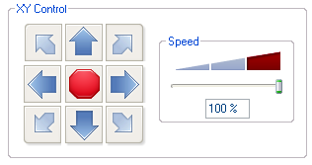
Figure 11. Stage direction controls and stage direction speed.

  - Set the initial scan parameters as follows: Scan size = 0, X offset = 0, Y offset = 0, Scan rate = 2 Hz, Integral gain = 0.5, Proportional gain = 1.0, Samples/Line = 512, Engage Setpoint = 1.0-1.10 (located under Engage Settings).
  - Engage the sample surface.
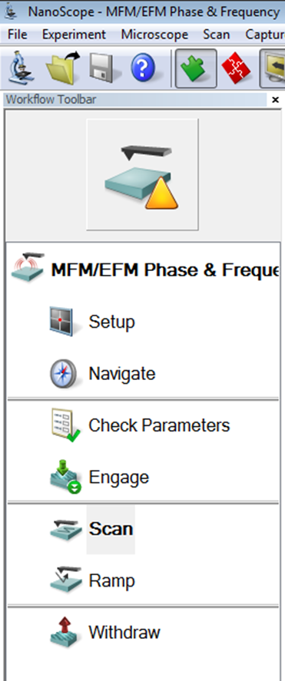

  - After the probe has engaged the surface, re-tune the cantilever in the Main mode. Use a minimum tip offset of 200 nm. Ensure the target amplitude is set at 500 mV and the peak offset is set to 5.00%. Interleave re-tuning at the surface is not required.

Imaging

  - Increase the scan size and begin imaging the sample surface.

    - To begin MFM imaging, in the settings under the Interleave tab, click the Interleave mode and select Lift. A good starting value for the lift height is the height of the sample’s tallest high aspect ratio topographical feature, or ~25-50 nm, whichever is higher.

  - Select Channel 1 for the first image screen; this will show topography (Height channel) data. Channel 2 will display the main line Amplitude Error signal. Channels 3 and 4 will correspond to the interleave/lift mode channels, i.e., the sample’s magnetic properties (Figure 12).

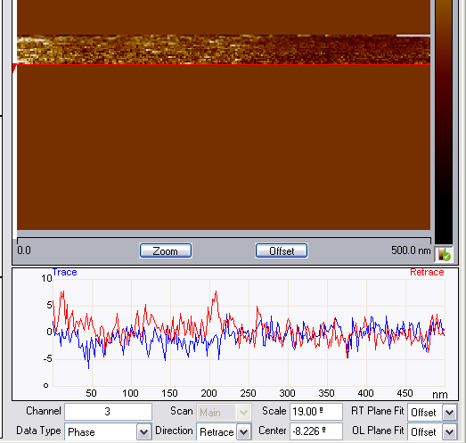
Figure 12. Interleave/lift mode magnetic phase image with Channel number and Scale indicated.
  - To maximize the phase image quality (i.e., magnetic response sensitivity), increase the interleave drive amplitude and/or decrease the lift height. Typical values for the interleave drive amplitude are ~50%-80% of the main drive amplitude, while lift heights as low as 10 nm can be realized for smooth samples in a low humidity environment (e.g., glovebox).

NOTE: While increasing the interleave drive amplitude will improve the MFM sensitivity, allowing detection of small differences in magnetic moment strength or orientation, increasing it too much will eventually cause the probe to tap the surface during interleave/lift mode (which will be evident based on the appearance of abrupt jumps in the phase signal). In this case, you will either need to decrease the interleave drive amplitude or increase the lift height (which will decrease the lateral spatial resolution of the MFM phase channel) so that the probe no longer hits the surface during the interleave/lift mode pass.
A phase near 0⁰ suggests the magnetic response lies in the plane of the sample. Phase values near the maximum (positive phase) will appear lighter and indicate a repulsive tip-sample interaction. Phase values near the minimum (negative phase) will appear darker and are indicative of an attractive tip-sample interaction. Figure 13 shows a schematic of each of these possible cases.
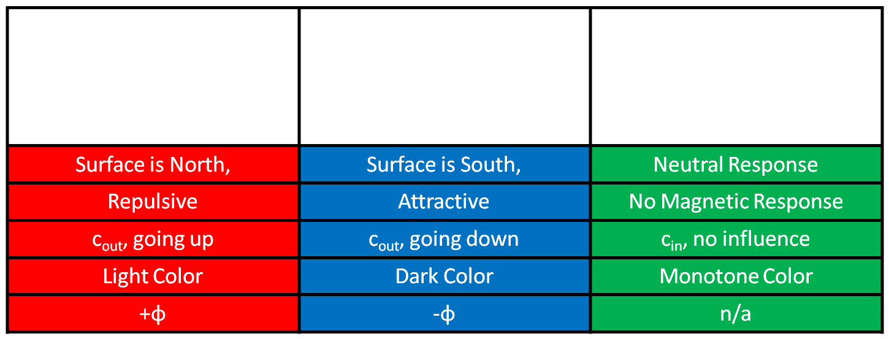
S
N
S
N
N
S
S
N
Figure 13. Different possible orientations of the magnetic response and corresponding probe responses.

  - For capturing images, select the proper folder in which to save the image. Give the image a name – include the date and type of sample. Under the capture drop down bar there are different options for capturing an image as described below.

    - Capture: Saves the next complete, uninterrupted (i.e., no changes in parameters) frame to the labeled file.

    - Capture Now: Immediately saves the current image before completing the frame.

    - Capture Last: Saves the last complete frame prior to the current one.

5.4.4 Capture Continuous: Continuously saves frame after frame until the probe is withdrawn or capture is aborted.

    - Capture Withdraw: Captures the next complete, uninterrupted frame and then withdraws the probe from the surface.

    - Abort Capture: Cancels the current capture status.
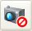

Shutdown

  - AFM shutdown.

    - Once imaging is complete and images are captured and saved, select Withdraw on the workflow column.

    - Move the probe away from the sample by going to Setup on the workflow column and pressing the Change Probe icon. Under this, select Move to Sample Loading position. If necessary, move the stage away from the probe.

    - Open the AFM chamber. Slowly rotate the sample chuck to allow access to the sample.

    - Turn the vacuum off and remove the sample from the stage. Unlock the AFM head by turning the set screw (Figure 5). Carefully remove the head from the dovetail rail. Remove the probe holder.

WARNING: Handle AFM head with extreme care! Any impact to the head may cause severe damage to the piezos, which is very expensive to repair/replace.

  - Place the probe holder on the mounting block and remove the probe. Place the probe back into the box, in the location it was removed from; ensure the probe is turned perpendicular to unused probes (to indicate that it has been used). Detail the condition of the probe on the box label.

  - Close the software. Complete the spreadsheet log in sheet on computer desktop with the number of hours and new probes used.

