Supplementary File 1

- Editing a PDB file: removing remarks. Remove all remarks preceding the protein coordinates.

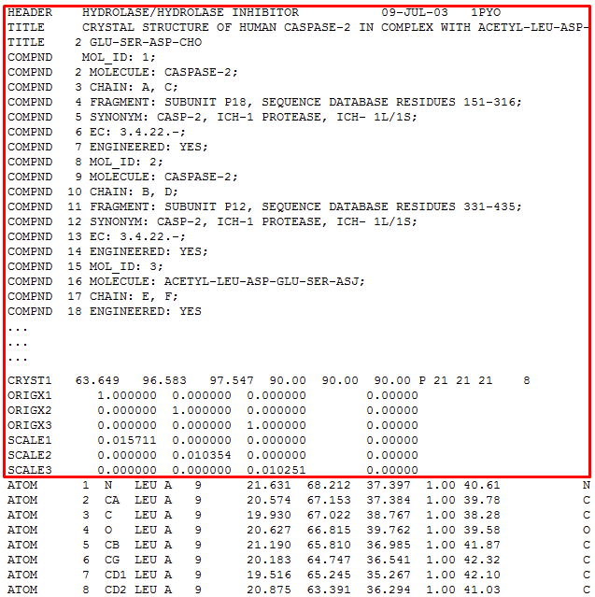

- Editing a PDB file: removing connectivity data. Remove the connectivity data following the coordinates.

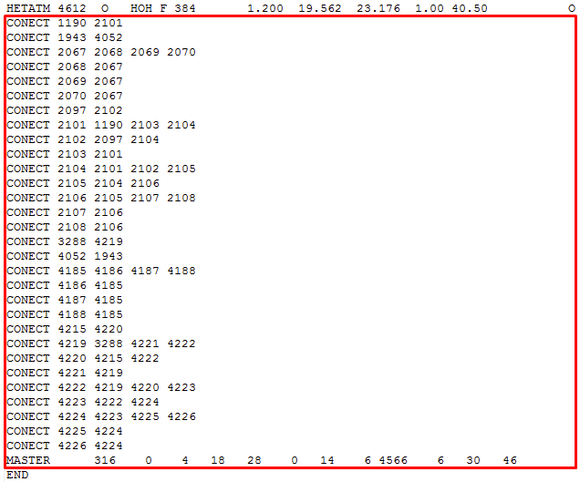

- Editing a PDB file: inserting a TER card. A TER card indicates that a new molecule (protein chain) is to be started. It should also be inserted between the protein and ligand coordinates (if present).

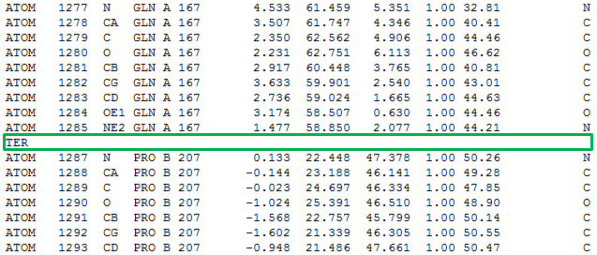

- Editing a PDB file: replacing the residue name HIS with HIE, HID, or HIP.

