Single-molecule diffusion and assembly on polymer-crowded lipid membranes
Satyaghosh Maurya, Vishwesh Haricharan Rai, Aditya Upasani, Saurabh Umrao, Diksha Parwana, Rahul Roy

List of MATLAB code files

  - Details for using the MATLAB files

    - binding_SPT: This MATLAB code finds out the number of particles in each frame as detected in u-track. INPUT: time_frame (integration time of image acquisition) and the analyzed binding movie folders from u-track (see step 2). OUTPUT: time (total time of movie); particle_no (Number of particles per frame). Plot the OUTPUT results and fit it onto a kinetic model to recover the binding rate.

    - ISD_analyzer: This MATLAB code plots the ISDs from trajectories found out in u-track analysis as heat maps, histograms, or violin plots. INPUT: data_all analyzed movie folder by u-track; pixel_size size of each pixel in micrometer. Two sets are included as supplementary data. Any other input is highlighted in the code. OUTPUT: Plots of ISDs as heat maps, histograms, or violin plots.

NOTE: Files such as uipickfiles, cbrewer, boundedline, and al_goodplot must be downloaded from MATLAB file exchange website and added to MATLAB path.

    - MSD_ISD: This MATLAB code plots the MSDs from trajectories calculated from u-track analysis as line plots. INPUT: Same as for ISD_analyzer. (Example data included with the Supplementary Coding File 3. Select all the 6 folders). OUTPUT: Plots of MSDs.

    - drift_correct_images: For correcting drift in photobleaching movies.

NOTE: Tested in MATLAB 2017b, and the inputs are movies in .tif format.

    - Extract_traces_1C: Package for analyzing intensity time trace of assembled structures in photobleaching movie (Sample data is included in the Supplementary Coding File 3). INPUT: movie files in tiff format. OUTPUT: Intensity time trace for each movie

    - Stepcount_immobile: Package for mapping x-y coordinates from u-track to raw movies. The raw movie should be at the same place where the analyzed u-track folder is. INPUT: u-track analyzed folder for photobleaching movies. OUTPUT: Intensity time trace for each movie

NOTE: stepDetection has to be downloaded⁵ and added to the MATLAB path.

    - uTrack_Int: Package for mapping x-y coordinates from u-track to raw movies. The raw movie should be at the same place where the analyzed u-track folder is. INPUT: u-track analyzed folder for photobleaching movies. OUTPUT: Intensity time trace for each movie and steps in the detected clusters in each movie.

    - Step_correction: MATLAB code for binomial correction for inaccurate labeling of biomolecules. INPUT: steps obtained from the MATLAB code Stepcount_immobile. OUTPUT: Binomially corrected mass fractions of different oligomeric species.

NOTE: This code is written for a system where the maximum possible step size is 12. Corrections can be applied to other systems with different assemblies.

Sample Data

    - Two sets of data for DNA mobility on two different membranes as u-track analyzed folders.

    - Photobleaching movie (Video 3) with u-track analyzed folder.

Steps in u-track GUI

NOTE: Tested in MATLAB R2014b.

  - Start the GUI after putting the necessary codes in MATLAB path by calling the function uTrackPackageGUI from the command window. The window below will appear. Click on New.
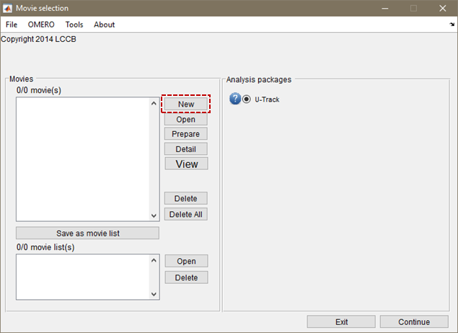

  - Click on Import Movie using Bio-Formats to load the movie. The movie should be in tiff format with the correct metadata. It can be seen or changed in ImageJ by checking the properties of the movie file.

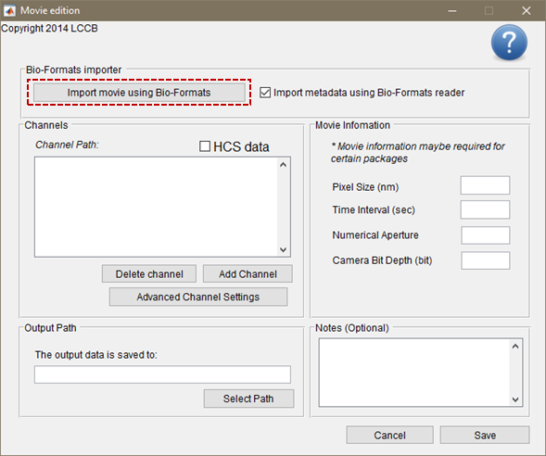

  - The movie will be loaded with the following window. Click on Save button.
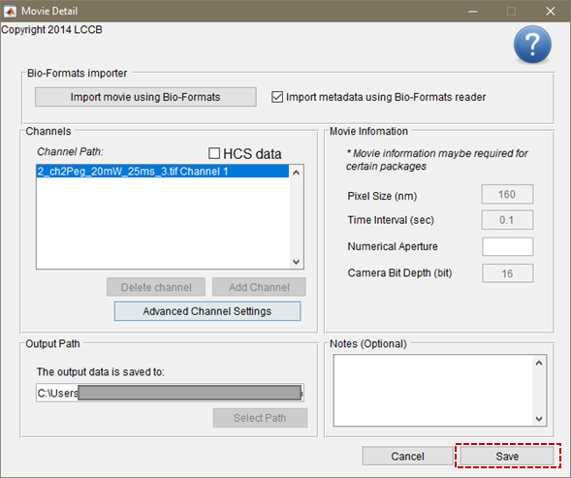
  - The above three steps can be repeated for loading multiple movies. Here we show the rest of the steps for one movie. Click on Continue button.

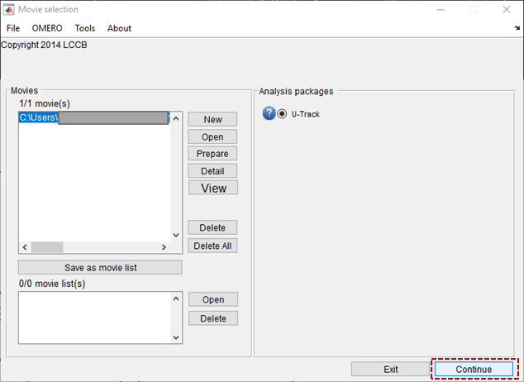

  - Select Single particles from the three options. Click on OK button.

  - Click on Setting button to input parameters for detection of particles.
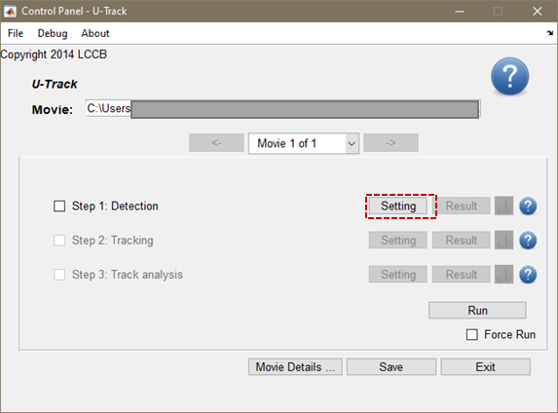

- 2.7. Select Gaussian Mixture-Model Fitting from the available options for the detection method. Click on Setting button.

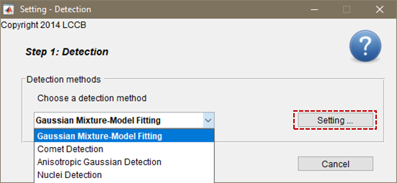

  - Make sure the different input parameters are correct.

    - Frames to use: The number of frames to analyze. If it shows only one frame, then there is a problem with the metadata of the tiff file. Correct it in ImageJ by checking its properties.

    - Gaussian Standard Deviation, input 1 pixels. Click on Apply button.

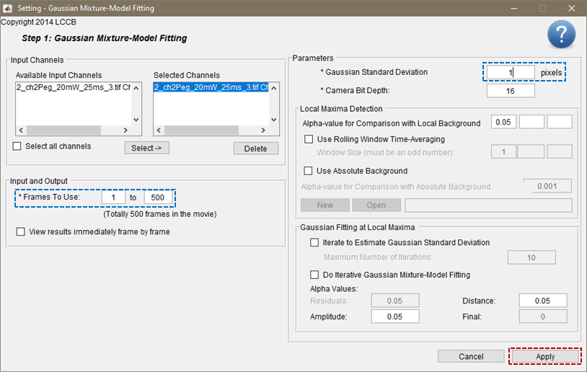

  - Click on Tracking button setting as seen in step 2.6. Input the parameter for Maximum Gap to close as 0.
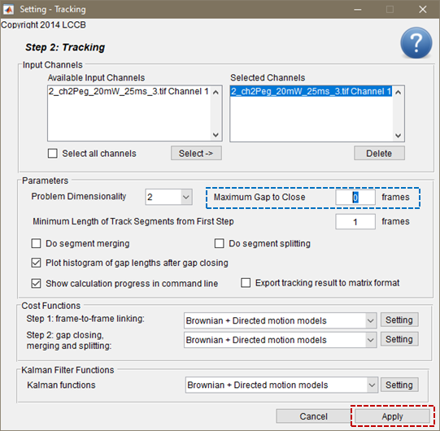

  - Click on Run button to analyze the movie. When multiple movies are input check on Run all Movies and press Run.

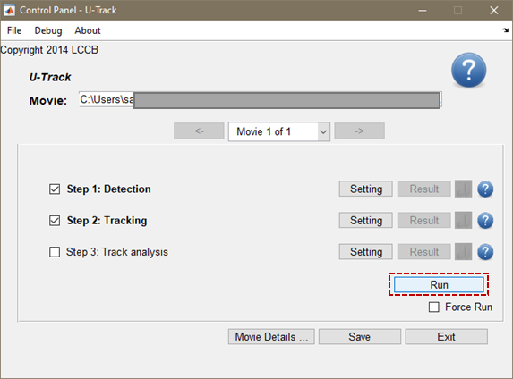

  - The following dialogue box appears on the completion of the analysis. Click on OK.
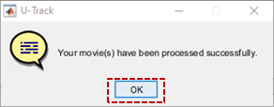

  - In the main GUI green tick mark will appear when the movie analysis is done successfully.

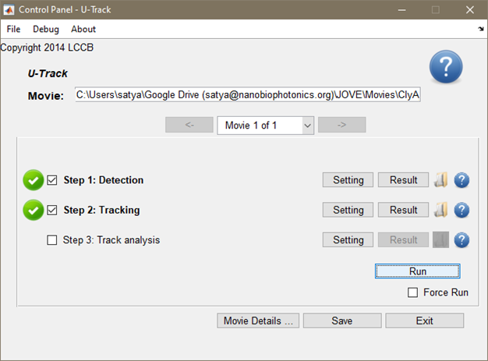

References:

Douglas Schwarz. uipickfiles: uigetfile on steroids https://www.mathworks.com/matlabcentral/fileexchange/10867-uipickfiles uigetfile-on-steroids, MATLAB Central File Exchange. Retrieved April 29, 2022 (2022).

Charles. cbrewer: colorbrewer schemes for Matlab https://www.mathworks.com/matlabcentral/fileexchange/34087-cbrewer-colorbrewer-schemes-for-matlab, MATLAB Central File Exchange. Retrieved April 29, 2022 (2022).

Kelly Kearney. boundedline.m https://github.com/kakearney/boundedline-pkg, GitHub. Retrieved April 29, 2022 (2022).

Antoine Legouhy. al_goodplot - boxblot & violin plot (https://www.mathworks.com/matlabcentral/fileexchange/91790-al_goodplot-boxblot-violin-plot), MATLAB Central File Exchange. Retrieved April 29, 2022 (2022).

McGuire, H., Aurousseau, M. R. P., Bowie, D., Blunck, R. Automating single subunit counting of membrane proteins in mammalian cells. Journal of Biological Chemistry. 287 (43), 35912–21 (2012).

