FluoroBox Assembly Instructions
By Ren Dodge

1 | 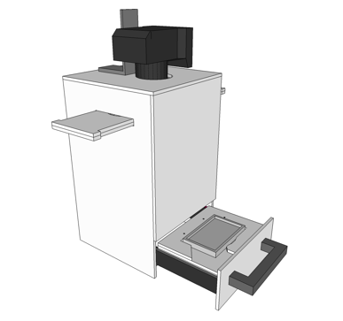 |  | Quality photographs can be used to document the data and to facilitate counting of CFUs. A robust and straightforward photography platform was developed in this study using commercially available components and a custom-cut acrylic box. The FluoroBox is designed to produce photos of the plates with even light intensity to minimize glare on the agar surface. Additionally, the design is capable of selecting fluorescent colonies using single color LED lights and colored photo filters. A digital camera is attached to a bracket on top of the box and is pointed directly down, normal to the center of the plate. A colored emission filter can be positioned in front of the lens using the filter rail, which slides into place. The light shield prevents lens flare by blocking direct light from the LED strips below. LED strips illuminate the plate from the sides, rather than above, to prevent glare on the plate. In addition to white light, single color blue and green LEDs are used to excite green and red fluorescent proteins, respectively. The plate is held in place by a plate holder on the drawer, and the drawer is equipped with common drawer sliders to make inserting the plate easy.
2 | 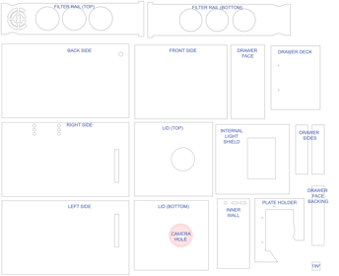 |  | Laser cut the pieces using the vector file. Black ¼ inch acrylic sheet is recommended. The materials and laser cutting can be ordered from online services (see Table of Materials). Make sure the 1in2 scale object (lower right corner) measures 1 inch in the editing software used.
3 | 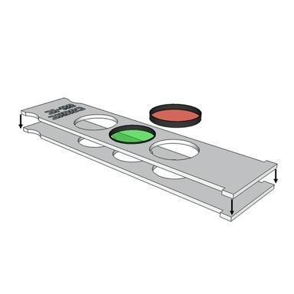 |  | The filter bar is designed for use with Tiffen 72 mm filters - the top half has holes with a diameter slightly larger, and the bottom half of the rail has holes slightly smaller such that the filters nest inside the bar. If a different size filter is to be used, adjust the size of those holes accordingly.
4 | 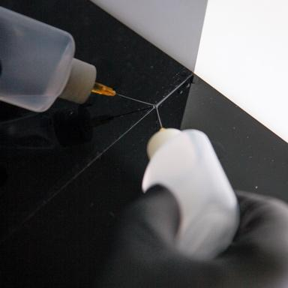 |  | Assemble the box using the acrylic glue (see Table of  Materials). First position the pieces, then apply a thin line of glue to the seam. The glue will penetrate into the seam with capillary action. Not much will be needed. It will harden quickly, within approximately 3 min.
5 | 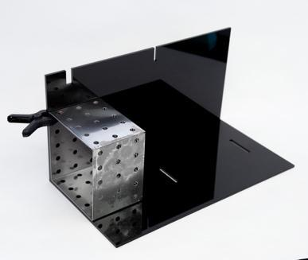 | It is helpful to have some clamps and/or heavy square blocks to hold the walls in place while assembling. A square corner space, for example, where the bench meets the wall, can be used .
6 | 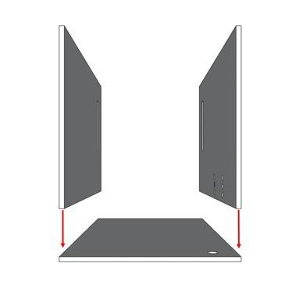 | Attach the sides to the back first. Make sure the internal light shield and lid-bottom fit between the sides. Look at the following steps to be certain of the geometry.
7 | 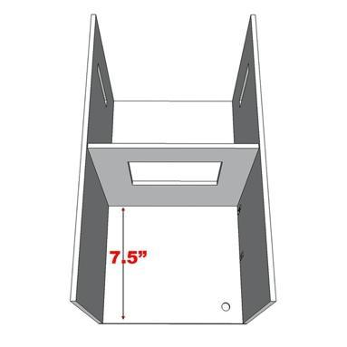 | Attach the internal light shield 7.5 inches from the bottom edge of the walls.
8 | 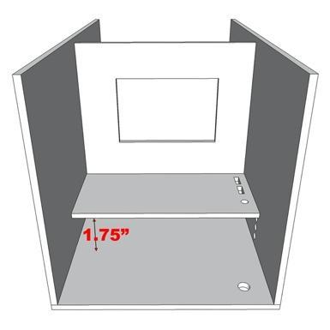 | Attach the inner wall 1.75 inches from the rear wall. A stack of printer paper is useful for supporting the inner wall while gluing.
9 | 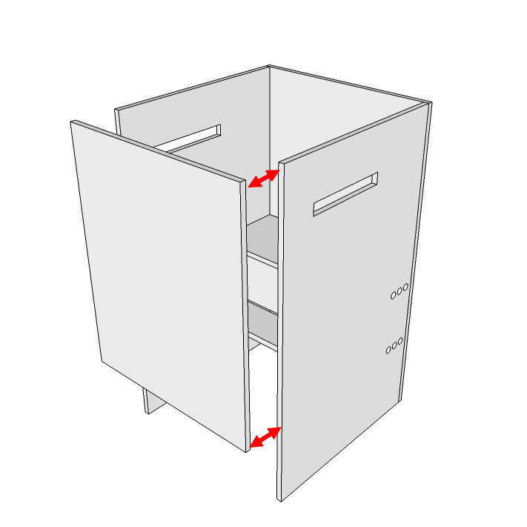 | Attach the front side (make sure the lid bottom will nest inside the walls).
10 | 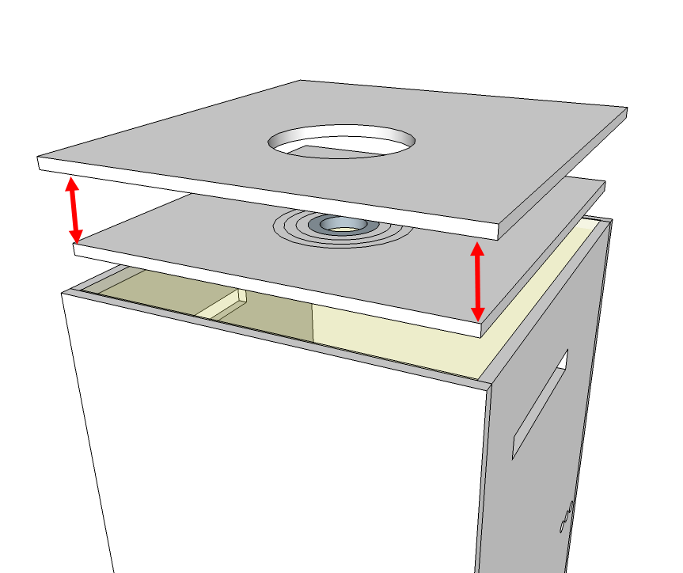 | Attach the lid bottom to the lid top. It should fit snugly on top of the box. Optionally, attach the 4 inches x 4 inches piece with a small hole in the center if using a smaller camera, rather than the Canon Ti.
11 | 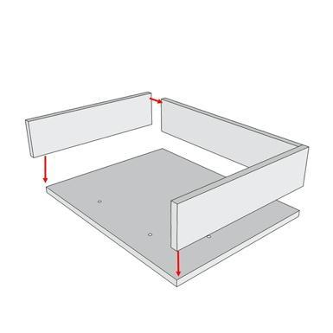 | Assemble the drawer sides, deck, and face backing (but not the face).
12 | 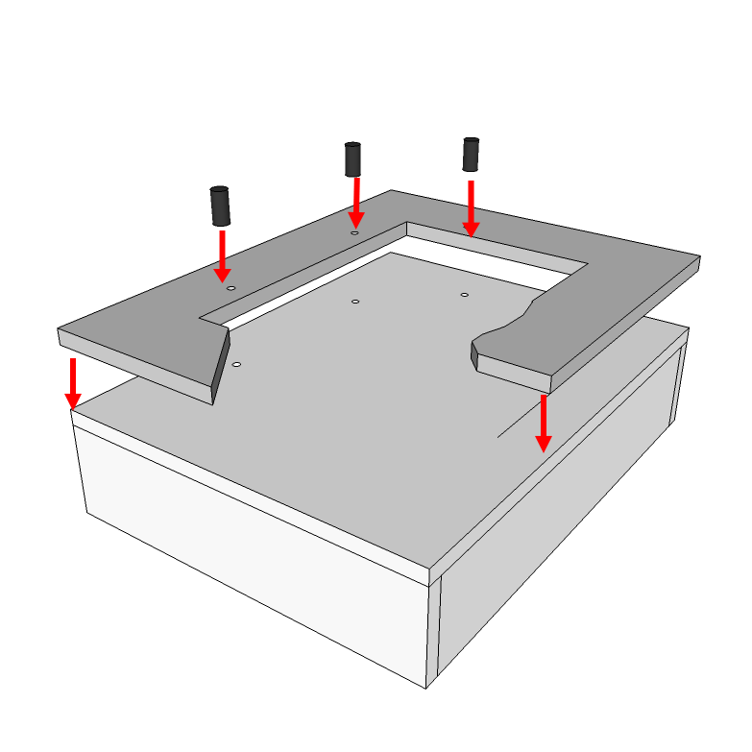 | Attach the plate holder to the drawer deck. Use the Connector Nuts and ¾ inch bolts for the rubber band holders.
13 | 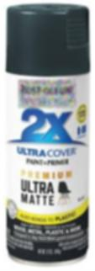 | Paint the INTERIOR of the box with flat black spray paint. Also paint the drawer deck. Use masking tape and plastic to cover areas which are not to be painted. Do this in a fume hood or outdoors to prevent inhalation of paint fumes.
14 | 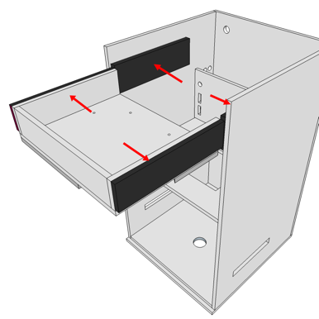 | 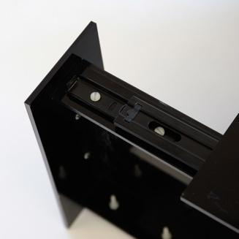  Attach the drawer sliders to the box. Make sure the drawer face lines up with the box face. Attach the drawer to the drawer sliders. It will be required to drill custom holes for the drawer sliders. There should be a ¾ inch clearance between the plate holder and the box face.
15 | 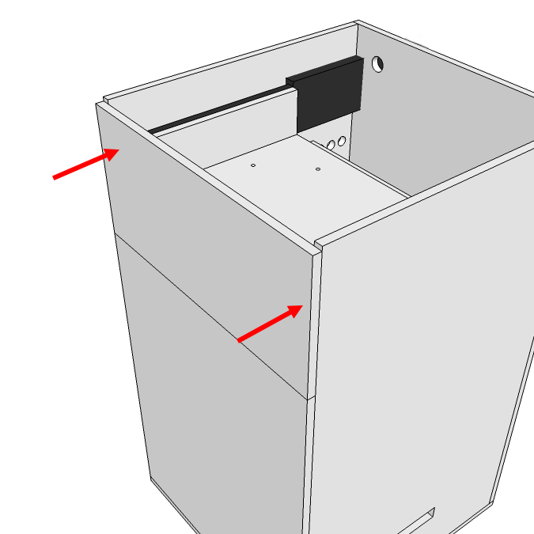 | Now glue the drawer face to the face backing piece so that it fits perfectly when the drawer is closed.
16 | 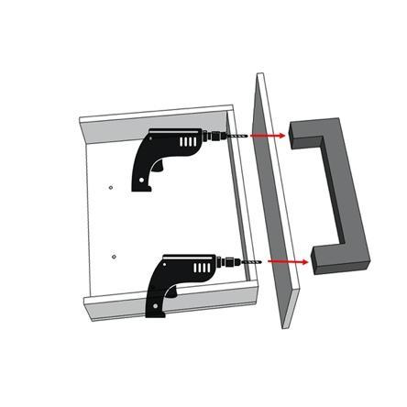 | Once the drawer face is glued in place, attach the drawer pull handle.
17 | 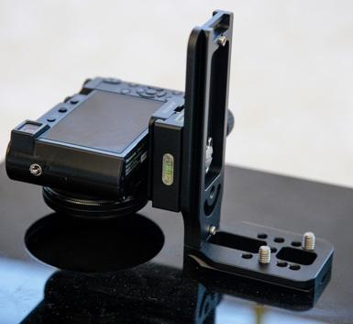 | Unscrew one leg of the L bracket and flip it around then re-attach, so that the camera is on the outside of the L. Attach the quick-release plate to the L-bracket. Attach the camera to the quick-release plate. Position the whole camera and bracket assembly so that the camera is centered above the camera hole.
18 | 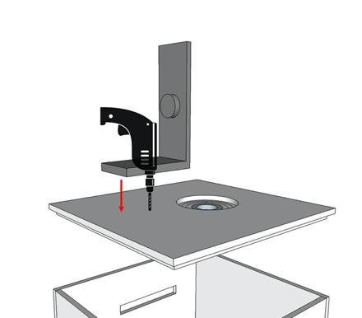 | Mark two holes to drill in the lid where the bracket will attach. Drill ¼ inch holes at these points. Attach the bracket to the lid using the ¼ inch-20 x ½ inch bolts and some washers.
19 |  | Lighting is supplied by attaching LED strip lights to the internal circumference of the FluoroBox, immediately above the position of the subject plate and below the light shield. This location blocks direct light from LEDs on the filter and the camera lens that would generate lens flare.
20 | 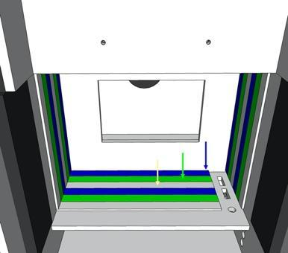 | Make two rows for each color of LED. There are holes included in the pattern for routing the wires and switches. There is room in the back of the box to contain bundled wires as well as the power supply.
21 | 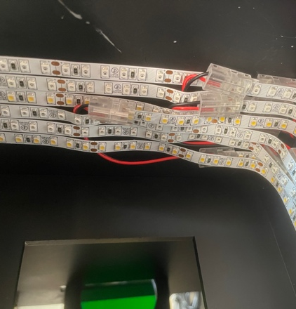 | Approximately 6 ft (2 m) of LED strip lighting will be needed to make two rows inside the box design. Strips must be cut into two segments and joined with a connector to achieve this. The dual rows of light provide more illumination as well as reduce shadows and make the lighting more even across the plate surface.
22 | 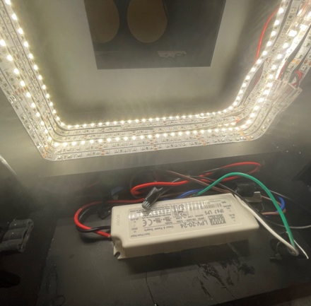 | There is a pocket where the power supply and wires can be attached and contained inside the box.
23 | Refer to the wiring diagram for assembly of the lighting circuit. It consists of the DC power supply, the three different colors of light strips connected to the power supply in parallel, and a switch for each of the light colors. Switches are fit in the pre-cut holes on the box wall. | 