Count-On-It Instructions
Count-On-It is a colony counting suite that is made for quantification of colony-forming units (CFUs) that are spot plated from a 96-well plate in a 8 x 12 grid onto a rectangular agar plate. It segments the object into a uniform grid and batches the results into a simple spreadsheet. It is in the form of an ImageJ plug-in, making it broadly compatible and free to all users. The macros are written in the IJ1 Macro scripting language, which is easily modified using the built-in editor in FIJI.

The software suite consists of three Plug-ins: Count-On-It Gridiron will batch process a folder of JPEG images, divide each image with a uniform grid, count the colonies in each cell, and output the results into a simple spreadsheet. Croptacular is a specialized cropping tool that allows the user to fine-tune the placement and boundaries of the counting grid for each image. Count-On-It Circus is included for convenience; this plug-in will batch process the photos of round plates, count the colonies, and output a .csv file.

Download the latest version of FIJI: https://imagej.net/software/fiji/downloads

Download the Count-On-It files (Included with Supplementary Materials)

- Install the Count-On-It plug-ins to FIJI; Navigate to Applications>FIJI then right-click on the application icon>Show package contents to open the plugins folder. Drag and drop the Count-On-It folder, which contains the files Circus_.ijm, Croptactular_.ijm, and Gridiron_.ijm, into the plugins folder. Restart FIJI. Note that the extensions are the files that end in “.ijm”.

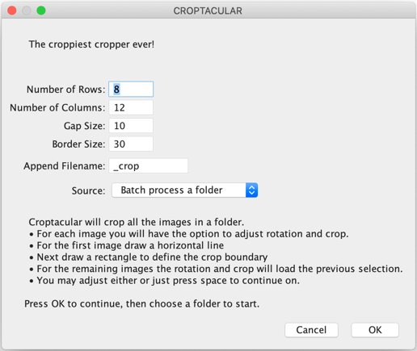
- Organize the images to be quantified into a folder. The filenames will become column titles for each set of counts, so name them in order that the plates can be distinguished. Within this folder make a subfolder named “cropped” and another named “receipts”.

- First launch Croptacular.
The default settings are usually sufficient, but depending on the resolution of the image, the lighting, the spot size, etc., it may be helpful to adjust the base parameters. Click OK to start cropping. The grid dimensions can be customized. The default filename is the original filename_crop.jpg, which can be changed. Start batching a new folder with the “Batch process a folder” option selected. Choose “Start from current image” if the plug-in crashes.
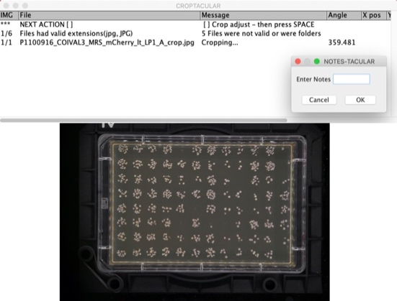
- If the image is already straight, simply press Space. Otherwise, straighten the image by drawing a line along an edge that should be horizontal. Redraw the line as many times as required if the image still doesn’t appear straightened. Drawing the line from right to left will rotate the image 180º. If the user fails to draw a line at all the plugin may exit. Relaunch Croptacular and choose start from current image option. Press Space when done.
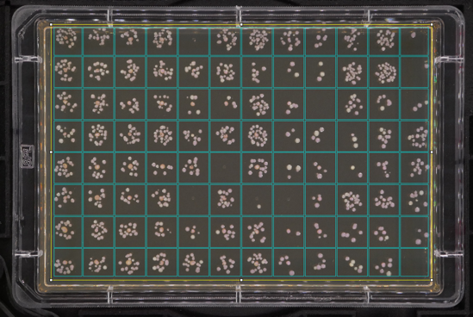
- Next, draw a boundary box of the area where counting is to be done. For the first image in a batch, the horizontal line will not disappear. That’s ok. Draw a rectangle around the agar surface. The size and proportion can be adjusted until all the spots are within their cells. Drag the cursor outside the boundary box to refresh the grid. When the grid looks good, press Space.

- The next image will automatically rotate to the same angle as the first one; the plugin assumes all the photos are aligned the same. If this is accurate, press Space to continue. Otherwise, the image can be straightened as before. The grid also recalls the same position as the previous image; adjust if necessary, then press Space.
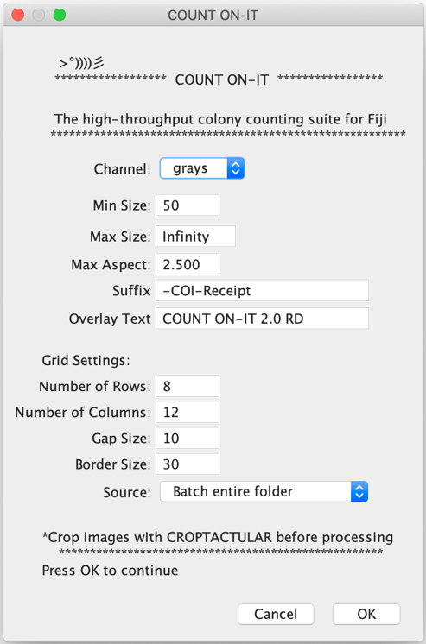
- Once cropping images is completed, launch Count-On-It>Gridiron. These default settings are usually good. Depending on the image, it may improve thresholding to use only one of the RGB channels. When using the green filter/blue light settings, it is advantageous to select the Channel: Green. The Min Size and Max Size can be useful for selecting specific colonies; these units are in pixels. The max aspect controls the aspect ratio of colonies. It may be useful to adjust this parameter if the colonies are more or less uniformly round than the 2.5 default aspect ratio. The filename can be appended with Suffix and the overlay text can also be customized. The grid settings should usually be the exact same as used with Croptacular. It is possible to batch an entire folder, a single image, or start from current image.

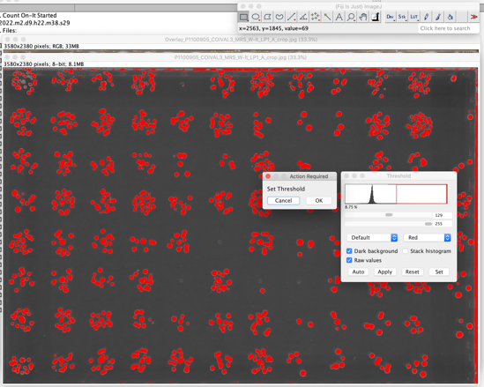
- The first step in counting is to set the threshold. This is based on a upper and lower pixel intensity value. Make the threshold as stringent as possible while still selecting all the colonies. Ideally there will be some space between selected colonies, but the software is capable of segmenting the blobs to a degree. Click OK on the action required box when the threshold is satisfactory.

- To inspect the results, zoom in and look more closely at the colony counts. Cancel will abort the plugin. Click OK to continue.
- On the first image, there is an option to proceed or return to the setup menu, for example, if the user wants to change the minimum colony size. Or the user may proceed with the batch process. Click OK, then select a folder to keep the receipts and results table. Use the “receipts” folder or create a new folder.

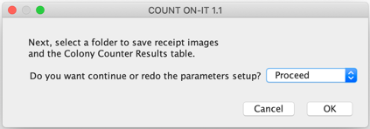
- After the first image, the following images will default to the same threshold as the previous settings. Click OK to use these settings or adjust the settings. If the photos are consistent and the setting is accurate, the user only needs to click OK on the “Action Required” dialogue box.
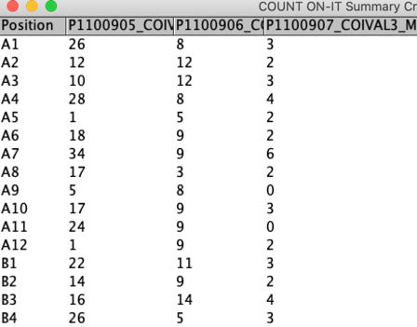
- When all the images in the batch have been completed, the results table will save automatically in the same folder as the receipts. If the software crashes or the user needs to quit, save the results table with a unique name like “Summary-1A” because when relaunching and starting from current image, it will automatically save the results table in the destination folder and overwrite the table from the first try.

Count
-
On
-
It Algorithm

Crop
•
Batch using
Croptacular
•
Straighten and crop image
•
Center 96 spots in grid squares
•
Minimize edge effects such as glare and bubbles
•
Resize to same dimensions (e.g., 3000 x 2000 px)
Set
Parameters
•
Border and gap options to omit regions of the image
•
Minimum size of colonies in pixels
•
Circularity
Image
Preparation
•
Convert to binary
•
Gaussian blur
-
softens edges to reduce aliasing
•
Watershed filter splits overlapping colonies
Manually
Threshold
•
Each image is manually thresholded to select colonies.
•
The same image(s) may be processed twice, once for fluorescent positive colonies, again for total colonies, thus obtaining a
ratio.
Automated
Counting
•
The image is divided into a grid of 96 regions
•
Within each region the number of “blobs” is counted using the Analyze Particles function in ImageJ
•
The average particle with a circularity greater than threshold is defined
•
The area of each particle is divided by the size of an average particle then rounded to a whole number
-
this is taken as the
number of colonies in a single blob.
•
An algorithm determines if there are too many non
-
circular areas and defines the region as “E”
Generate
Receipt
•
The grid is drawn on the image
•
Blobs containing multiple colonies are outlined in red, those with single colonies are outlined in yellow
•
The sum of the colonies is reported and added to the overlay in the appropriate square
•
The receipt is exported as a .jpg
•
The results are added to the spreadsheet
-
in the case of batch processing the spreadsheet continues to accumulate columns,
1
for each plate
Manually
Error Check
•
Receipts are used to visually inspect the results
•
Visually scan each receipt to make sure results are reasonable.
•
The values in the spreadsheet are manually adjusted (e.g., 0 colonies or blank well, 1 colony was missed, etc.)

