Steps to analyze H & E images in Aperio ImageScope
Aperio ImageScope is an online software from Leica Biosystems to analyze digitally scanned images. The digitally scanned images of H & E stained skin samples were uploaded at eSlide Manager by the Pathology Service core at the University of North Carolina at Chapel Hill. Here are the steps to analyze the scanned image.
1. Set up an account with Aperio eSlide Manager using the web address provided.
https://tpl-spectrum.med.unc.edu/Login.php.
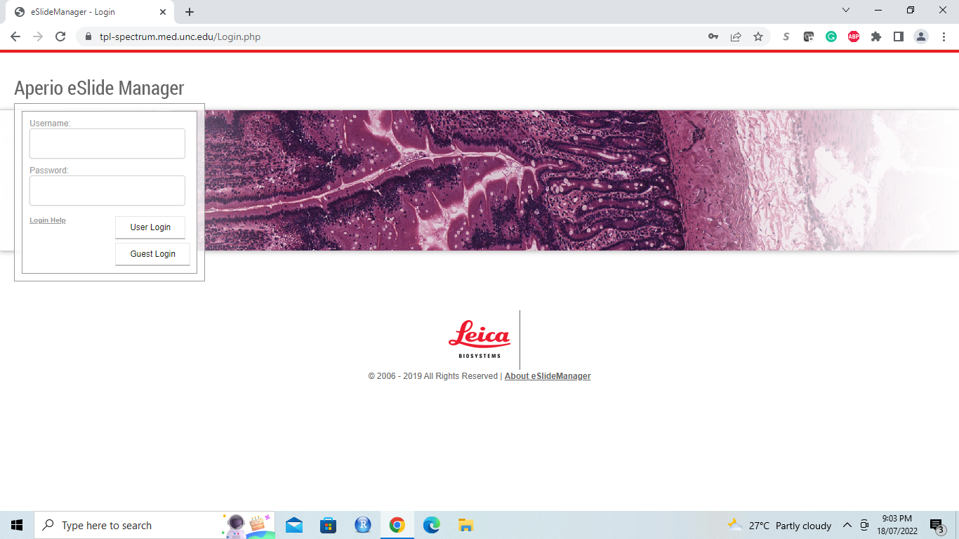
2. Log in to the account
After setting up the account, login to the account. After logging in, wait for the screen shown below to appear. Click on the eSlides option to access the images and scan them using the Aperio AT2 (Leica) scanner at 40x objective.
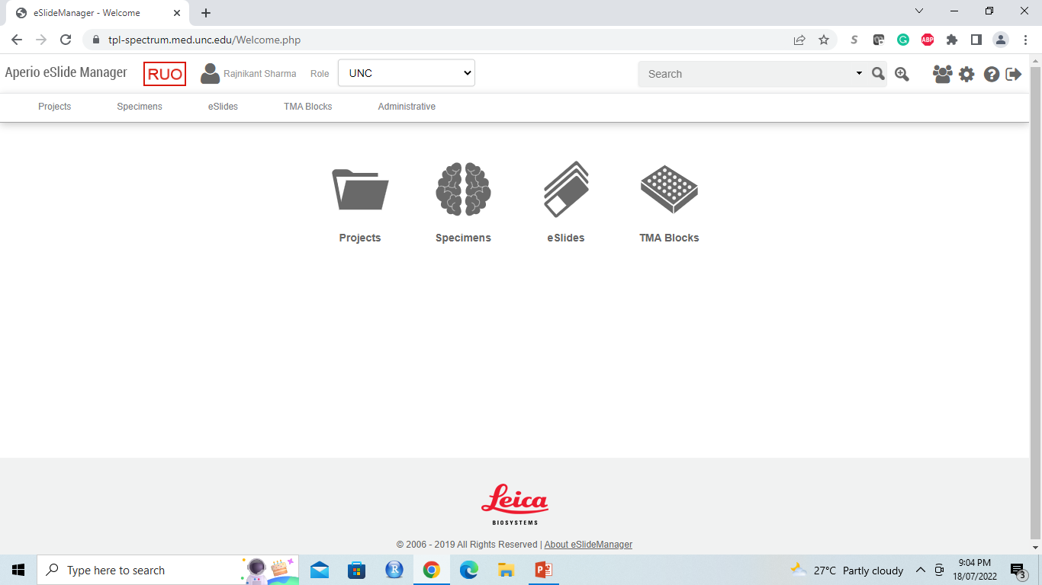
3. Image processing
3.1. After selecting the eSlide option, wait for a list of all the uploaded images to appear (see the screenshot below). Select the image to be analyzed by double-clicking on the image slide and wait for it to be downloaded from the server. See the screenshot below.
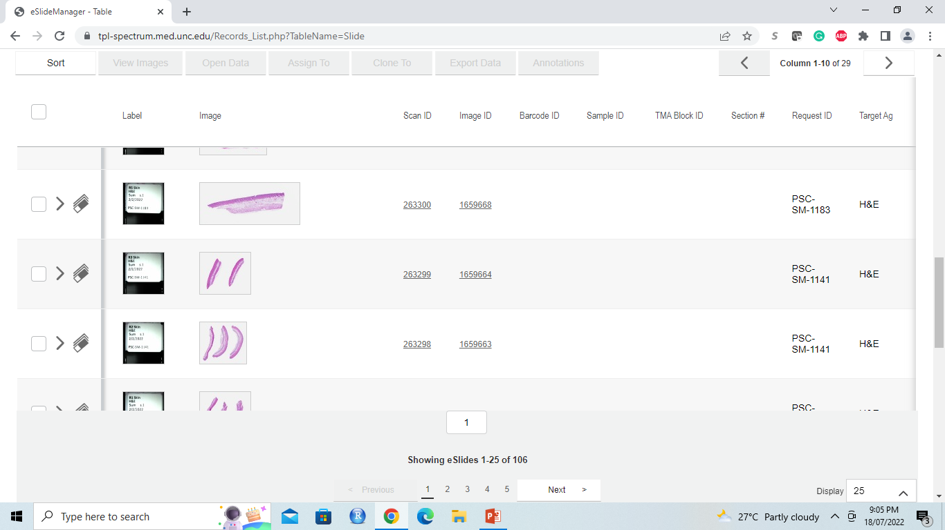
3.2. Locate the downloaded file once the download is complete as indicated at the lower left-hand corner (red circle).
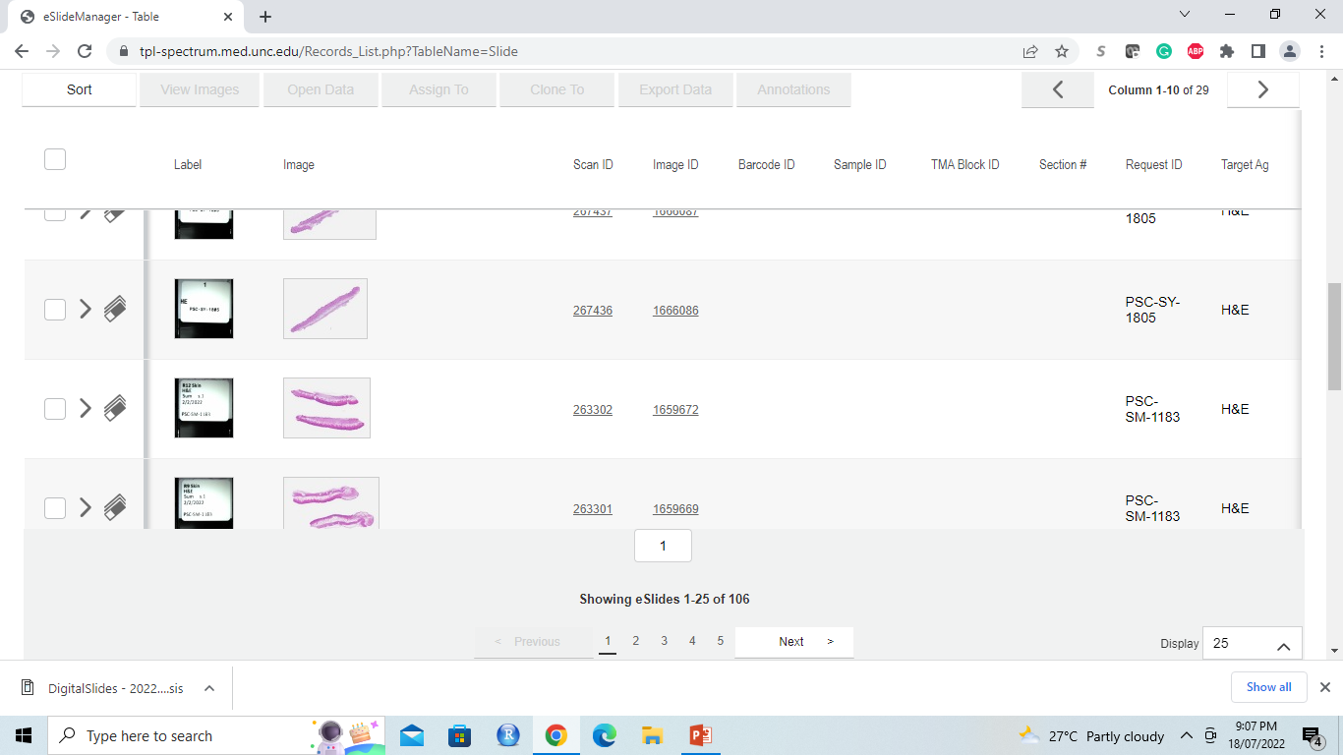

3.3. Click on the file to see a processing bar indicating the file is being opened. See the screenshot below.
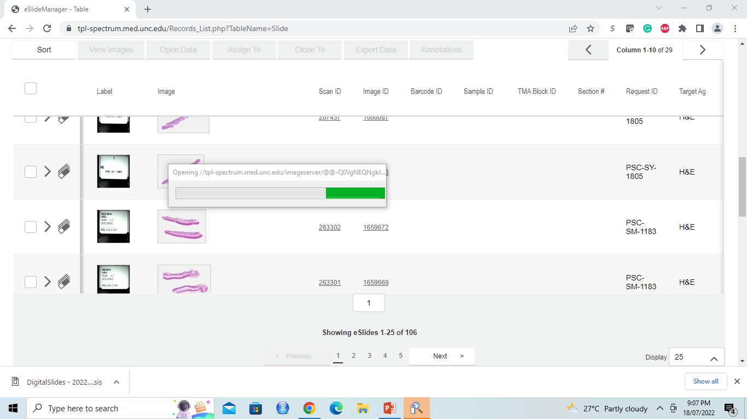
3.4. The file will be opened in a new window. See the screenshot below.
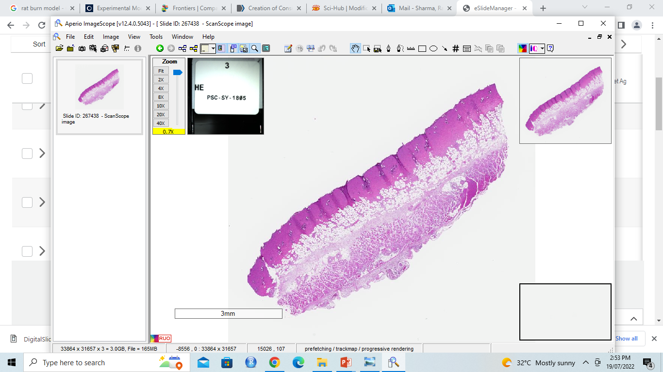
3.5. Click on the image option and wait for a dropdown menu to appear. From the dropdown menu, select Rotate image if the image is to be rotated to a particular angle. See the screenshots below.
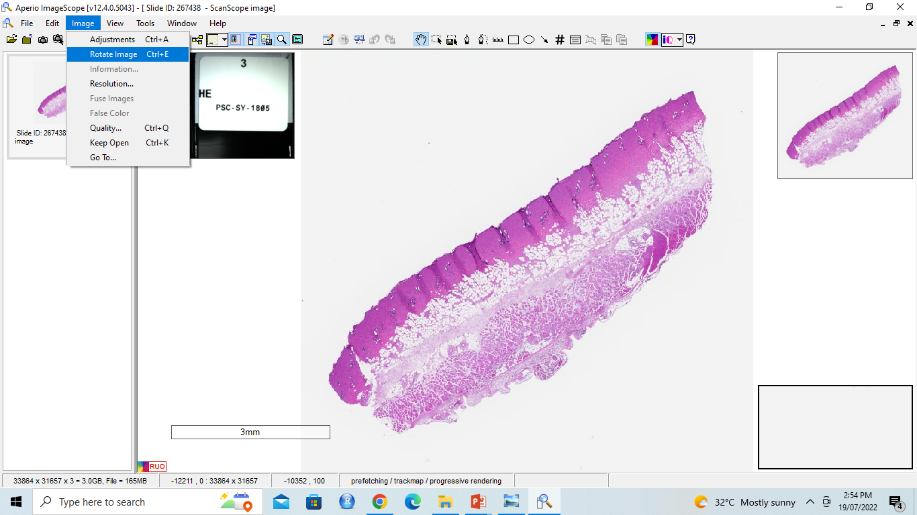

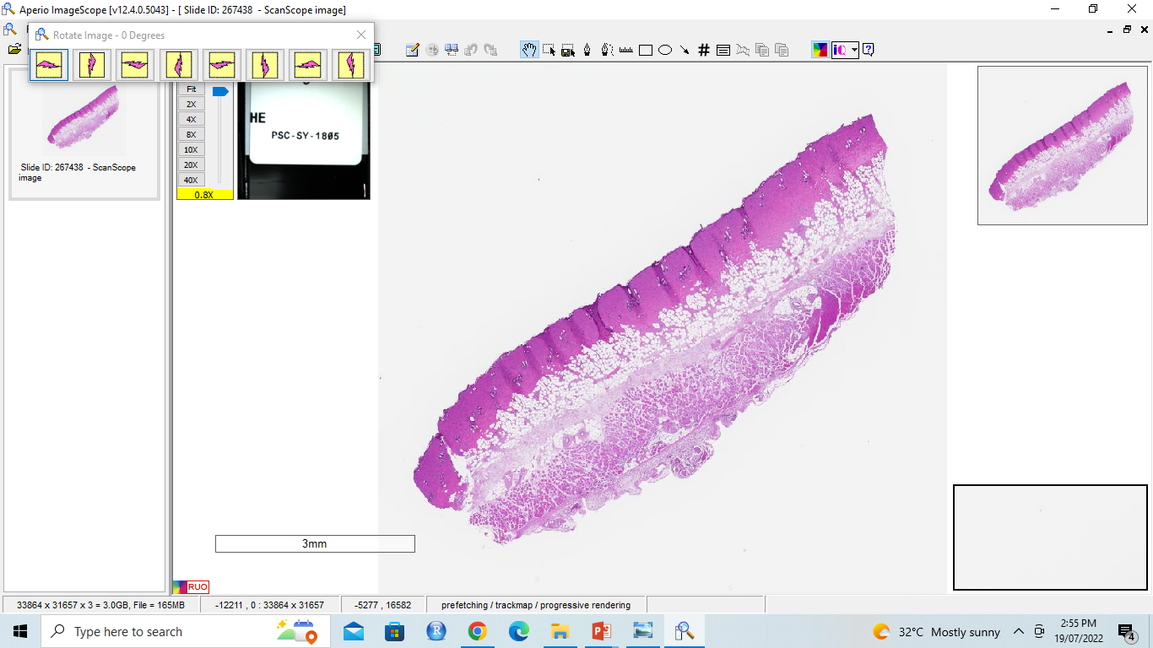
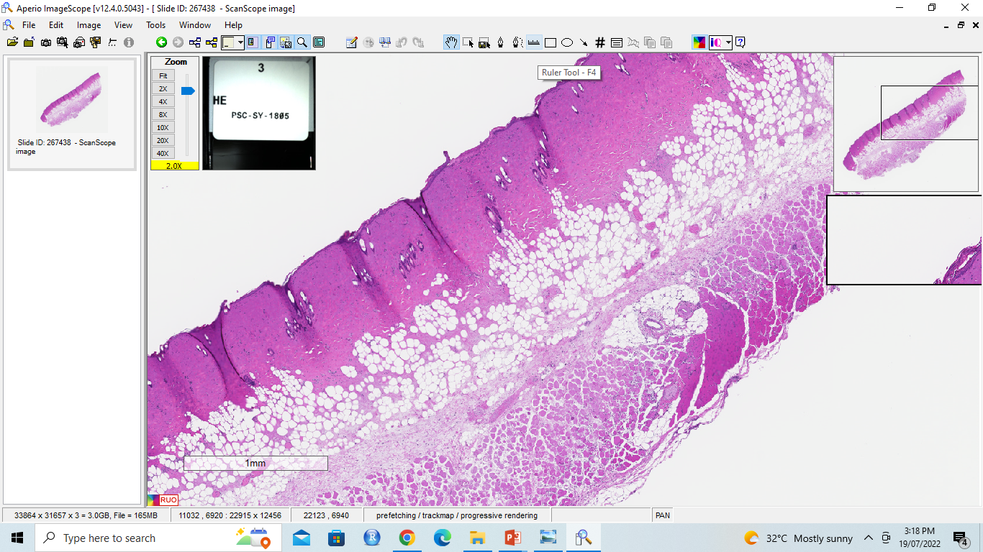
3.6. Zoom in by using the zoom function (red outline in the screenshot below) to analyze the image details.

Step 4. Image analysis

3.7. Use this software to measure the depth of the burn injury to compare the thickness of the burn to normal skin. Select the ruler option in the red circle below to measure the burn depth and thickness of the skin.

3.8. After selecting the ruler, draw a line across the image to measure the thickness as shown in screenshot below.
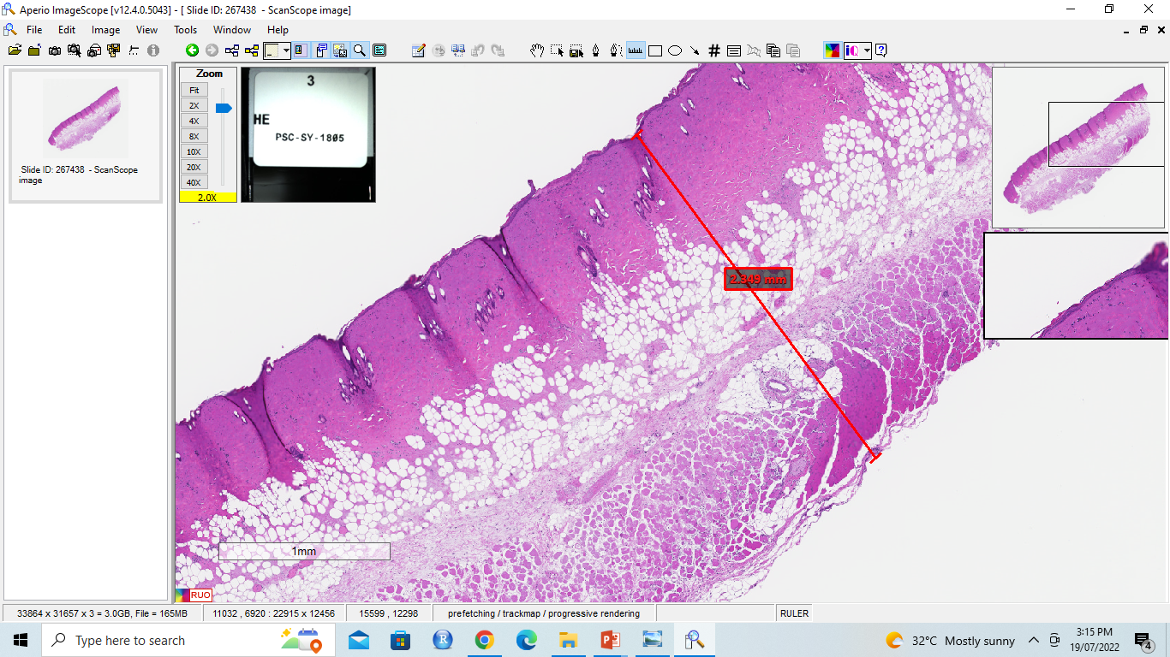
3.9. Move the scale bar on the image from the left to the right side. See the options from the dropdown menu in the screenshot below.
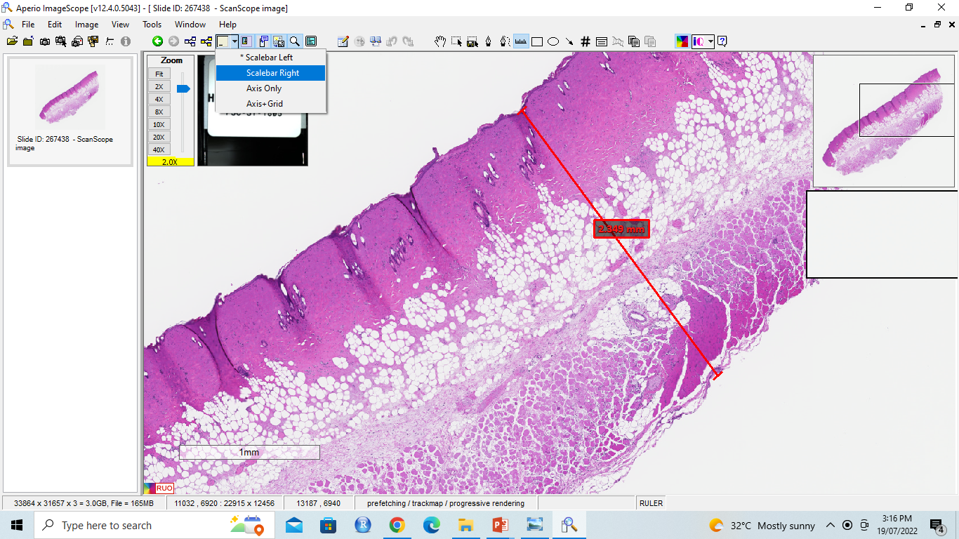
Scale bar

3.10. After clicking on the option, move the scale bar from the left to the right side in the image. See the screenshot below. 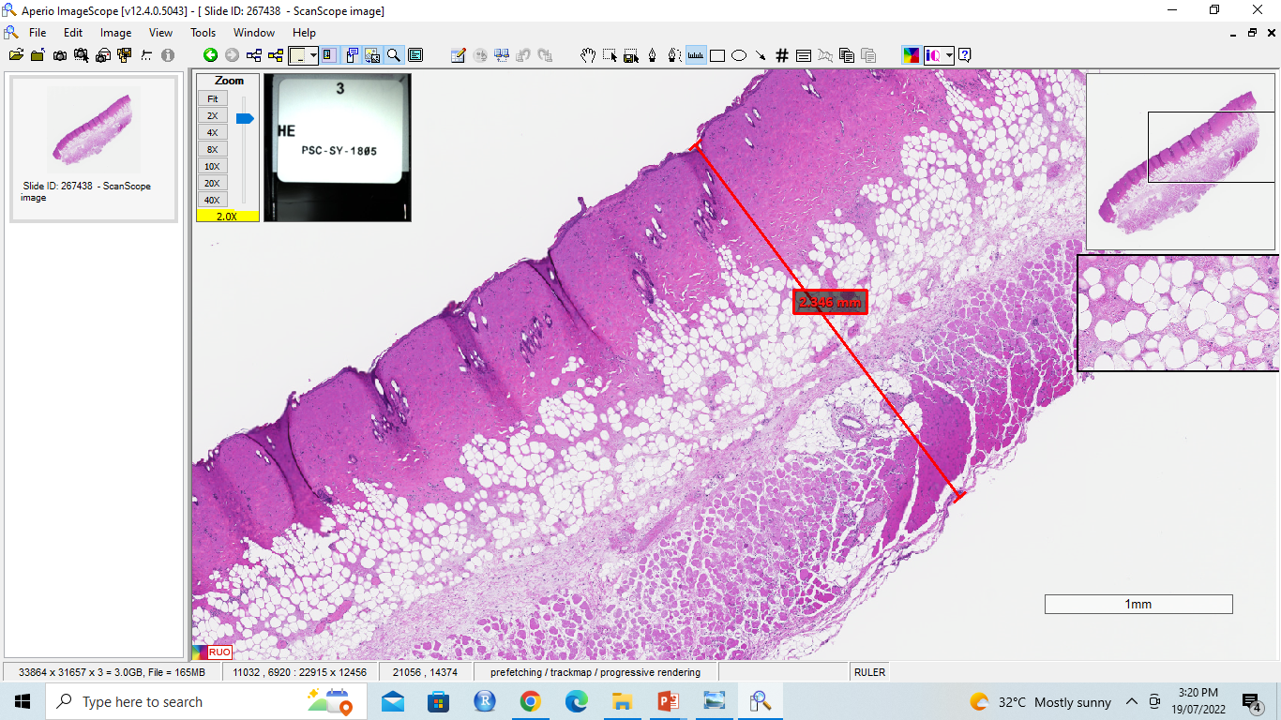
3.11. Zoom in to analyze the minute details. Once the analysis of the image is complete, click on the file option and select export image from the dropdown menu. See the screenshot below.
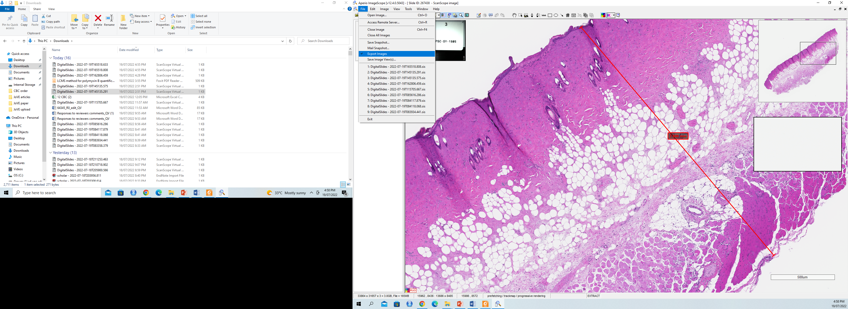
3.12. After selecting the export image, select a part of the image and wait for a popup window to appear with the selection as shown in the screenshot below.
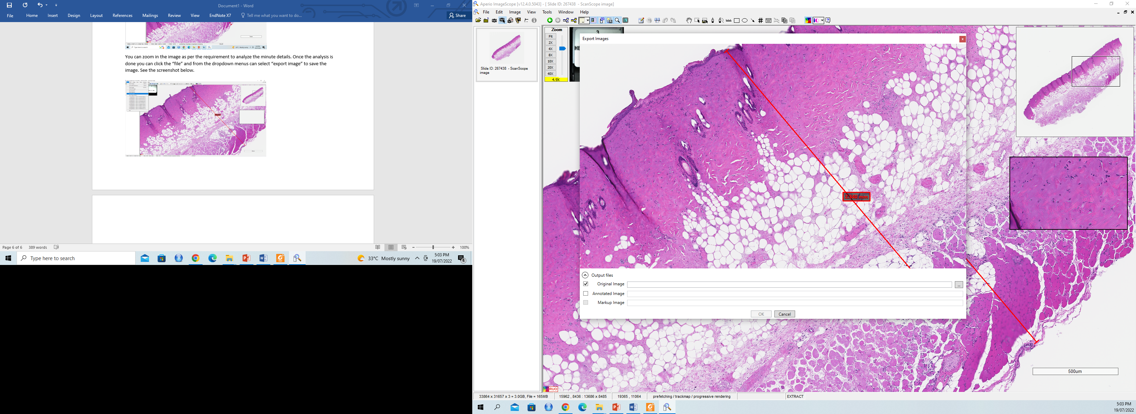
3.13. Save the image with a specific name or select the Edit option | copy to copy the image with all modifications and paste it on to a PowerPoint slide and save it as a “.tiff” format image.
NOTE: Here, the image was pasted on to a PowerPoint slide and saved it as a .tiff file as shown in the screenshot below.
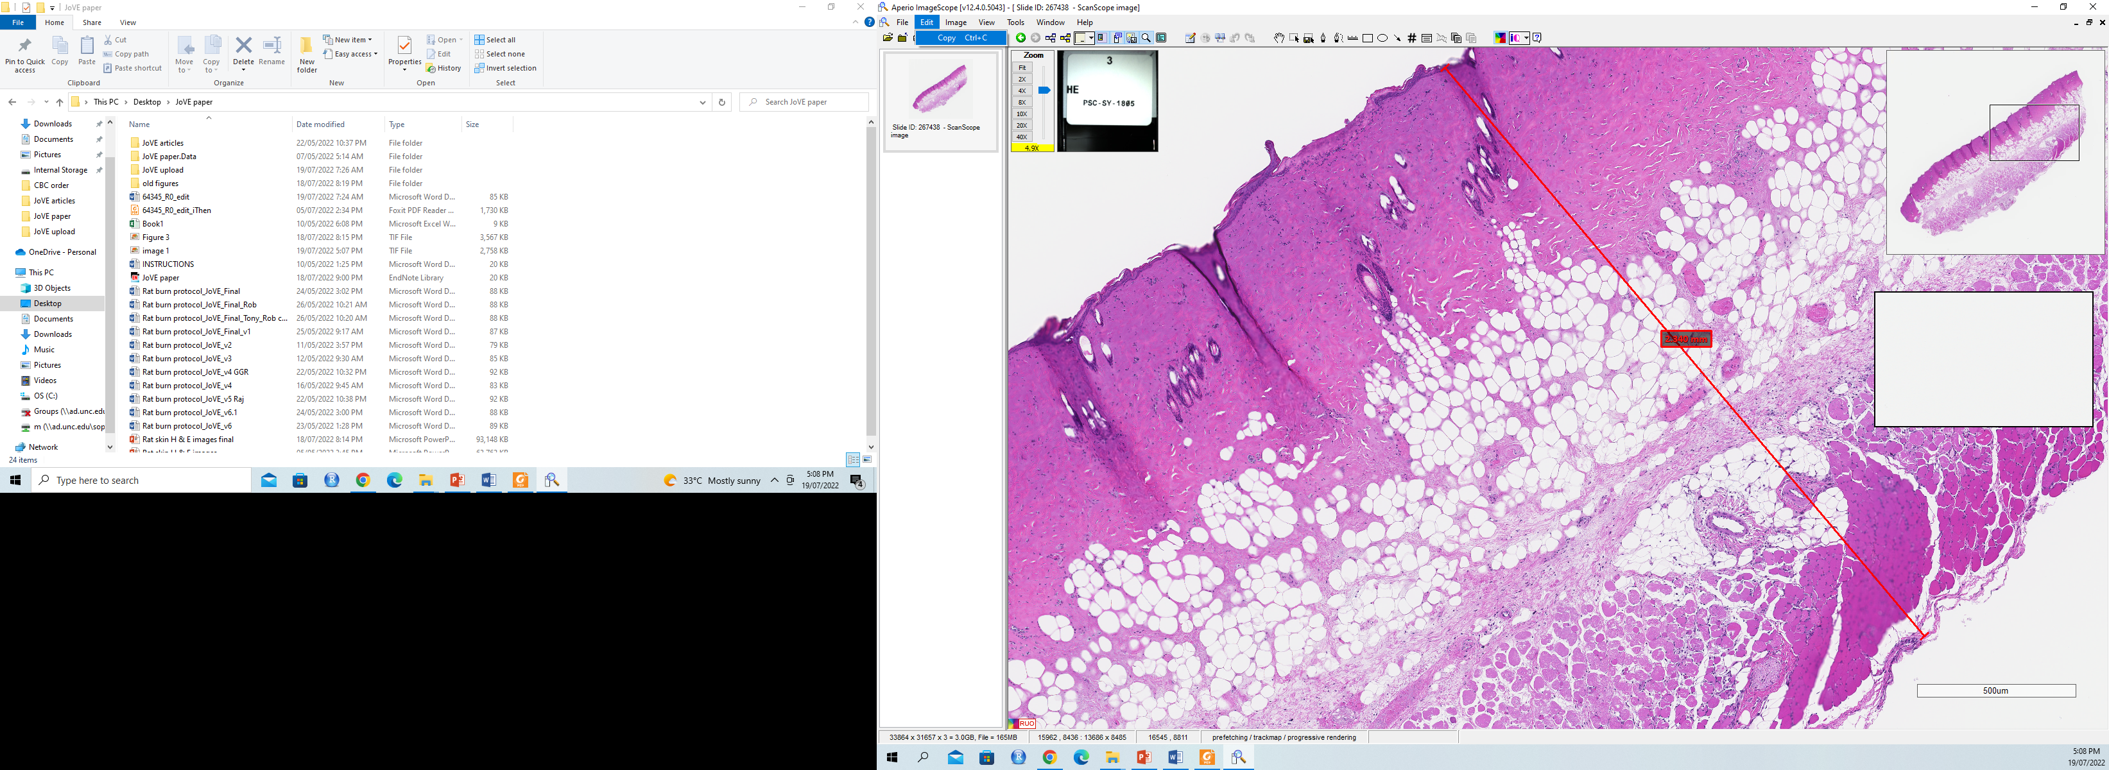
3.14. Observe that the image has all the modifications made so far. Similar to the steps outlined here, make the same modifications to the other images and compare them side by side to assess the burn effect on different layers of the skin.
