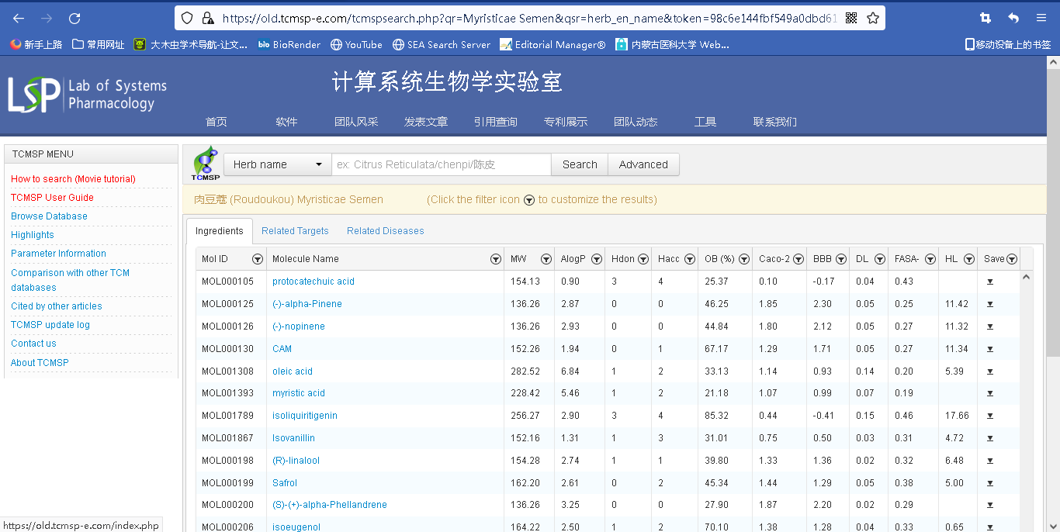
Search the components from “TCMSP”

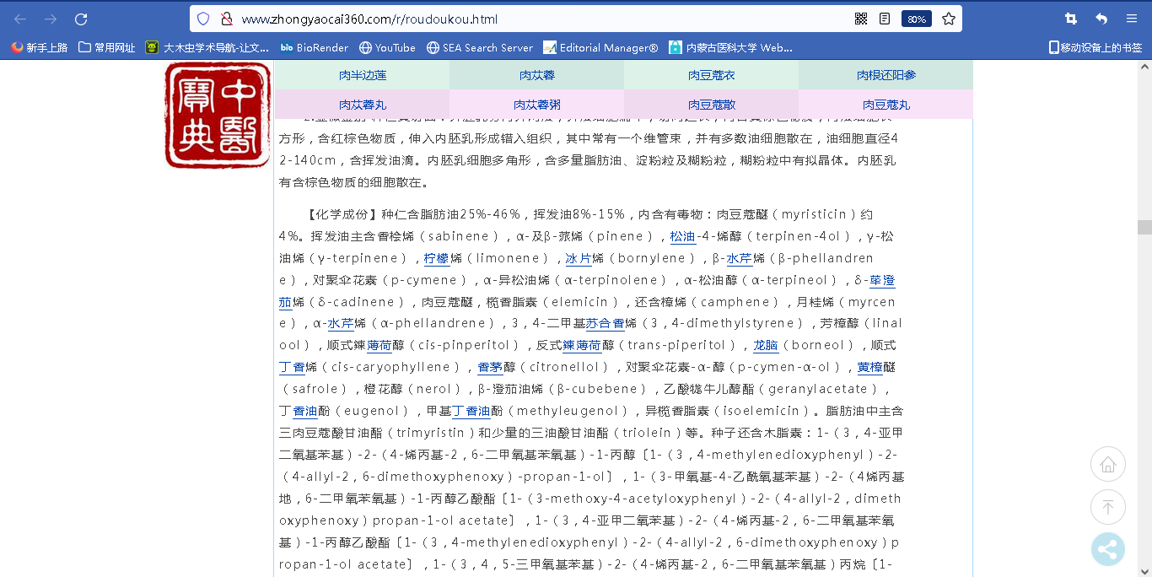

Search the component of Zadi -5 from “Chinese medicine pharmacopoeia”

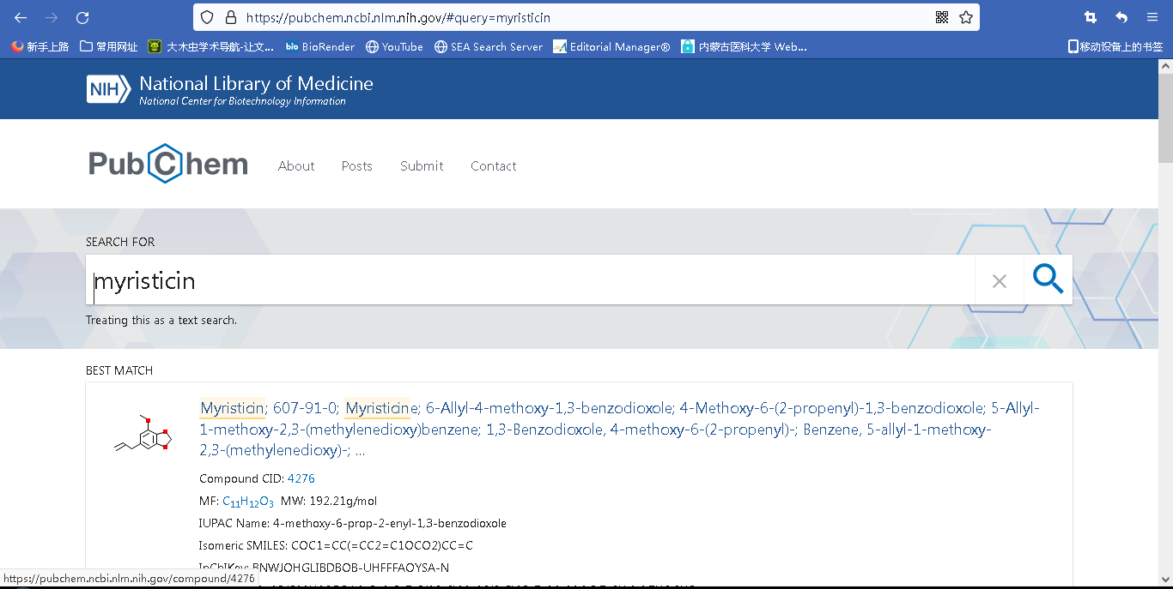
Search the Inchkey or SMILES of chemical names from “Pubchem”

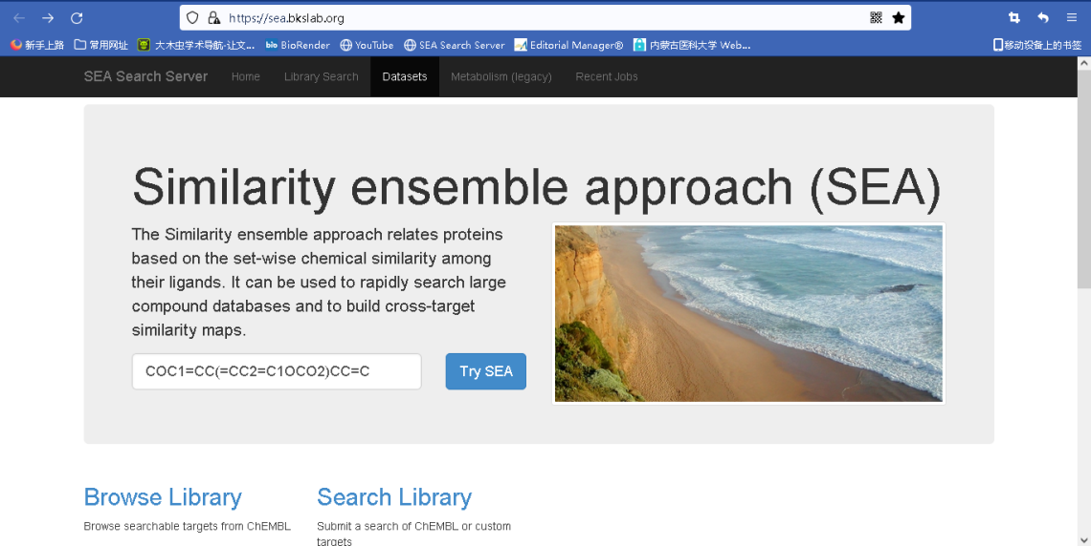
Search the target proteins of Zadi-5 from SEA
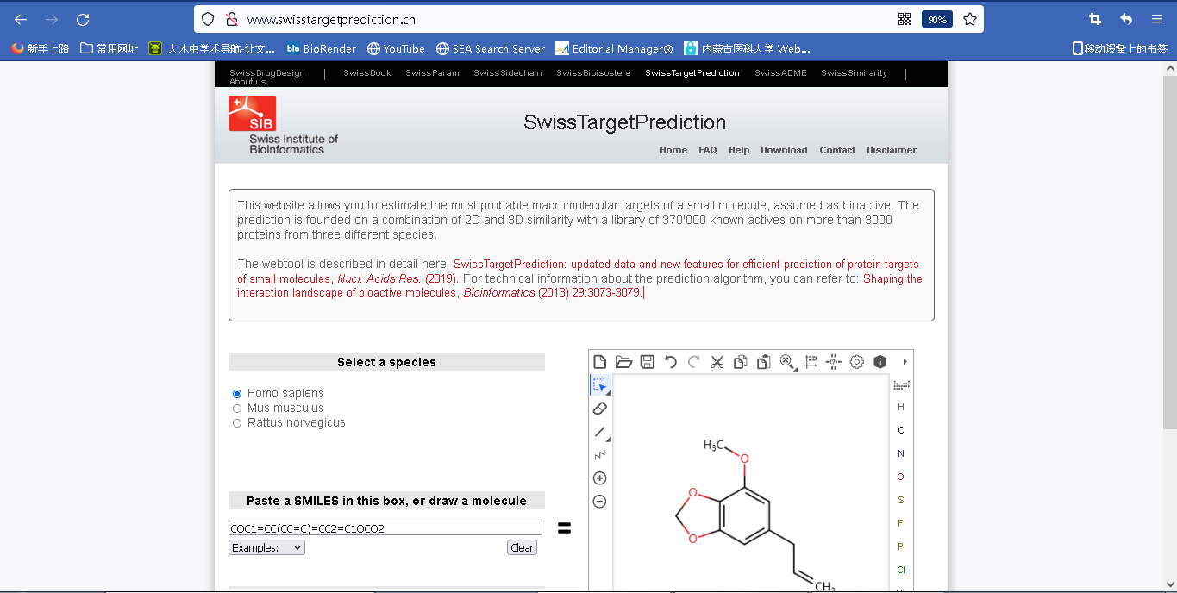
Search the target proteins of Zadi-5 from “Swiss target prediction”

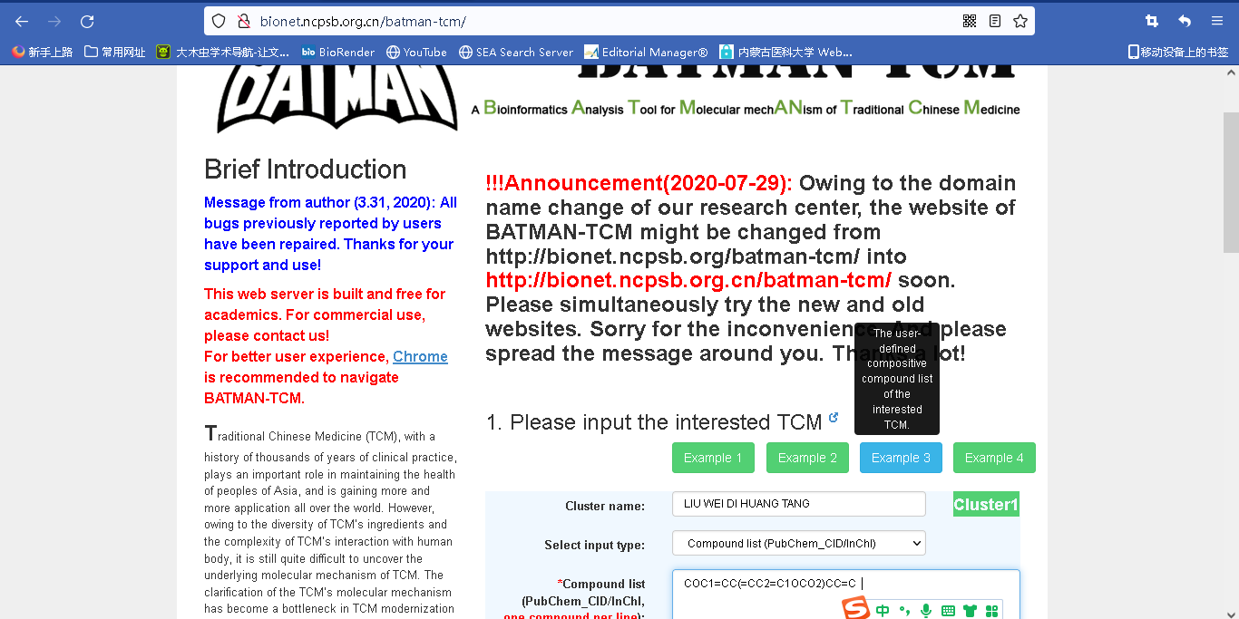
Search the target proteins of Zadi-5 from “BATMAN”

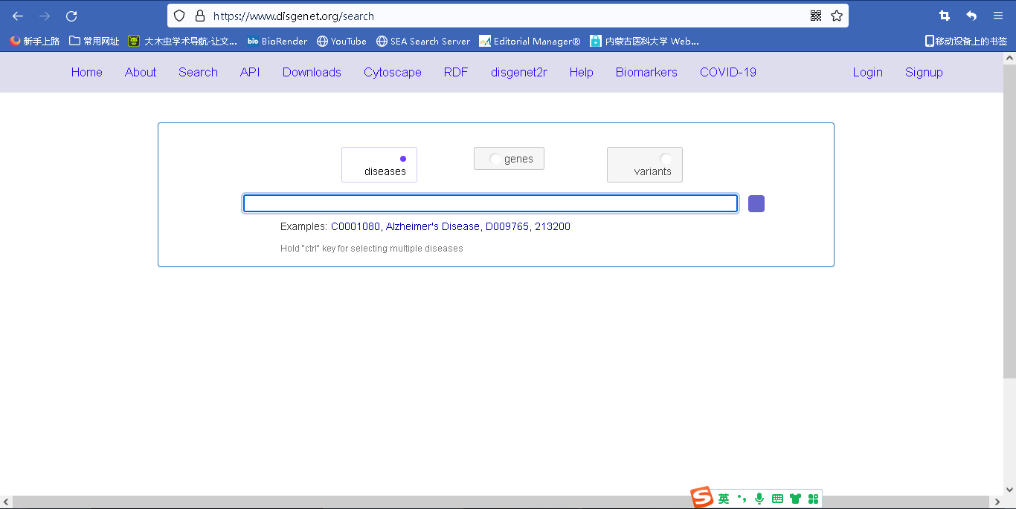
Search the target proteins of depression from “disgenet”

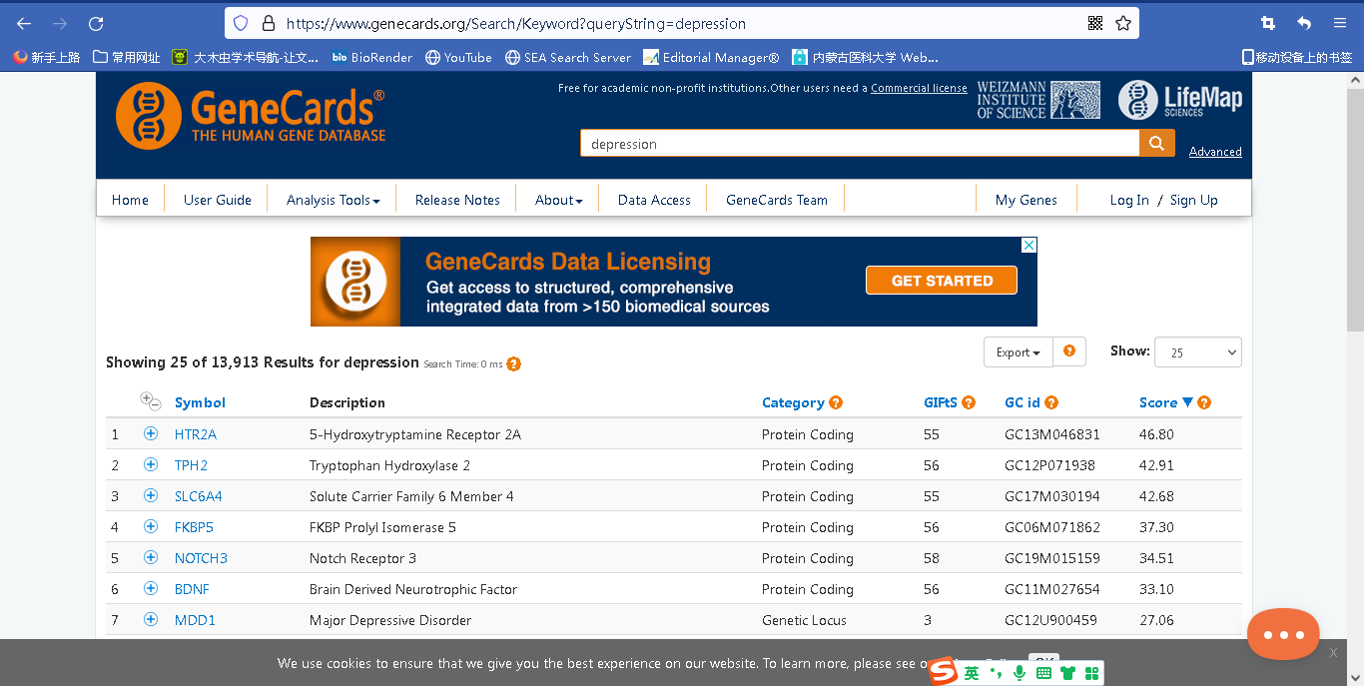
Search the target proteins of depression from “Genecard”
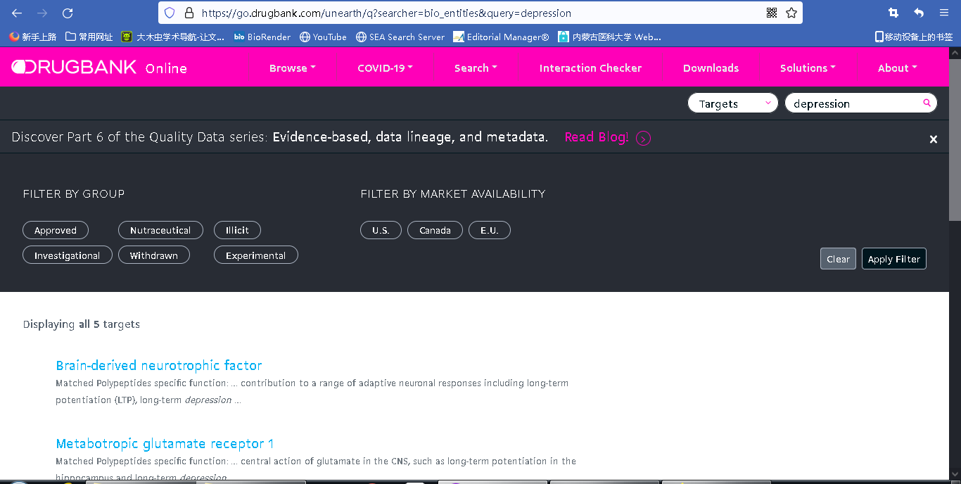
Search the target proteins of depression from “Drugbank”

