**Alpha-stim Daily Use Log**

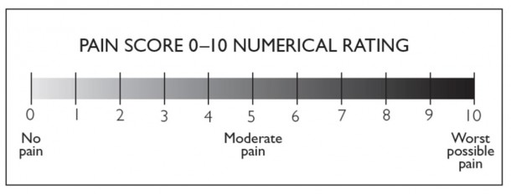

|  |  |  |  |
| --- | --- | --- | --- |
| **Week 1** | **Pain Score Pre** | **Alpha-Stim 60 min** | **Pain Score Post** |
|  |  |  |  |
|  |  |  |  |
|  |  |  |  |
|  |  |  |  |
|  |  |  |  |
|  |  |  |  |
|  |  |  |  |
| **Week 2** | **Pain Score Pre** | **Alpha-Stim 60 min** | **Pain Score Post** |
|  |  |  |  |
|  |  |  |  |
|  |  |  |  |
|  |  |  |  |
|  |  |  |  |
|  |  |  |  |
|  |  |  |  |
| **Week 3** | **Pain Score Pre** | **Alpha-Stim 60 min** | **Pain Score Post** |
|  |  |  |  |
|  |  |  |  |
|  |  |  |  |
|  |  |  |  |
|  |  |  |  |
|  |  |  |  |
|  |  |  |  |
| **Week 4** | **Pain Score Pre** | **Alpha-Stim 60 min** | **Pain Score Post** |
|  |  |  |  |
|  |  |  |  |
|  |  |  |  |
|  |  |  |  |
|  |  |  |  |
|  |  |  |  |
|  |  |  |  |
| **Week 5** | **Pain Score Pre** | **Alpha-Stim 60 min** | **Pain Score Post** |
|  |  |  |  |
|  |  |  |  |
|  |  |  |  |
|  |  |  |  |
|  |  |  |  |
|  |  |  |  |
|  |  |  |  |
| **Week 6** | **Pain Score Pre** | **Alpha-Stim 60 min** | **Pain Score Post** |
|  |  |  |  |
|  |  |  |  |
|  |  |  |  |
|  |  |  |  |
|  |  |  |  |
|  |  |  |  |
|  |  |  |  |