Supplemental Table S1: Summary of compounds classification for QSAR modeling.
Class | Protein target | Compound range | Total number of selected compounds
1 | NL4-3 wild-type HIV-1 | (8a1-8e5 – EC₅₀ (nM)ª) | 25
2 | IIIB WT HIV-1 | 13a1-13d6 - EC₅₀ (nM)ª | 23
3 | RES056 NNRTI-resistant strain | 13a1-13d6 - EC₅₀ (nM)ª | 23
4 | ROD HIV-2 strain | 13a1-13d6 - EC₅₀ (nM)ª | 23
Total of compounds selected for QSAR modeling |  |  | 94

Supplemental Table S2: Class 1 compounds used for QSAR modeling, Ar-groups added, and their respective activity values.
Compound | Ar-Group | Activity value (pKi)
8a1 | 4-SO₂NH₂-Ph | 8.6576
8a2 | 4-CONH₂-Ph | 6.6253
8a3 | 3-CONH₂-Ph | 7.9872
8a4 | 4-SO₂CH₃-Ph | 8.0009
8a5 | pyridine-4-yl | 7.4989
8b1 | 4-SO₂NH₂-Ph | 6.6635
8b2 | 4-CONH₂-Ph | 6.6345
8b3 | 3-CONH₂-Ph | 6.6345
8b4 | 4-SO₂CH₃-Ph | 6.6635
8b5 | pyridine-4-yl | 6.6003
8c1 | 4-SO₂NH₂-Ph | 8.061
8c2 | 4-CONH₂-Ph | 7.983
8c3 | 3-CONH₂-Ph | 7.384
8c4 | 4-SO₂CH₃-Ph | 7.857
8c5 | pyridine-4-yl | 7.7959
8d1 | 4-SO₂NH₂-Ph | 6.983
8d2 | 4-CONH₂-Ph | 7.2549
8d3 | 3-CONH₂-Ph | 6.6021
8d4 | 4-SO₂CH₃-Ph | 7.295
8d5 | pyridine-4-yl | 7.7773
8e1 | 4-SO₂NH₂-Ph | 8.3439
8e2 | 4-CONH₂-Ph | 8.3224
8e3 | 3-CONH₂-Ph | 8.0482
8e4 | 4-SO₂CH₃-Ph | 6.684
8e5 | pyridine-4-yl-Ph | 8.6556

Supplemental Table S3: Class 1 compounds used for QSAR modeling, Ar-groups added, and their respective activity values.
Site number | SiteScore | Dscore | Volume
Site 1 | 1.074117 | 1.102809 | 399
Site 2 | 1.065912 | 1.017736 | 388
Site 3 | 1.027333 | 1.049117 | 382
Site 4 | 1.106673 | 1.157615 | 237
Site 5 | 1.060972 | 0.936143 | 202
*Volume units = Å³

Supplemental Table S4: Results of the six docked NNRTIs against HIV-1 protein (PDB code 1HQU).
Protein name | Ligand | Docking score after DFT | Docking score before DFT
1HQU | Efavirenz | -10,432 | -9,075
1HQU | Etravirine | -9,647 | -7,764
1HQU | HBY_561 | -9,242 | -7,768
1HQU | Doravirine | -9,04 | -7,828
1HQU | Nevirapine | -8,825 | -7,881
1HQU | Rilpivirine | -7,722 | -7,628
1HQU | Delavirdine | -6,519 | -4.831
*Docking units = kCal/mol

Supplemental Table S5: Energy gaps for optimized ligands and enumerated ligands.
Ligand | E_{gap}_Enumerated | Egap_Docked (original ligands)
Doravirine | 0,12345 | 0,11497
Efavirenz | 0,14996 | 0,15477
Etravirine | 0,14222 | 0,1374
Nevirapine | 0,12916 | 0,12843
HBY561 | 0,12452 | 0,12259

Supplemental Table S6: HOMO and LUMO 3D-QSAR model statistical parameters for drug classes obtained using KPLS regression.
Drug Class | Activity fitting at 85 percent
Drug Class | Model code | Score | SD | R² | RMSE | Q² | Q² MW (Null Hypothesis
1 (HOMO) | kpls_radial_47 | 0.8367 | 0.0014 | 0.8297 | 0.0010 | 0.5510 | -0.6796
1 (LUMO) | kpls_radial_28 | 0.8573 | 0.0014 | 0.8570 | 0.0012 | 0-0.1552 | -1.96280

Supplemental Table S7: Comparison of the predicted energy gaps of the enumerated NNRTIs and the original energy gap of the optimized NNRTIs.
LIGAND | Energy gap after Optimization | Energy gap after Enumeration | Gap Difference between Optimized and Enumerated compounds
Doravirine | 0.115 | 0.126 | 0.011
Rilpivirine | 0.101 | 0.127 | 0.030
Etravirine | 0.133 | 0.126 | 0.010
Efavirenz | 0.155 | 0.126 | 0.030
Delavirdine | 0.117 | 0.126 | 0.010
Nevirapine | 0.128 | 0.126 | 0.002
HBY_561 | 0.122 | 0.126 | 0.004
*All units reported are in eV.

Supplemental Table S8: Docking score comparison between the optimized and enumerated NNRTIs.
Enumerated Ligand | Rule of 5 properties |  |  |  |  |  | Added side group | Enumerated docking score | Actual docking score | Redocked Enumerated compounds
Enumerated Ligand | AlogP | PSA | HBD | HBA | MW | MPO
Doravirine | 2.4 | 125.9 | 2 | 8 | 441.8 | 0.49 | Hydroxyl | -8.894 | -9.04 | -9.739
Etravirine | 4.4 | 140.9 | 3 | 8 | 451.3 | 0.37 | Hydroxyl | -10.258 | -9.647 | -10.517
Efavirenz | 3.7 | 64.3 | 2 | 3 | 330.7 | 0.75 | Amine | -10.284 | -10.432 | -11.025
Nevirapine | 2.6 | 58.1 | 1 | 4 | 284.3 | 0.73 | Fluoride | -9.112 | -8.825 | -9.445
HBY_561 | 2.4 | 93.9 | 2 | 6 | 358.5 | 0.66 | Amide | -9.596 | -9.242 | -10.1
*Docking score unit: kCal/mol

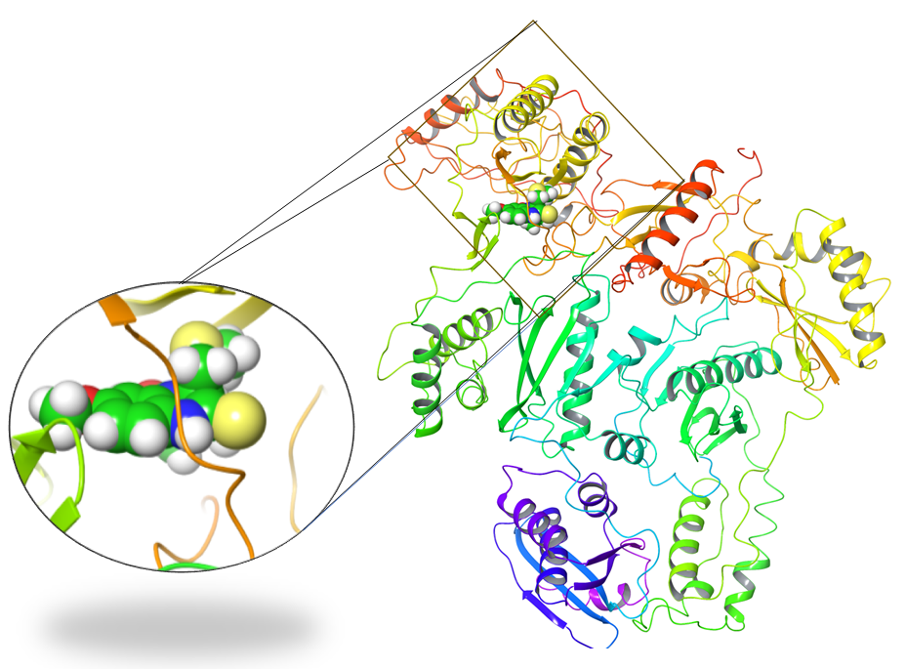
Supplemental Figure S1: Protein bound to crystal ligand after protein preparation.

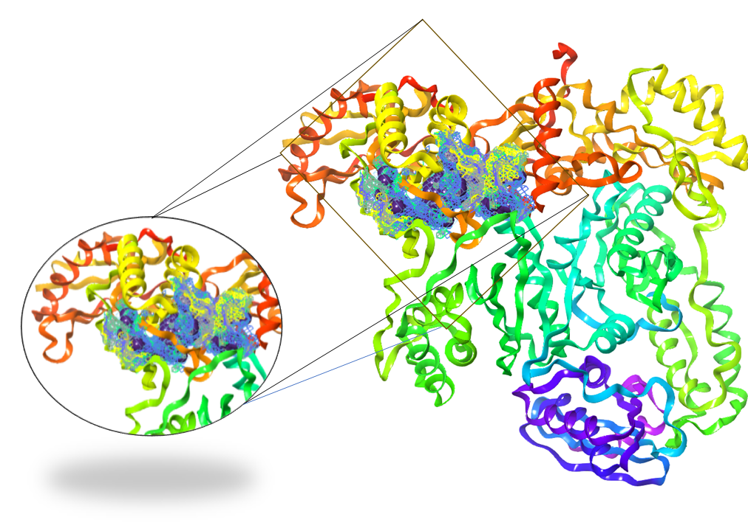
Supplemental Figure S2: Potential binding pocket of HIV-1 (PDB:1HQU).

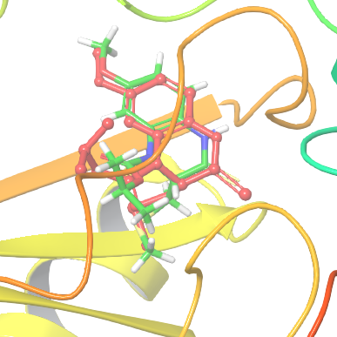
Supplemental Figure S3: Root-mean-square deviation (RMSD) evaluation between docked pose (red) and reference structure

A  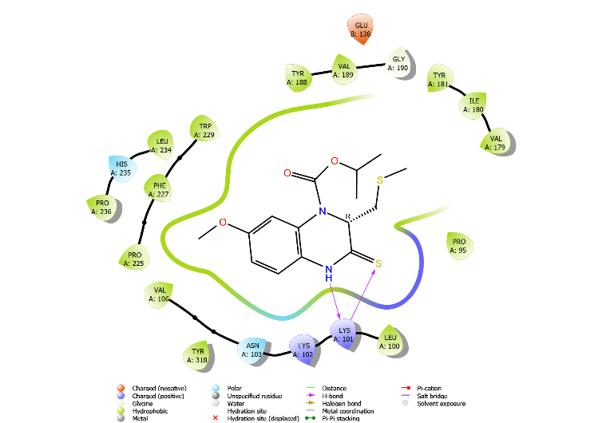 | B  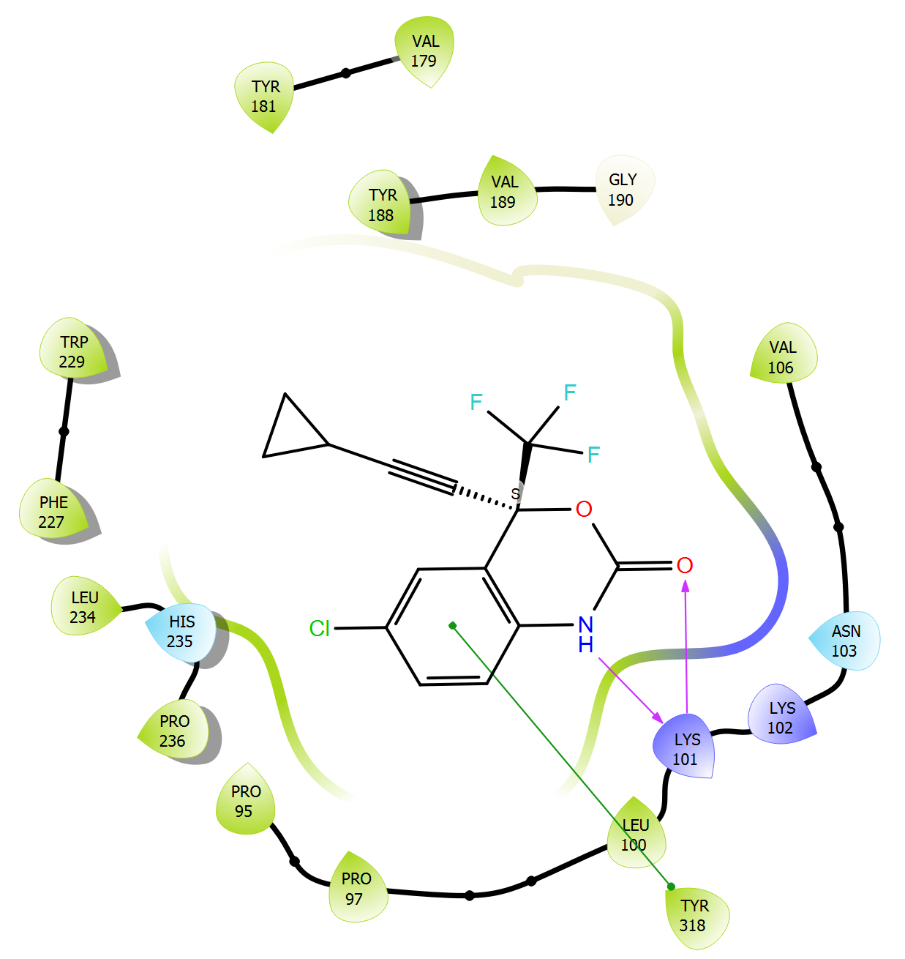
C  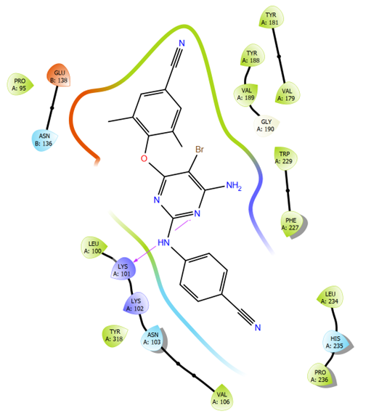 | 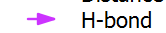  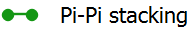  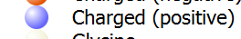  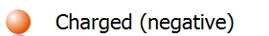  

Supplemental Figure S4: Ligand interaction diagrams. Interaction diagrams between the original HIV-1 protein and (A) Crystal ligand, (B) Etravirine, and (C) Efavirenz.

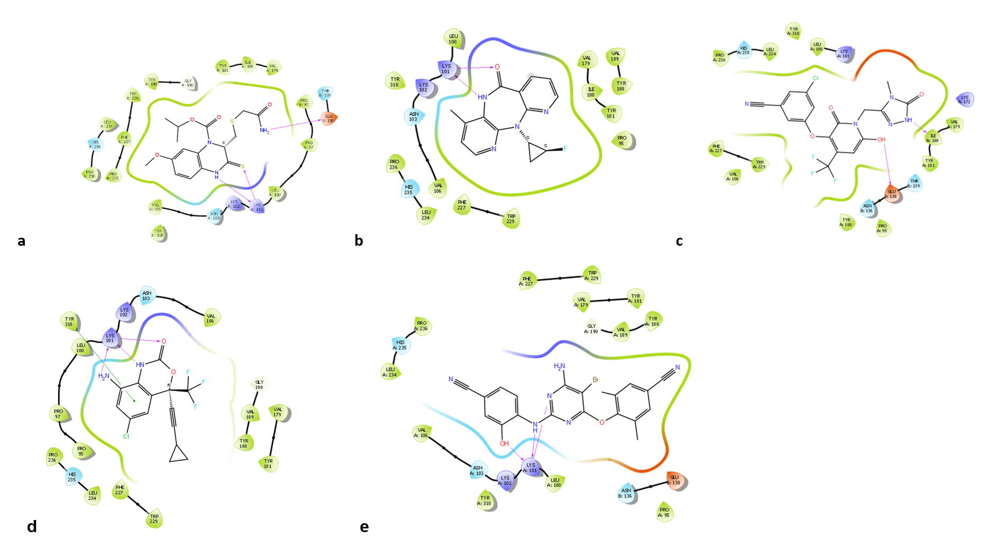
Supplemental Figure S5: Ligand interaction diagrams. (A) HBY_561, (B) Nevirapine, (C) Doravirine, (D) Efavirenz, (E) Etravirine.

Supplemental Figure S6: HOMO-LUMO energy gaps for the six optimized NNRTIs.

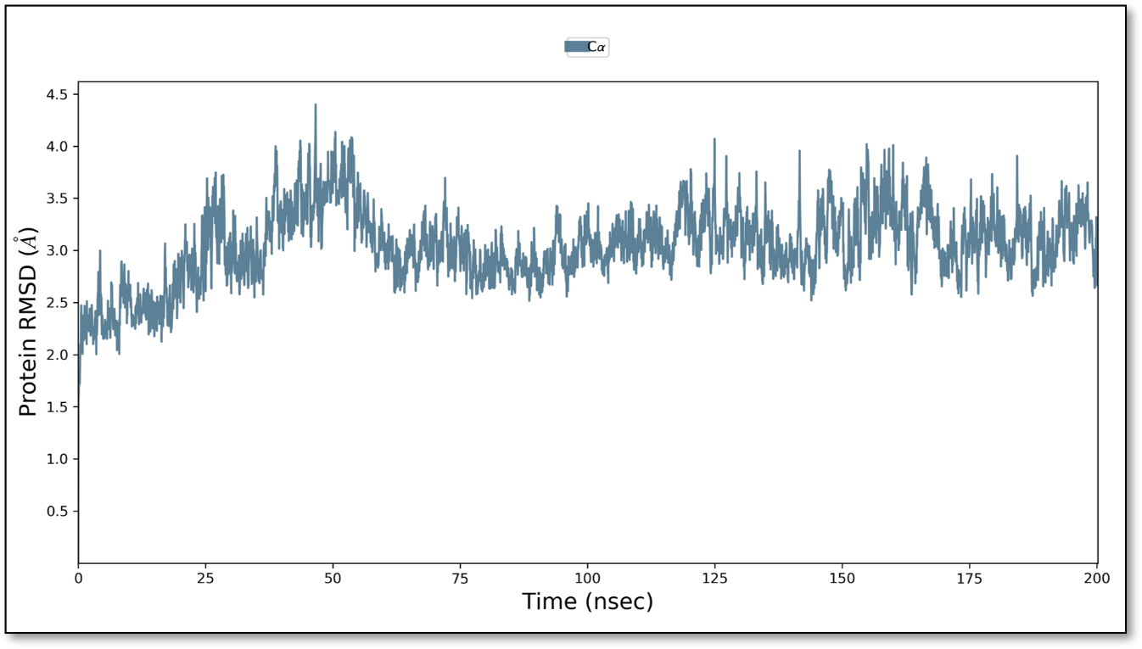
Supplemental Figure S7: Molecular dynamics diagram of the free protein.

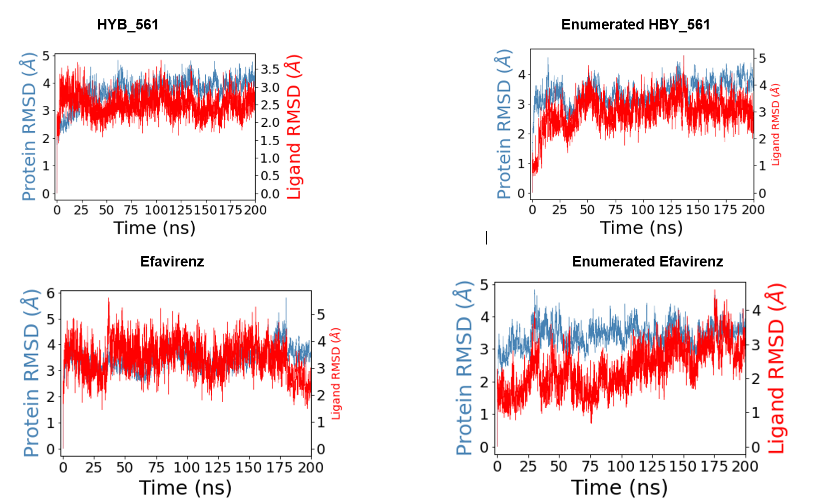
Supplemental Figure S8: Molecular dynamics diagrams for HBY_561 and Etravirine and their Enumerated compounds.

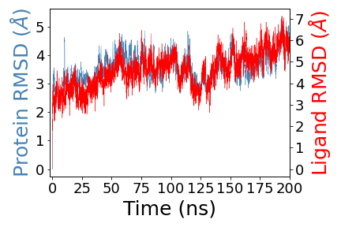
Supplemental Figure S9: Molecular dynamics diagram for enumerated Nevirapine.

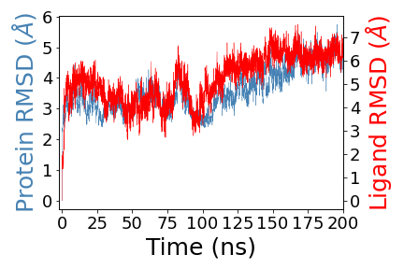
Supplemental Figure S10: Molecular dynamics diagram for enumerated Doravirine.

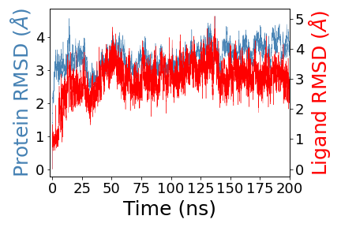
Supplemental Figure S11: Molecular dynamics diagram for enumerated ligand.

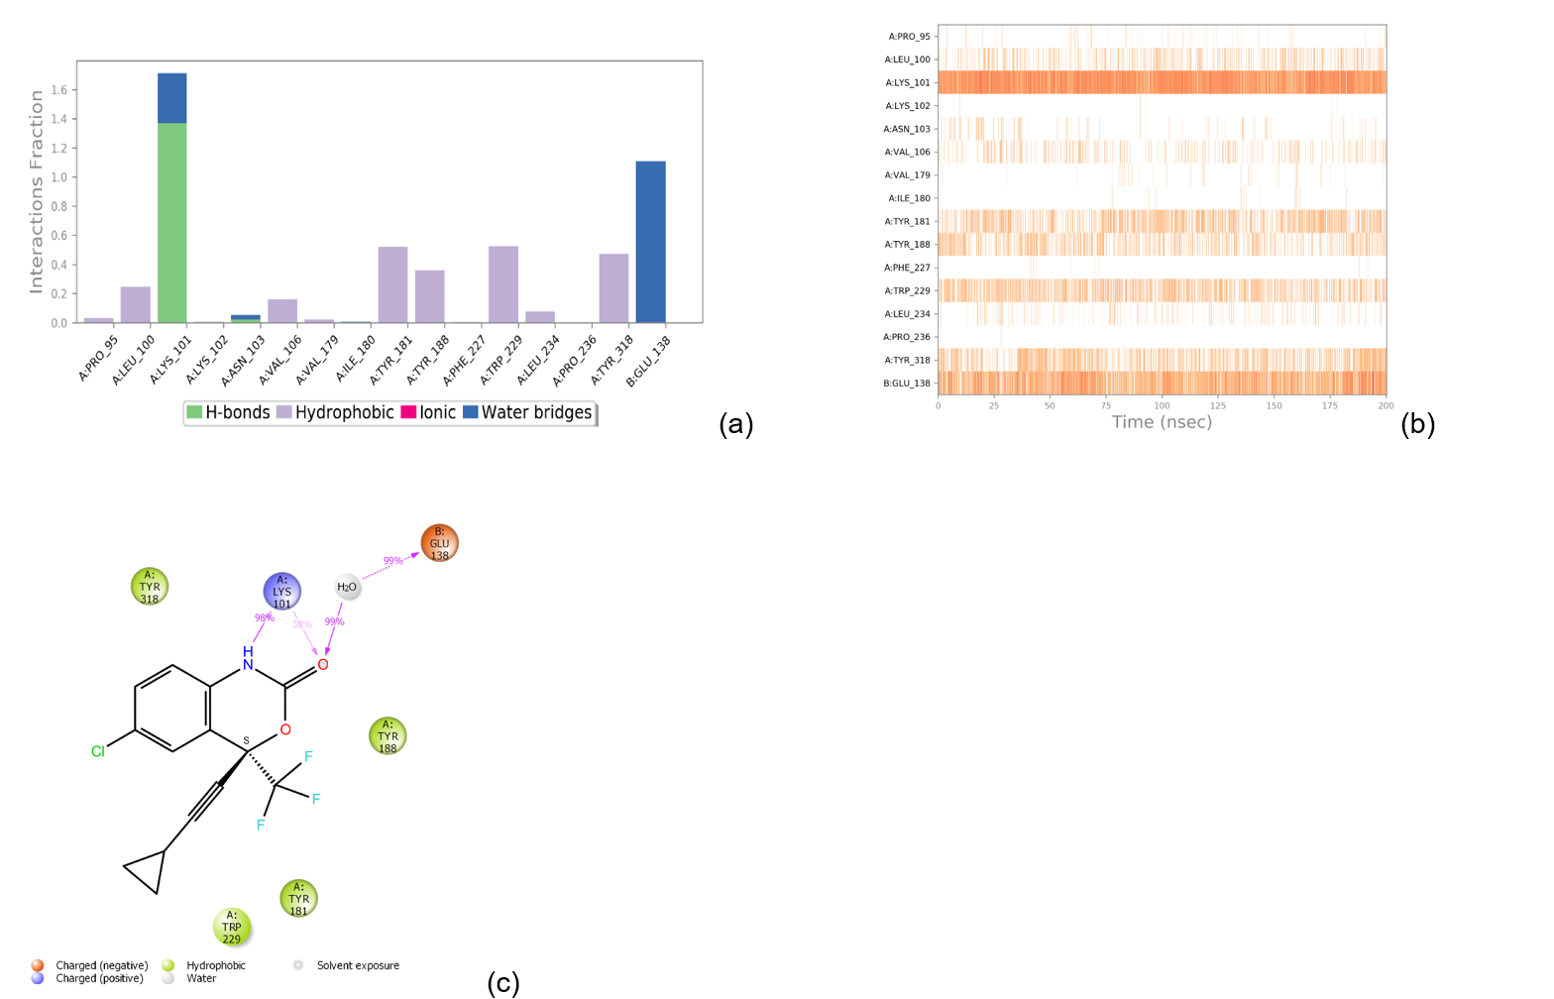
Supplemental Figure S12: Analyses of the binding between Efavirenz and the protein. (A) Interactions contacts histogram, (B) Ligand-Protein Contacts 2d summary, and (C) Protein-Ligand Contacts timeline.

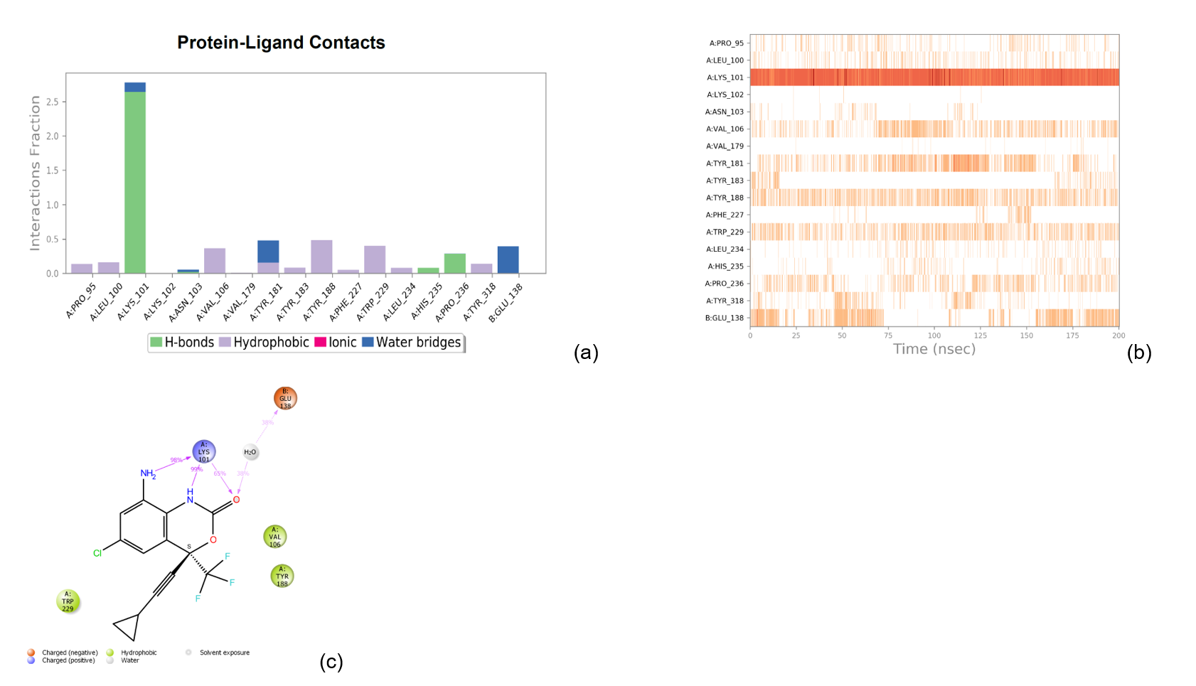
Supplemental Figure S13: Analyses of the binding between enumerated Efavirenz and the protein. (A) Interactions contacts histogram, (B) Ligand-Protein Contacts 2d summary, and (C) Protein-Ligand Contacts timeline.

(a)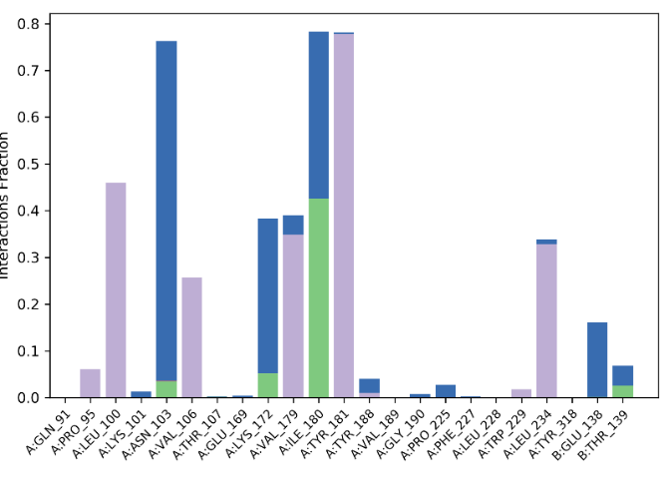(b) 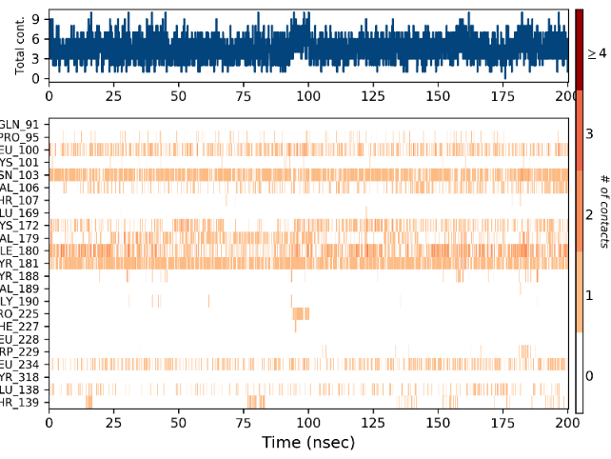

(c)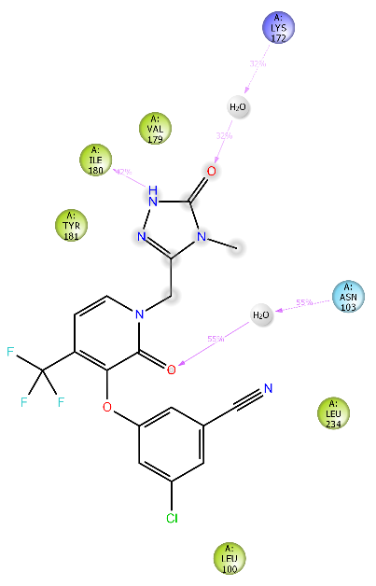
Supplemental Figure S14: Analyses of the binding between Doravirine and the protein. (A) Interactions contacts histogram, (B) Ligand-Protein Contacts 2d summary, and (C) Protein-Ligand Contacts timeline.

(a)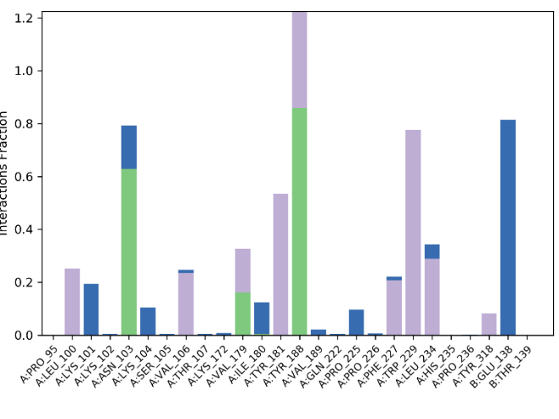 (b) 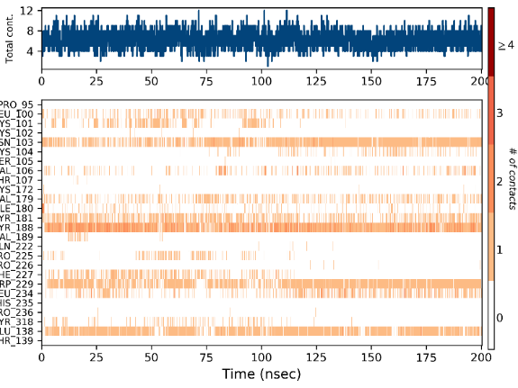

(c) 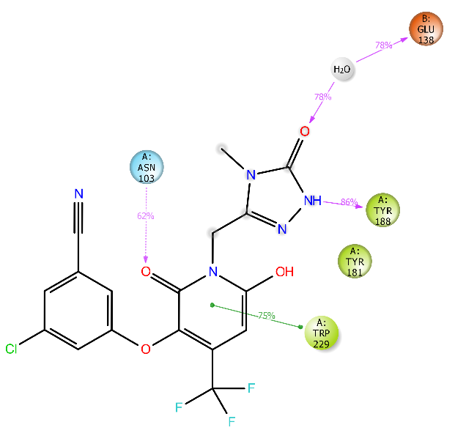

Supplemental Figure S15: Analyses of the binding between enumerated Doravirine and the protein. (A) Interactions contacts histogram, (B) Ligand-Protein Contacts 2d summary, and (C) Protein-Ligand Contacts timeline.

(a)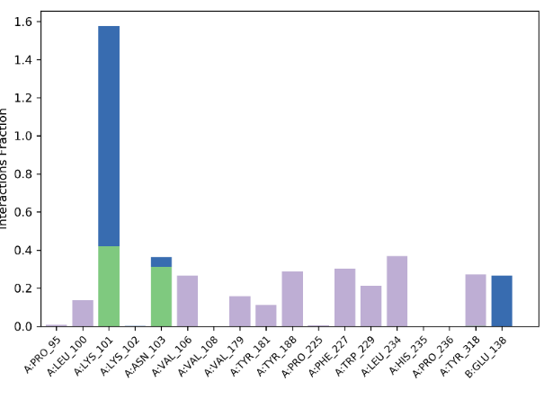 (b) 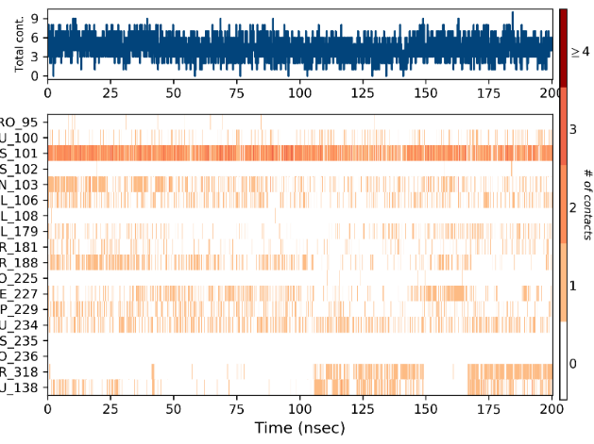

(c)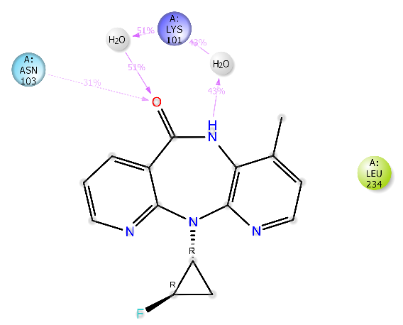

Supplemental Figure S16: Analyses of the binding between enumerated Nevirapine and the protein. (A) Interactions contacts histogram, (B) Ligand-Protein Contacts 2d summary, and (C) Protein-Ligand Contacts timeline.

(a)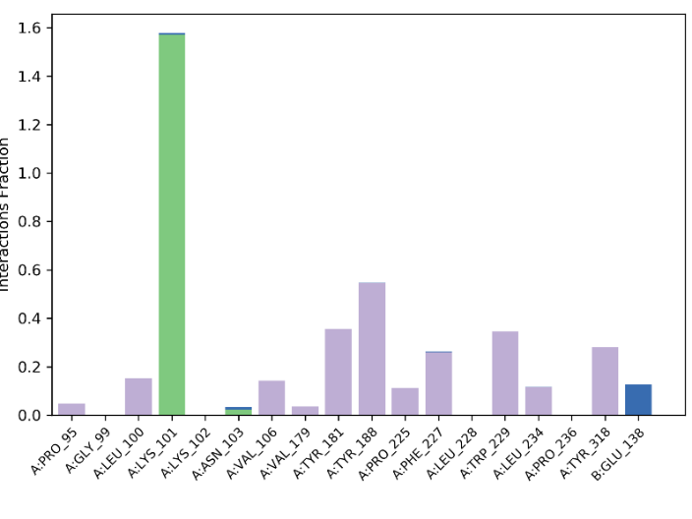 (b) 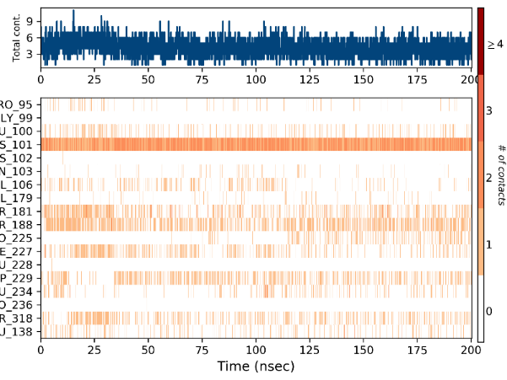

(c)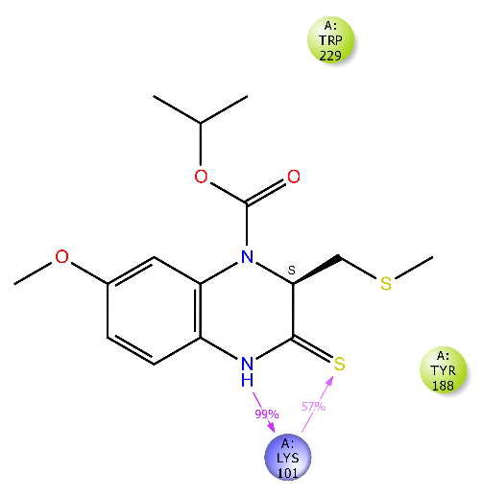

Supplemental Figure S17: Analyses of the binding between 1HQU and the protein. (A) Interactions contacts histogram, (B) Ligand-Protein Contacts 2d summary, and (C) Protein-Ligand Contacts timeline.

(a)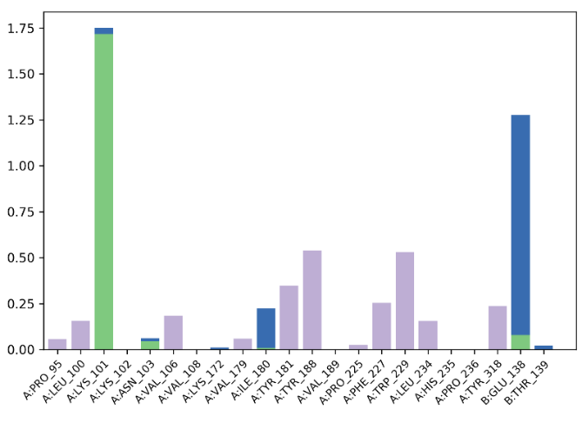 (b) 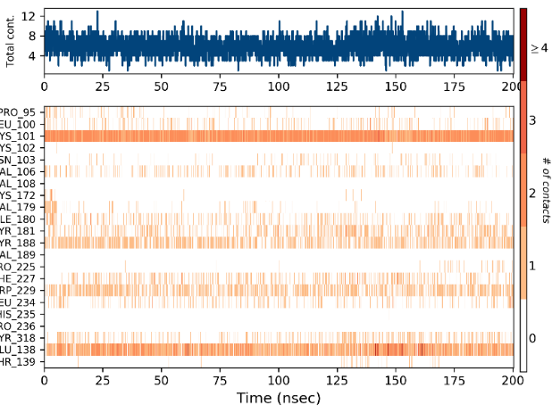

(c)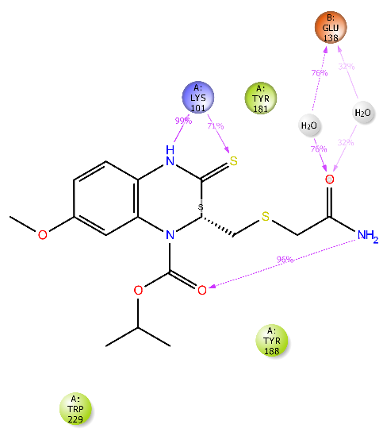

Supplemental Figure S18: Analyses of the binding between enumerated 1HQU and the protein. (A) Interactions contacts histogram, (B) Ligand-Protein Contacts 2d summary, and (C) Protein-Ligand Contacts timeline.

