Contamination Test Procedure
Nine columns were arranged in a diamond pattern around the edges of the racks, as splashes are more likely to occur at the edges. The contaminant (PCR amplicon d184) was added to the center column, and clean water was added to the side columns. Therefore, if splashes from the center column reached the side columns, the contaminant was detected in the columns, which were then rinsed with water. The water and contaminant rinse procedure were repeated 10 times, and the final eluates were collected for analysis (sample 1-18). The positions of the contaminant and clean water rinse columns were then reversed: clean water was added to the center column, and contaminant was added to the surrounding columns, and the procedure was also repeated 10 times (sample 19-36). After rinsing, the columns were removed and rinsed with 20 µL of qPCR water. We tested Mini rack version (without the Filter Column Layer) and The Reservoir-less (uncovered) version.

PCR Protocol

Name | Temperature, ℃ | Time, sec
Pre-denaturation | 95 | 300
Denaturation | 95 | 35 | Repeat 45 times
Annealing | 62 | 35 | Repeat 45 times

PCR Master Mix

Component | Final concenration
10X Taq Turbo buffer (Evrogen) | 1x
dNTP (Evrogen) | 0,2 mM
Forward (Genterra) CCATATGTTTCTTTCCCAATGGC | 0,2 μL
Revers (Genterra) AAGTCGTCGTACCCAGCAAG | 0,2 μL
Probe (Genterra) [Cy5.5] TGCAGACCAAGAGCTCATGACCT [BHQ3] | 0,1 μL
HS Taq DNA Polymerase (Evrogen) | 0,1 μL per 25 μL
DNA of CHO cell line (or amplicon d184) | 1 ng/mL
Water | to 25 μL

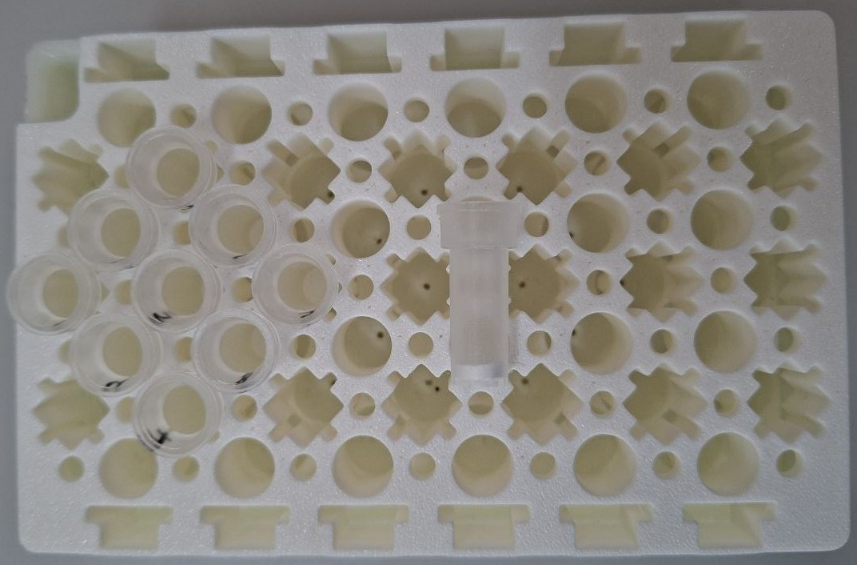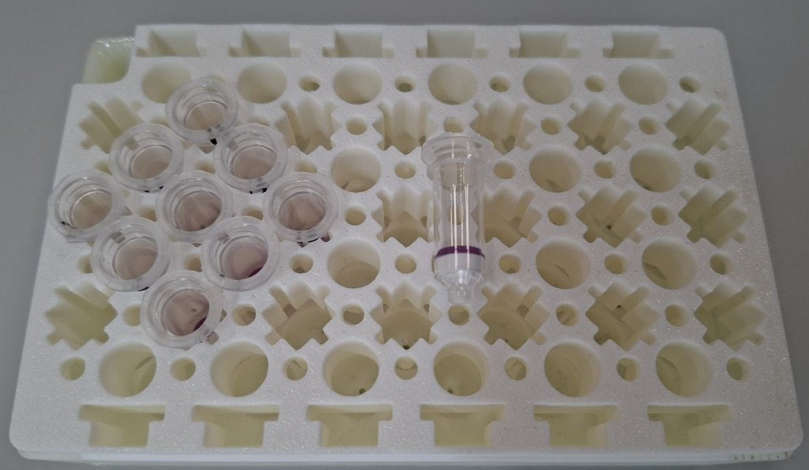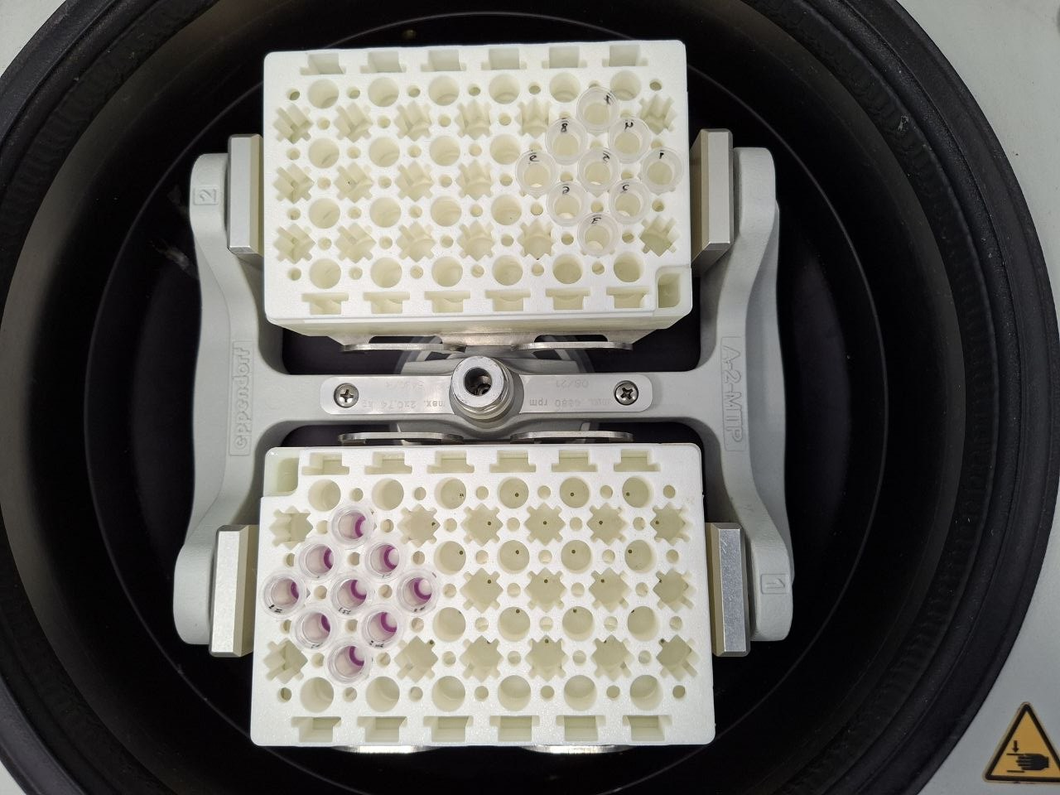
18
17
16
15
14
13
12
11
10
9
8
7
6
5
4
3
2
1

