Supplemental Methods and Equipment Specifications

Animals

  - Generate Agpat2^{+/+} (wild type) and Agpat2^{−/−} mice by mating Agpat2^{+/−} progenitors.

  - Genotype Agpat2^{−/−} mice as previously described¹⁸.

  - Maintain mice under a 12:12 h light/dark cycle. Provide chopped paper and cardboard cones as environmental enrichment.

NOTE: Perform all animal procedures in accordance with the institutional, national and international guidelines and only after the Institutional Animal Care and Use Committee (IACUC) has granted its approval. The procedures in this work were approved by Pontificia Universidad Católica de Chile IACUC under the protocol # 210609003.

Statistical analysis

  - Record the number of independent experimental replicates and the statistical tests used in each figure legend.

  - Identify outliers using the ROUT method.

  - Assess the normality of mRNA expression data using the Shapiro-Wilk test.

  - Compare more than two groups using one-way ANOVA followed by Dunnett’s post-test.

  - Set statistical significance at p < 0.05.

  - Present graph data as the mean ± standard deviation (SD).

  - Assess differences in lipid droplet (LD) size distribution using a Chi-square test of independence.

  - Perform the Chi-square test in RStudio (v4.5.2) using the chisq.test() function from the base package.

  - Use standardized residuals from the Chi-square test to interpret overrepresented and underrepresented LD size classes.

  - Interpret positive standardized residuals as observed frequencies higher than expected and negative standardized residuals as observed frequencies lower than expected.

Flow cytometry acquisition and analysis

  - Perform flow cytometry using a cell analyzer equipped with forward scatter (FSC), side scatter (SSC), and far-red fluorescence detection capabilities.

  - Acquire data using the instrument acquisition software and record 30,000 events per sample.

  - Set the FSC photomultiplier tube (PMT) voltage to 273 V and the SSC PMT voltage to 127 V. Record area, height, and width parameters for FSC and SSC.

  - Set the fluorescence PMT voltages as follows: Alexa Fluor 647 channel, 672 V; FITC channel, 208 V; PE channel, 430 V; PE-Cy7 channel, 662 V; BV421 channel, 318 V; BV510 channel, 484 V; APC-Alexa 680 channel, 380 V; and APC-Alexa 700 channel, 358 V.

  - Verify instrument performance before each run using cytometer setup and tracking beads according to the manufacturer’s instructions.

  - Open each flow cytometry standard file in the analysis software (https://floreada.io./analysis).

  - Generate an FSC-A versus SSC-A plot and gate the main cell population to exclude debris.

  - Generate sequential FSC-H versus FSC-W and SSC-H versus SSC-W plots from the gated cell population and gate single cells to exclude doublets.

  - Plot the far-red fluorescence intensity from the singlet gate to identify MitoTracker Deep Red-positive cells.

  - Use recipient cells without mitochondrial transfer as the negative control to set the background fluorescence threshold.

  - Apply the same gates and fluorescence threshold to all samples in the experiment.

  - Export the percentage of MitoTracker Deep Red-positive cells and the fluorescence intensity values for downstream analysis.
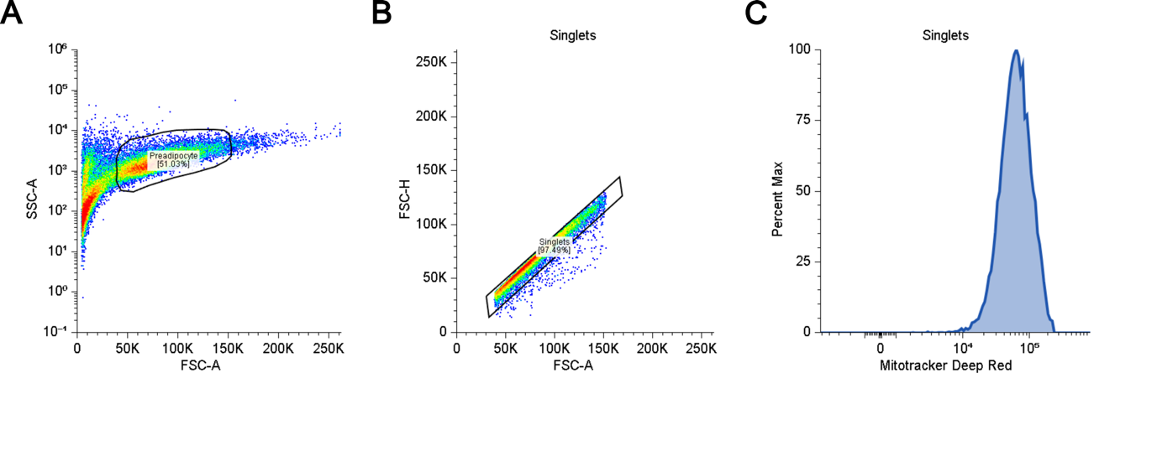Supplemental Figure S1: Gating Strategy. (A) Cell selection. (B) Singlet Selection. (C) Mitotracker Deep Red Intensity.

Microscopy and image acquisition

Live-cell imaging

    - Acquire live-cell confocal images using an inverted confocal laser scanning microscope controlled by the acquisition software.

    - Use a 60x oil-immersion objective with a numerical aperture of 1.4.

    - Maintain the refractive index at 1.515 and set the confocal pinhole to 30.0 µm.

    - Capture images at 1024 × 1024 pixels with a 12-bit depth. Set the lateral pixel size to 0.2104 µm.

    - Acquire images using a Galvano scanner and set line averaging to 2 to improve the signal-to-noise ratio.

    - Excite the FITC channel with the 488 nm laser line at 4.0% transmission power and collect emission using a 525/50 nm filter set. Set the FITC detector PMT high voltage to 90.

    - Excite the Cy5 channel with the 640 nm laser line at 8.0% transmission power and collect emission using a 561 nm long-pass filter. Set the Cy5 detector PMT high voltage to 70.

    - Use a 405/488/561/640 multiband dichroic mirror for both fluorescence tracks.

    - Save the acquired image files with sample identifiers, fluorophore channels, magnification, and acquisition date.

Fixed-cell imaging

    - Acquire fixed-cell fluorescence images using a confocal laser scanning microscope equipped with an Airyscan detector.

    - Use a 10x/0.45 air objective for image acquisition.

    - Capture images at 6412 × 6412 pixels with a 16-bit depth. Set the lateral pixel size to 0.1323 µm and the digital zoom to 1.0x.

    - Excite samples using a 488 nm argon laser at 2.0% transmission power.

    - Collect emission using a BP 495-550 + LP 570 filter set.

    - Set the detector gain to 750 and the virtual pinhole size to 8.89 AU.

    - Acquire data in Fast Airyscan 2D mode.

    - Process images after acquisition using the automated Airyscan deconvolution algorithm in the microscope software.

    - Apply a Super Resolution parameter of 2.99 for the 488 nm channel.

    - Save the processed image files with sample identifiers, channel information, magnification, and acquisition date.

4.3. TEM imaging

4.3.1. Visualize the grids using a transmission electron microscope. In this work we used a TALOS F200C.

4.3.2. Operate the microscope at an accelerating voltage of 200 kV.

4.3.3. Acquire ultrastructural images at an acquisition magnification of 11,000× using a Ceta CMOS camera.

4.3.4. Capture images at 1024 × 1024 pixels with a 1 s exposure time.

4.3.5. Set the lateral pixel size to 5.4 nm.

4.3.6. Save the acquired image files with sample identifiers, magnification, and acquisition date.

Primary brown adipocyte isolation and differentiation

5.1. Dissect and digest tissue

    - Euthanize the newborn mouse (P0.5) by quick decapitation with a surgical scissor. Open the skin on the interscapular space with surgical scissors and forceps. Dissect the interscapular brown adipose tissue (iBAT) from newborn mice.

5.1.2. Mince the iBAT in small pieces (~2-3 mm) with surgical scissors. Digest the tissue with collagenase type I buffer for 30 min at 37 °C under gentle agitation.

5.2. Isolate and purify the stromal vascular fraction.

5.2.1. Pass the digested tissue through a 100 μm cell strainer and add ACK lysis buffer.

5.2.2. Collect the stromal vascular fraction (SVF) by centrifugation at 300 × g for 5 min.

5.2.3. Resuspend the pellet in DMEM/F12 supplemented with 10% FBS and 1% penicillin/streptomycin.

5.2.4. Filter the suspension through a 40 μm cell strainer, centrifuge again at 300 × g for 5 min, and resuspend the final pellet in DMEM/F12.

5.3. Cell culture and expansion

5.3.1. Plate the cells from each mouse in 6 wells of a 24-well plate in DMEM/F12 and maintain at 37 °C in 5% CO₂.

5.3.2. Transfer cultures onto a 12-well plate once they reach confluence and expand the culture until confluence is reached again.

5.3.3. Trypsinize, count, and plate cells onto the corresponding experimental plates.

5.4. Adipogenic differentiation induction

5.4.1. Once confluence is achieved, induce brown adipocyte differentiation using differentiation induction medium (DIM) for 48 h (corresponding to 2 days of differentiation).

5.4.2. Subsequently, replace DIM with differentiation maintenance medium (DMM) for 24–120 h (corresponding to 3 days of differentiation up to 7 days of differentiation)

6. Reynolds’ method (Lead citrate contrast staining)

6.1. Preparation of the chamber for Reynolds’ solution

6.1.1. Place solid NaOH pellets inside a Petri dish next to a sheet of Parafilm to eliminate ambient CO₂.

6.2. Dispense and stain.

6.2.1. Deposit drops of the filtered solution of Reynolds’ Solution onto the Parafilm.

6.2.2. Float TEM grids (section-side down) on the drops and incubate the covered system for 10 min.

6.3. Wash and dry.

6.3.1. Remove the grids, rinse them immediately in boiled distilled water, and blot excess liquid from the edge using filter paper.

6.3.2. Allow to air-dry completely.

