Supplemental Figure S1. Quality assessment of expression normalization in GSE75360 and GSE74144. (A) Boxplot of expression distributions in GSE75360 before normalization. (B) Boxplot of expression distributions in GSE75360 after normalization. (C) Boxplot of expression distributions in GSE74144 before normalization. (D) Boxplot of expression distributions in GSE74144 after normalization. Orange indicates hypertension samples and blue indicates control samples. These plots show that between-sample expression distributions became more comparable after normalization, supporting the use of the processed data for downstream analyses.

Supplemental Figure S2. Validation and correlation analysis of the 18 RAS-related differentially expressed genes in GSE75360. (A) Group comparison plot showing expression differences of the 18 RASRDEGs between hypertension and control samples in GSE75360. (B-E) ROC curves of the significantly different RASRDEGs for distinguishing hypertension from control samples in GSE75360. (F) Correlation heatmap of the 18 RASRDEGs in GSE75360. These analyses show that multiple RASRDEGs differ significantly between groups, display moderate discriminatory ability, and exhibit coordinated expression patterns.

Supplemental Figure S3. GO and KEGG enrichment visualization of the 18 RASRDEGs. (A) Bubble plot of significantly enriched GO terms and KEGG pathways for the 18 RASRDEGs. (B) Network plot of enriched biological process terms. (C) Network plot of enriched cellular component terms. (D) Network plot of enriched molecular function terms. (E) Network plot of enriched KEGG pathways. These enrichment results indicate that the identified RASRDEGs are associated mainly with immune/inflammatory processes, vesicle-related cellular components, and vascular/inflammatory signaling pathways.

Supplemental Figure S4. Preranked GSEA of the ranked gene list in GSE75360. (A) Overview plot of significant gene sets identified by preranked GSEA in GSE75360. (B) Enrichment plot for Overview of Proinflammatory and Profibrotic Mediators. (C) Enrichment plot for Immune Infiltration in Pancreatic Cancer. (D) Enrichment plot for IL26 Signaling Pathway. (E) Enrichment plot for Development and Heterogeneity of the ILC Family. These results show that the hypertension-associated ranked transcriptome in GSE75360 is enriched predominantly for immune- and inflammation-related signatures.

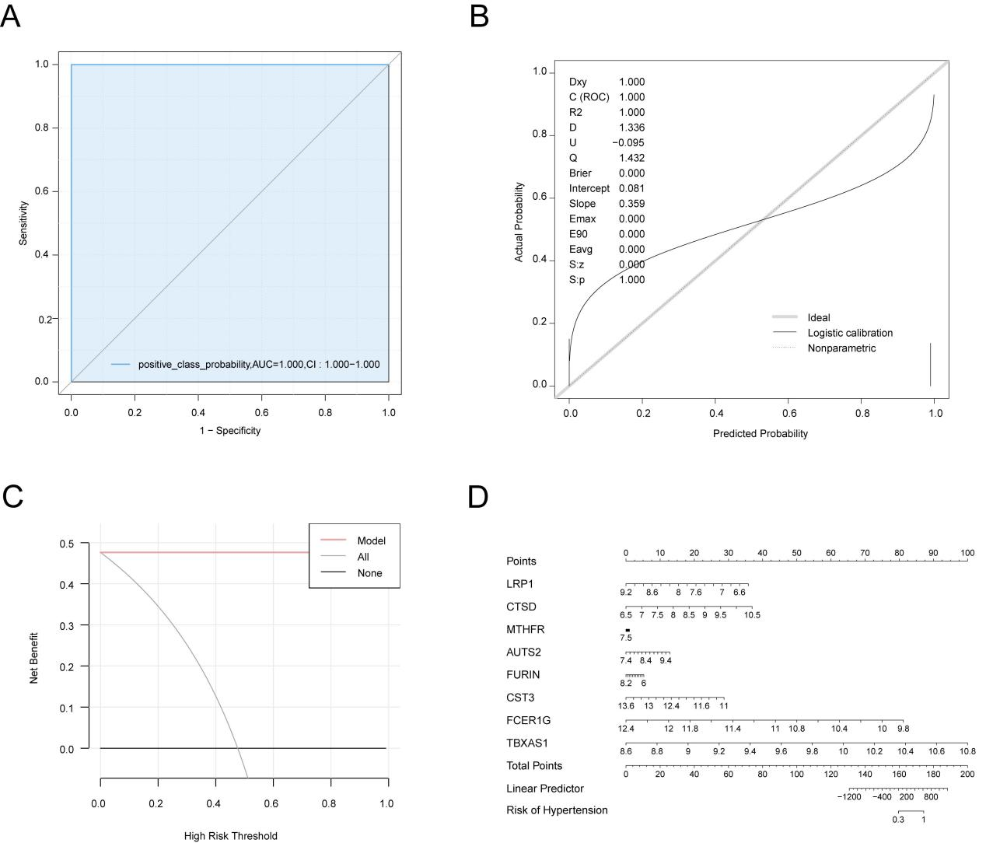
Supplemental Figure S5. Internal validation of the eight-gene hypertension diagnostic model in the discovery cohort (GSE75360). (A) ROC curve of the eight-gene logistic regression model in GSE75360. (B) Calibration curve of the eight-gene model in GSE75360. (C) Decision curve analysis of the eight-gene model in GSE75360. (D) Nomogram of the eight-gene model in GSE75360. These analyses show that the candidate diagnostic model has strong discrimination in the discovery cohort and displays acceptable calibration and net benefit within this dataset.
Supplemental Figure S6. Single-gene GSEA for AUTS2, CST3, CTSD, and FCER1G in GSE75360. Single-gene GSEA results for (A) AUTS2, (B) CST3, (C) CTSD, (D) FCER1G. For each key gene, samples were stratified into high- and low-expression groups, and GSEA was performed on the ranked gene list. These plots show that several of these genes are associated with recurrent immune- and inflammation-related signatures.

Supplemental Figure S7. Single-gene GSEA for FURIN, LRP1, MTHFR, and TBXAS1 in GSE75360. Single-gene GSEA results for (A) FURIN, (B) LRP1, (C) MTHFR, (D) TBXAS1. For each key gene, samples were stratified into high- and low-expression groups, and GSEA was performed on the ranked gene list. These plots further support that the key genes are linked primarily to immune- and inflammation-associated pathway activity.

Supplemental Figure S8. PPI and functional association networks of hub genes. (A) STRING protein-protein interaction (PPI) network of the hub genes. (B) GeneMANIA functional association network of the hub genes and related genes. These analyses indicate that seven hub genes are connected within a broader functional interaction network, supporting their potential biological relatedness.

