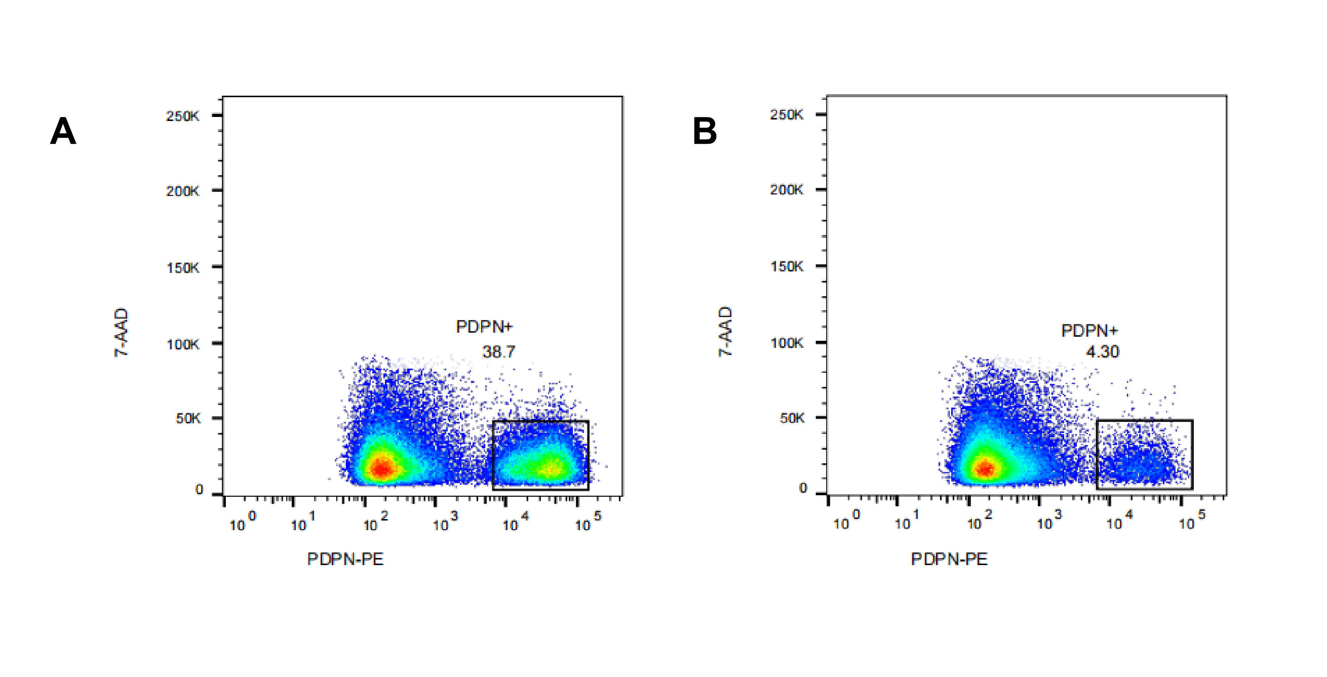
Supplemental Figure S1. Flow cytometry analysis of PDPN expression in human bone marrow mesenchymal stem cells (hBMSCs). (A) Pre-sort frequency of PDPN⁺ cells (38.7%). (B) Post-sort negative fraction showing residual PDPN⁺ cells (4.30%).

Flow cytometry validation

- Stain the cells with PE-conjugated anti-PDPN antibody and 7-AAD live/dead dye.

- Prepare unstained cells without antibody or 7-AAD as the negative control. Use this control to set the PDPN-positive threshold.

- Gate the cells using FSC-A/SSC-A to exclude debris.

- Gate the singlet population using SSC-A/SSC-H to exclude doublets.

- Gate the 7-AAD-negative population to exclude dead cells.

- Gate the PDPN-PE-positive population within the live singlet cells. Record the percentage of PDPN-positive cells.

NOTE: Include 7-AAD to exclude dead cells, which can cause false-positive PDPN signals through nonspecific antibody binding. Unstained cells were used to set the PDPN-positive threshold. Single-color controls were not included in this validation because PE and 7-AAD were sufficiently separated under the acquisition settings used. Because sorting and post-sort assessment were based on PDPN-PE labeling, interpret the post-sort value as PDPN-PE positivity after washing, culture, trypsinization, and live-cell gating.

